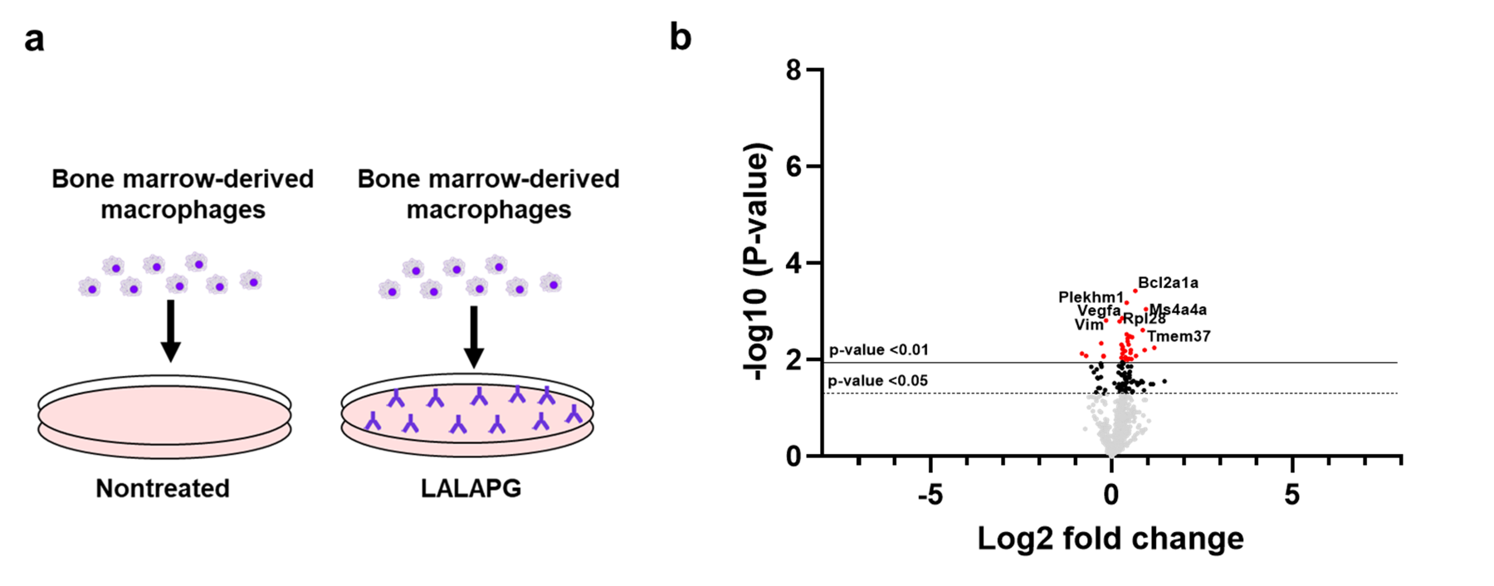
Supplemental Figure 7. Bone marrow-derived macrophages plated with by LALAPG have no significant differential gene expression from non-treatment group. (a) Schematic diagram showing macrophages treated with by immunodeficient LALAPG control antibodies. (b) Volcano plots showing not significantly differentially expressed genes in LALAPG activated macrophages vs. control nontreated macrophages. Horizontal line values correspond to p-value <.01(solid), p-value <.05(dashed).

