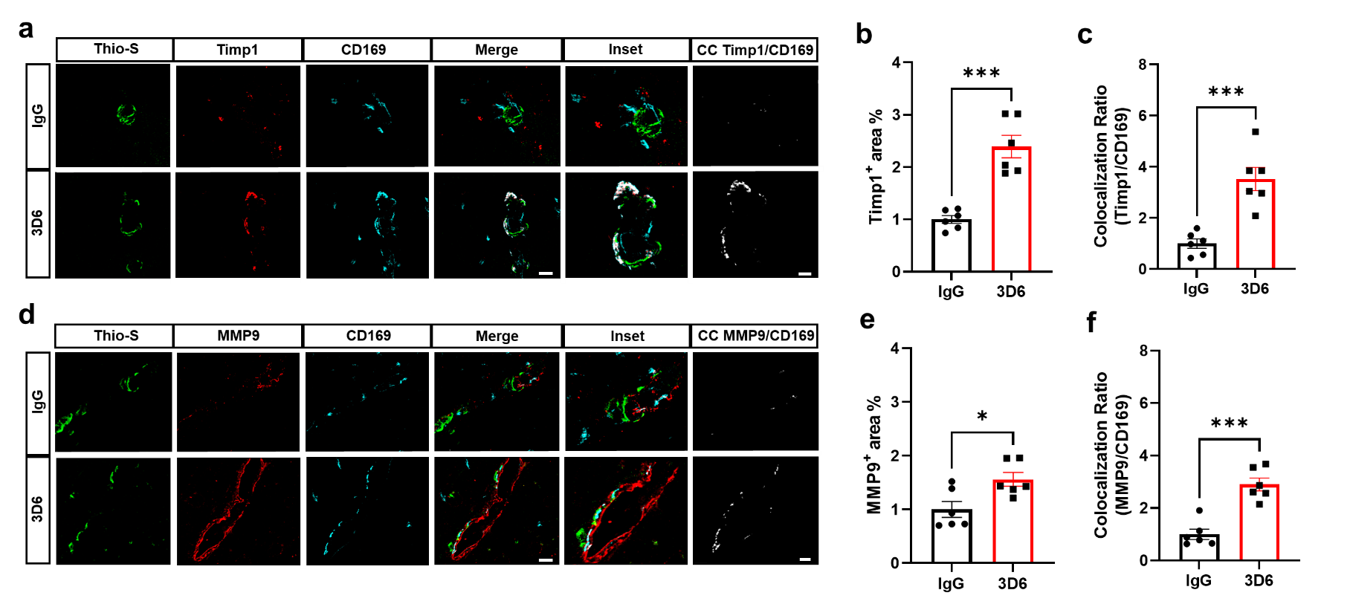
Supplemental Figure 8. Aβ immunotherapy activated perivascular macrophages of penetrating vessels express extracellular matrix remodeling genes. (a) Triple immunofluorescence of amyloid (Thio-S, green), Timp1 (red) and perivascular macrophages (CD169, cyan) in PDAPP mice treated with 3D6 or IgG control. Thio-S, Timp1 and CD169 immunoreactivity overlay (Merge). Colocalization analysis (white). (b) Quantification of Timp1⁺ area (%) of IgG or 3D6 treated mice. (c) Quantification of colocalization ratio of Timp1 and CD169. (d) Triple immunofluorescence of amyloid (Thio-S, green), MMP9 (red) and perivascular macrophages (CD169, cyan) in PDAPP mice treated with 3D6 or IgG control. Thio-S, MMP9 and CD169 immunoreactivity overlay (Merge). Colocalization analysis (white). (e) Quantification of MMP9⁺ area (%) of IgG or 3D6 treated mice. (f) Quantification of colocalization ratio of MMP9 and CD169. The number of vascular amyloid deposits analyzed was 8-10 per animal. Results are shown as ± SEM of n = 6 (mice). Asterisks indicate significant differences, where *p<.05 and ***p < 0.001 by unpaired Student's t test. Scale bar 5 μm CC or 10 μm merge, respectively.

