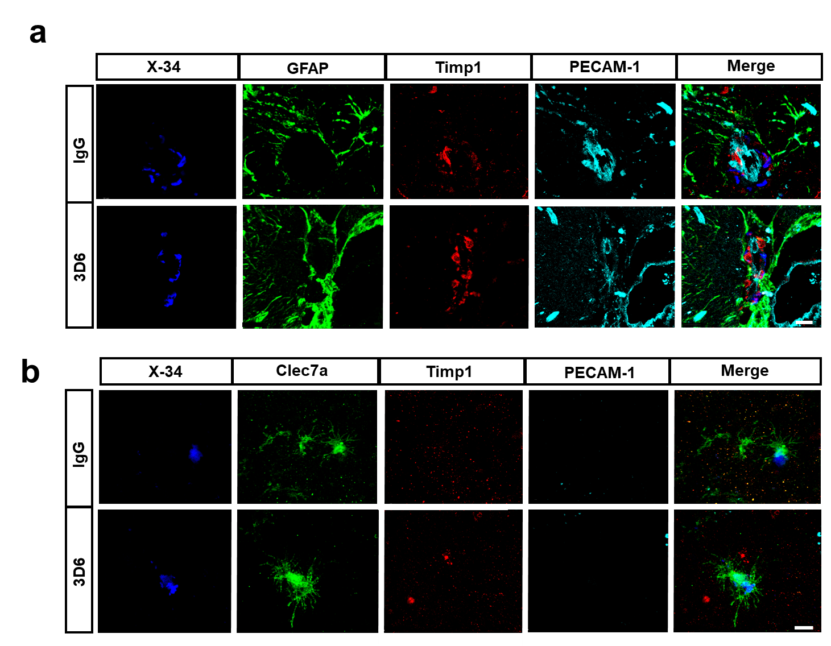Supplemental Figure 9. Timp1⁺ immunoreactivity was not detected in astrocytes, microglia, or endothelial cells. (a) Four color immunofluorescence of amyloid (X-34, blue), astrocytes (GFAP, green), Timp1( red) and endothelial cells (PECAM-1) in PDAPP mice treated with 3D6 or IgG control. (b) Four color immunofluorescence of amyloid (X-34, blue), microglia (Clec7a, green), Timp1 (red) and endothelial cells (PECAM-1) in PDAPP mice treated with 3D6 or IgG control. Immunoreactivity overlay (Merge). Scale bar 10 μm.

