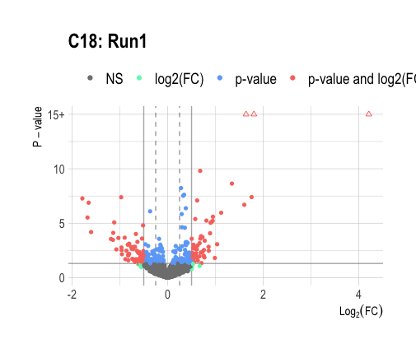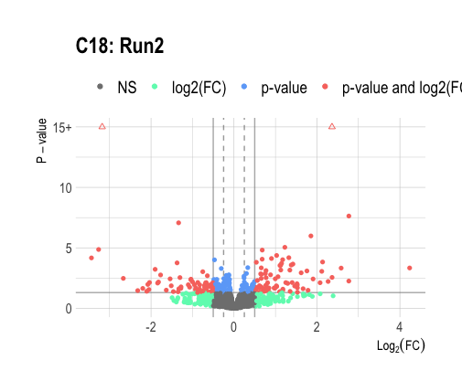
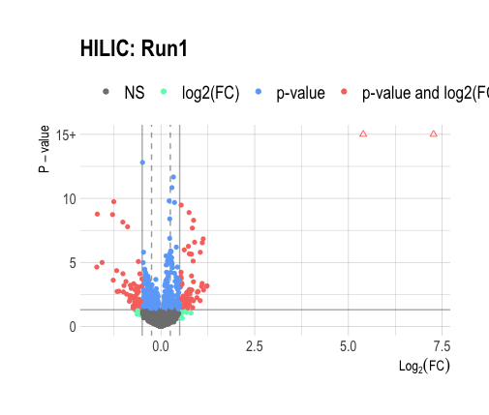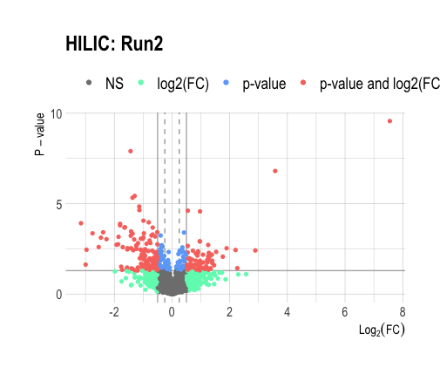

Supplemental Figure 9. Volcano plots for the HILIC and C18 analysis with each run was processed (e.g., normalization and combat batch correction) and analyzed independently.

