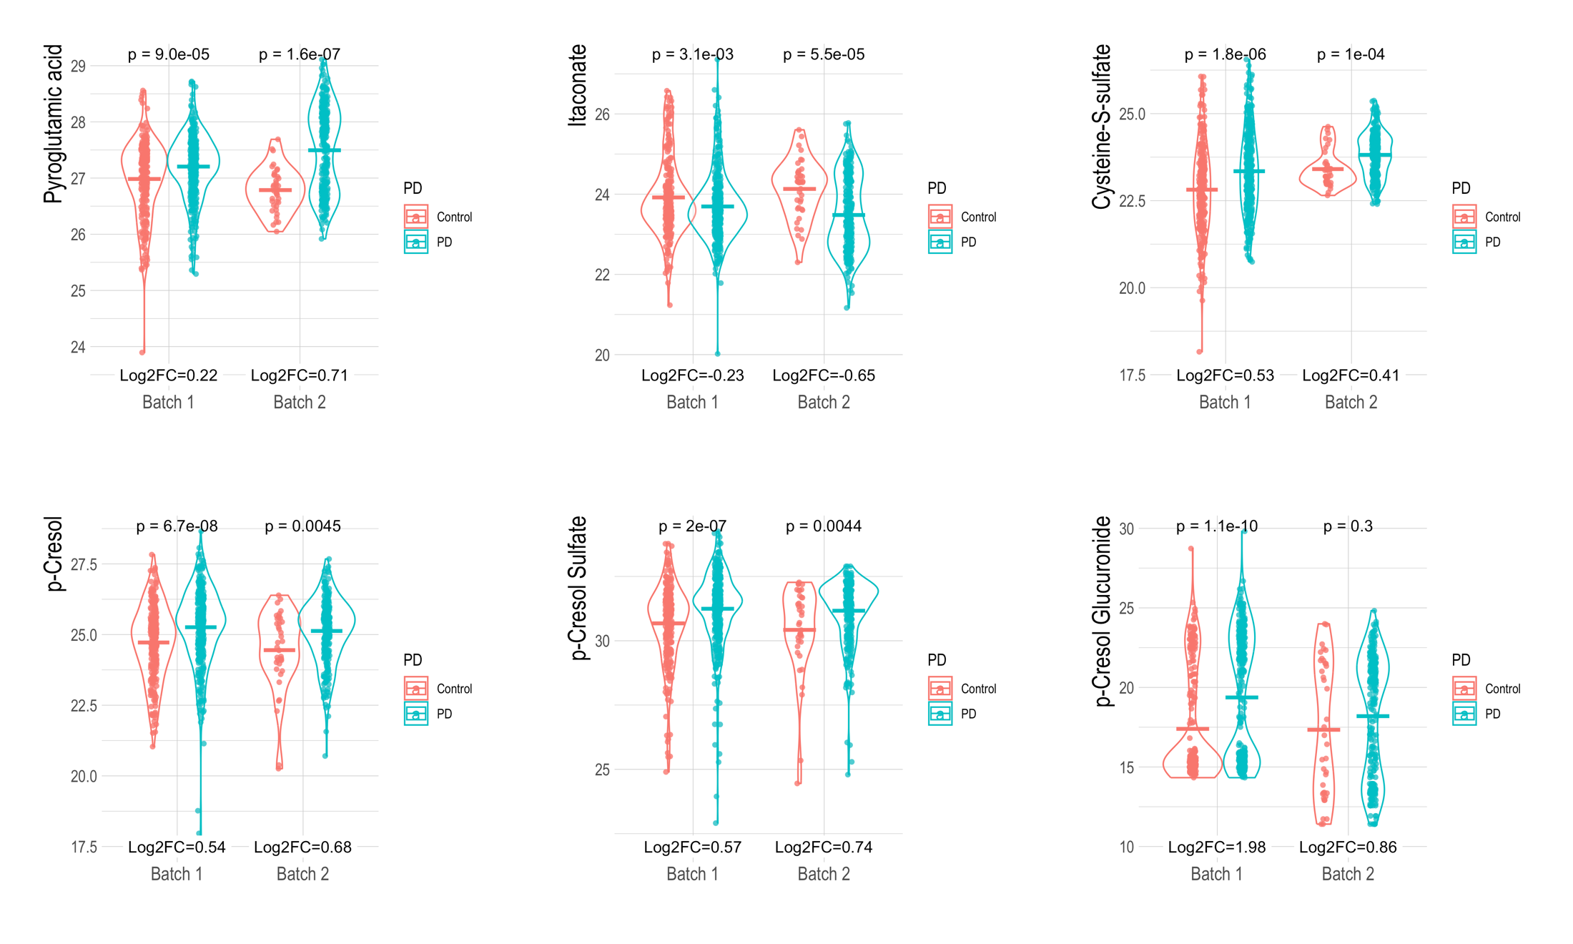

Supplemental Figure 11. Top metabolite results shown by HRMS run. Processing / normalization on pooled data. Mean comparisons of the crude data, shown on the log2 scale, and compared with a Wilcoxon test. Supplemental Tables 2 and 3 show results from adjusted models.

