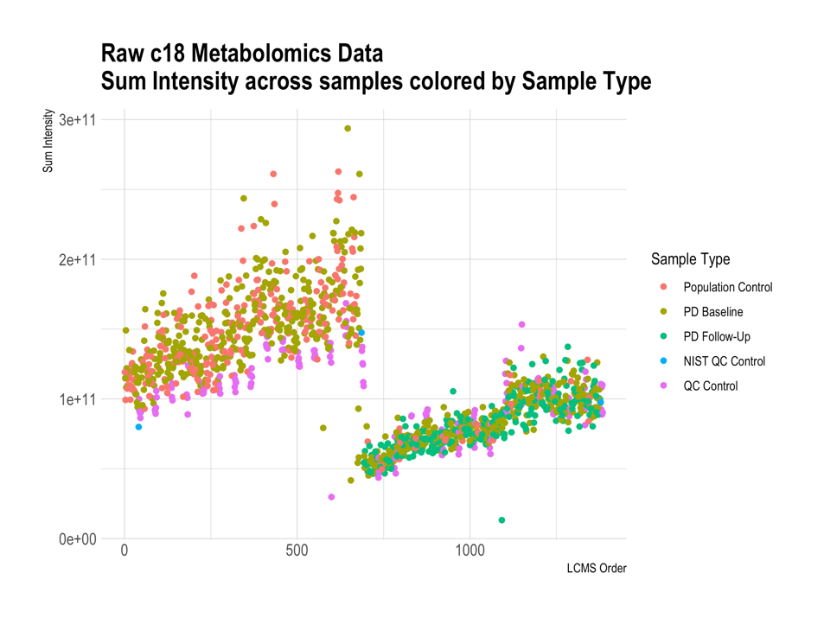
Supplemental Figures
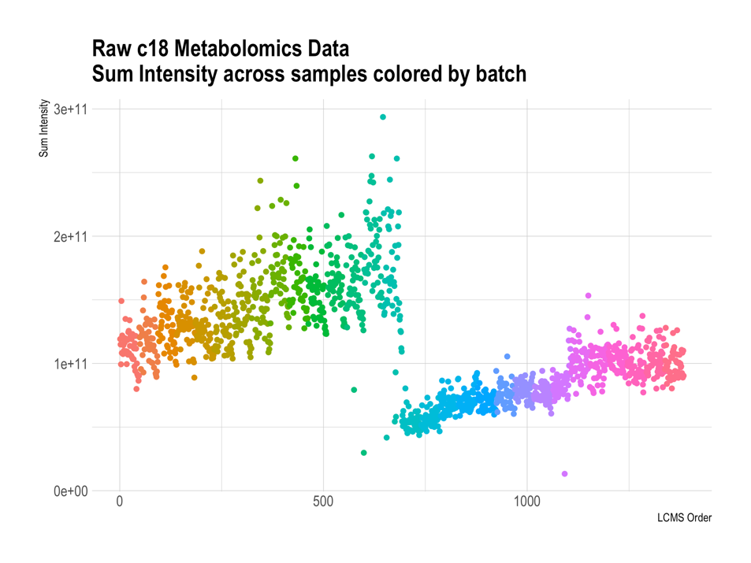

Supplemental Figure 1. C18 negative column metabolomics processing: Sum of metabolite intensities across samples colored by batch & sample type, before pre-processing (log transformation, quantile normalization, ComBat batch correction). LCMS was run across 30 batches (n=46); machine was reset after 694 samples (i.e., samples ran in two larger groups of n=694 samples, each with 15 smaller batches within run). Run, batch, and drift effects are apparent in raw data.

