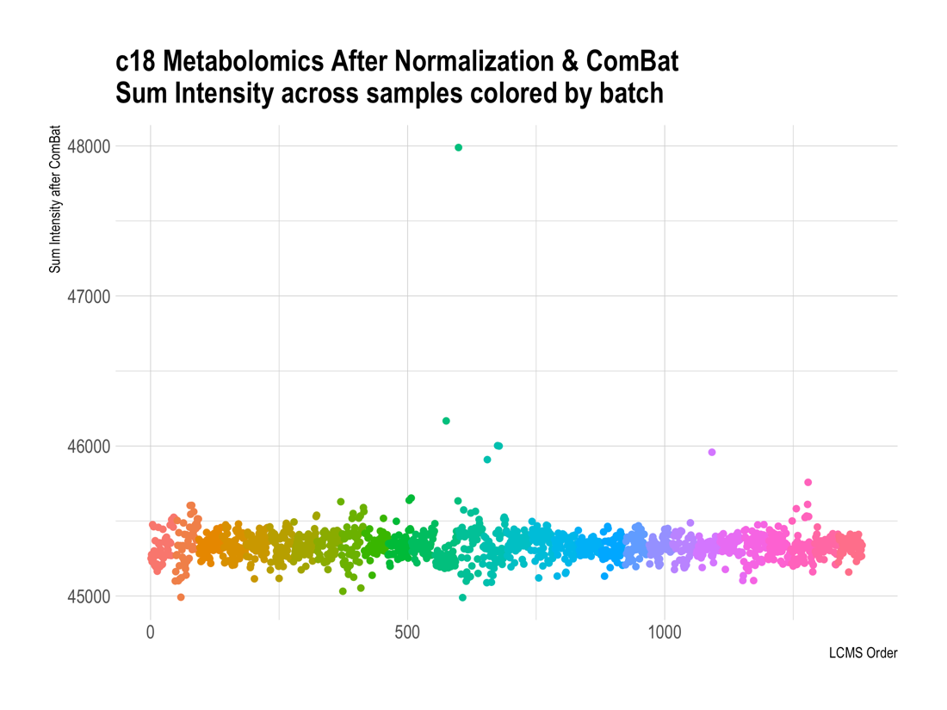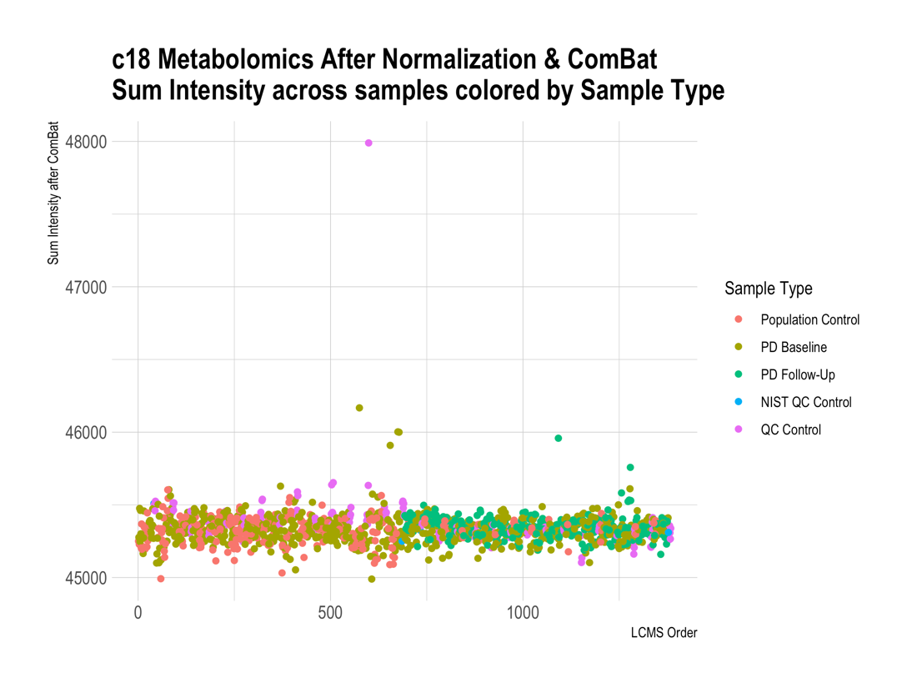
Supplemental Figure 2. C18 negative column after metabolomics processing. Raw c18 data was log transformation, quantile normalized, followed by ComBat for batch correction. LCMS was run across 30 batches (n=46); machine was reset after 694 samples (i.e., samples ran in two larger groups of n=694 samples, each with 15 smaller batches within run. While there are several apparent outliers, after processing, technical variation has been removed.

