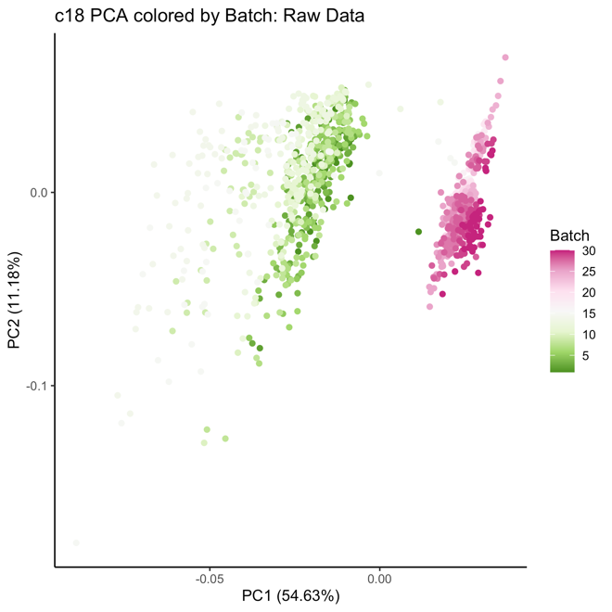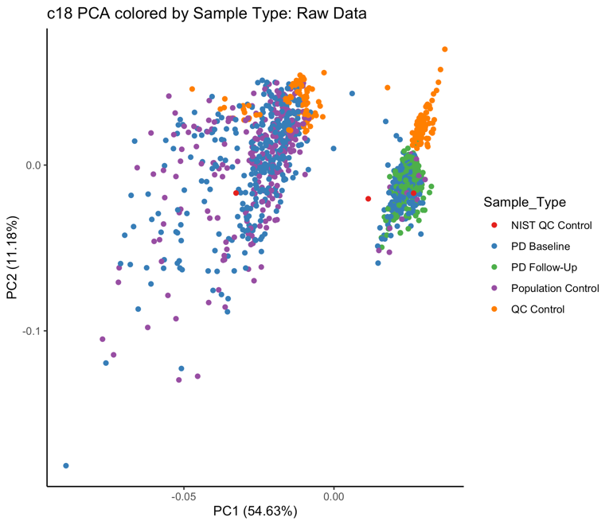
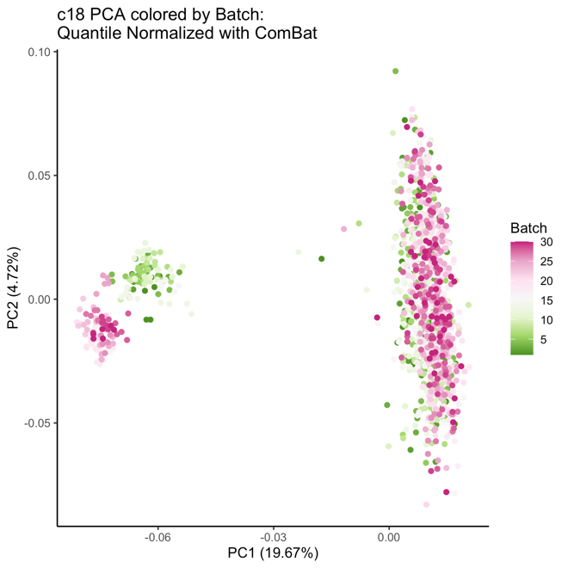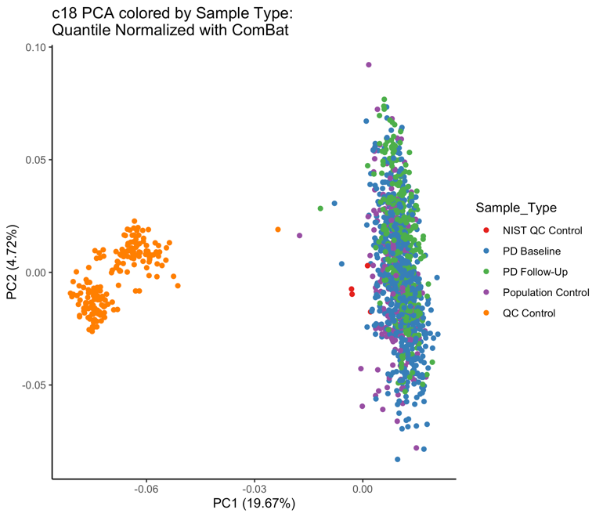
Supplemental Figure 3. C18 negative column metabolomics processing: Principal component analysis of raw and processed metabolomics data. PC variation primarily explained by LCMS run in raw data. After correction, sample type (quality control sample versus the study serum samples) primarily explains variation.

