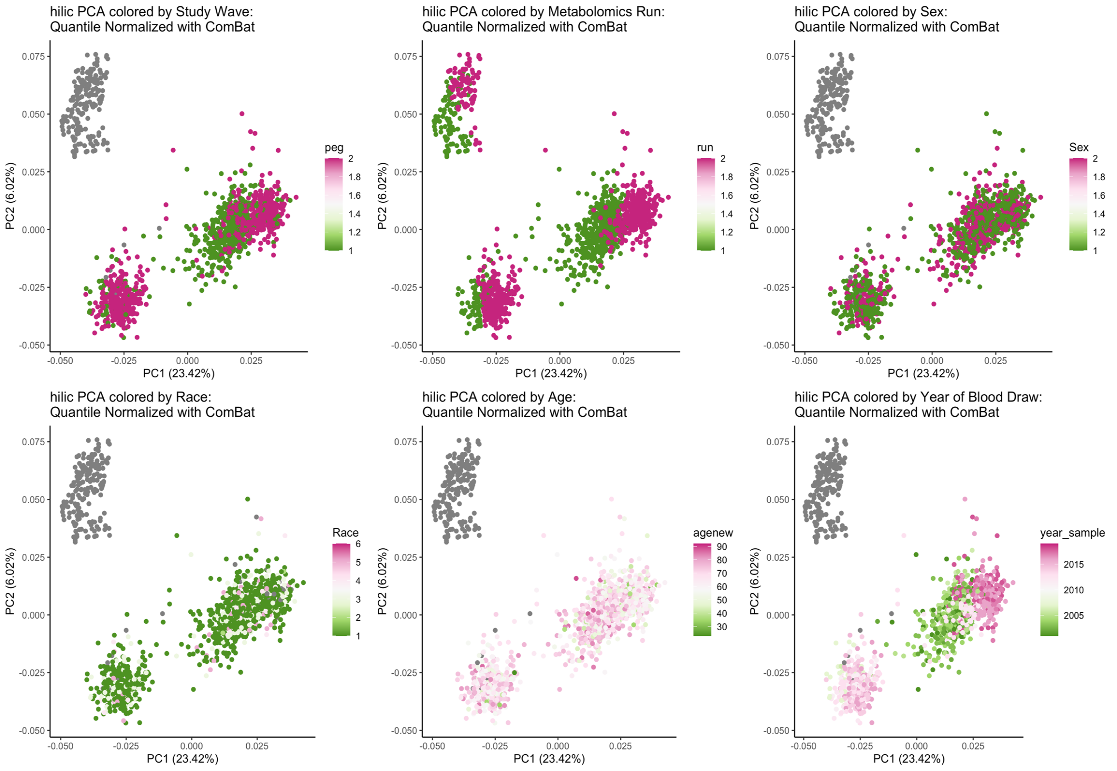

Supplemental Figure 6. HILIC positive PCA of processed data, colored by different covariates. No distinguishing variables to describe the different clusters of study samples, though there is some separation by year of sample. Note gray indicates the QC samples. Therefore, we additionally corrected for inclusion in this cluster, as variation appears technical and is very influential in MWAS (Supplemental Figure 7).

