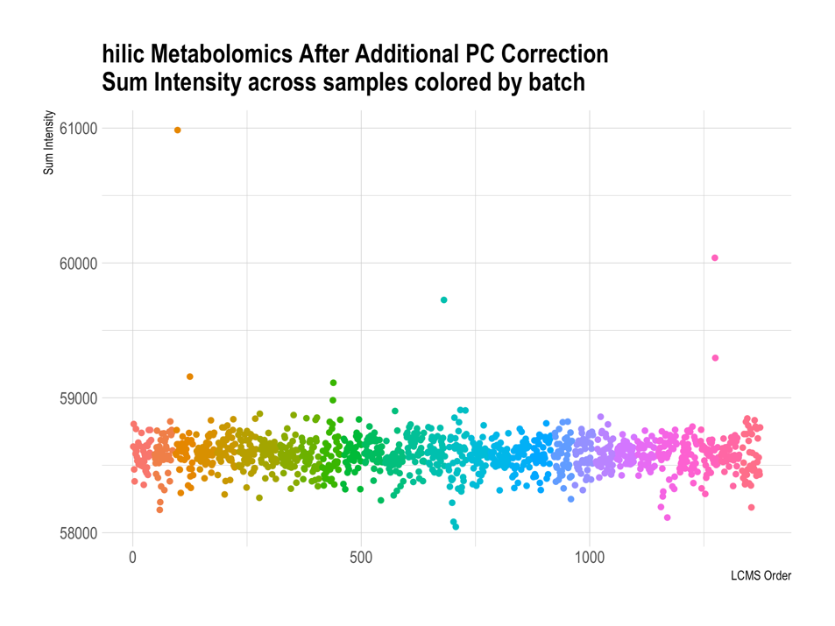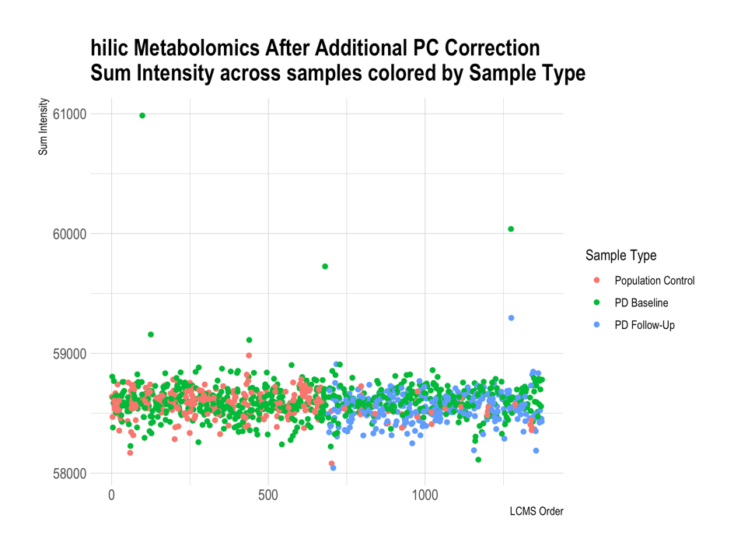

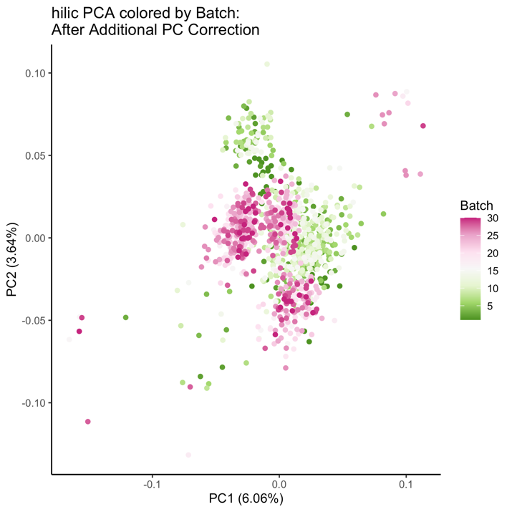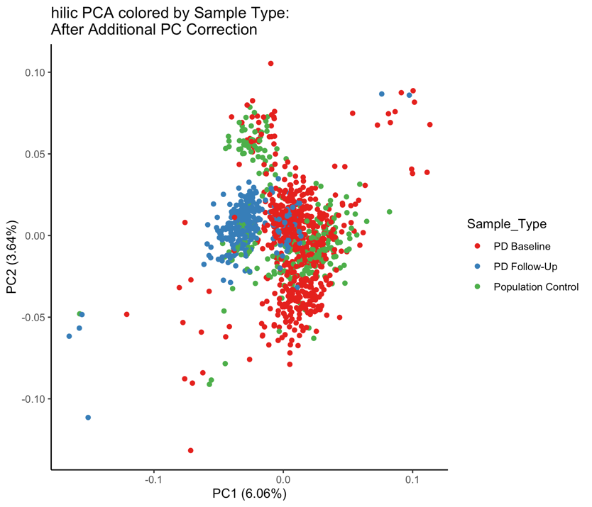
Supplemental Figure 7. HILIC positive metabolomics data after processing: Log transformation, quantile normalization, ComBat batch correction, and additional adjustment for unexplained PC.

