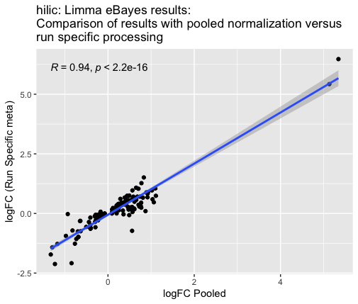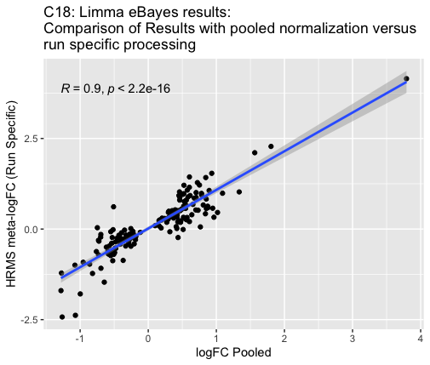
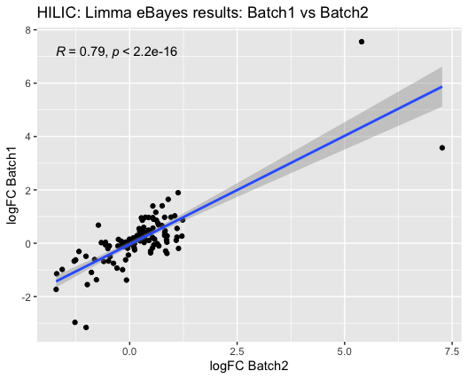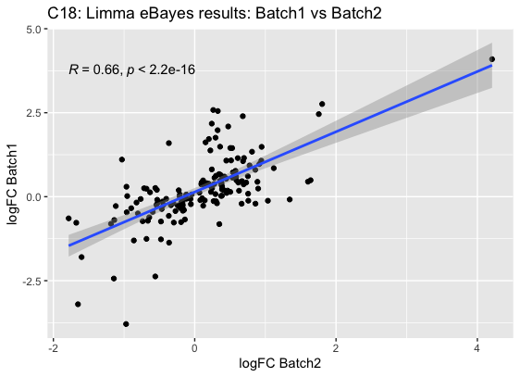

Supplemental Figure 8. Comparison of MWAS results (log2FC) when pooling the data and the processing (e.g., normalization and combat batch correction) versus processing and analyzing the data independently. (A & B) HILIC and C18 features: comparing the pooled processing logFC to a meta-analysis combining the results from each run, which was processed independently. (C & D) HILIC and C18 features: comparing the stratified results from run1 and run2, with each run was processed independently.

