Supplemental data.

Table S1. Binding sites on TREM2 basic site and CDR2 regions for IL-34 helices predicted by hydropathy mapping to have at least 75% percent match and a degree of complementary hydropathy (DCH) of at least 0.5.
Region (Residues) |  | Forward |  |  |  | Reverse
IL-34 | TREM2 | Match | DCH | Start | End | Match | DCH | Start | End
Helix 2  (67-82) | Basic site and CDR2  (62-78) | 75.00% | 0.533 | 60 | 75 | 75.00% | 0.545 | 60 | 75
Helix 2  (67-82) | CDR2 and Basic site  (69-78) |  |  |  |  | 75.00% | 0.54 | 71 | 86
Helix 2  (67-82) | Basic site  (112-114) |  |  |  |  | 75.00% | 0.616 | 112 | 127
Helix 5  (139-151) | Basic site  (47-50) | 76.92% | 0.503 | 49 | 61
Helix 5  (139-151) | Basic site  (62-68) |  |  |  |  | 76.92% | 0.539 | 53 | 65
Helix 5  (139-151) | CDR2 and Basic site  (69-78) | 76.92% | 0.538 | 70 | 82
Helix 5  (139-151) | Basic site  (112-114) |  |  |  |  | 84.62% | 0.573 | 114 | 126
Helix 5  (139-151) | Other |  |  |  |  | 84.62% | 0.568 | 117 | 129
Helix6  (160-181) | Basic site and CDR2  (47-75) |  |  |  |  | 77.27% | 0.521 | 49 | 70
Helix6  (160-181) | Basic site  (112-114) | 77.27% | 0.552 | 100 | 121

Table S2. Potential binding regions on IL-34 for TREM2 predicted by hydropathy mapping to have at least 75% percent match and a degree of complementary (DCH) hydropathy of at least 0.5. Note: Rows with text colored in red represent the top predicted binding site(s) between a pair of regions.
Region (Residues) |  | Forward |  |  |  | Reverse
TREM2 | IL-34 | Match | DCH | Start | End | Match | DCH | Start | End
Basic 1  (47-50) | Negative Electrostatic Surface Potential | 75.00% | 0.664 | 40 | 43 | 75.00% | 0.511 | 37 | 40
Basic 1  (47-50) | Negative Electrostatic Surface Potential |  |  |  |  | 75.00% | 0.528 | 64 | 67
Basic 1  (47-50) | Negative Electrostatic Surface Potential |  |  |  |  | 75.00% | 0.550 | 83 | 86
Basic 1  (47-50) | Negative Electrostatic Surface Potential | 75.00% | 0.519 | 92 | 95 | 75.00% | 0.608 | 90 | 93
Basic 1  (47-50) | Negative Electrostatic Surface Potential | 100.00% | 0.658 | 96 | 99 | 100.00% | 0.661 | 93 | 96
Basic 1  (47-50) | Negative Electrostatic Surface Potential |  |  |  |  | 75.00% | 0.531 | 97 | 100
Basic 1  (47-50) | Negative Electrostatic Surface Potential | 75.00% | 0.542 | 105 | 108 | 75.00% | 0.542 | 105 | 108
Basic 1  (47-50) | Negative Electrostatic Surface Potential | 75.00% | 0.606 | 109 | 112 | 75.00% | 0.675 | 106 | 109
Basic 1  (47-50) | Negative Electrostatic Surface Potential | 75.00% | 0.531 | 119 | 122 | 75.00% | 0.531 | 119 | 122
Basic 1  (47-50) | Negative Electrostatic Surface Potential |  |  |  |  | 75.00% | 0.608 | 122 | 125
Basic 1  (47-50) | Negative Electrostatic Surface Potential |  |  |  |  | 75.00% | 0.586 | 123 | 126
Basic 1  (47-50) | Negative Electrostatic Surface Potential | 100.00% | 0.733 | 126 | 129 | 75.00% | 0.531 | 127 | 130
Basic 1  (47-50) | Negative Electrostatic Surface Potential | 75.00% | 0.608 | 133 | 136 | 75.00% | 0.617 | 136 | 139
Basic 1  (47-50) | Negative Electrostatic Surface Potential | 75.00% | 0.542 | 135 | 138 | 75.00% | 0.617 | 142 | 145
Basic 1  (47-50) | Negative Electrostatic Surface Potential |  |  |  |  | 75.00% | 0.600 | 143 | 146
Basic 1  (47-50) | Negative Electrostatic Surface Potential | 100.00% | 0.658 | 145 | 148 | 100.00% | 0.647 | 146 | 149
Basic 1  (47-50) | Negative Electrostatic Surface Potential | 100.00% | 0.667 | 148 | 151 | 75.00% | 0.517 | 149 | 152
Basic 1  (47-50) | Negative Electrostatic Surface Potential | 100.00% | 0.681 | 171 | 174 | 100.00% | 0.669 | 172 | 175
Basic 1  (47-50) | Negative Electrostatic Surface Potential | 100.00% | 0.625 | 174 | 177 | 100.00% | 0.539 | 177 | 180
Basic 1  (47-50) | Negative Electrostatic Surface Potential | 75.00% | 0.603 | 179 | 182 | 75.00% | 0.531 | 183 | 186
Basic 1  (47-50) | Negative Electrostatic Surface Potential | 75.00% | 0.603 | 185 | 188 | 75.00% | 0.547 | 191 | 194
Basic 1  (47-50) | Positive Electrostatic Surface Potential | 75.00% | 0.519 | 57 | 60 | 75.00% | 0.528 | 51 | 54
Basic 1  (47-50) | Positive Electrostatic Surface Potential | 100.00% | 0.753 | 71 | 74 | 75.00% | 0.561 | 69 | 72
Basic 1  (47-50) | Positive Electrostatic Surface Potential | 100.00% | 0.697 | 74 | 77 | 100.00% | 0.686 | 72 | 75
Basic 1  (47-50) | Positive Electrostatic Surface Potential | 75.00% | 0.636 | 77 | 80 | 75.00% | 0.553 | 75 | 78
Basic 1  (47-50) | Positive Electrostatic Surface Potential | 75.00% | 0.531 | 155 | 158 | 100.00% | 0.744 | 156 | 159
Basic 1  (47-50) | Positive Electrostatic Surface Potential | 75.00% | 0.650 | 158 | 161 | 75.00% | 0.567 | 161 | 164
Basic 1  (47-50) | Positive Electrostatic Surface Potential | 75.00% | 0.664 | 164 | 167 | 75.00% | 0.600 | 166 | 169
Basic 1  (47-50) | Positive Electrostatic Surface Potential | 100.00% | 0.697 | 168 | 171 | 100.00% | 0.681 | 169 | 172
Basic 1  (47-50) | Other | 75.00% | 0.519 | 23 | 26 | 75.00% | 0.539 | 24 | 27
Basic 1  (47-50) | Other | 75.00% | 0.542 | 209 | 212 | 75.00% | 0.525 | 205 | 208
Basic 1  (47-50) | Other |  |  |  |  | 75.00% | 0.622 | 230 | 233
Basic 1  (47-50) | Other | 75.00% | 0.556 | 232 | 235 | 75.00% | 0.503 | 233 | 236
Basic 1  (47-50) | Other |  |  |  |  | 75.00% | 0.578 | 238 | 241
Basic 2  (62-68) | Negative Electrostatic Surface Potential | 85.71% | 0.667 | 90 | 96
Basic 2  (62-68) | Negative Electrostatic Surface Potential | 85.71% | 0.644 | 105 | 111
Basic 2  (62-68) | Negative Electrostatic Surface Potential | 85.71% | 0.594 | 122 | 128
Basic 2  (62-68) | Negative Electrostatic Surface Potential | 85.71% | 0.644 | 142 | 148
Basic 2  (62-68) | Positive Electrostatic Surface Potential | 85.71% | 0.684 | 159 | 165 | 85.71% | 0.678 | 74 | 80
Basic 2  (62-68) | Positive Electrostatic Surface Potential | 85.71% | 0.627 | 165 | 171 | 85.71% | 0.586 | 162 | 168
Basic 3  (76-78) | Negative Electrostatic Surface Potential | 100.00% | 0.819 | 95 | 97 | 100.00% | 0.819 | 95 | 97
Basic 3  (76-78) | Negative Electrostatic Surface Potential | 100.00% | 0.804 | 108 | 110 | 100.00% | 0.804 | 108 | 110
Basic 3  (76-78) | Negative Electrostatic Surface Potential | 100.00% | 0.789 | 125 | 127 | 100.00% | 0.789 | 125 | 127
Basic 3  (76-78) | Positive Electrostatic Surface Potential | 100.00% | 0.715 | 163 | 165 | 100.00% | 0.715 | 163 | 165
Basic 4  (112-114) | Negative Electrostatic Surface Potential | 100.00% | 0.641 | 64 | 66 | 100.00% | 0.641 | 64 | 66
Basic 4  (112-114) | Negative Electrostatic Surface Potential | 100.00% | 0.641 | 83 | 85 | 100.00% | 0.641 | 83 | 85
Basic 4  (112-114) | Negative Electrostatic Surface Potential | 100.00% | 0.619 | 93 | 95 | 100.00% | 0.619 | 93 | 95
Basic 4  (112-114) | Negative Electrostatic Surface Potential | 100.00% | 0.615 | 97 | 99 | 100.00% | 0.615 | 97 | 99
Basic 4  (112-114) | Negative Electrostatic Surface Potential | 100.00% | 0.526 | 99 | 101 | 100.00% | 0.526 | 99 | 101
Basic 4  (112-114) | Negative Electrostatic Surface Potential | 100.00% | 0.715 | 127 | 129 | 100.00% | 0.715 | 127 | 129
Basic 4  (112-114) | Negative Electrostatic Surface Potential | 100.00% | 0.730 | 136 | 138 | 100.00% | 0.730 | 136 | 138
Basic 4  (112-114) | Negative Electrostatic Surface Potential | 100.00% | 0.600 | 146 | 148 | 100.00% | 0.600 | 146 | 148
Basic 4  (112-114) | Negative Electrostatic Surface Potential | 100.00% | 0.626 | 149 | 151 | 100.00% | 0.626 | 149 | 151
Basic 4  (112-114) | Negative Electrostatic Surface Potential | 100.00% | 0.630 | 172 | 174 | 100.00% | 0.630 | 172 | 174
Basic 4  (112-114) | Negative Electrostatic Surface Potential | 100.00% | 0.570 | 175 | 177 | 100.00% | 0.570 | 175 | 177
Basic 4  (112-114) | Negative Electrostatic Surface Potential | 100.00% | 0.504 | 177 | 179 | 100.00% | 0.504 | 177 | 179
Basic 4  (112-114) | Negative Electrostatic Surface Potential | 100.00% | 0.667 | 191 | 193 | 100.00% | 0.667 | 191 | 193
Basic 4  (112-114) | Positive Electrostatic Surface Potential | 100.00% | 0.563 | 35 | 37 | 100.00% | 0.563 | 35 | 37
Basic 4  (112-114) | Positive Electrostatic Surface Potential | 100.00% | 0.619 | 58 | 60 | 100.00% | 0.619 | 58 | 60
Basic 4  (112-114) | Positive Electrostatic Surface Potential | 100.00% | 0.726 | 72 | 74 | 100.00% | 0.726 | 72 | 74
Basic 4  (112-114) | Positive Electrostatic Surface Potential | 100.00% | 0.641 | 75 | 77 | 100.00% | 0.641 | 75 | 77
Basic 4  (112-114) | Positive Electrostatic Surface Potential | 100.00% | 0.715 | 156 | 158 | 100.00% | 0.715 | 156 | 158
Basic 4  (112-114) | Positive Electrostatic Surface Potential | 100.00% | 0.715 | 169 | 171 | 100.00% | 0.715 | 169 | 171
Basic 4  (112-114) | Other | 100.00% | 0.630 | 24 | 26 | 100.00% | 0.630 | 24 | 26
Basic 4  (112-114) | Other | 100.00% | 0.678 | 233 | 235 | 100.00% | 0.678 | 233 | 235
CDR1  (39-46) | Negative Electrostatic Surface Potential | 75.00% | 0.586 | 90 | 97 | 75.00% | 0.542 | 93 | 100
CDR1  (39-46) | Negative Electrostatic Surface Potential | 75.00% | 0.535 | 92 | 99 | 75.00% | 0.503 | 95 | 102
CDR1  (39-46) | Negative Electrostatic Surface Potential | 75.00% | 0.614 | 122 | 129
CDR1  (39-46) | Negative Electrostatic Surface Potential | 75.00% | 0.567 | 142 | 149 | 75.00% | 0.578 | 142 | 149
CDR1  (39-46) | Negative Electrostatic Surface Potential | 75.00% | 0.519 | 145 | 152 | 75.00% | 0.522 | 145 | 152
CDR1  (39-46) | Negative Electrostatic Surface Potential | 75.00% | 0.521 | 171 | 178 | 75.00% | 0.521 | 171 | 178
CDR1  (39-46) | Positive and Negative Electrostatic Surface Potential | 87.50% | 0.615 | 168 | 175 | 87.50% | 0.615 | 168 | 175
CDR1  (39-46) | Positive Electrostatic Surface Potential | 75.00% | 0.585 | 71 | 78 | 75.00% | 0.585 | 71 | 78
CDR1  (39-46) | Positive Electrostatic Surface Potential | 75.00% | 0.513 | 158 | 165
CDR1  (39-46) | Positive Electrostatic Surface Potential | 75.00% | 0.554 | 164 | 171
CDR1  (39-46) | Positive Electrostatic Surface Potential | 75.00% | 0.589 | 165 | 172 | 75.00% | 0.600 | 165 | 172
CDR2  (69-75) | Negative Electrostatic Surface Potential | 85.71% | 0.632 | 86 | 92 | 100.00% | 0.667 | 88 | 94
CDR2  (69-75) | Negative Electrostatic Surface Potential | 85.71% | 0.541 | 89 | 95 | 85.71% | 0.565 | 103 | 109
CDR2  (69-75) | Negative Electrostatic Surface Potential | 85.71% | 0.565 | 115 | 121 | 85.71% | 0.538 | 114 | 120
CDR2  (69-75) | Negative Electrostatic Surface Potential | 100.00% | 0.638 | 118 | 124 | 100.00% | 0.689 | 117 | 123
CDR2  (69-75) | Negative Electrostatic Surface Potential | 85.71% | 0.514 | 132 | 138 | 85.71% | 0.557 | 120 | 126
CDR2  (69-75) | Negative Electrostatic Surface Potential | 85.71% | 0.560 | 141 | 147 | 100.00% | 0.624 | 131 | 137
CDR2  (69-75) | Negative Electrostatic Surface Potential | 85.71% | 0.503 | 176 | 182 | 85.71% | 0.541 | 140 | 146
CDR2  (69-75) | Positive and Negative Electrostatic Surface Potential | 85.71% | 0.602 | 79 | 85
CDR2  (69-75) | Positive Electrostatic Surface Potential | 85.71% | 0.606 | 28 | 34 | 85.71% | 0.562 | 27 | 33
CDR2  (69-75) | Positive Electrostatic Surface Potential |  |  |  |  | 85.71% | 0.571 | 30 | 36
CDR2  (69-75) | Positive Electrostatic Surface Potential | 85.71% | 0.641 | 44 | 50 | 85.71% | 0.622 | 43 | 49
CDR2  (69-75) | Positive Electrostatic Surface Potential | 85.71% | 0.597 | 47 | 53 | 85.71% | 0.635 | 46 | 52
CDR2  (69-75) | Positive Electrostatic Surface Potential | 100.00% | 0.663 | 50 | 56 | 100.00% | 0.625 | 49 | 55
CDR2  (69-75) | Positive Electrostatic Surface Potential | 85.71% | 0.632 | 73 | 79 | 85.71% | 0.605 | 75 | 81
CDR2  (69-75) | Positive Electrostatic Surface Potential | 100.00% | 0.705 | 76 | 82 | 100.00% | 0.667 | 78 | 84
CDR2  (69-75) | Positive Electrostatic Surface Potential | 85.71% | 0.594 | 155 | 161 | 85.71% | 0.594 | 154 | 160
CDR2  (69-75) | Other | 100.00% | 0.565 | 25 | 31 | 85.71% | 0.511 | 197 | 203
CDR2  (69-75) | Other | 85.71% | 0.541 | 192 | 198 | 85.71% | 0.535 | 200 | 206
CDR2  (69-75) | Other | 85.71% | 0.540 | 201 | 207 | 85.71% | 0.508 | 210 | 216
CDR2  (69-75) | Other | 85.71% | 0.525 | 211 | 217 | 85.71% | 0.522 | 225 | 231
CDR2  (69-75) | Other | 85.71% | 0.598 | 229 | 235 | 100.00% | 0.633 | 228 | 234
CDR3  (88-91) | Negative Electrostatic Surface Potential | 100.00% | 0.5 | 93 | 96 | 75.00% | 0.514 | 40 | 43
CDR3  (88-91) | Negative Electrostatic Surface Potential | 75.00% | 0.553 | 105 | 108 | 75.00% | 0.514 | 82 | 85
CDR3  (88-91) | Negative Electrostatic Surface Potential | 75.00% | 0.525 | 106 | 109 | 75.00% | 0.553 | 105 | 108
CDR3  (88-91) | Negative Electrostatic Surface Potential | 75.00% | 0.542 | 119 | 122 | 75.00% | 0.542 | 119 | 122
CDR3  (88-91) | Negative Electrostatic Surface Potential | 75.00% | 0.542 | 127 | 130 | 100.00% | 0.572 | 126 | 129
CDR3  (88-91) | Negative Electrostatic Surface Potential |  |  |  |  | 75.00% | 0.553 | 135 | 138
CDR3  (88-91) | Negative Electrostatic Surface Potential |  |  |  |  | 100.00% | 0.506 | 148 | 151
CDR3  (88-91) | Negative Electrostatic Surface Potential | 100.00% | 0.508 | 172 | 175 | 100.00% | 0.519 | 171 | 174
CDR3  (88-91) | Negative Electrostatic Surface Potential |  |  |  |  | 75.00% | 0.506 | 190 | 193
CDR3  (88-91) | Positive Electrostatic Surface Potential | 100.00% | 0.525 | 72 | 75 | 100.00% | 0.592 | 71 | 74
CDR3  (88-91) | Positive Electrostatic Surface Potential |  |  |  |  | 100.00% | 0.536 | 74 | 77
CDR3  (88-91) | Positive Electrostatic Surface Potential | 75.00% | 0.503 | 80 | 83 | 75.00% | 0.503 | 80 | 83
CDR3  (88-91) | Positive Electrostatic Surface Potential |  |  |  |  | 75.00% | 0.542 | 155 | 158
CDR3  (88-91) | Positive Electrostatic Surface Potential | 100.00% | 0.583 | 156 | 159 | 75.00% | 0.5 | 158 | 161
CDR3  (88-91) | Positive Electrostatic Surface Potential |  |  |  |  | 75.00% | 0.514 | 164 | 167
CDR3  (88-91) | Positive Electrostatic Surface Potential | 100.00% | 0.519 | 169 | 172 | 100.00% | 0.536 | 168 | 171
CDR3  (88-91) | Other | 75.00% | 0.528 | 230 | 233 | 75.00% | 0.528 | 230 | 233
CDR3  (88-91) | Other | 75.00% | 0.514 | 233 | 236

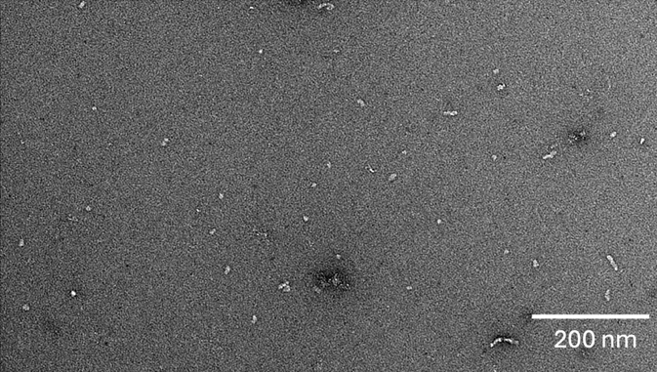
Supplemental Figure 1. TEM of oAβ42 preparations. TEM shows amorphous oligomers (small round and oval spots) and some short protofibrils (squiggles).

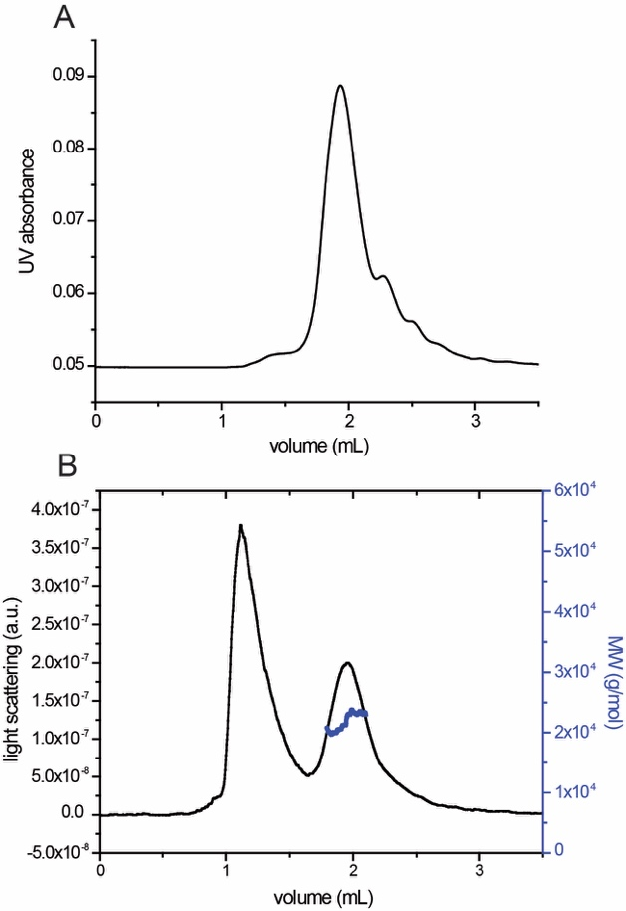
Supplemental Figure 2. SEC-MALS analysis WT sTREM2 shows a monomer in solution. SEC-MALS analysis showing the (A) absorbance and (B) light scattering of WT sTREM2. Mass estimate from Rayleigh ratio is shown in blue (MW_{avg} = 21.3 ± 0.5 kDa [MW_{calc} = 17.0 kDa]; Polydispersity = 1.002 ± 0.001; n = 3).

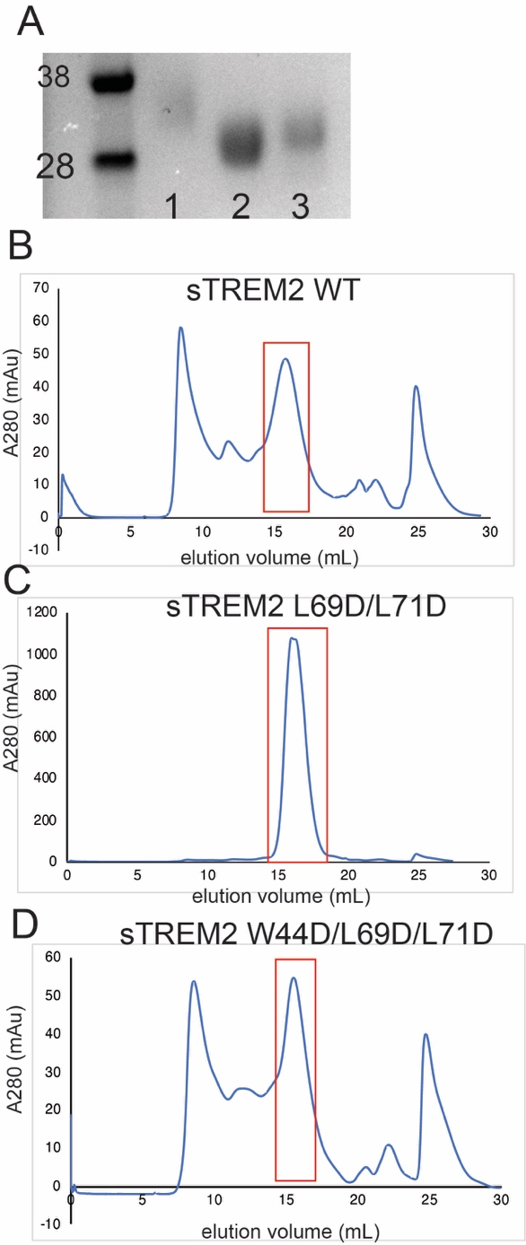
Supplemental Figure 3. sTREM2 gel and s200 SEC chromatograms A) protein gel with sTREM2 WT in lane 1, sTREM2 L69D/L71D in lane 2, and sTREM2 W44D/L69D/L71D in lane 3 B-D) s200 SEC chromatograms for sTREM2 B) WT, C) sTREM2 L69D/L71D, D) sTREM2 W44D/L69D/L71D.

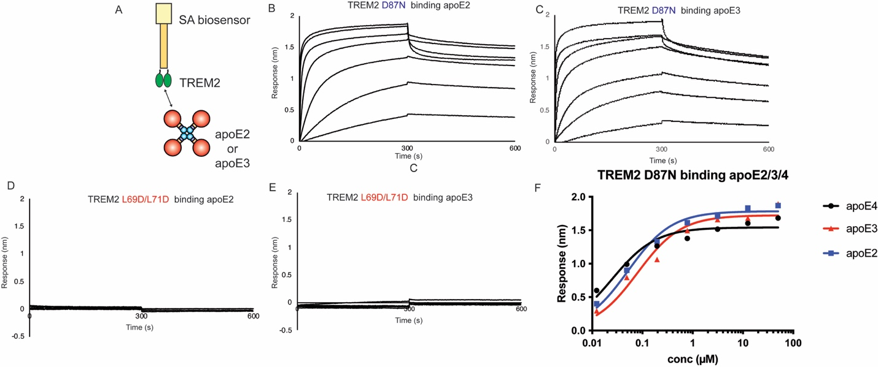

Supplemental Figure 4. ApoE2, apoE3, and apoE4 bind TREM2 variants similarly. Immobilized TREM2 WT and variants were probed for binding to apoE2 and apoE3 (0.012 - 50 μM). (A) Scheme of experiment. B-E) BLI sensorgrams for B) TREM2 D87N binding apoE2, C)TREM2 D87N binding apoE3, D) TREM2 L69D/L71D binding apoE2, and E) TREM2 L69D/L71D binding apoE3, Double-reference subtracted data shown in black. F) Steady state analysis and non-linear fits to derive K_{D} from data shown in B&C. The derived K_{D}s are: TREM2 D87N/apoE2 = 52 nM; TREM2 D87N/apoE3 = 79 nM; TREM2 D87N/apoE4 = 25 nM.

Supplemental Figure 5. ELISA. Immobilized apoE4 was plated, washed, and probed for binding to TREM2 WT and variants. Replicates were carried out (n=6). Absorbance readings were plotted in Prism as mean +/- standard error of the mean and statistics were analyzed by One-way ANOVA. *p < 0.05, *p < 0.01,***p < 0.001.

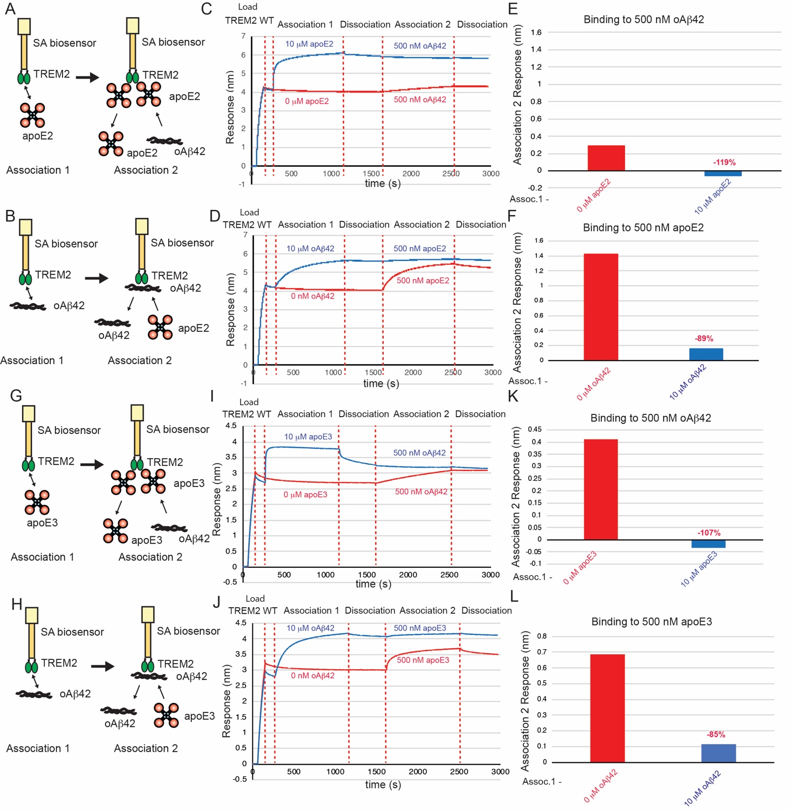
Supplemental Figure 6. ApoE2/3 and oAβ42 compete for binding to TREM2. A&B) Schematic of competition binding BLI experiments. C&D) BLI sensorgrams for C) apoE2 competing oAβ42 binding to TREM2 and D) oAβ42 competing apoE2 binding to TREM2. Red sensorgrams are TREM2 binding to C) 500 nM oAβ42 or D) 500 nM apoE2 alone while blue sensorgrams show competition experiments where C) 10 μM apoE2 or D) 10 μM oAβ42 are bound first. E&F) BLI binding magnitudes for TREM2 binding to E) 500 nM oAβ42 when pre-binding apoE2 or F) 500 nM apoE2 when pre-binding oAβ42. Percent decrease in Association 2 binding signal in the
presence of the competitor is shown above the bars.
G & H) Schematic of competition binding BLI experiments. I&J) BLI sensorgrams for I) apoE3 competing oAβ42 binding to TREM2 and J) oAβ42 competing apoE3 binding to TREM2. Red sensorgrams are TREM2 binding to I) 500 nM oAβ42 or J) 500 nM apoE3 alone while blue sensorgrams show competition experiments where I) 10 μM apoE3 or J) 10 μM oAβ42 are bound first. K&L) BLI binding magnitudes for TREM2 binding to K) 500 nM oAβ42 when pre-binding apoE3 or L) 500 nM apoE3 when pre-binding oAβ42. Percent decrease in Association 2 binding signal in the presence of the competitor is shown above the bars.

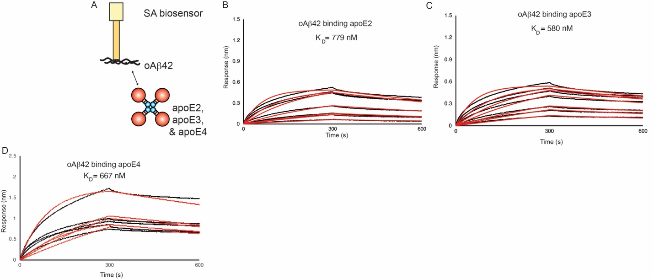

Supplemental Figure 7. oAβ42 binding to apoE2,3,4. A ) Scheme of experiment B-D) BLI sensorgrams for oAβ42 binding B) apoE2, C) apoE3, D) apoE4. Black = BLI sensorgrams; red = 1:1 kinetic fits. Derived K_{D}s are shown.

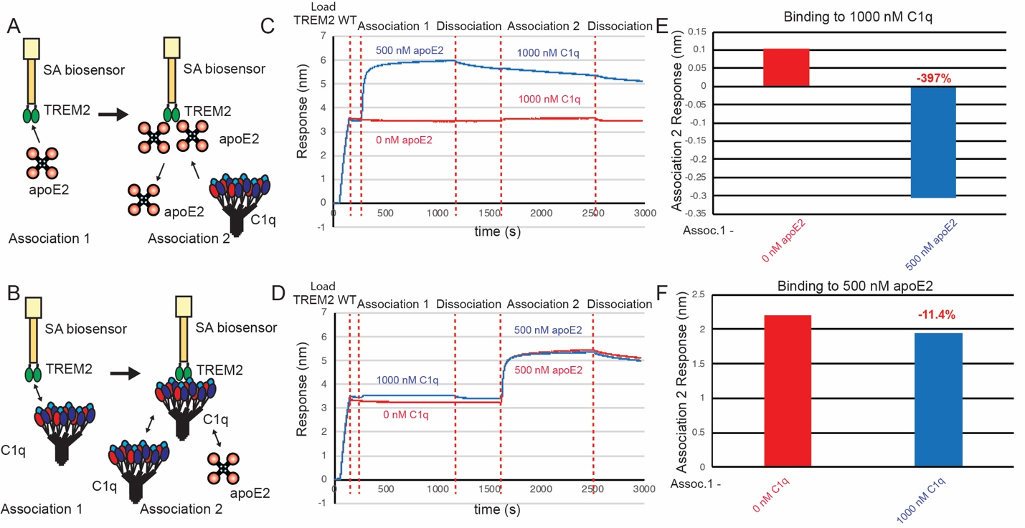
Supplemental Figure 8. C1q minimally competes with apoE2 for binding to TREM2. A&B) Schematic of competition binding BLI experiments. C&D) BLI sensorgrams for C) apoE2 competing C1q binding to TREM2 and D) C1q competing apoE2 binding to TREM2. Red sensorgrams are TREM2 binding to C) 1000 nM C1q or D) 500 nM apoE2 alone while blue sensorgrams show competition experiments where C) 500 nM apoE2 or D) 1000 nM C1q are bound first.

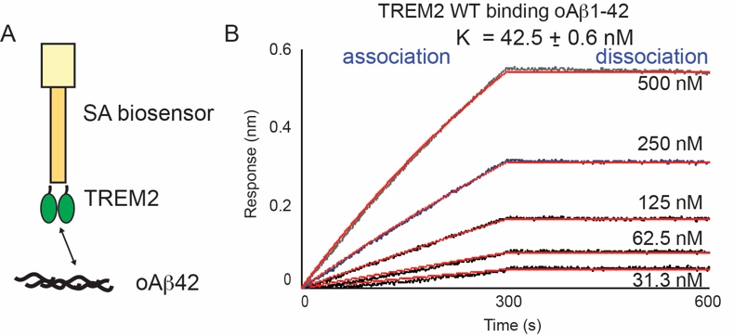
Supplemental Figure 9. TREM2 WT binds to oAb42 with high affinity. Immobilized TREM2 WT was probed for binding to oligomeric Ab42 (500 – 31.25 nM). (A) Scheme of experiment. (B) BLI response for TREM2 WT. Double-reference subtracted data (black) overlayed with 1:1 kinetic fits (red). K_{D} was derived from kinetic fits.

