Supplementary information
Supplementary Figure 1
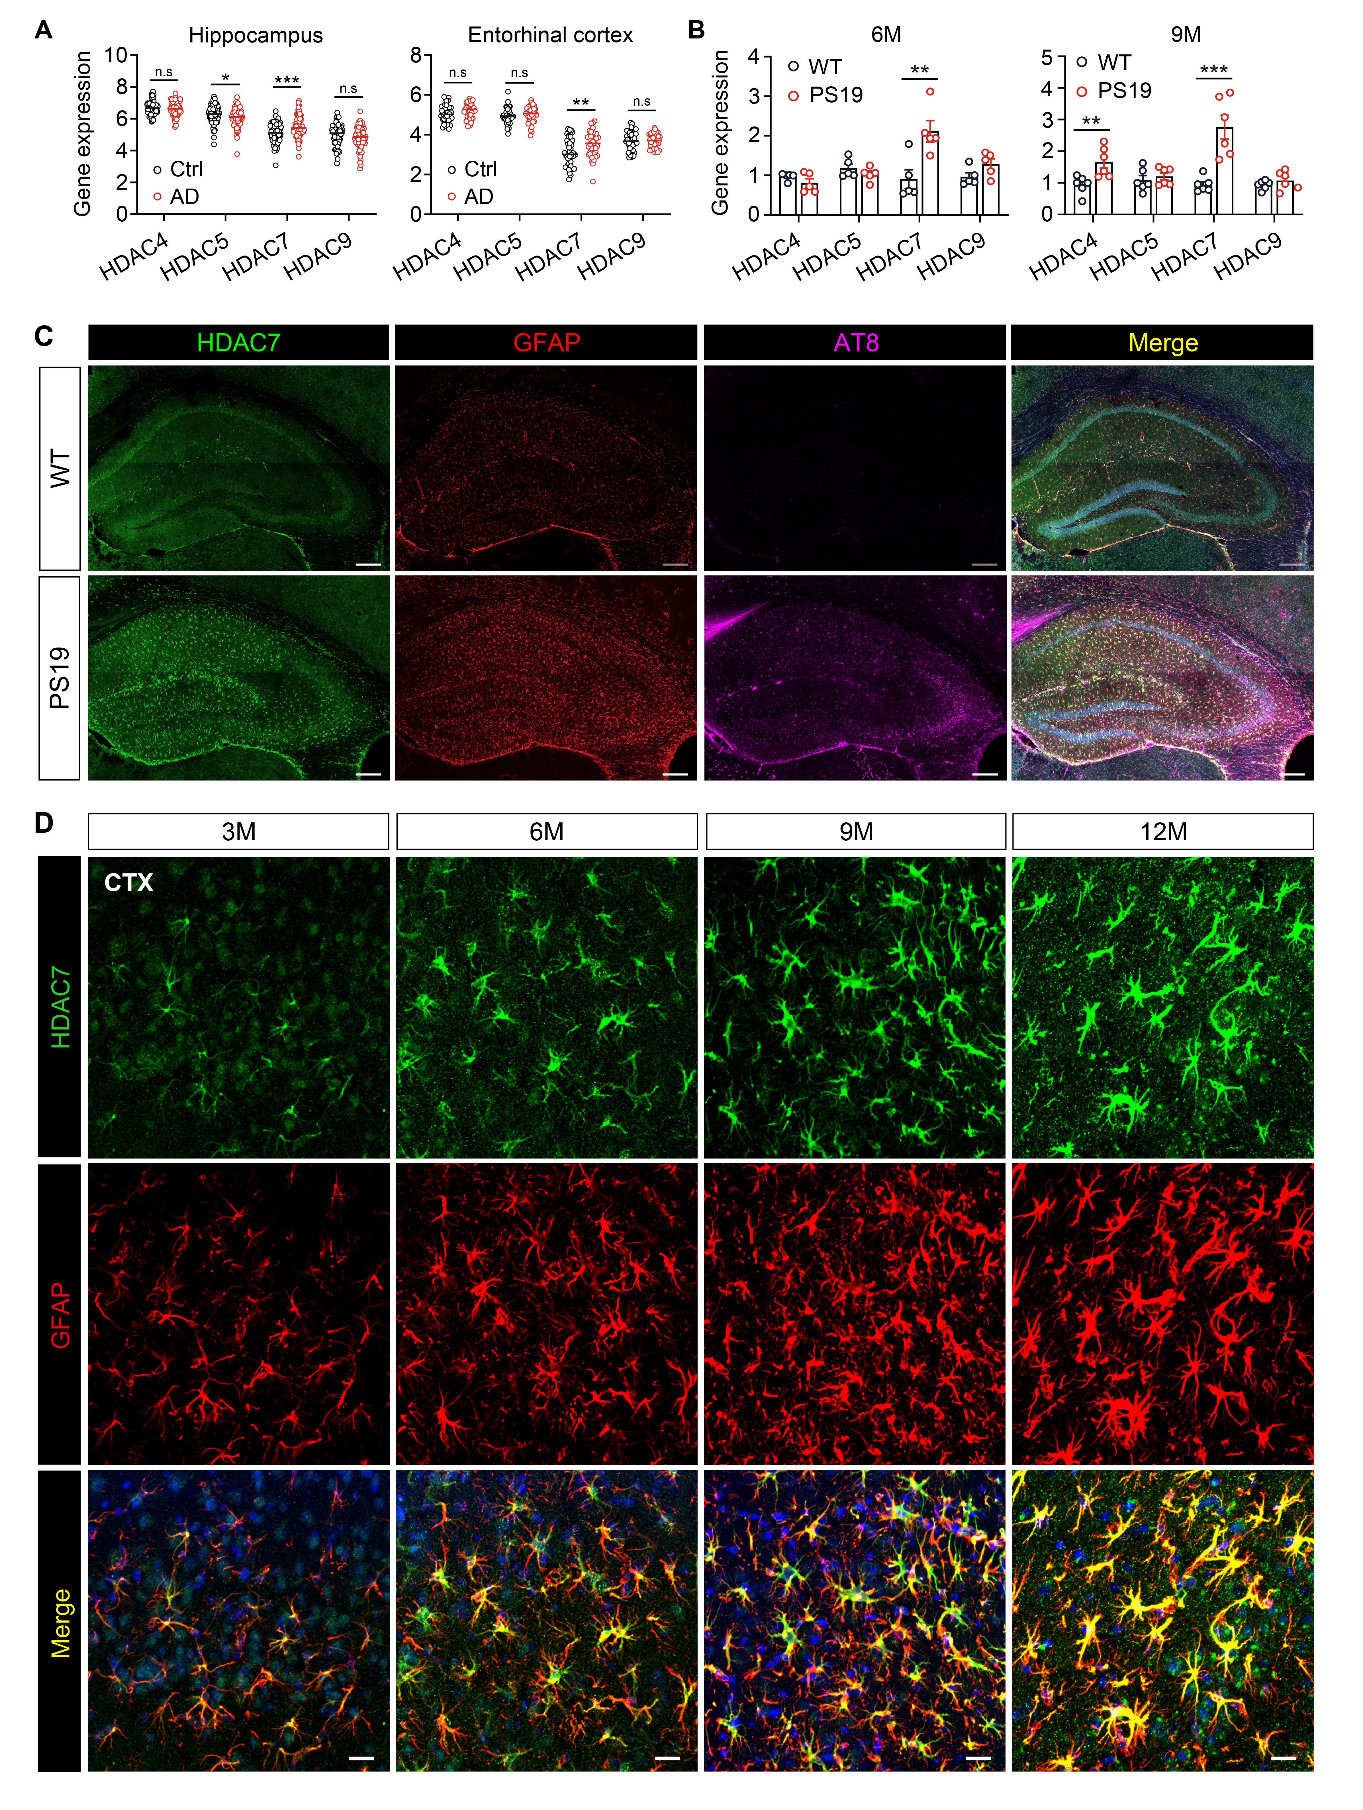
Supplementary Figure 1 The mRNA expression of class IIa HDACs (HDAC4, 5, 7 and 9) and protein expression of HDAC7 in PS19 mice.
(A) Gene levels of Class IIa HDACs (HDAC4, 5, 7 and 9) in the hippocampus and entorhinal cortex of AD patients and control individuals. All data are obtained from Alzdata database (http://www.alzdata.org). hippocampus: n = 66 (Ctrl), 74 (AD), entorhinal cortex: n = 39 (Ctrl), 39 (AD). (B) mRNA levels of HDAC4, 5, 7 and 9 measured by RT-qPCR in the hippocampus of 6- and 9-month-old WT and PS19 mice n = 5 (6M group), 6 (9M group). (C) Co-immunostaining of HDAC7, GFAP and AT8 in the hippocampus of 9-month-old WT and PS19 mice. Scale bar: 200 μm. (D) Representative immunostaining images of HDAC7 and GFAP in the cortex of 3, 6, 9 and 12-month-old PS19 mice. Scale bar: 20 μm. Statistical significance was determined by unpaired Student’s t test. Data are shown as mean ± SEM, *p < 0.05, **p < 0.01, ***p < 0.001, n. s, not significant.

Supplementary Figure 2
Supplementary Figure 2 Immunostaining of NeuN and HDAC7 in PS19 mice injected with AAVs.
(A, B) Representative immunostaining images and quantification of HDAC7 knockdown efficiency in the hippocampus of PS19 mice after AAV injection. n = 7 (PS19-Vec), 8 (PS19-shHD7). Scale bar: 40 μm. (C, D) Representative immunostaining images and quantification of GFAP in the hippocampus of PS19 mice after AAV injection. n = 7 (PS19-Vec), 8 (PS19-shHD7). Scale bar: 40 μm. (E, F) Representative immunostaining images and quantification of Iba1 in the hippocampus of PS19 mice after AAV injection. n = 7 (PS19-Vec), 8 (PS19-shHD7). Scale bar: 40 μm. Statistical significance was determined by unpaired Student’s t test. Data are shown as mean ± SEM, *p < 0.05, **p < 0.01, ***p < 0.001.

Supplementary Figure 3
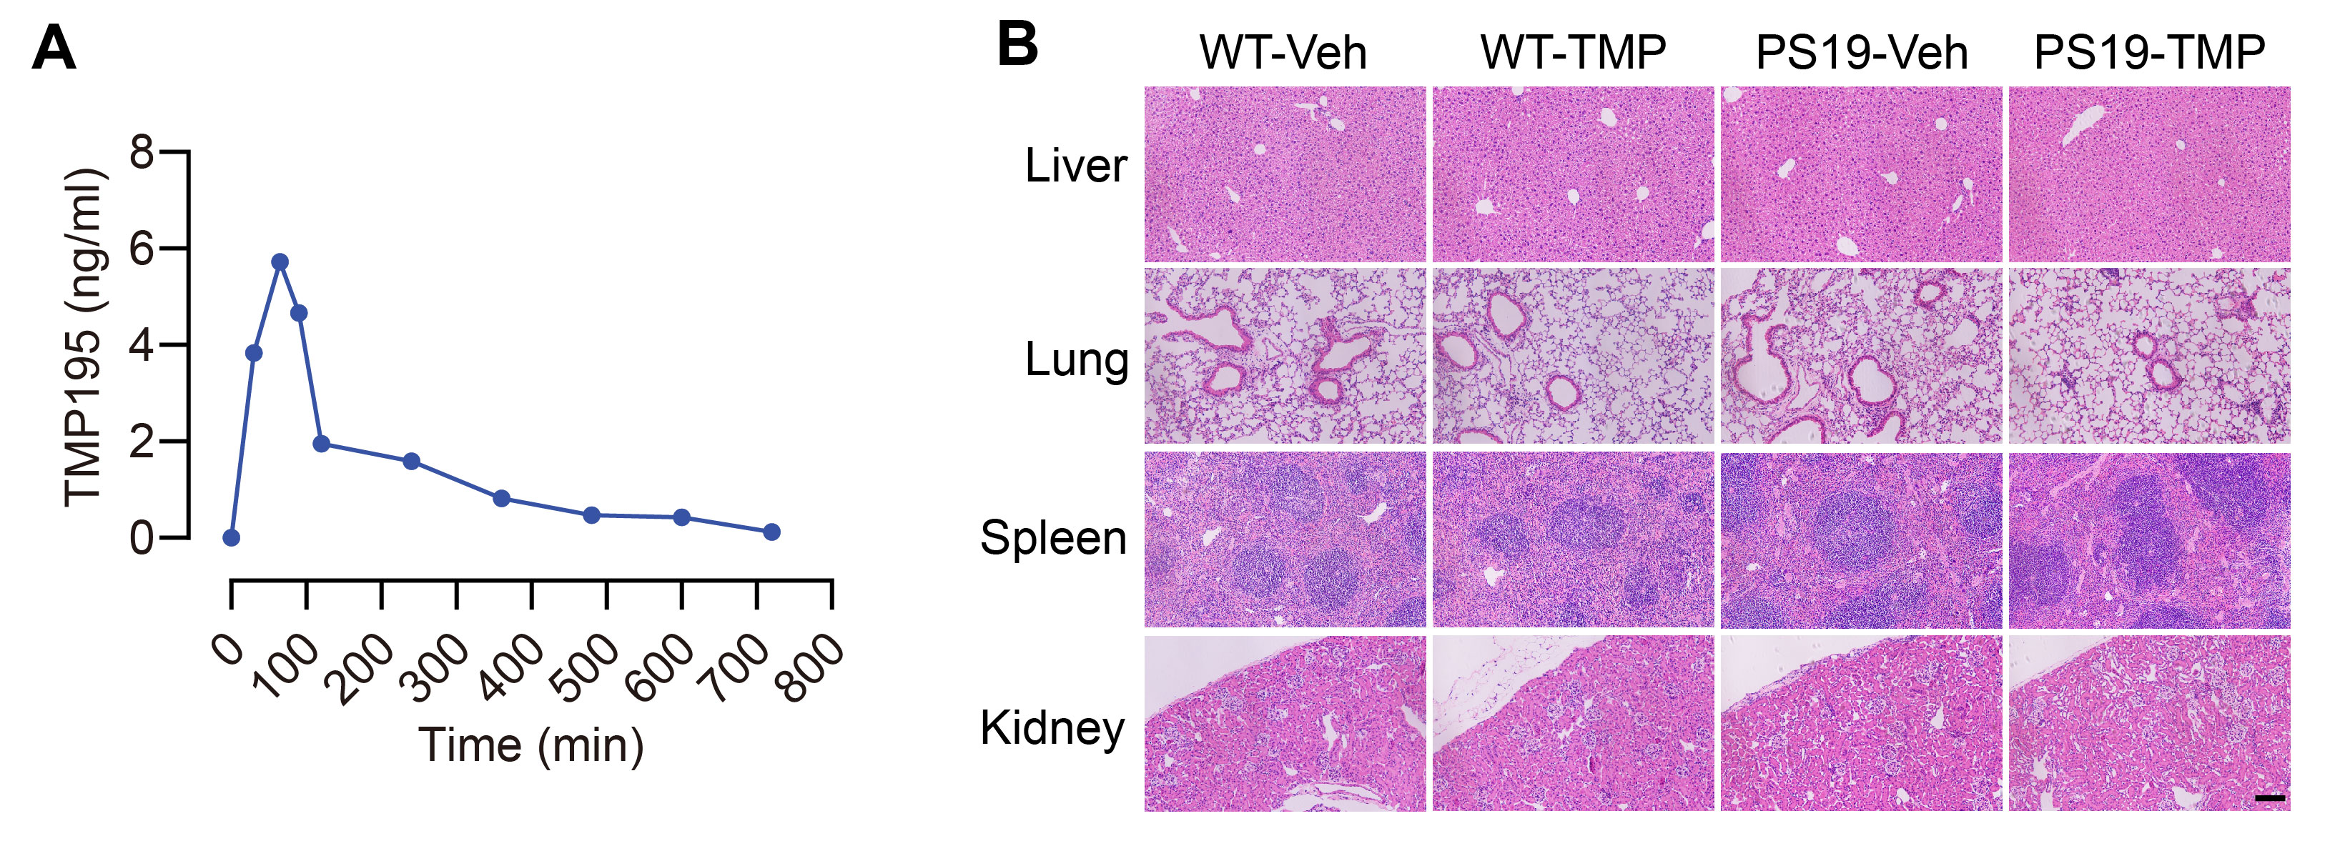
Supplementary Figure 3 TMP195 enters the brain and shows little toxicity to peripheral organs.
(A) Metabolic time curve of TMP195 in the brain of C57/BL6 mice using mass spectrometry analysis. 5-month-old C57BL/6 mice were intraperitoneally injected with TMP195 (50 mg/kg) and sacrificed at 2 h, 4 h, 6 h, 8 h, 10 h or 12 h post injection. The concentration of TMP195 in mice brains were extracted by methanol and quantified using mass spectrometry analysis. n = 1 mouse per time point. (B) hematoxylin-eosin staining analysis in the liver, lung, spleen and kidney tissues of WT and PS19 mice treated with TMP195 or vehicle. Scale bar: 200 μm.

Supplementary Figure 4
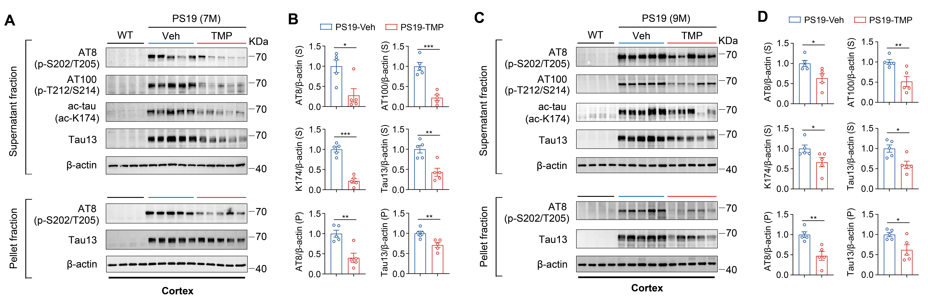
Supplementary Figure 4 TMP195 treatment reduces tau accumulation in the cerebral cortex of both young and aged PS19 mice.
(A, B) Western blotting analysis and quantification of AT8, AT100, PHF13 and tau13 in the supernatant and pellet fraction of hippocampal extracts from WT and PS19 mice in the preventative cohort (7-month-old). n = 5 per group. (C, D) Western blotting analysis and quantification of AT8, AT100, PHF13 and tau13 in the supernatant and pellet fraction of cortex from WT and PS19 mice in the preventative cohort (9-month-old). n = 5 per group. Statistical significance was determined by unpaired Student’s t test. Data are shown as mean ± SEM, *p < 0.05, **p < 0.01, ***p < 0.001.

Supplementary Figure 5
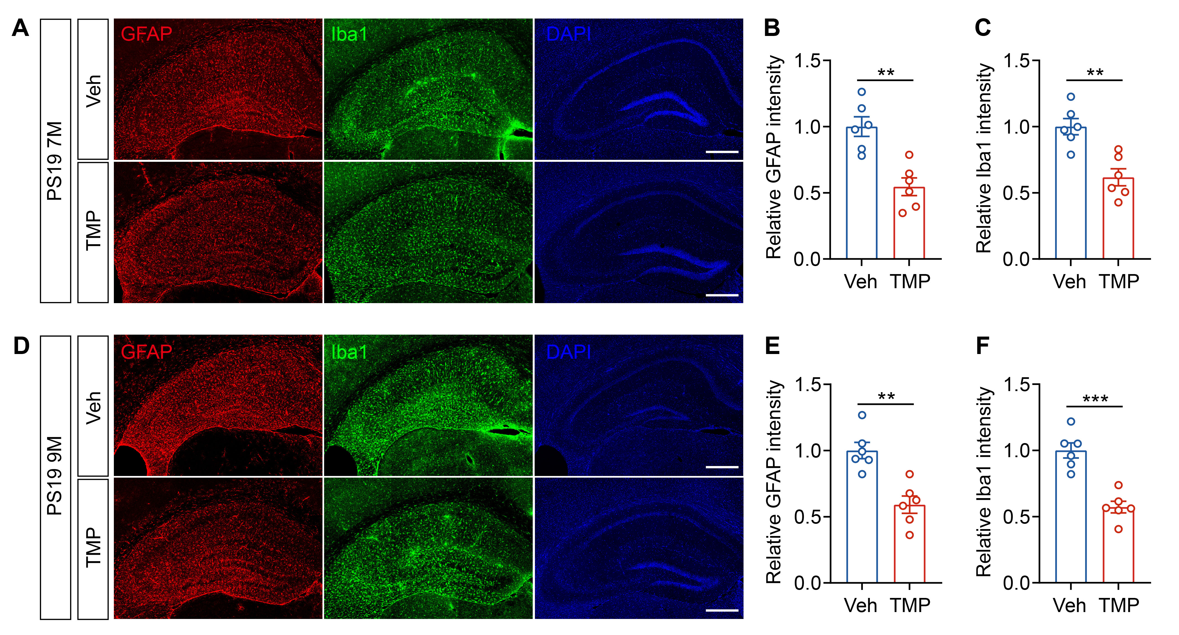
Supplementary Figure 5 TMP195 treatment attenuates gliosis in young and aged PS19 mice.
(A) Representative images of astrogliosis (GFAP) and microgliosis (Iba1) in the hippocampus of preventative cohort (7-month-old) PS19 mice administrated with TMP195 or vehicle. Scale bar: 200 μm. (B, C) Quantification of GFAP and Iba1 intensity in A normalized to control vehicle, n = 6 per group. (D) Representative images of astrogliosis (GFAP) and microgliosis (Iba1) in the hippocampus of treatment cohort (9-month-old) PS19 mice administrated with TMP195 or vehicle. Scale bar: 200 μm. (E-F) Quantification of GFAP and Iba1 intensity in D normalized to control vehicle. n = 6 per group. Statistical significance was determined by unpaired Student’s t test. Data are shown as mean ± SEM, **p < 0.01, ***p < 0.001.

Supplementary Figure 6
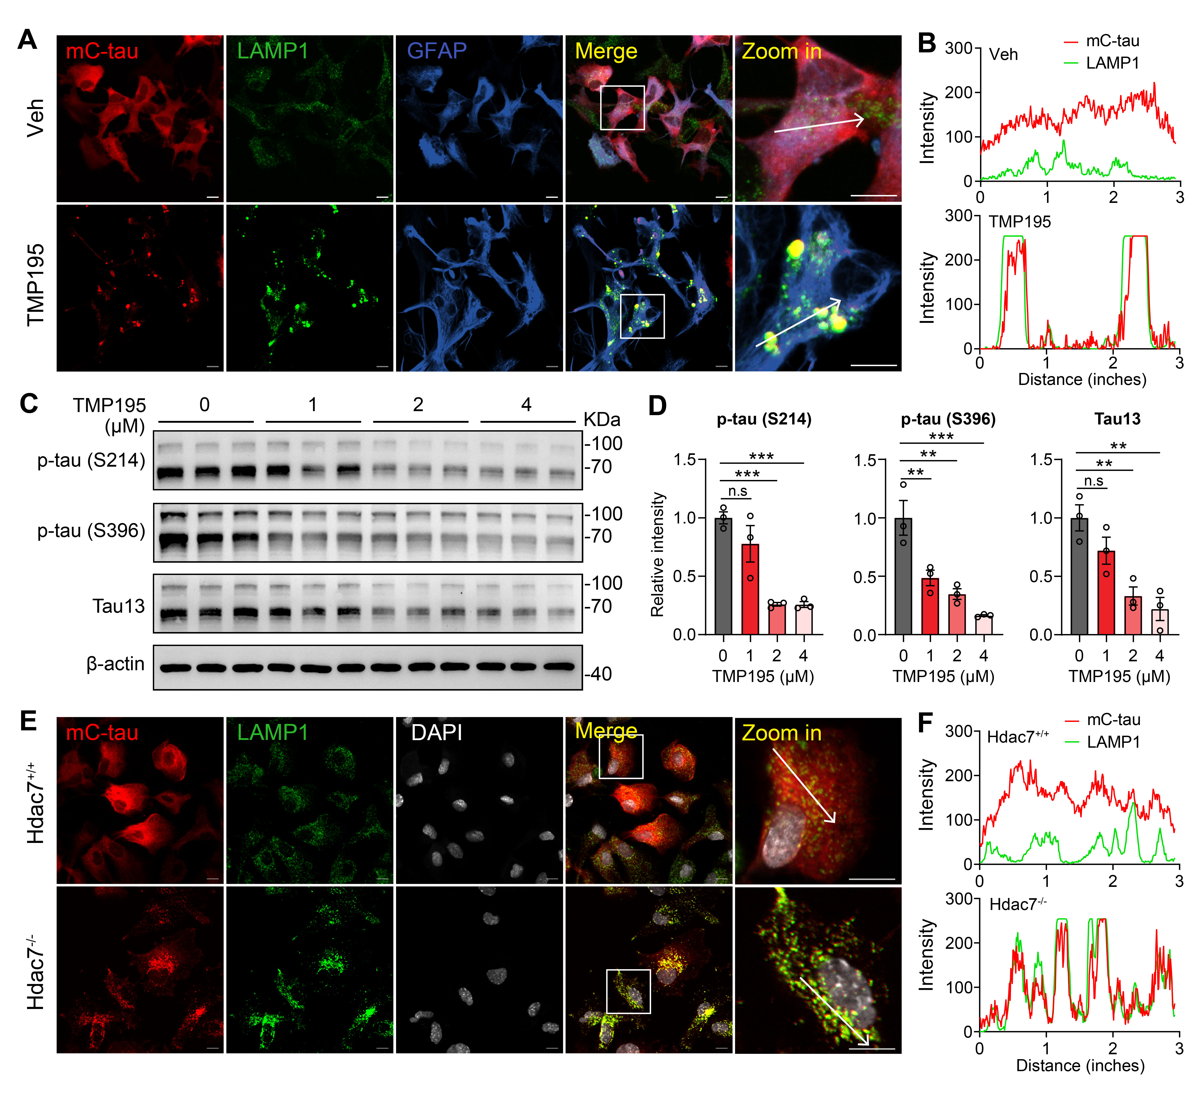
Supplementary Figure 6 Inhibition or deletion of HDAC7 enhances lysosomal tau degradation in primary astrocytes.
(A) Representative fluorescence images showing colocalization of mCherry-tau and lysosomes (LAMP1) in primary astrocytes (GFAP) infected with LV-G1-mCherry-tau (human P301S-tau, 1N4R) and then treated with TMP195 or vehicle for 24 h. (B) The fluorescence intensity profile along the lines indicated in A. (C, D) Western blotting analysis and quantification of p-tau (S214), p-tau (S396) and tau13 in P301S tau-overexpressing astrocytes treated with TMP195 for 24 h. n = 3 per group. (E) Representative fluorescence images showing colocalization of mCherry-tau and lysosomes (LAMP1) in control and HDAC7 knockout astrocytes infected with LV-G1-mCherry-tau. (F) The fluorescence intensity profile along the lines indicated in E. Data are shown as mean ± SEM, **p < 0.01, ***p < 0.001, n. s, not significant.

Supplementary Figure 7
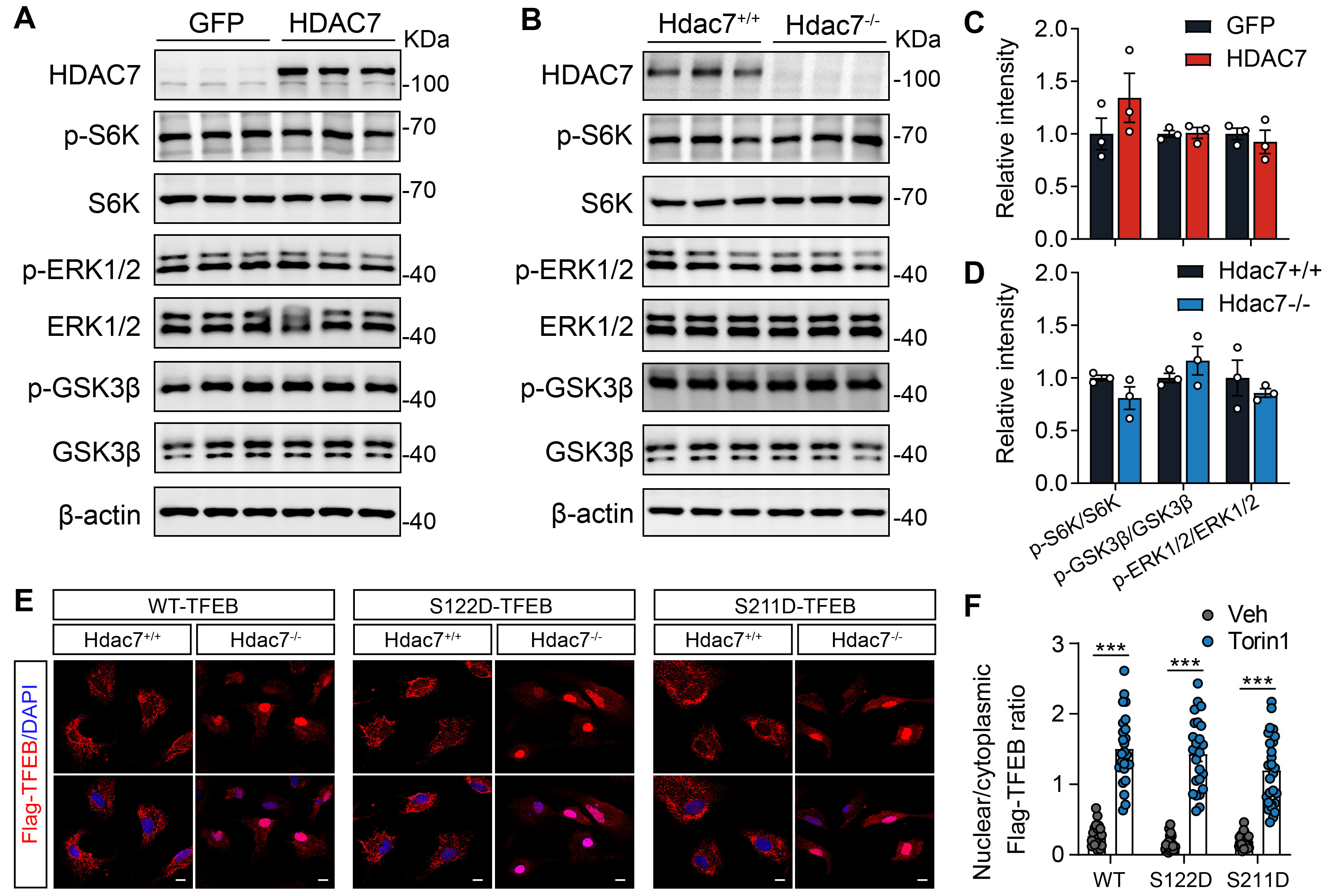
Supplementary Figure 7 Overexpression or deletion of HDAC7 has no effects on the activity of TFEB upstream kinases.
(A-D) Western blotting analysis and quantification of HDAC7, p-S6K, S6K, p-ERK1/2, ERK1/2, p-GSK3β and GSK3β in HDAC7-overexpressing or HDAC7 knockout primary astrocytes. n = 3 per group. (E) Representative immunostaining images of WT/S122D/S211D Flag-TFEB in control and Torin1-treated astrocytes. Scale bar: 10 μm. (F) Quantification of Flag-TFEB nuclear/cytoplasmic ratio in E. n = 24 to 28 cells per group. Statistical significance was determined by unpaired Student’s t test. Data are expressed as mean ± SEM, ***p < 0.001.

Supplementary Figure 8
Supplementary Fig. 8 Acetyl-mimic mutation of TFEB at K310 rescues HDAC7 overexpression-induced impairments of TFEB-lysosome signaling.
(A, B) Immunoprecipitation assay showing the acetylation level of exogeneous WT or mutated (K to Q) Flag-TFEB in control and HDAC7-overexpressing HEK293T cells. (C) Representative immunostaining images of WT/K310R Flag-TFEB in control and Torin1-treated astrocytes. Scale bar: 10 μm. (D) Quantification of Flag-TFEB nuclear/cytoplasmic ratio in C. n = 31 (Veh+WT-TFEB), 32 (Torin1+WT-TFEB), 30 (Veh+K310R-TFEB), 35 (Torin1+K310R-TFEB). (E, F) Immunoprecipitation assay showing the acetylation level of exogeneous WT or K310Q mutated Flag-TFEB in control and HDAC7-overexpressing primary astrocytes. The acetylation level of Flag-TFEB was quantified. n = 3 per group. (G) Representative immunostaining images of WT/K310Q Flag-TFEB in control and HDAC7-overexpressing astrocytes. Scale bar: 10 μm. (H) Quantification of Flag-TFEB nuclear/cytoplasmic ratio in C. n = 34 (Vec+WT-TFEB), 30 (HDAC7+WT-TFEB), 35 (Vec+K310Q-TFEB), 32 (HDAC7+K310Q-TFEB). (I) Analysis of Lamp1, Ctsb, Ctsd and Uvrag mRNA levels by RT-qPCR in primary astrocytes overexpressed with HDAC7 and WT/K310Q Flag-TFEB. n = 4 per group. Statistical significance was determined by one-way ANOVA with Tukey’s post hoc analysis. Data are shown as mean ± SEM, *p < 0.05, **p < 0.01, ***p < 0.001, n. s, not significant.

Supplementary Figure 9
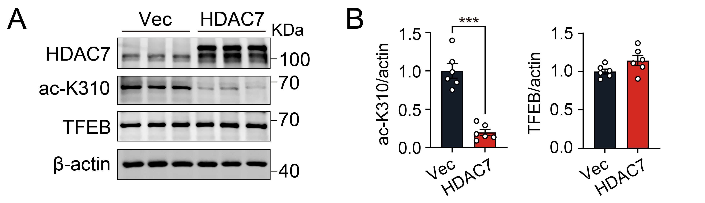
Supplementary Figure 9 Overexpression of HDAC7 inhibits TFEB acetylation at K310.
(A, B) Western blotting analysis and quantification of ac-K310 and total TFEB in GFP and HDAC7-overexpressing astrocytes. n = 6 per group. Statistical significance was determined by unpaired Student’s t test. Data are shown as mean ± SEM, ***p < 0.001.

Supplementary table 1 Primary antibodies used in the study
Antibodies | Applications | Source | Catelogy
Rabbit monoclonal recombinant anti-HDAC4 antibody [EPR22937-157] | WB: 1:500 | Abcam | Cat# ab12171
Rabbit polyclonal anti-HDAC5 antibody | WB: 1:500 | Abcam | Cat# ab55403
Rabbit polyclonal anti-HDAC7 antibody (KG-17) | WB: 1:500 | Sigma-Aldrich | Cat# H2662
Rabbit polyclonal anti-HDAC9 antibody | WB: 1:500 | Sigma-Aldrich | Cat# SAB4503694
Mouse monoclonal anti-phospho-tau (Ser202, Thr205) antibody (AT8) | WB: 1:500  IF: 1:200  IHC: 1:250 | ThermoFisher | Cat# MN-1020
Mouse monoclonal anti-phospho-tau (Thr212, Ser214) antibody (AT100) | WB: 1:1000 | ThermoFisher | Cat# MN-1060
Mouse monoclonal anti-phospho-tau (Ser396) antibody (PHF13.6) | WB: 1:1000 | ThermoFisher | Cat# 35-5300
Rabbit polyclonal anti-acetyl-tau (K174) antibody | WB: 1:1000 | Signalway Antibody | Cat# HW181
Mouse monoclonal anti-tau antibody [tau-13] | WB: 1:1000 | Biolegend | Cat# 835204
Chicken polyclonal anti-GFAP antibody | IF: 1:500 | Abcam | Cat# ab4674
Mouse monoclonal anti-GFAP antibody (GA5) | IF: 1:500 | Cell signaling | Cat# 3670
Rabbit polyclonal anti-Iba1 antibody | IF: 1:500 | WAKO | Cat# 019-19741
Rabbit monoclonal anti-NeuN antibody [EPR12763] | IF: 1:500 | Abcam | Cat# ab177487
Rabbit polyclonal anti-LAMP1 antibody | WB: 1:1000  IF: 1:150 | Abcam | Cat# ab24170
Mouse monoclonal anti-LAMP1 antibody (D4O1S) | IP: 1:80 | Cell signaling | Cat# 15665
Rabbit monoclonal anti-DYKDDDDK (Flag) antibody (D6W5B) | WB: 1:1000  IP: 1:200  IF: 1:500 | Cell signaling | Cat# 14793
Rabbit polyclonal anti-Acetylated-Lysine Antibody | WB: 1:1000 | Cell signaling | Cat# 9441
Rabbit polyclonal anti-TFEB antibody | WB: 1:1000  IP: 1:100  IF: 1:100 | Proteintech | Cat# 13372-1-AP
Rabbit polyclonal anti-ac-TFEB (K310) antibody | WB: 1:500  IF: 1:100 | Ye Lab | N/A
Rabbit recombinant monoclonal anti-Cathepsin B antibody [EPR21033] | WB: 1:1000 | Abcam | Cat# ab214428
Rabbit recombinant monoclonal anti-Cathepsin D antibody [EPR3057Y] | WB: 1:1000 | Abcam | Cat# ab75852
Mouse monoclonal anti-β-Actin antibody (13E5) | WB: 1:1000 | Cell signaling | Cat# 4970
Rabbit recombinant monoclonal anti-p70 S6 kinase antibody (E8K6T) | WB: 1:1000 | Cell signaling | Cat# 34475
Rabbit recombinant monoclonal anti-phospho-p70 S6 kinase (Thr389) antibody (108D2) | WB: 1:1000 | Cell signaling | Cat# 9234
Rabbit monoclonal anti-GSK3 beta antibody [Y174] | WB: 1:1000 | Abcam | Cat# ab32391
Rabbit monoclonal anti- phospho-GSK3 beta (Ser9) antibody [EPR2286Y] | WB: 1:1000 | Abcam | Cat# ab75814
Rabbit recombinant monoclonal anti-p44/42 MAPK (Erk1/2) antibody (137F5) | WB: 1:1000 | Cell signaling | Cat# 4695
Rabbit recombinant monoclonal anti-phospho-p44/42 MAPK (Erk1/2) (Thr202/Tyr204) antibody (D13.14.4E) | WB: 1:1000 | Cell signaling | Cat# 4370

Supplementary table 2 Information for human brain samples
Case number | Gender | Age | Neuropathological Diagnosis | Postmortem Interval (h)
PTB078 | Female | 86 | AD | 6.33
PTB079 | Female | 80 | AD | 18
PTB083 | Female | 100 | AD | 3
PTB108 | Male | 72 | AD | /
PTB114 | Female | 80 | AD | 13
PTB129 | Male | 83 | AD | 4.5
PTB139 | Male | 82 | AD | 38
PTB041 | Male | 80 | Control | 7.5
PTB054 | Female | 84 | Control | 20
PTB088 | Male | 79 | Control | 29
PTB140 | Male | 83 | Control | 38
PTB144 | Female | 96 | Control | 32
PTB158 | Male | 86 | Control | 5
PTB186 | Female | 87 | Control | 12.5

Supplementary table 3 Primers used for RT-qPCR
Genes | Forward (5’ to 3’) | Reverse (5’ to 3’)
Hdac4 | AGCAGCACCAGCAGTTCCT | CCGCTTCTTCCTCCTCACTCT
Hdac5 | AGCAGCACCAGCAGTTCCT | CACTCTCGCCATCCTCATCCT
Hdac7 | CGCAGCCAGTGTGAGTGTCT | GCTCGTTCCAGATGGTGTCAGTA
Hdac9 | GATGATGATGCCTGTGGTGGAT | TGCTGCTGCTGCTGAATAAGAA
Lamp1 | GCCTCTATGGCACTGCAACT | TTTGGGCTGATGTTGAACGC
Ctsb | TGACCGAACCTGCATTCACA | ATGCTCCAGAGGGATAGCCA
Ctsd | CCACGGAGCCAGTGTCAGAGTTA | CCACAGGTTAGAGGAGCCAGTATCA
Ctsf | GAGCCACCTTGCAATGATCC | TCACAGAGAAGTCCTGGGGC
Map1lc3b | GCCTTCTTCCTCCTGGTGAA | TGCTGTCCCGAATGTCTCC
Atg9b | TCATCAACAGCAGCAGCAAGAACT | AAGCAGGACTGGAGCCATCACT
β-actin | CCACCATGTACCCAGGCATT | CGGACTCATCGTACTCCTGC

