Supplementary Figures and Tables
Cellular senescence induced by cholesterol accumulation is mediated by lysosomal ABCA1 in APOE4 and AD

Shaowei Wang^{1†}, Boyang Li^{1†}, Jie Li¹, Zhiheng Cai¹, Cristelle Hugo¹, Yi Sun¹, Lu Qian², Julia TCW^{2,3}, Helena C. Chui¹, Dante Dikeman⁴, Isaac Asante⁵, Stan G Louie⁴, David A. Bennett⁶, Zoe Arvanitakis⁶, Alan T. Remaley⁷, Bilal Kerman¹, and Hussein N. Yassine^{1*}

¹ Keck School of Medicine, University of Southern California, Los Angeles, CA 90033, USA
² Department of Pharmacology, Physiology & Biophysics, Chobanian & Avedisian School of Medicine, Boston University, Boston, MA 02118, USA
³ Bioinformatics Program, Faculty of Computing & Data Sciences, Boston University, Boston, MA 02215, USA
⁴ Alfred Mann School of Pharmacy, University of Southern California, Los Angeles, CA 90089, USA
⁵Department of Ophthalmology, Keck School of Medicine, Los Angeles, CA 90033, USA
⁶ Rush Alzheimer’s Disease Center, Rush University Medical Center, Chicago, IL 60612, USA
⁷ National Heart, Lung and Blood Institute, National Institutes of Health, Bethesda, MD 20892, USA
*Correspondence
Hussein Yassine
2250 Alcazar Street, Room 210, Los Angeles, CA 90033, USA
hyassine@usc.edu

†These authors contributed equally to this work.
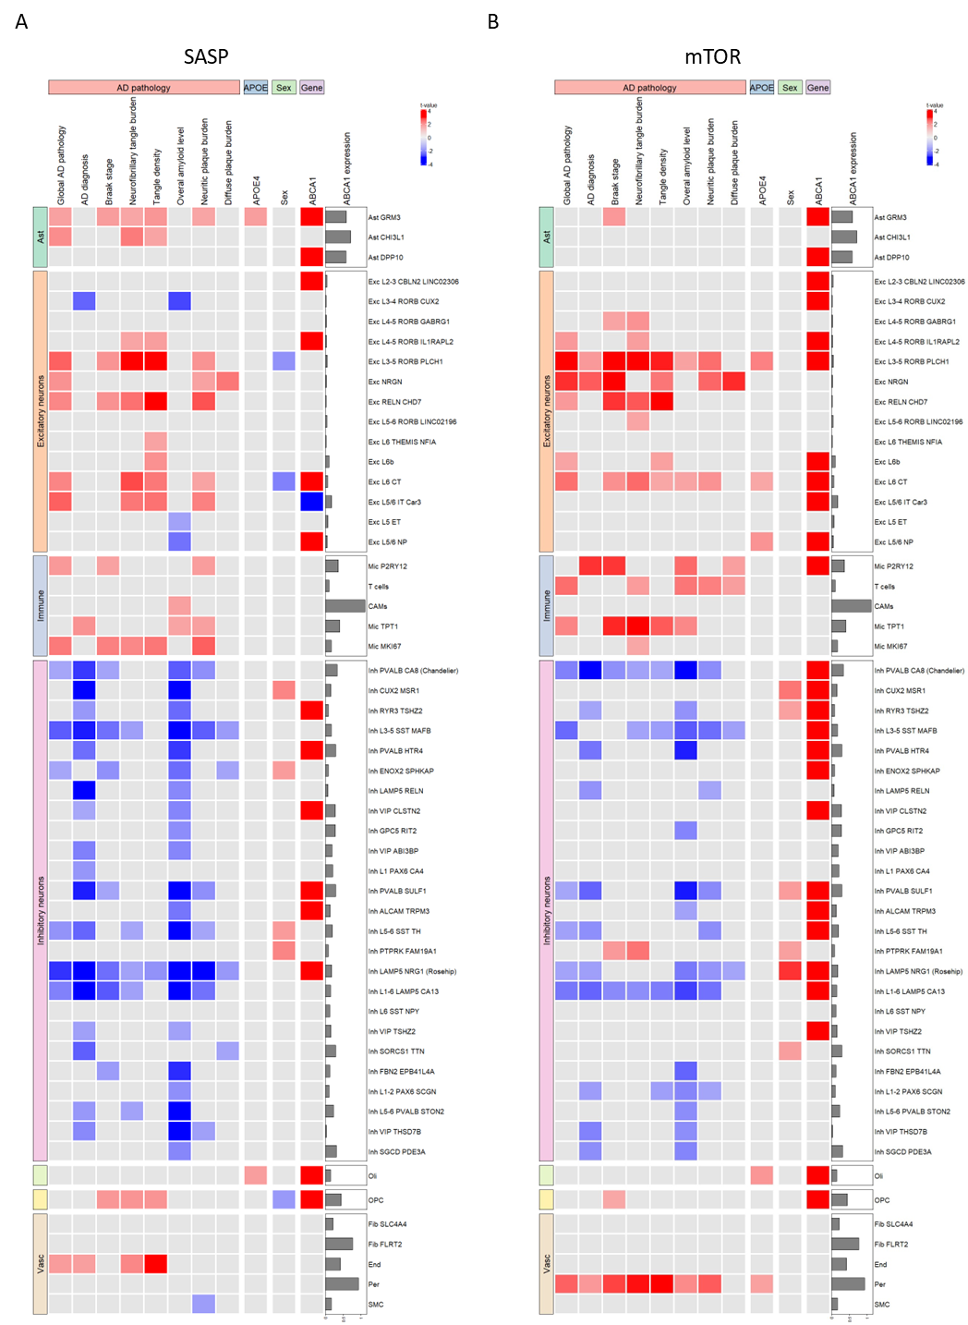
Supplementary Figure 1. Single-nucleus RNA (sn-RNA) sequencing analysis of the association between senescence-associated secretory phenotype (SASP) (A) and mTOR expression (B) in different brain cells with factors including AD pathology, sex, APOE4 genotype, and ABCA1 expression. (Related to Fig. 1).
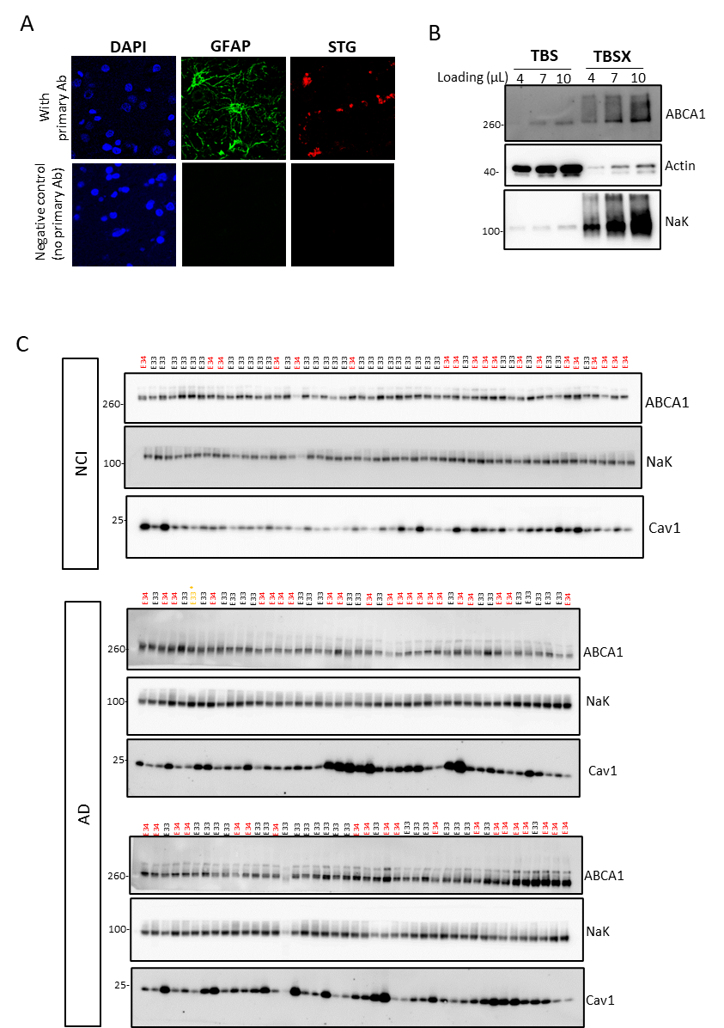
Supplementary Figure 2. Validation of immunofluorescent staining and whole blotting of western blots. (A) Validation of STG and GFAP staining. The negative control refers to omitting the primary antibody. (B) Frozen human postmortem mid-frontal lobe tissues were homogenized with different buffers and ABCA1 expression was detected by WB. Beta-actin and Na +/K + ATPase were used as markers for different fractions. (C) Total membrane ABCA1 and caveolin-1 protein levels in human postmortem mid-frontal lobe tissues were detected by WB. (NCI E3/3, n=33; NCI E3/4, n=19; AD E3/3, n=44; AD E3/4, n=42. One sample labelled with a star was excluded as it had MCI). (Related to Fig.2).

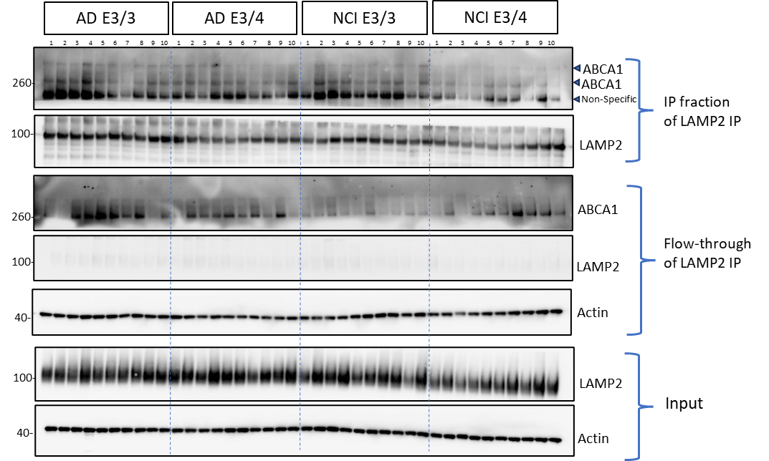
Supplementary Figure 3. The full blot of ABCA1 detection in lysosome membrane enriched fraction in human brain homogenate (immunoprecipitation with anti-LAMP2 antibody) (Related to Fig. 2C).
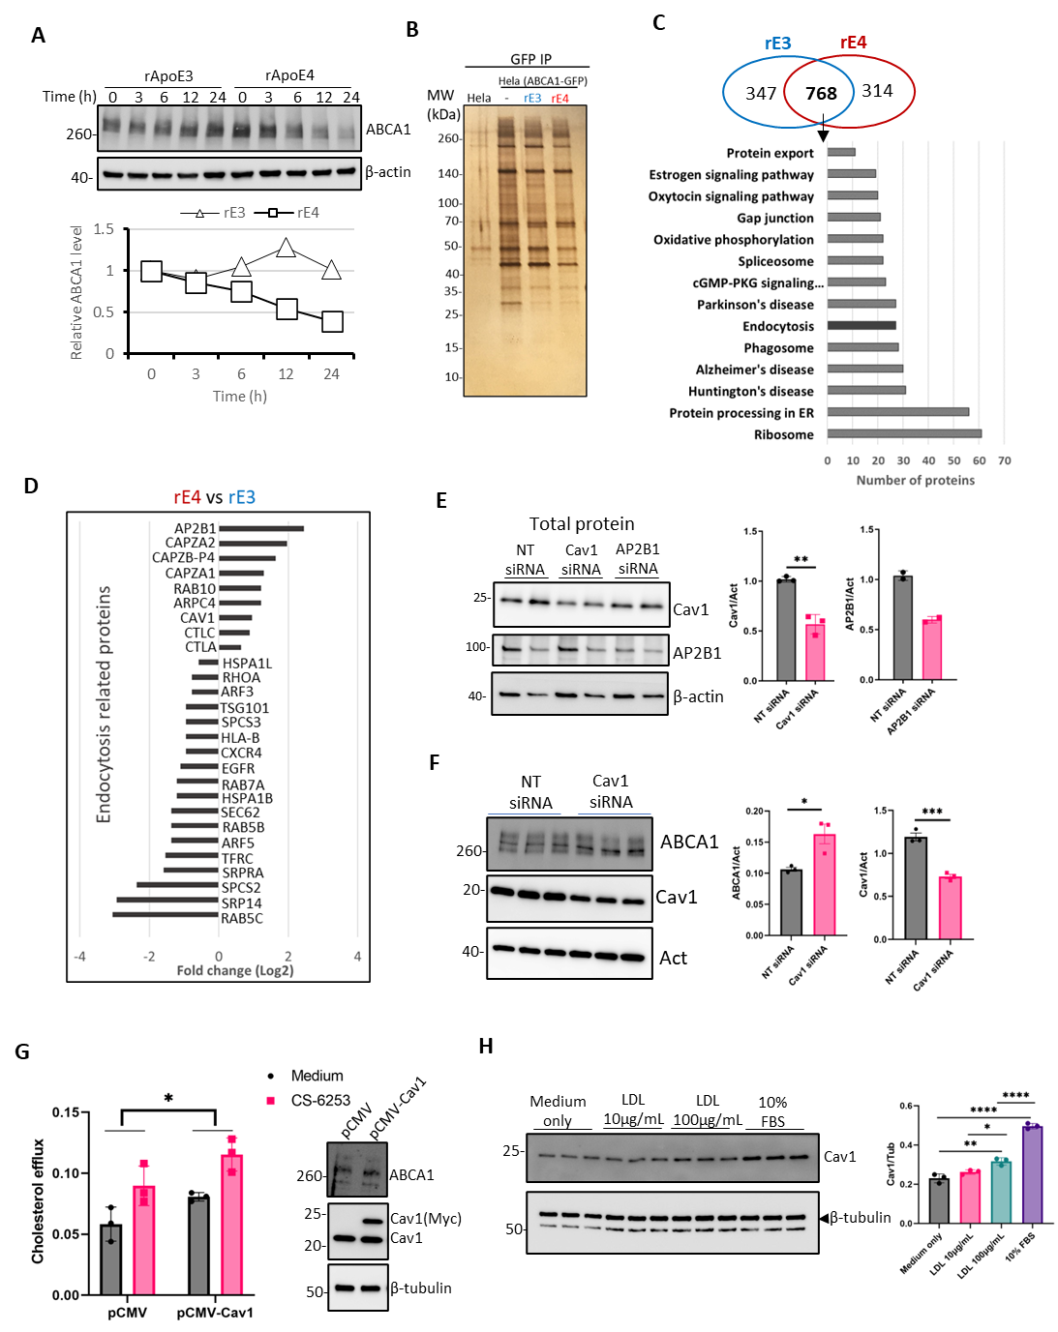
Supplementary Figure 4. Caveolin-1 regulates ABCA1 degradation. (A) HeLa cells expressing ABCA1-GFP were treated with recombinant ApoE3 or ApoE4 (0.2μM) for different hours. Cells were lysed with RIPA buffer and total ABCA1 levels were detected by WB using an anti-GFP antibody. The lower panel shows the densitometric quantification of the blots shown in the upper panel. ABCA1 was normalized to β-actin and then normalized to rApoE3 at the 0 h point. (B) Immunoprecipitation was performed with GFP-trap agarose in the lysate of HeLa cells or HeLa (ABCA1-GFP) cells treated with or without recombinant APOE3 (rE3) or APOE4 (rE4) for 4 h. Elution was detected using sodium dodecyl sulfate-polyacrylamide gel electrophoresis with silver staining. (C) 1115 and 1082 ABCA1 binding targets were detected in the recombinant APOE3 (rE3) and recombinant APOE4 (rE4) treatment groups, respectively, whereas 768 targets were found in both rE3 and rE4 groups. The top 14 candidates of the enriched KEGG pathways were identified from these 768 common targets (FDR < 0.05). (D) Enrichment levels (rE4 vs. rE3) of targets in the endocytic pathway. NSAF was used to calculate the fold change of each target. See the methods for calculating the NSFA. (E) Primary astrocytes were transfected with 15nM of non-target (NT), Caveolin-1 and AP2B1 siRNA for 48 h. The total protein levels of caveolin-1 and AP2B1 were detected by WB after siRNA transfection. (F) Immortalized astrocytes were transfected with 20nM of non-target (NT) or caveolin-1 siRNA for 48 h. The total protein levels of ABCA1 and caveolin-1 were detected by WB after siRNA transfection (n=3 biological replicates). (G) Caveolin-1 is overexpressed in immortalized astrocytes for 24 h, followed by labeling with 3H-cholesterol for 18 h. Cholesterol efflux was measured after treatment with the CS6253 peptides for 4 h (n=3 biological replicates). The right panel shows ABCA1 and caveolin-1 protein levels after plasmid transfection. (H) BHK cells were treated with LDL for 24 h, and caveolin-1 protein levels were detected by WB (n=3 biological replicates). Data are represented as mean± SD and were analyzed using unpaired t-test (E, F), one-way ANOVA (H), or two-way ANOVA (G) followed by Tukey’s test. *p<0.05, ** p<0.01, ***p<0.001; **** p<0.0001. (Related to Fig. 3).
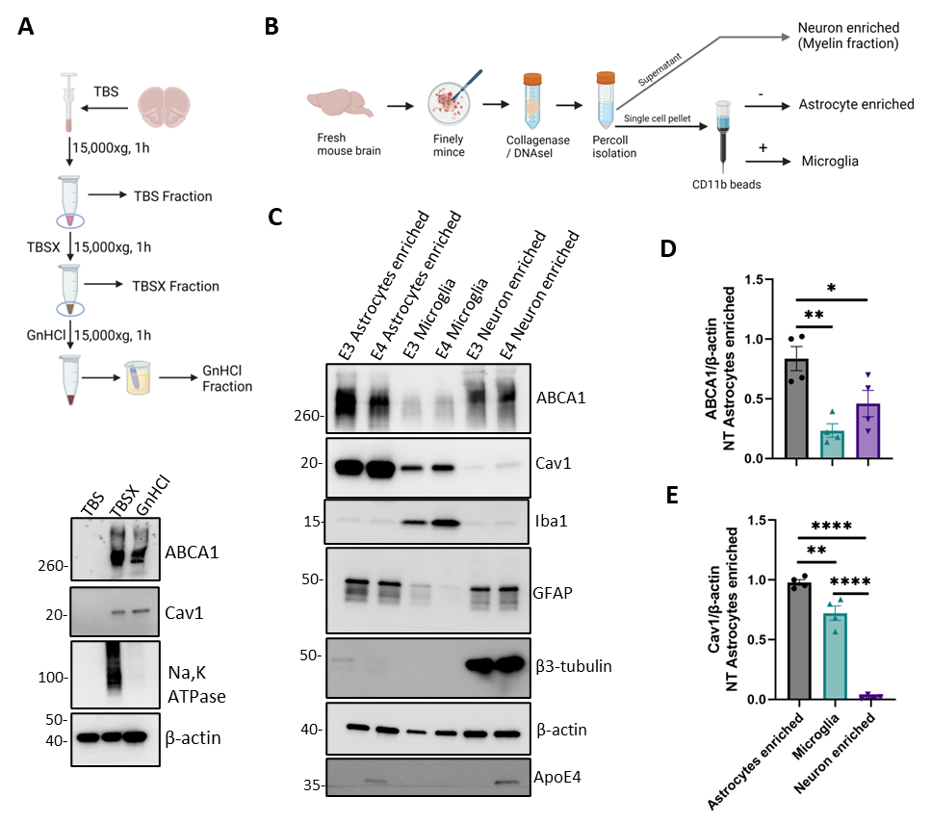
Supplementary Figure 5. ABCA1 and caveolin1 expression in different cell types isolated from adult mouse brains. (A) Mouse brain tissues were homogenized with TBS and TBS containing 1% Triton X-100 (TBSX) and then dissolved with guanidinium chloride (GnHCl). Validation of ABCA1 and caveolin-1 expression in the different fractions. (B) Diagram of the isolation of different cell types from mouse brains. (C) Brains of APOE3 or APOE4-TR mice (male, 9-10-month-old) were collected and dissociated to form single-cell suspensions to isolate different cell types. Cell type-specific markers were used to determine the purity of the cell population using western blotting. ABCA1 and caveolin-1 protein levels were measured by western blotting. (D-E) Quantification of ABCA1 (D) and caveolin-1 expression (E) in different cell types (4 mice total from two independent experiments). Data are presented as mean± SD and were analyzed using one-way ANOVA followed by Tukey’s test. *p<0.05, **p<0.01, ****p<0.0001. (Related to Fig. 3).

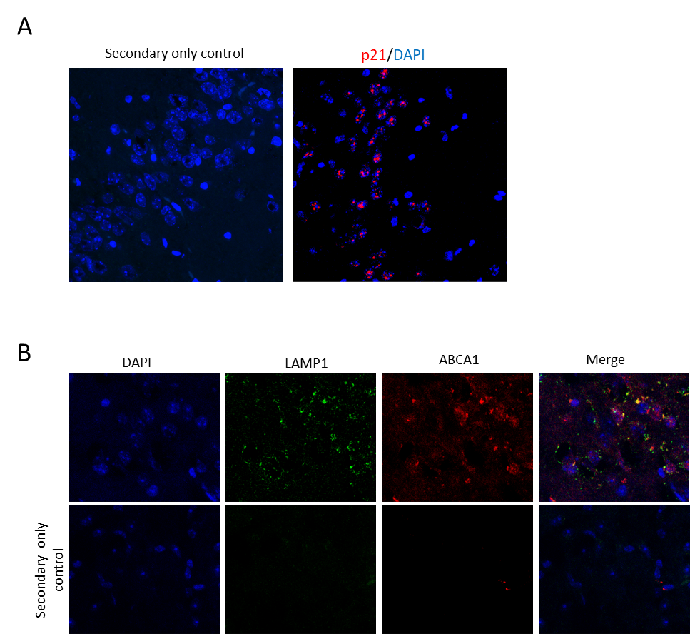
Supplementary Figure 6. Secondary only controls for p21 (A) and ABCA1-LAMP1 (B) immunostainings in mouse brain slides. (Related to Fig. 4).
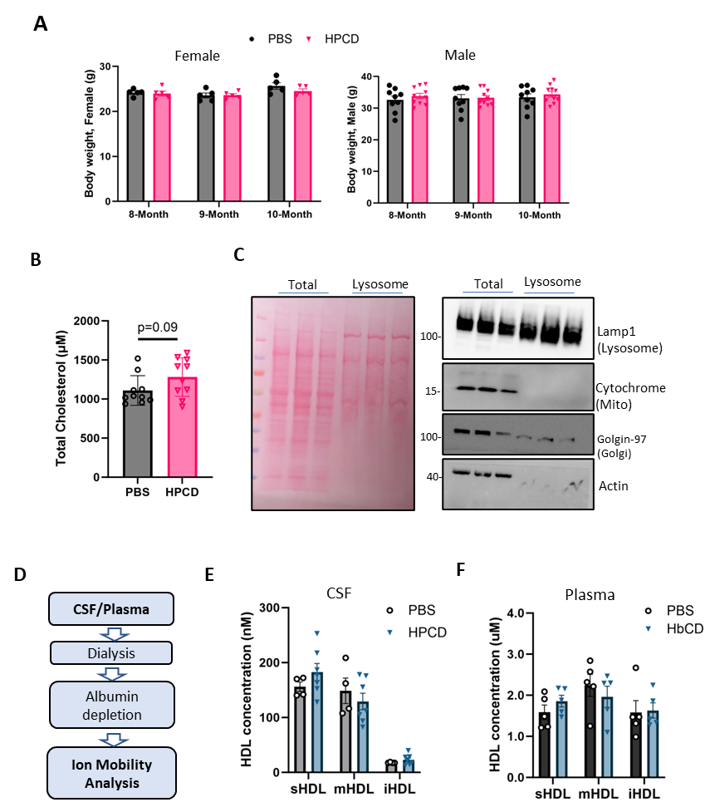
Supplementary Figure 7. Effects of cyclodextrin treatment on body weight, cholesterol levels in APOE4-TR mice. (A) Body weight of mice in the experimental processing (PBS group, n=14, 5 females and 9 males; HPCD group n=15, 5 females and 10 males). (B) Total cholesterol level in plasma was measured by cholesterol assay kit. n=10 mice, 5 females and 5 males in each group. (C) Validation of lysosome isolation from mouse brain. Ponceau S staining (left panel) and immuno-blotting (right panel) were shown. (D-F) HDL particles in mouse CSF and plasma were analyzed by ion mobility. Concentration of HDL of different sizes in CSF (E) and plasma (F). (n=4-7 in each group). Data are represented as mean± SD. (Related to Fig. 5).
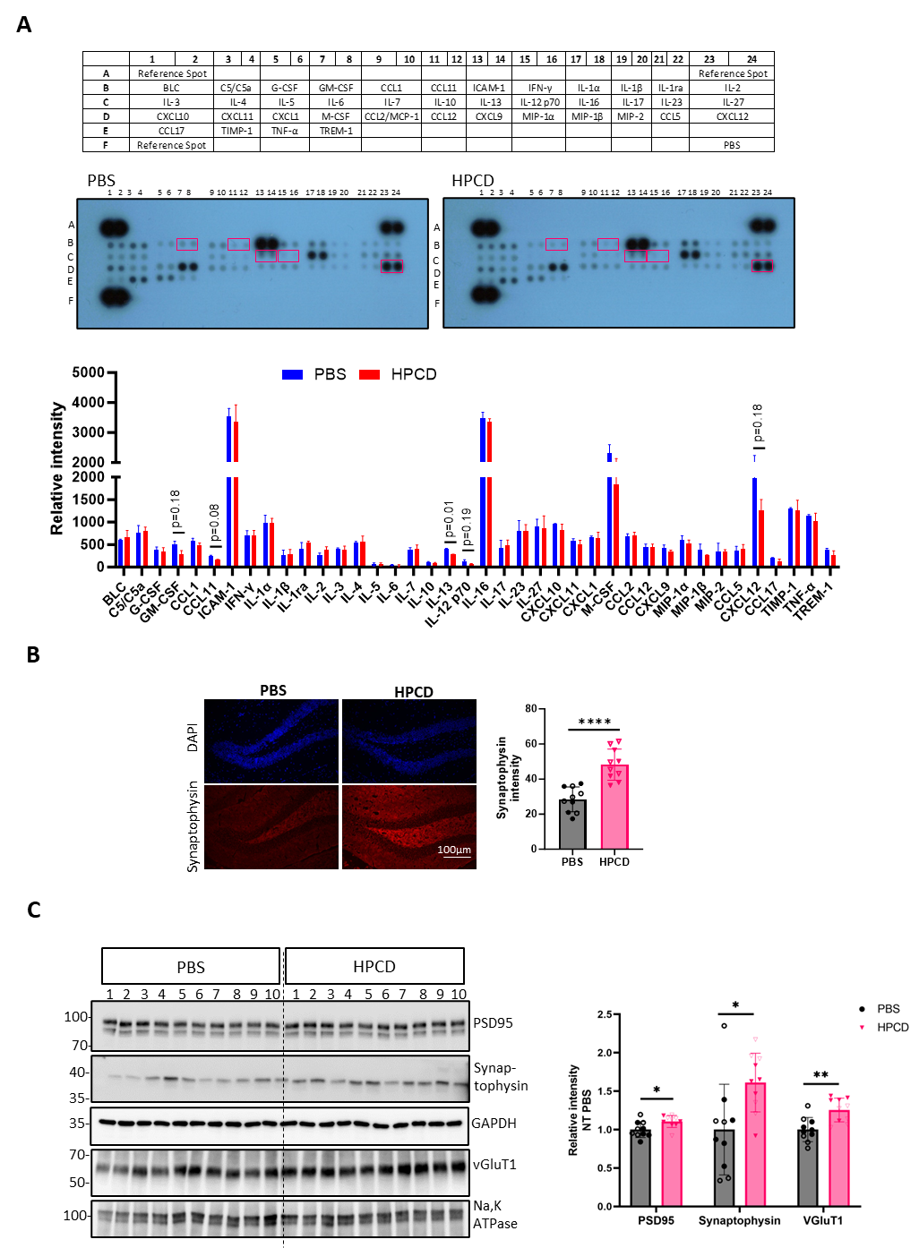
Supplementary Figure 8. Cyclodextrin increases neuronal functional markers and decreases cytokine levels in the brain of APOE4-TR mice. (A) Cytokines in the mouse cortex homogenate with TBSX buffer were measured using proteome profiler cytokine array kit, panel A. (n=2 samples each group, pooled 5 mice in one sample). (B) Synaptophysin levels in the hippocampus were determined using immunofluorescence staining (n=10). (C) PSD95, synaptophysin, and VGluT1 protein levels in the cortex were determined by western blotting (n=10). Data are presented as mean± SD and were analyzed using unpaired t-test. *p<0.05, **p<0.01, ****p<0.0001. (Related to Fig. 6).

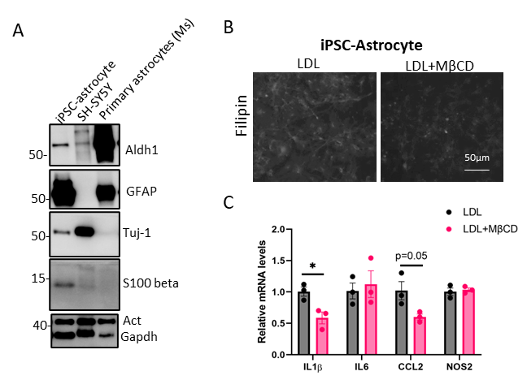
Supplementary Figure 9. Reduction of cholesterol by cyclodextrin reduces neuroinflammation in human iPSC-astrocytes model. (A)Validation of APOE4 human iPSC-astrocytes differentiation. (B) APOE4 human iPSC-astrocytes were cultured and loaded with LDL (10μg/mL) for 24 hours, followed by treatment with MβCD (1mM) for 2 hours. Cholesterol levels were measured using filipin staining. (C) After loading with LDL and treatment with MβCD, the cells were stimulated with TNFα+IFNγ for 18 hours. The mRNA levels of cytokines and chemokines were detected using qPCR (n=3 biological replicates). Data are presented as mean± SD and were analyzed using unpaired t-test. *p<0.05.

Supplementary tables
Supplementary Table 1. Characteristics of the human samples used for bulk-RNA sequencing.
Diagnosis | NCI |  |  | MCI |  | AD
APOE genotype | E33 | E34 | E44 | E33 | E34 | E33 | E34 | E44
Sample size | (N=62) | (N=7) | (N=1) | (N=117) | (N=28) | (N=82) | (N=58) | (N=2)
Age (Mean (SD)) | 83 (± 5.7) | 85 (± 5.6) | 85 (± NA) | 87 (± 3.9) | 86 (± 4.8) | 88 (± 3.3) | 88 (± 3.1) | 90 (± 0.44)
Gender
Male | 29 (46.8%) | 4 (57.1%) | 0 (0%) | 45 (38.5%) | 10 (35.7%) | 21 (25.6%) | 20 (34.5%) | 1 (50.0%)
Female | 33 (53.2%) | 3 (42.9%) | 1 (100%) | 72 (61.5%) | 18 (64.3%) | 61 (74.4%) | 38 (65.5%) | 1 (50.0%)
Cogdx
4 | 0 (0%) | 0 (0%) | 0 (0%) | 0 (0%) | 0 (0%) | 82 (100%) | 58 (100%) | 2 (100%)
3 | 0 (0%) | 0 (0%) | 0 (0%) | 7 (6.0%) | 1 (3.6%) | 0 (0%) | 0 (0%) | 0 (0%)
2 | 0 (0%) | 0 (0%) | 0 (0%) | 110 (94.0%) | 27 (96.4%) | 0 (0%) | 0 (0%) | 0 (0%)
1 | 62 (100%) | 7 (100%) | 1 (100%) | 0 (0%) | 0 (0%) | 0 (0%) | 0 (0%) | 0 (0%)
Ceradsc
4 | 46 (74.2%) | 3 (42.9%) | 0 (0%) | 39 (33.3%) | 5 (17.9%) | 0 (0%) | 0 (0%) | 0 (0%)
3 | 16 (25.8%) | 4 (57.1%) | 1 (100%) | 16 (13.7%) | 2 (7.1%) | 0 (0%) | 0 (0%) | 0 (0%)
2 | 0 (0%) | 0 (0%) | 0 (0%) | 38 (32.5%) | 10 (35.7%) | 36 (43.9%) | 13 (22.4%) | 1 (50.0%)
1 | 0 (0%) | 0 (0%) | 0 (0%) | 24 (20.5%) | 11 (39.3%) | 46 (56.1%) | 45 (77.6%) | 1 (50.0%)

Supplementary Table 2. Characteristics of the human samples used for single-nucleus RNA sequencing.
Diagnosis | no ADª |  |  |  |  | ADª
APOE genotype | E22 | E23 | E24 | E33 | E34 | E23 | E24 | E33 | E34 | E44
Sample size | N=3 | N=33 | N=3 | N=128 | N=20 | N=22 | N=7 | N=124 | N=77 | N=8
Age (Mean (SD)) | 89 (± 2.4) | 85 (± 5.8) | 89 (± 1.2) | 85 (± 4.9) | 85 (± 6.1) | 88 (± 3.5) | 88 (± 2.6) | 88 (± 3.6) | 86 (± 4.1) | 86 (± 3.3)
Gender
Male | 2 (66.7%) | 18 (54.5%) | 2 (66.7%) | 66 (51.6%) | 11 (55.0%) | 5 (22.7%) | 4 (57.1%) | 63 (50.8%) | 37 (48.1%) | 3 (37.5%)
Female | 1 (33.3%) | 15 (45.5%) | 1 (33.3%) | 62 (48.4%) | 9 (45.0%) | 17 (77.3%) | 3 (42.9%) | 61 (49.2%) | 40 (51.9%) | 5 (62.5%)
Cogdx
1 | 1 (33.3%) | 15 (45.5%) | 1 (33.3%) | 69 (53.9%) | 9 (45.0%) | 7 (31.8%) | 1 (14.3%) | 30 (24.2%) | 13 (16.9%) | 0 (0%)
2 | 0 (0%) | 8 (24.2%) | 0 (0%) | 34 (26.6%) | 6 (30.0%) | 4 (18.2%) | 1 (14.3%) | 33 (26.6%) | 16 (20.8%) | 0 (0%)
3 | 0 (0%) | 2 (6.1%) | 0 (0%) | 4 (3.1%) | 0 (0%) | 1 (4.5%) | 0 (0%) | 0 (0%) | 1 (1.3%) | 0 (0%)
4 | 1 (33.3%) | 7 (21.2%) | 2 (66.7%) | 10 (7.8%) | 3 (15.0%) | 7 (31.8%) | 4 (57.1%) | 58 (46.8%) | 43 (55.8%) | 7 (87.5%)
5 | 1 (33.3%) | 1 (3.0%) | 0 (0%) | 4 (3.1%) | 2 (10.0%) | 2 (9.1%) | 0 (0%) | 2 (1.6%) | 3 (3.9%) | 1 (12.5%)
6 | 0 (0%) | 0 (0%) | 0 (0%) | 7 (5.5%) | 0 (0%) | 1 (4.5%) | 1 (14.3%) | 1 (0.8%) | 1 (1.3%) | 0 (0%)
Ceradsc
1 | 0 (0%) | 0 (0%) | 0 (0%) | 0 (0%) | 0 (0%) | 10 (45.5%) | 5 (71.4%) | 56 (45.2%) | 48 (62.3%) | 6 (75.0%)
2 | 0 (0%) | 1 (3.0%) | 0 (0%) | 12 (9.4%) | 2 (10.0%) | 12 (54.5%) | 2 (28.6%) | 67 (54.0%) | 28 (36.4%) | 2 (25.0%)
3 | 1 (33.3%) | 6 (18.2%) | 1 (33.3%) | 25 (19.5%) | 8 (40.0%) | 0 (0%) | 0 (0%) | 1 (0.8%) | 1 (1.3%) | 0 (0%)
4 | 2 (66.7%) | 26 (78.8%) | 2 (66.7%) | 91 (71.1%) | 10 (50.0%) | 0 (0%) | 0 (0%) | 0 (0%) | 0 (0%) | 0 (0%)

ªOne more participant in both no AD and AD that APOE genotype is unknow is not listed in table.

Supplementary Table 3. Characteristics of postmortem brain samples used for protein extraction.
Regions sampled and source | Mid frontal lobe (ROS, RUSH ADRC)
Clinical diagnosis | NCI | NCI | AD | AD
Genotype | APOE3/3 | APOE3/4 | APOE3/3 | APOE3/4
Sample size, n | 33 | 19 | 44 | 42
Age at death (years ± SD) | 85±7 | 87±5 | 92±5 | 91±5
Sex (n, female/male) * | 17/16 | 9/10 | 31/13 | 29/13

Supplementary Table 4. List of rApoE4 enriched endocytosis related proteins.
Pathways | Abbreviation | Full name
Clathrin-dependent endocytosis | AP2B1 | Adaptor Related Protein Complex 2 Subunit Beta 1
Clathrin-dependent endocytosis | CAPZA2 | Capping Actin Protein of Muscle Z-Line Subunit Alpha 2
Clathrin-dependent endocytosis | CAPZB | Capping Actin Protein of Muscle Z-Line Subunit Beta
Clathrin-dependent endocytosis | CAPZA1 | Capping Actin Protein of Muscle Z-Line Subunit Alpha 1
Clathrin-dependent endocytosis | ARPC4 | Actin Related Protein 2/3 Complex Subunit 4
Clathrin-dependent endocytosis | RAB10 | Ras-related protein Rab-10
Clathrin-dependent endocytosis | CTLC | Clathrin heavy chain 1
Clathrin-dependent endocytosis | CTLA | Clathrin light chain A
Caveolae-dependent endocytosis | CAV-1 | Caveolin-1

Supplementary Table 5. List of antibodies used.
Antibody name | Catalog | Supplier | Usage | Dilution
ABCA1 | ab18180 | Abcam | WB | 1:1000
 |  |  | IF | 1:40
ABCA1 | 96292 | CST | WB | 1:1000
ABCA1 | NB100-2068 | Novus Biologicals | IF | 1:100
GFP | 2950 | CST | WB | 1:1000
 |  |  | IP | 1:50
Caveolin-1 | 3267S | CST | WB | 1:1000
 |  |  | IF | 1:200
AP2B1 | GTX79316 | GeneTex | WB | 1:1000
 |  |  | IF | 1:200
GFAP | Z0334 | Dako | IHC | 1:2000
GFAP | NBP1-05198 | Novus Biologicals | IF | 1:200
Iba-1 | GTX100042 | GeneTex | IHC | 1:100
β-actin | 3700 | CST | WB | 1:1000
β-tubulin | 2146 | CST | WB | 1:1000
Na,K-ATPase | 3010S | CST | WB | 1:1000
APOE4 | 8941S | CST | WB | 1:1000
β3-Tubulin | 5568S | CST | WB | 1:1000
PSD95 | 3450S | CST | WB | 1:1000
Synaptophysin | 34606S | CST | WB | 1:1000
 |  |  | IF | 1:100
VGluT1 | MAB5502 | Sigma | WB | 1:1000
GAPDH | 2118S | CST | WB | 1:1000
EEA1 | 3288S | CST | WB | 1:1000
Lamp1 | 99437S | CST | WB | 1:1000
 |  |  | IF | 1:25
Lamp1 | 46843S | CST | WB | 1:1000
Rab9 | 5133 | CST | WB | 1:1000
Biotin Polyclonal Antibody | 31852 | Thermo Fisher | IF | 1:200
Phospho-mTOR (Ser2448) (D9C2) Rabbit mAb | 5536S | CST | WB | 1:1000
mTOR rabbit mAb | 2983S | CST | WB | 1:1000
Phospho-p70 S6 Kinase (Thr389) Rabbit mAb | 97596S | CST | WB | 1:1000
p70 S6 Kinase Antibody | 9202S | CST | WB | 1:1000
Phospho-4E-BP1 Rabbit mAb | 2855S | CST | WB | 1:1000
4E-BP1 Rabbit mAb | 9644S | CST | WB | 1:1000
p21 | 37543 | CST | WB | 1:1000
 |  |  | IHC | 1:200
p16 | 29271 | CST | WB | 1:1000
p53 | 2524 | CST | WB | 1:1000
LAMP2 (H4B4) antibody | sc-18822 | Santa Cruz Biotechnology | IP | 4µg/mL
Goat anti-mouse IgG, Alexa 488 | A32723 | Thermo Fisher | IF | 1:200
Goat anti-mouse IgG, Alexa 594 | A11005 | Thermo Fisher | IF | 1:200
Donkey anti-Rabbit IgG, Alexa 488 | A32731 | Thermo Fisher | IF | 1:200
Donkey anti-Rabbit IgG, Alexa 594 | A21207 | Thermo Fisher | IF | 1:200
Rabbit anti-Goat IgG, Alexa 594 | A-11080 | Thermo Fisher | IF | 1:200
Goat anti-Goat Chicken IgY, Alexa 405 | A48260 | Thermo Fisher | IF | 1:200
HRP-linked anti-mouse IgG | 7076 | CST | WB | 1:2000
HRP-linked anti-rabbit IgG | 7074 | CST | WB | 1:2000
ª WB, Western Blot; IF, Immunofluorescence; IP, immunoprecipitation; IHC, Immunohistochemistry; CST, Cell Signaling Technology

Supplementary Table 6. List of primers for qPCR.
Target | Forward | Reverse
Nfkb1 | AAGACAAGGAGCAGGACATG | AGCAACATCTTCACATCCCC
Nfkb2 | CACCCATCTAGTCACCAAGC | TCAGCACCAGCCTTTAGAAG
Rela | ACCCGAAACTCAACTTCTGTC | TTGATGGTGCTGAGGGATG
Relb | GCTGTACTTGCTCTGTGACA | TGGCGTTTTGAACACAATGG
Rel | ACCAGAACGCAGACCTTTG | TCGCAGTCTTCAATGTCCAG
Cdkn1a | CAGATCCACAGCGATATCCAG | AGAGACAACGGCACACTTTG
Cdkn1b | TGGACCAAATGCCTGACTC | GGGAACCGTCTGAAACATTTTC
Cdkn2a | CTCTGGCTTTCGTGAACATG | TCGAATCTGCACCGTAGTTG
Cdkn2b | CTGCCACTGGAGATTGACTG | TGGGTAGGGTTCAAGTTTTGG
Il1a | TGCAGTCCATAACCCATGATC | ACAAACTTCTGCCTGACGAG
Il1b | GCAACTGTTCCTGAACTCAACT | ATCTTTTGGGGTCCGTCAACT
Il6 | TAGTCCTTCCTACCCCAATTTCC | TTGGTCCTTAGCCACTCCTTC
Tnfa | CAGGCGGTGCCTATGTCTC | CGATCACCCCGAAGTTCAGTAG
Ccl2 | GTCCCTGTCATGCTTCTGG | GCTCTCCAGCCTACTCATTG
18sRNA |  | GGCCTCACTAAACCATCCAA
  GCAATTATTCCCCATGAACG | GGCCTCACTAAACCATCCAA

Supplementary table 7. Expression of 129 senescence genes in astrocytes
Gene | per cell average expression | PValue | Statistic
AGO1 | 0.161449 | 0 | 0.139117
AGO3 | 0.980128 | 0 | 0.524592
AGO4 | 0.435584 | 0 | 0.304865
ANAPC1 | 0.322029 | 0 | 0.235547
ANAPC10 | 0.362749 | 0 | 0.247188
ANAPC11 | 0.076933 | 0 | 0.070748
ANAPC16 | 0.684945 | 0 | 0.414495
ANAPC4 | 0.191678 | 0 | 0.161663
ANAPC5 | 0.308054 | 0 | 0.243999
ANAPC7 | 0.156902 | 0 | 0.137425
ATM | 0.490218 | 0 | 0.333616
CABIN1 | 0.484127 | 0 | 0.327064
CBX6 | 0.155853 | 0 | 0.137378
CDC16 | 0.400173 | 0 | 0.300231
CDC23 | 0.084977 | 0 | 0.077595
CDC27 | 0.597434 | 0 | 0.386038
CEBPB | 0.179014 | 0 | 0.141029
E2F3 | 0.391387 | 0 | 0.263617
EED | 0.136997 | 0 | 0.119639
EHMT1 | 1.450735 | 0 | 0.63675
EHMT2 | 0.155358 | 0 | 0.137712
EP400 | 0.485765 | 0 | 0.341085
FOS | 0.320484 | 0 | 0.151968
FZR1 | 0.079996 | 0 | 0.075322
HIRA | 0.104575 | 0 | 0.092847
ID1 | 0.126292 | 0 | 0.091001
IGFBP7 | 1.661061 | 0 | 0.562096
JUN | 0.471469 | 0 | 0.252611
KAT5 | 0.116657 | 0 | 0.106574
MAP2K3 | 0.081587 | 0 | 0.070728
MAP2K4 | 0.63449 | 0 | 0.390905
MAP2K6 | 0.229851 | 0 | 0.142841
MAP2K7 | 0.157517 | 0 | 0.139839
MAP3K5 | 4.110258 | 0 | 0.838859
MAP4K4 | 3.551418 | 0 | 0.806496
MAPK1 | 0.809566 | 0 | 0.479493
MAPK10 | 8.257873 | 0 | 0.925494
MAPK11 | 0.187713 | 0 | 0.164017
MAPK14 | 0.37455 | 0 | 0.27499
MAPK3 | 0.093362 | 0 | 0.086401
MAPK8 | 0.98083 | 0 | 0.486928
MAPK9 | 0.20828 | 0 | 0.172181
MAPKAPK2 | 0.221713 | 0 | 0.179482
MAPKAPK5 | 0.157752 | 0 | 0.137251
MDM2 | 0.327037 | 0 | 0.240662
MDM4 | 0.544952 | 0 | 0.378181
MINK1 | 0.820524 | 0 | 0.456111
MOV10 | 0.236203 | 0 | 0.193998
MRE11 | 0.11661 | 0 | 0.100189
NBN | 0.159771 | 0 | 0.132417
NFKB1 | 0.408584 | 0 | 0.267027
PHC1 | 0.302692 | 0 | 0.239573
PHC2 | 0.287775 | 0 | 0.211403
PHC3 | 0.866092 | 0 | 0.484875
POT1 | 0.263831 | 0 | 0.203814
RB1 | 0.713288 | 0 | 0.41178
RBBP4 | 0.345465 | 0 | 0.267662
RBBP7 | 0.125209 | 0 | 0.111602
RELA | 0.084255 | 0 | 0.078231
RING1 | 0.208608 | 0 | 0.17999
RPS27A | 0.142206 | 0 | 0.123925
RPS6KA2 | 6.421509 | 0 | 0.885028
RPS6KA3 | 0.352452 | 0 | 0.231108
SCMH1 | 1.237567 | 0 | 0.548897
SP1 | 0.164772 | 0 | 0.140481
STAT3 | 1.11435 | 0 | 0.530162
SUZ12 | 0.604113 | 0 | 0.394529
TERF1 | 0.299489 | 0 | 0.234738
TERF2 | 0.155471 | 0 | 0.132825
TERF2IP | 0.613795 | 0 | 0.37215
TFDP1 | 0.113167 | 0 | 0.097474
TFDP2 | 0.859432 | 0 | 0.438332
TNIK | 10.04595 | 0 | 0.932113
TNRC6A | 6.24644 | 0 | 0.923394
TNRC6B | 2.995788 | 0 | 0.81002
TNRC6C | 1.057336 | 0 | 0.547279
TP53 | 0.313163 | 0 | 0.21734
UBA52 | 0.08707 | 0 | 0.079347
UBB | 0.288564 | 0 | 0.217701
UBC | 0.869308 | 0 | 0.431859
UBE2E1 | 0.673759 | 0 | 0.390598
UBN1 | 0.190441 | 0 | 0.159082
ASF1A | 0.074179 | 2.09E-299 | 0.067867
ANAPC2 | 0.061896 | 5.10E-227 | 0.059087
CDKN1B | 0.063761 | 1.85E-226 | 0.059014
CDC26 | 0.0634 | 1.49E-223 | 0.058633
RNF2 | 0.066917 | 6.18E-217 | 0.057757
MAPKAPK3 | 0.060545 | 1.39E-206 | 0.056359
CBX4 | 0.056714 | 1.03E-183 | 0.053143
TXN | 0.054594 | 2.07E-165 | 0.050422
CDK4 | 0.050516 | 4.99E-151 | 0.048175
BMI1 | 0.039276 | 3.99E-91 | 0.037397
CDKN2D | 0.034803 | 1.75E-72 | 0.033338
HMGA2 | 0.044946 | 5.94E-64 | 0.031306
CDKN1A | 0.042285 | 1.24E-63 | 0.031225
TINF2 | 0.031807 | 3.64E-61 | 0.03061
UBE2S | 0.031613 | 1.39E-59 | 0.030209
HMGA1 | 0.030918 | 1.86E-54 | 0.028872
ETS2 | 0.029567 | 4.95E-51 | 0.027942
ANAPC15 | 0.026425 | 2.29E-43 | 0.025743
ACD | 0.02488 | 5.41E-39 | 0.024399
MAPK7 | 0.024231 | 1.96E-36 | 0.023576
CDK6 | 0.025923 | 5.09E-35 | 0.023108
ETS1 | 0.025763 | 6.28E-33 | 0.022399
EZH2 | 0.024813 | 5.85E-31 | 0.021711
LMNB1 | 0.02278 | 4.06E-26 | 0.019919
CDKN2C | 0.019678 | 8.64E-24 | 0.018996
CCNA2 | 0.01705 | 2.03E-18 | 0.016676
CCNE1 | 0.012015 | 5.44E-09 | 0.011527
CDKN2A | 0.012697 | 3.06E-08 | 0.011012
CDK2 | 0.01126 | 5.12E-08 | 0.010852
CCNE2 | 0.00914 | 1.65E-05 | 0.008893
CDKN2B | 0.008472 | 0.000185 | 0.00793
CBX8 | 0.00684 | 0.002526 | 0.006733
E2F1 | 0.006312 | 0.006875 | 0.006212
RAD50 | 0.00442 | 0.124117 | 0.00438
RPS6KA1 | 0.003738 | 0.279966 | 0.003698
CBX2 | 0.002735 | 0.704645 | 0.002681
CCNA1 | 0.002193 | 0.924378 | 0.002186
CXCL8 | 2.67E-05 | 1 | 2.67E-05
E2F2 | 0.001351 | 1 | 0.001344
ERF | 4.01E-05 | 1 | 4.01E-05
IFNB1 | 6.69E-06 | 1 | 6.69E-06
IL1A | 0.000147 | 1 | 0.000147
IL6 | 0.000127 | 1 | 0.00012
UBE2C | 0.000388 | 1 | 0.000388
VENTX | 0.000321 | 1 | 0.000321
UBE2D1 | 0.078892 | 3.01598562360003e-311 | 0.069197
KDM6B | 0.076291 | 8.52095899041904e-317 | 0.069812

