Monoallelic TYROBP deletion is a novel risk factor for Alzheimer’s disease

Henna Martiskainen^{1#}*, Roosa-Maria Willman^{1#}, Päivi Harju¹, Sami Heikkinen¹, Mette Heiskanen¹, Stephan A. Müller^{2,3}, Rosa Sinisalo¹, Mari Takalo¹, Petra Mäkinen¹, Teemu Kuulasmaa¹, Viivi Pekkala^{1,4}, Ana Galván del Rey¹, Sini-Pauliina Juopperi¹, Heli Jeskanen¹, Inka Kervinen¹, Kirsi Saastamoinen¹, FinnGen†, Marja Niiranen⁵, Sami V. Heikkinen⁶, Mitja I. Kurki^{7,8,9,10}, Jarkko Marttila¹¹, Petri I. Mäkinen⁴, Hannah Rostalski^{4,12,13}, Tomi Hietanen⁴, Tiia Ngandu^{,14,15}, Jenni Lehtisalo^{6,14}, Céline Bellenguez¹⁶, Jean-Charles Lambert^{,16}, Christian Haass^{2,17,18}, Juha Rinne ^{19,20}, Juhana Hakumäki^{11,21}, Tuomas Rauramaa ^{22,23}, Johanna Krüger ^{24,25,26}, Hilkka Soininen⁶, Annakaisa Haapasalo⁴, Stefan F. Lichtenthaler^{2,3,18}, Ville Leinonen ^{27,28}, Eino Solje^{28,29}, and Mikko Hiltunen¹*

¹Institute of Biomedicine, University of Eastern Finland; Kuopio, Finland.
²German Center for Neurodegenerative Diseases (DZNE); Munich, Germany.
³Neuroproteomics, School of Medicine and Health, Technical University of Munich; Munich, Germany.
⁴A. I. Virtanen Institute for Molecular Sciences, University of Eastern Finland; Kuopio, Finland.
⁵Neuro Center - Neurology, Kuopio University Hospital; Kuopio, Finland.
⁶Institute of Clinical Medicine - Neurology, University of Eastern Finland; Kuopio, Finland.
⁷Institute for Molecular Medicine Finland (FIMM), Helsinki Institute of Life Science (HiLIFE), University of Helsinki; Helsinki, Finland.
⁸Program in Medical and Population Genetics, Broad Institute of Harvard and MIT; Cambridge, MA, USA.
⁹Stanley Center for Psychiatric Research, Broad Institute of Harvard and MIT; Cambridge, MA, USA.
¹⁰Analytic and Translational Genetics Unit, Massachusetts General Hospital; Boston, MA, USA.
¹¹Department of Clinical Radiology, Imaging Center, Kuopio University Hospital; Kuopio, Finland.
¹²Department of Clinical Medicine and Biotech Research and Innovation Centre (BRIC), University of Copenhagen, Copenhagen, Denmark¹³The Bartholin Institute, Department of Pathology, Rigshospitalet, Copenhagen University Hospital, Copenhagen, Denmark
¹⁴Department of Public Health, Finnish Institute for Health and Welfare, Helsinki, Finland.
¹⁵Division of Clinical Geriatrics, Center for Alzheimer Research, Department of Neurobiology, Care Sciences and Society, Karolinska Institutet, Stockholm, Sweden.
¹⁶Université de Lille, Inserm, CHU Lille, Institut Pasteur de Lille, LabEx DISTALZ - U1167-RID-AGE Facteurs de risque et déterminants moléculaires des maladies liées au vieillissement; Lille, France.
¹⁷Metabolic Biochemistry, Biomedical Centre (BMC), Faculty of Medicine, Ludwig-Maximilian University of Munich; Munich, Germany.
¹⁸Munich Cluster for Systems Neurology (Synergy); Munich, Germany.
¹⁹Turku PET Centre, Turku University Hospital; Turku, Finland.
²⁰ InFLAMES Research Flagship Center, University of Turku; Turku, Finland.
²¹ Unit of Radiology, Institute of Clinical Medicine, University of Eastern Finland; Kuopio, Finland.
²²Department of Clinical Pathology, Kuopio University Hospital; Kuopio, Finland.
²³Unit of Pathology, Institute of Clinical Medicine, University of Eastern Finland; Kuopio, Finland.
²⁴Research Unit of Clinical Medicine, Neurology, University of Oulu; Oulu, Finland.
²⁵Medical Research Center, Oulu University Hospital; Oulu, Finland.
²⁶Neurocenter, Neurology, Oulu University Hospital; Oulu, Finland.
²⁷Department of Neurosurgery, Kuopio University Hospital; Kuopio, Finland.
²⁸Institute of Clinical Medicine, University of Eastern Finland; Kuopio, Finland.
²⁹Neuro Center - Neurology, Kuopio University Hospital; Kuopio, Finland.

Supplementary Materials and Methods
Supplementary Figures 1-7

Supplementary Materials and Methods

Immunocytochemistry
For immunocytochemistry, MDMi cells and monocytes were cultured in 96-well Ibidi µ-slides (#89626, Ibidi, Mediq, Finland) at a density of 90,000 cells per well. Monocytes, isolated from PBMCs as previously described, were kept for 24 hours in RPMI-1640 Glutamax (61870010, Gibco) medium supplemented with 10% FBS (A5256801, Thermo Fisher) and 1% penicillin/streptomycin (ECB3001D, BioNordica, Finland). MDMi were differentiated from monocytes until DIV 11 as described above.
Cells were first fixed with 4% PFA (28908, Thermo Fisher) for 10 minutes and washed twice with PBS. For intracellular staining, cells were permeabilized with 0.1% Triton X-100 (BDH Laboratory Supplies, England) for 10 minutes, followed by a single PBS wash. Blocking was performed using 5% BSA (A9647-100G, Sigma-Aldrich) in PBS for 30 minutes at RT, after which the cells were incubated overnight at 4°C with primary antibodies diluted in 1% BSA/PBS. The primary antibodies were anti-CX3CR1 (702321, Thermo Fisher, 1:200), anti-IBA1 (019-19741, Wako, 1:400), anti-P2RY12 (HPA014518, Sigma-Aldrich, 1:125), anti-PU.1 (2266S, Cell Signaling Technology, 1:200), anti-TMEM119 (HPA051870, Thermo Fisher, 1:250) and anti-TREM2 (91068S, Cell Signaling Technology, 1:200). Negative control wells without primary antibodies were processed simultaneously.
Following overnight incubation, the cells were washed three times with PBS and incubated for 1 h at RT in the dark with an Alexa488-conjugated secondary antibody (A-21206, Thermo Fisher, 1:500) diluted in 1% BSA/PBS. After three additional PBS washes, nuclei were stained with DAPI (D1306, Thermo Fisher, 1 mg/ml, 1:1,000) for 5 min at RT in the dark. Finally, the cells were washed three times with PBS and stored in PBS at 4°C, protected from light. Images were acquired using a Zeiss LSM700 confocal laser scanning microscope (Carl Zeiss, Germany) with a 20x objective. No unspecific staining was observed in the negative control samples. Exposure settings were kept constant for each primary antibody. Image processing was performed using ImageJ (1.54g, NIH, USA).

Creation and validation of Tyrobp KO BV2 cell lines
Immortalized mouse microglial BV2 cells were cultured in RPMI-1640 medium (R0883-500ML, Sigma-Aldrich) supplemented with 10 % fetal bovine serum (10500064, Thermo Fisher), 1 % penicillin-streptomycin (DE17-602E, Lonza™), and 2 mM L-glutamine (BE17-605E, Thermo Fisher) in humidified atmosphere in 37ºC with 5 % CO2. For the experiments, the concentration of FBS was lowered to 5%.
To generate Tyrobp KO cell lines, BV2 cells were transduced with LV01 all-in-one CRISPR-Cas9 lentiviral vector targeting exon three of Tyrobp (MMPD0000041569, Sigma-Aldrich). To generate control lines, LV01 non-targeting NegativeControl1 vector was used.
A total of 600,000 cells were seeded on 6-well plates and let to adhere for 2 h before adding the viral vector at multiplicity of infection 10 together with 8 µg/ml of polybrene (TR-1003-G, Sigma-Aldrich). After 21 hours, the virus containing medium was replaced with fresh medium, and the puromycin selection (3 µg/ml, P8833-10MG, Sigma-Aldrich) was started four hours later. After four days of selection, monoclonal lines were established by sorting single GFP-positive cells on 96-wells by fluorescence-activated cell sorting. Monoclonal cell populations were expanded, and DNA and protein samples were collected for determining the knock-out lines.
Sanger sequencing for Tyrobp exon three was performed to identify clones with successful gene editing. The region was amplified by PCR using primers 5’-TTCTCCTTAGGATTAAGTCCCGT-3’ (forward) and 5’-TGTGACCTTGACGCTTCCAC-3’ (reverse), and the product was purified with ExoSAP-IT™ PCR Product Cleanup Reagent (78201.1.ML, Thermo Fisher Scientific). The sequencing reaction was performed using BigDye™ Terminator v3.1 kit (4337455, Thermo Fisher Scientific), and after ethanol/EDTA precipitation, the pure product was resuspended in Hi-Di™ Formamide (4311320, Thermo Fisher Scientific). The sequencing was performed at Genome Center of Eastern Finland. TIDE online tool (http://shinyapps.datacurators.nl/tide/) was used to investigate the generated indels in the lines.

siRNA transfection
BV2 cells were transfected with siRNA targeting mouse Tyrobp (s75642, Invitrogen), or non-targeting negative control siRNA (4390843, Invitrogen) using Lipofectamine RNAiMAX (13778075, Invitrogen) according to the manufacturer’s instructions. Briefly, siRNA and Lipofectamine were diluted in Opti-MEM reduced serum medium (31985062, Gibco), combined, and incubated for 5 min at room temperature. 25 pmol of siRNA per 12 million cells was used, and the siRNA-Lipofectamine mixture was plated together with the cells on 150 mm dish and incubated for 20 h. Fresh medium was added to the cells two hours before starting the starvation.

M-CSF treatment
BV2 cells transfected with Tyrobp or non-targeting control siRNA were placed in RPMI-1640 medium without FBS to induce serum starvation for 2 h. Next, the cells were treated with 100 ng/ml recombinant human M-CSF (BioLegend cat. 574,806, San Diego, CA, USA) or PBS as vehicle control for 5 min. Samples were then placed on ice and centrifugated at 10,000 x g for 1 min at 4°C. Supernatant was removed, and the cell pellet was lysed in RIPA supplemented with protease and phosphatase inhibitors (Halt™ 78420 and 87786, Thermo Fisher), mixed, and incubated on ice for 10 min. Samples were centrifugated at 16,000 x g for 10 min at 4°C, and the supernatants were stored at -20°C.

Western immunoblotting
Western immunoblotting was carried out as previously (26). Proteins were detected using the following primary antibodies diluted in the appropriate ratio with 1x TBST: Recombinant rabbit anti-mouse DAP12 [EPR24244-119] (1:1,000, ab280568, Abcam), mouse anti-β-actin (1:1,000, ab8226, Abcam), rabbit anti-phospho-Syk Tyr525/526 (1:1,000, #2711, Cell Signaling Technology), and rabbit anti-Syk [D3Z1E] (1:1000, #13198, Cell Signaling Technology). HRP-conjugated secondary antibodies used were anti-rabbit-HRP (1:5,000 NA934 Cytiva), and sheep anti-mouse-HRP (1:5,000, NA931V, GE Healthcare, Chicago, IL, USA). Two-way ANOVA followed by Tukey’s post hoc test was used to analyze Western blot data from BV2 cells.

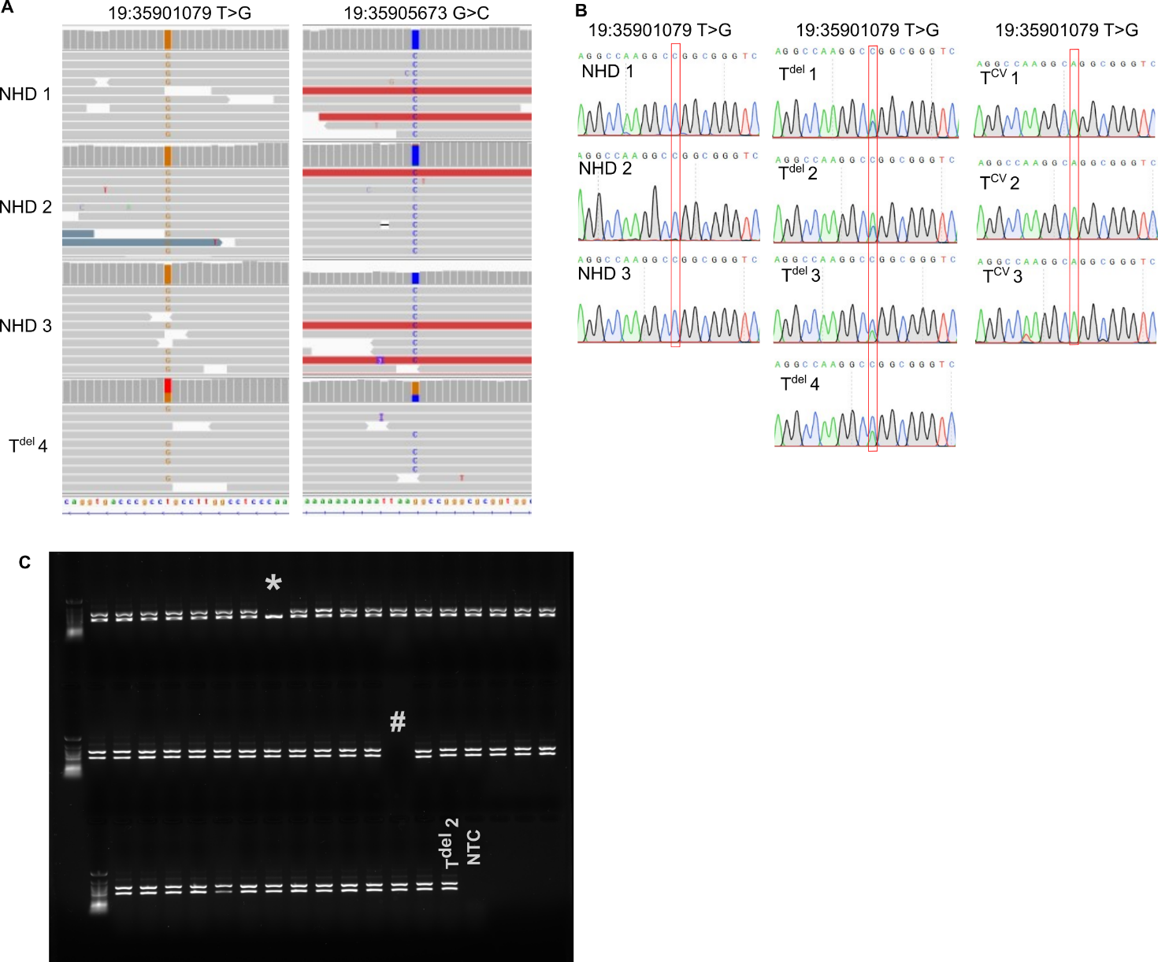
Fig. S1 Validation of the 5.2-kb TYROBP deletion proxy markers. (A) 5.2-kb TYROBP deletion proxy markers identified in the whole genome sequencing data of three NHD patients (homozygous for the 5.2-kb TYROBP deletion) and one monoallelic deletion carrier. (B) TYROBP deletion proxy marker rs1244787406 (19:35901079 T>G) was confirmed with Sanger sequencing in three NHD patients, three monoallelic TYROBP deletion carriers, and three individuals with the common variant of TYROBP. (C) Deletion-specific PCR of 50 imputed 19:35901079 T>G carriers from the FinnGen cohort. Two bands (~500 kb and ~700 kb) indicate individuals heterozygous for the TYROBP deletion, while single 500-kb band indicates an individual homozygous for the common variant of TYROBP. * denotes an individual with low (0.52) genotype probability for the 19:35901079 T>G variant. # denotes an empty well. NHD, Nasu Hakola disease patient; NTC, non-template control; T^{del}, monoallelic TYROBP deletion carrier; T^{CV}, TYROBP common variant.
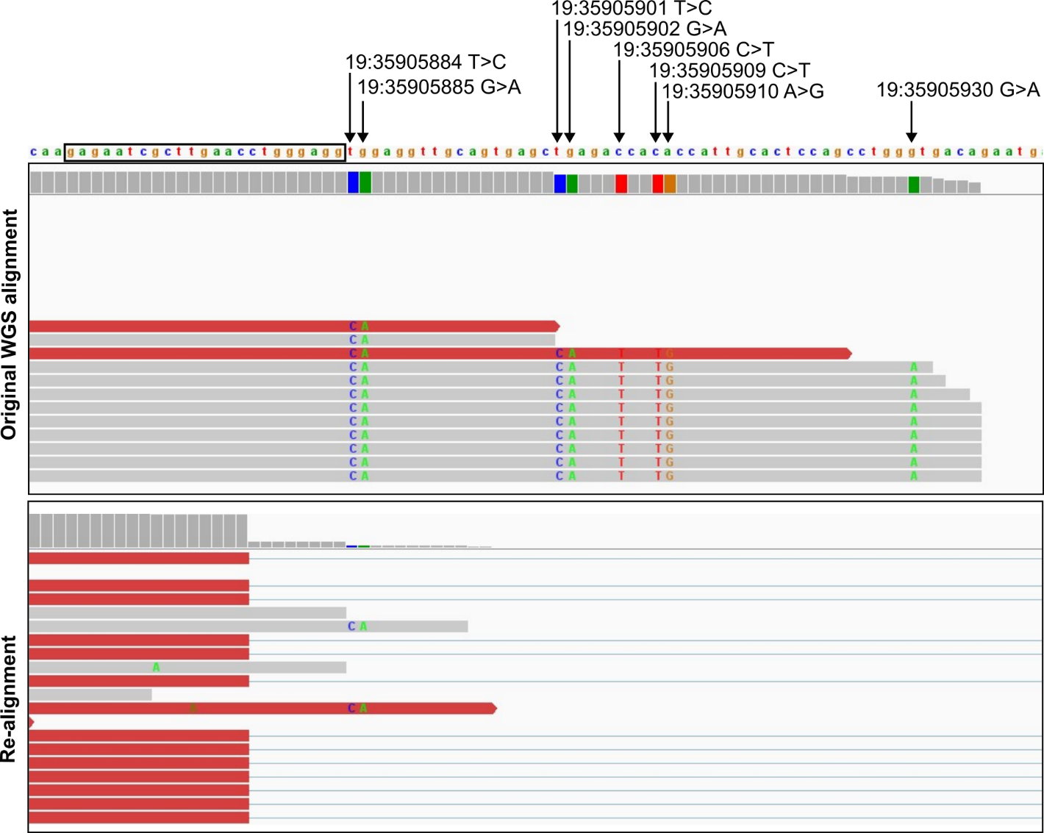
Fig. S2 Artefact single nucleotide variants arise from incorrect alignment of WGS reads spanning the 5.2-kb TYROBP deletion. The upper panel shows the original alignment of WGS data from an NHD patient with homozygous 5.2-kb TYROBP deletion. The lower panel shows the same data after re-alignment with parameters allowing large deletions. Horizontal lines in the lower panel indicate reads that span across the deletion. The deletion 5’ and 3’ break points are located within a 23-bp identical sequence (indicated in the figure with a black box) within 120 bp almost identical Alu repeats. This sequence similarity leads to incorrect alignment of the reads that span the deletion when standard parameters for WGS read alignment are used and to the detection of artefact SNVs at chromosome positions within the deleted region (indicated by arrows and chromosomal location in the figure).

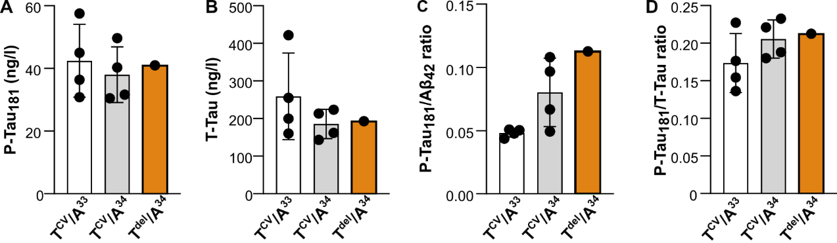
Fig. S3 Effect of the Finnish 5.2-kb TYROBP deletion on AD-related Tau pathology in the CSF. A) P-Tau181, B) total Tau (T-Tau), C) P-Tau181/Aβ42 ratio, and D) P-Tau181/T-Tau ratio in the CSF is in the same range for the monoallelic TYROBP deletion carrier and individuals without the TYROBP deletion. n=1-4 individuals per genotype. Data are shown as mean ± SD. Independent samples T-test was used to compare T^{CV}/A³³ and T^{CV}/A³⁴ groups. T^{CV}, TYROBP common variant; T^{del}, monoallelic TYROBP deletion; A³³, APOE ε3ε3; A³⁴, APOE ε3ε4.
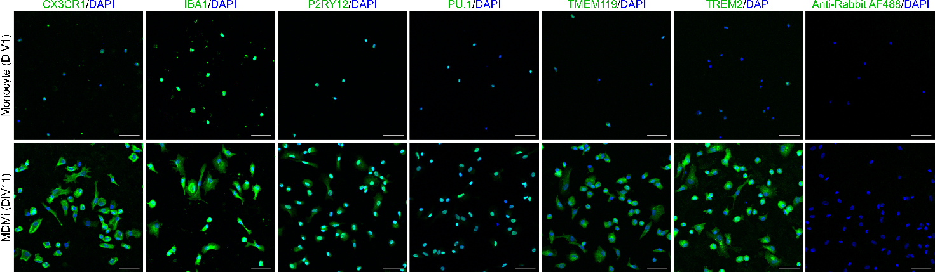
Fig. S4 Monocyte-derived microglia-like cells (MDMi) express microglial markers CX3CR1, IBA1, P2RY12, PU.1, TMEM119, and TREM2 (green). Nuclei are labelled with DAPI (blue). Negative controls processed without primary antibodies show no unspecific staining. Scale bars 50 µm. DIV, days in vitro.

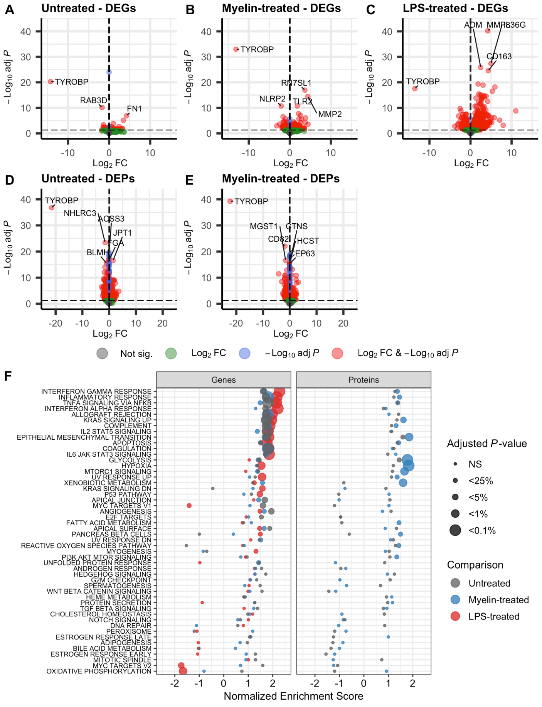
Fig S5 Increased inflammatory response induced by biallelic TYROBP deletion in MDMi cells. (A-C) Differentially expressed genes (DEG) and (D-E) proteins (DEP) in NHD patient-derived MDMi cells compared to controls upon untreated (A, D), myelin-treated (B, E) and LPS-treated (C) conditions. (F) Pathway enrichment of genes (left panel) and proteins (right panel) differentially expressed in the NHD patient MDMi cells compared to controls. NHD, n=2 (A-E); controls with TYROBP common variant, n=12 (A), n=7 (B), n=3 (C-E).
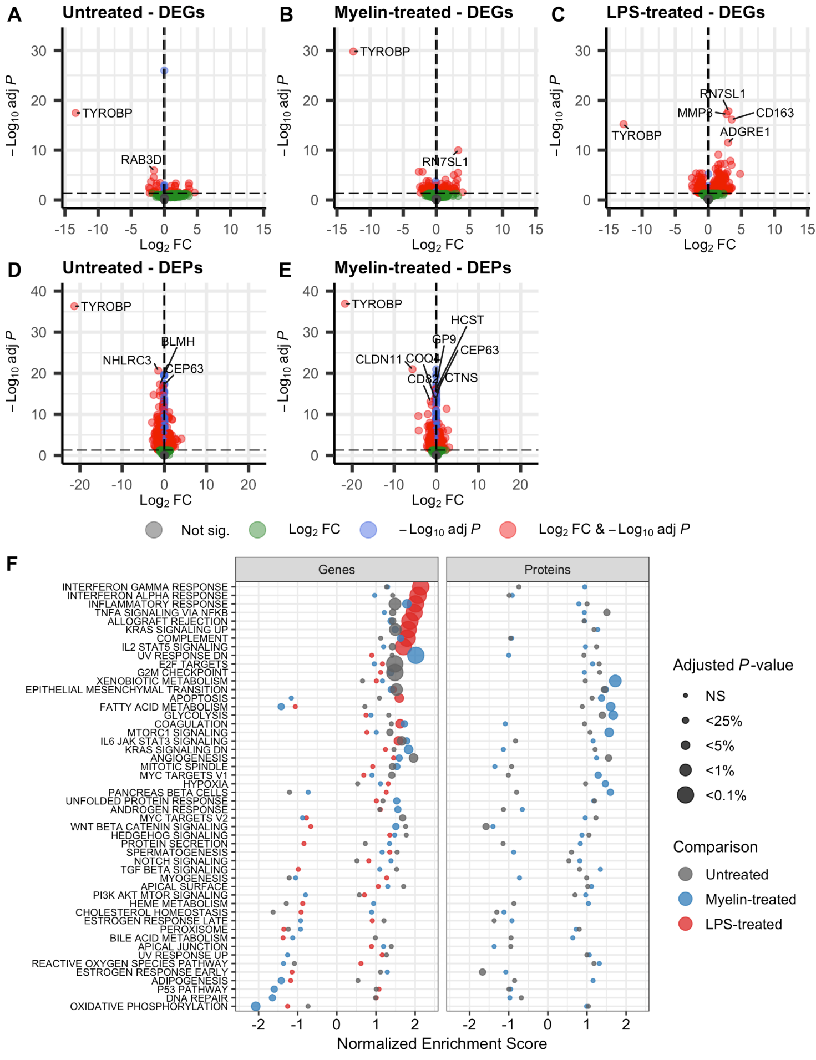
Fig S6 Altered pathways induced by biallelic vs. monoallelic TYROBP deletion in MDMi cells. (A-C) Differentially expressed genes (DEG) and (D-E) proteins (DEP) in NHD patient-derived MDMi cells compared to monoallelic TYROBP deletion carriers upon untreated (A, D), myelin-treated (B, E) and LPS-treated (C) conditions. (F) Pathway enrichment of genes (left panel) and proteins (right panel) differentially expressed in the NHD patient MDMi cells compared to monoallelic TYROBP deletion carriers. NHD, n=2 (A-E); monoallelic TYROBP deletion carrier, n=3 (A-E).
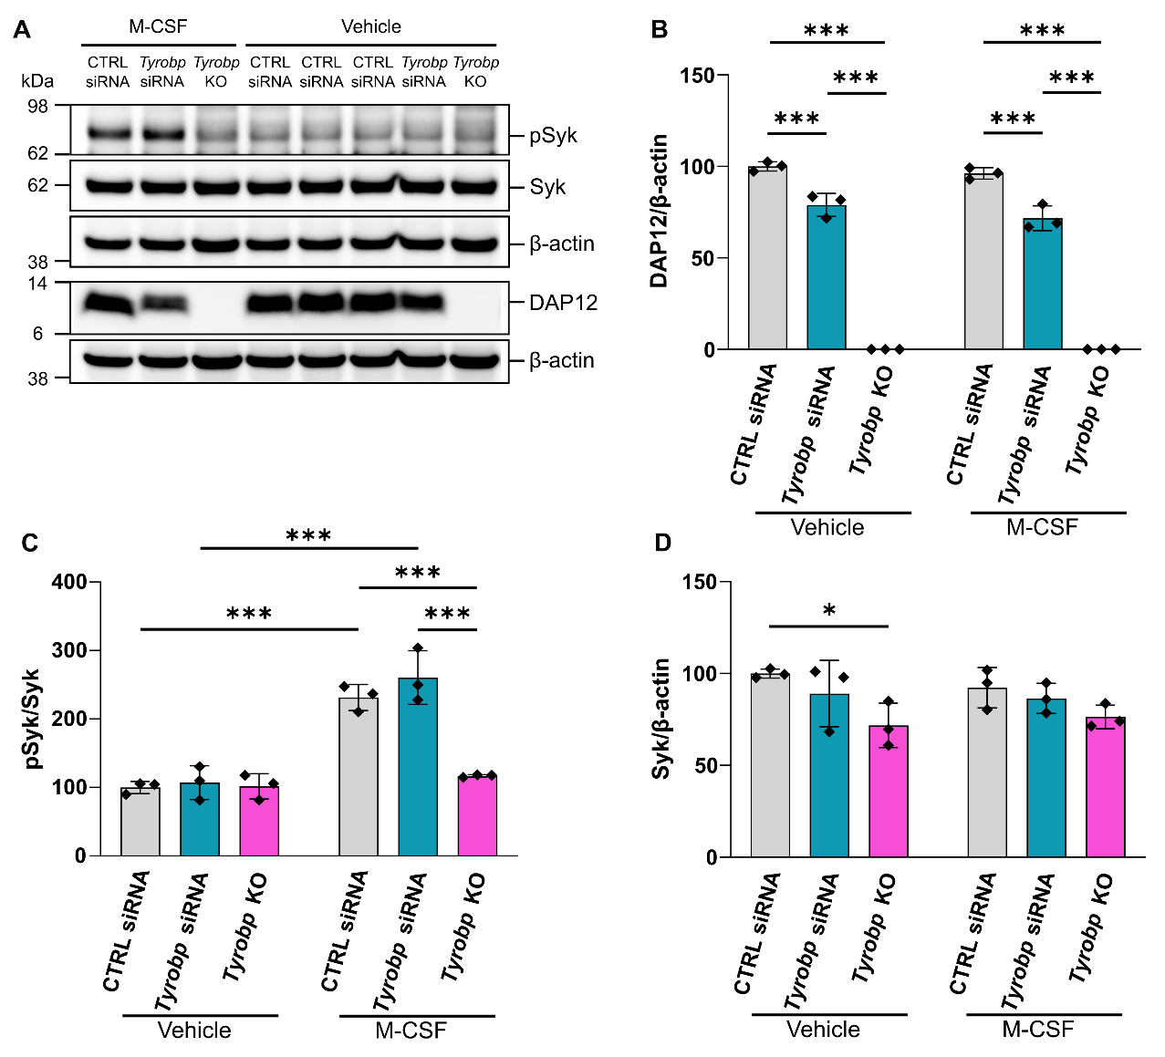
Fig. S7 M-CSF signalling in DAP12 deficient immortalized BV2 microglial cells. (A) Western blot of phosphorylated Syk (pSyk), total Syk, and DAP12 in BV2 cells after M-CSF treatment. DAP12 deficiency was obtained by siRNA silencing of Tyrobp or by lentiviral CRISPR-Cas9 editing yielding stable Tyrobp knockout (KO) cells. Non-targeting control (CTRL) siRNA was used for the control group and Tyrobp KO cells. DAP12 was detected from a separate blot. β-actin was used as a loading control. (B) Quantification of DAP12 protein normalized to β-actin, (C) pSyk normalized to total Syk, and (D) total Syk normalized to β-actin. All data in B-D are shown as mean ± SD, n=3, and the values are shown as % of vehicle-treated control siRNA group. Two-way ANOVA with Tukey’s post hoc test. T^{KO}, Tyrobp KO; WT, wild type. *: P<0.05, ***: P<0.001.

