Supplementary figures to

Early intervention anti-Aβ immunotherapy attenuates microglial activation without inducing exhaustion at residual plaques
Lis de Weerd^{1,#}, Selina Hummel², Stephan A. Müller^{1,7}, Iñaki Paris^{1,§}, Thomas Sandmann³, Marie Eichholtz⁶, Robin Gröger², Amelie L. Englert², Stephan Wagner², Connie Ha³, Sonnet S. Davis³, Valerie Warkins³, Dan Xia³, Brigitte Nuscher⁴, Anna Berghofer¹, Marvin Reich^{1,†}, Astrid F. Feiten⁴, Kai Schlepckow¹, Michael Willem⁴, Stefan F. Lichtenthaler^{1,5,7}, Joseph W. Lewcock³, Kathryn M. Monroe³, Matthias Brendel^{1,2,5}, Christian Haass^{1,4,5,#}
¹ German Center for Neurodegenerative Diseases (DZNE), Munich, Germany.
² Department of Nuclear Medicine, University Hospital of Munich, Ludwig Maximilians University, Munich, Germany.
³ Denali Therapeutics, Inc., South San Francisco, USA.
⁴ Metabolic Biochemistry, Biomedical Center, Faculty of Medicine, Ludwig-Maximilians Universität (LMU), Munich, Germany.
⁵ Munich Cluster for Systems Neurology (SyNergy), Munich, Germany.
⁶ Biochemistry Master’s Program, Gene Center Munichs, Ludwig-Maximilians University (LMU), Munich, Germany.
⁷ Neuroproteomics, School of Medicine and Health, Klinikum Rechts der Isar, Technical University of Munich (TUM), Munich, Germany.

† Current address: Department of Neurology and Neurological Sciences, Stanford University School of Medicine, Stanford University, Stanford, CA, USA

# Corresponding authors:
Christian Haass, PhD
Email: christian.haass@mail03.med.uni-muenchen.de
Lis de Weerd
Email: lis.deweerd@dzne.de

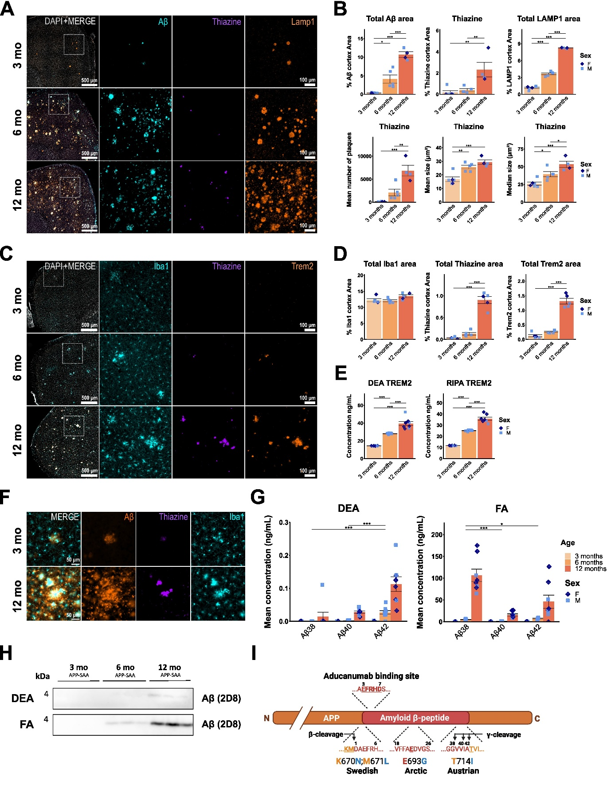

Figure S1: Progression of amyloid pathology in the APP-SAA mouse model
(A) Representative immunofluorescent images of sagittal cortical sections showing Aβ (cyan), thiazine (purple), and Lamp1 (orange) and (B) quantification of percent cortical thiazine area, plaque count and size, and percent cortical Lamp1 area. (C) Representative immunofluorescent images of sagittal cortical sections showing Iba1 (cyan), thiazine (purple) and Trem2 (orange) and (D) quantification of percent cortical area of Iba1, thiazine and Trem2. (E) ELISA quantification of Trem2 in DEA and RIPA brain lysate. (F) Representative immunofluorescent images showing Aβ (orange), thiazine (purple), and Iba1 (cyan), and microglia clustering around diffuse Aβ plaques at 3 months and a comparison to dense plaques at 12 months. (G) Aβ-triplex ELISA quantification of DEA- and FA-extracted Aβ. (H) Western blot of DEA and FA fractions for Aβ (antibody 2D8). (I) Schematic of the human APP protein with Swedish, Arctic, and Austrian mutations and anti-Aβ (Aducanumab) binding site indicated. *: P < 0.05; **: P < 0.01; ***: P < 0.001. One-way ANOVA with Tukey’s post hoc test (B, D). Two-way ANOVA with Tukey’s post hoc test (G). Schematic (F) was created with BioRender.com. For (B): 3 months n = 2 f, 3 m, 6 months n = 5 m, 12 months n = 2 f, 2 m. For (D): 3 months n = 2 f, 3 m, 6 months n = 5 m, 12 months n = 2 f, 3 m. For (E, G): 3 months n = 4 f, 3 m, 6 months n = 9 m, 12 months n = 5 f, 3 m.

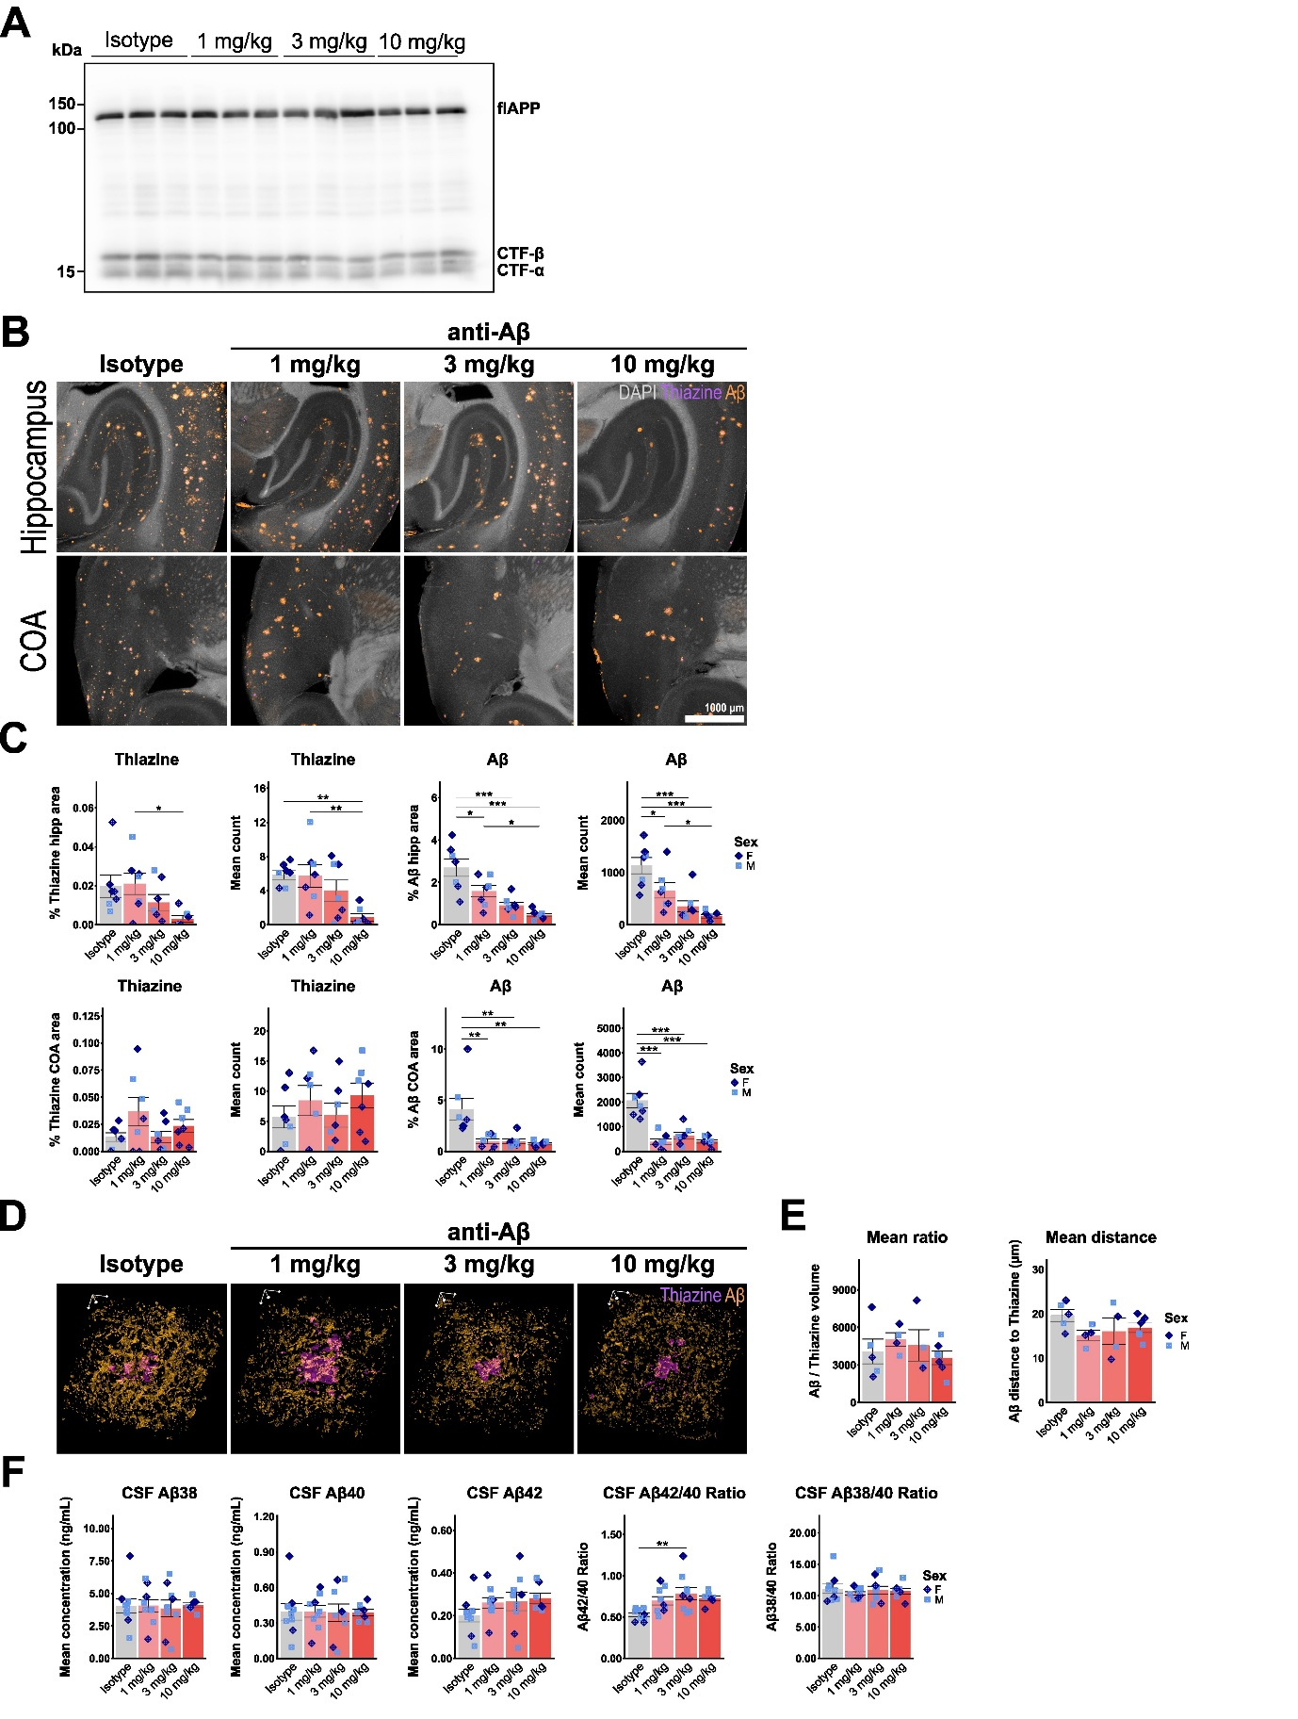

Figure S2: Chronic anti-Aβ treatment reduces amyloid-β levels in a dose-dependent manner
(A) Western blot showing full-length APP, CTF-β, and CTF-α in RIPA brain extract. (B) Representative immunofluorescent images of sagittal hippocampus and cortico-amygdala area (COA) sections showing DAPI (grey), thiazine (purple), and Aβ (3552 antibody, orange). (C) Quantification of percent cortical thiazine and Aβ area and number in the hippocampus and COA. (D) Isotropic 3D rendering of confocal immunofluorescent images showing thiazine (purple) and Aβ (3552 antibody, orange). Scale bar = 10 µm. (E) Quantification of mean Aβ/thiazine ratio and mean distance of Aβ to thiazine border. (F) ELISA quantification of Aβ₃₈, Aβ₄₀ and Aβ₄₂, as well as the Aβ_{42/40} and Aβ_{38/40} ratio in terminally-collected CSF. *: P < 0.05; **: P < 0.01; ***: P < 0.001. One-way ANOVA with Tukey’s post hoc test (C, E, F). For (C): isotype n = 5 f, 3 m, 1 mg/kg n = 5 f, 4 m, 3 mg/kg n = 5 f, 5 m, 10 mg/kg n = 5 f, 4 m (same samples as Fig. 1F, 2F, 5D, F, 6D, F). For (E): isotype n = 3 f, 2m, 1 mg/kg n = 3 f, 2 m, 3 mg/kg n = 3 f, 2 m, 10 mg/kg n = 2 f, 3 m (same samples as Fig. 6A, B). For (F): isotype n = 3 f, 6 m, 1 mg/kg n = 3 f, 6 m, 3 mg/kg n = 3 f, 6 m, 10 mg/kg n = 3 f, 4 m (same samples as Fig. 2A, B, C, Fig. S4A, B, C).

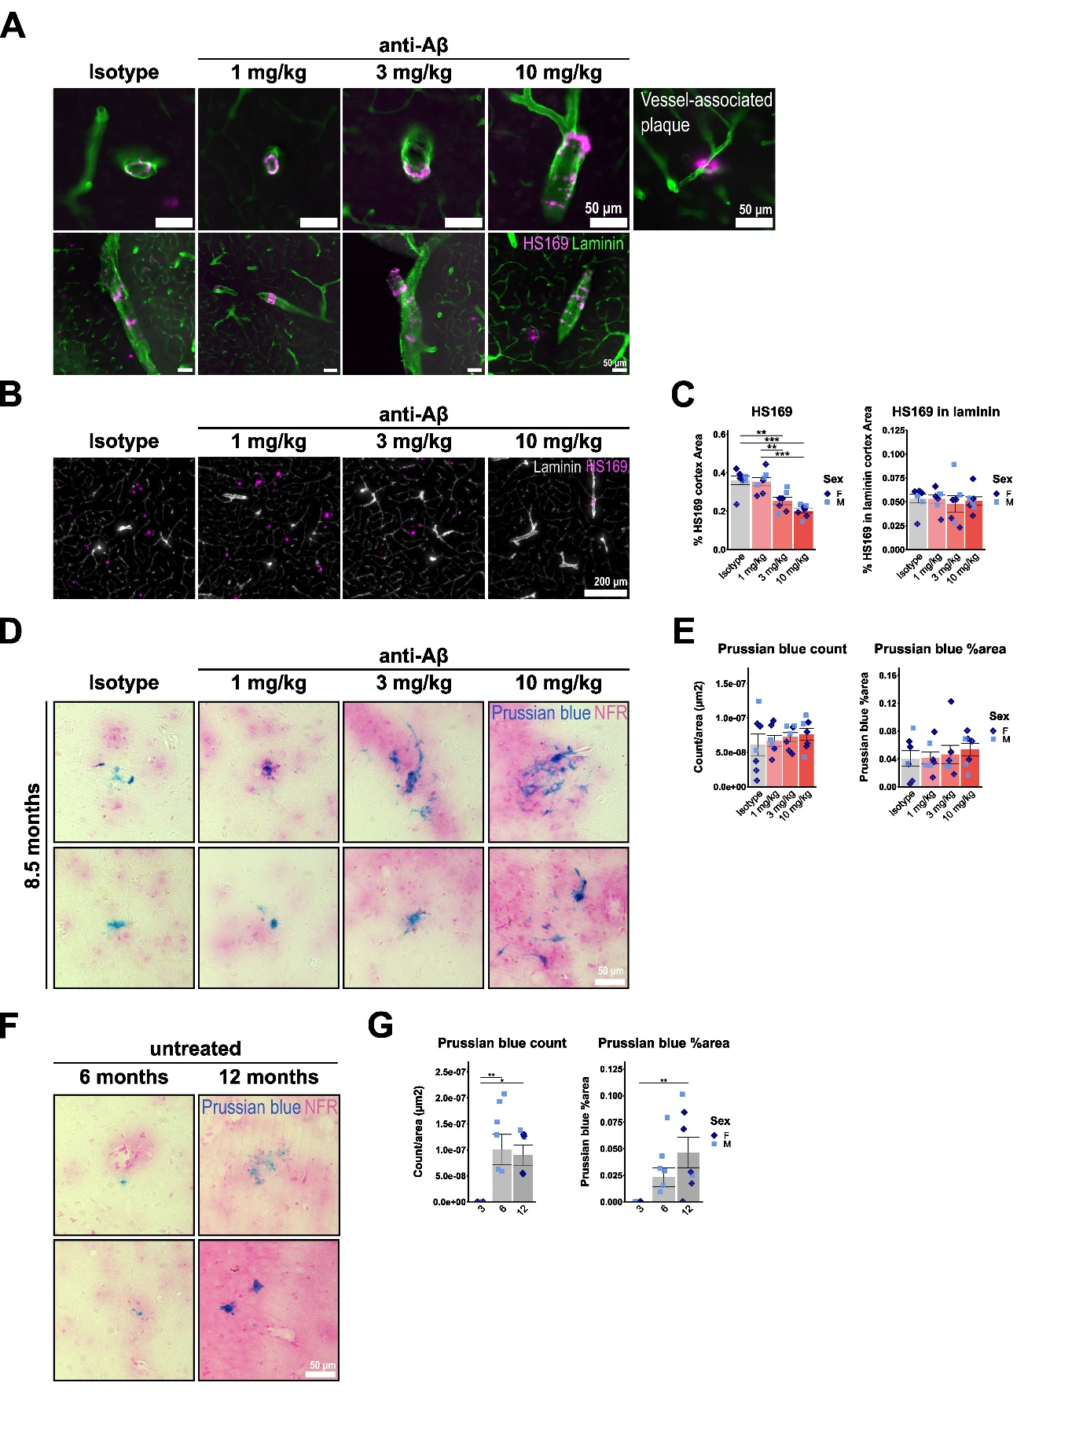

Figure S3: APP-SAA KI mice develop CAA and spontaneous microhaemorrhages, which are not increased by chronic anti-Aβ treatment
(A) Representative immunofluorescence images of CAA as stained with HS169 in APP-SAA KI mice. (B) Representative immunofluorescent images of sagittal cortical sections showing co-staining of Laminin and HS169. (C) Quantification of percent cortical HS169 and HS169 in Laminin area. (D) Representative bright-field images of Prussian blue-positive deposits and microglial cell-shaped foci in anti-Aβ or isotype-treated mice. (E) Quantification of mean Prussian blue foci count and percent area. (F) Representative images of Prussian blue-positive deposits and microglial cell-shaped foci in 6- and 12-month-old APP-SAA KI mice. (G) Quantification of mean Prussian blue foci count and percent area. *: P < 0.05; **: P < 0.01. One-way ANOVA with Tukey’s post hoc test (C, E, G). For (C, E): isotype n = 5 f, 2m, 1 mg/kg n = 4 f, 3 m, 3 mg/kg n = 4 f, 3 m, 10 mg/kg n = 4 f, 3 m. For (G): 3 months n = 4 f, 3 m, 6 months n = 6 m, 12 months n = 5 f, 2 m (same samples as Fig. S1).

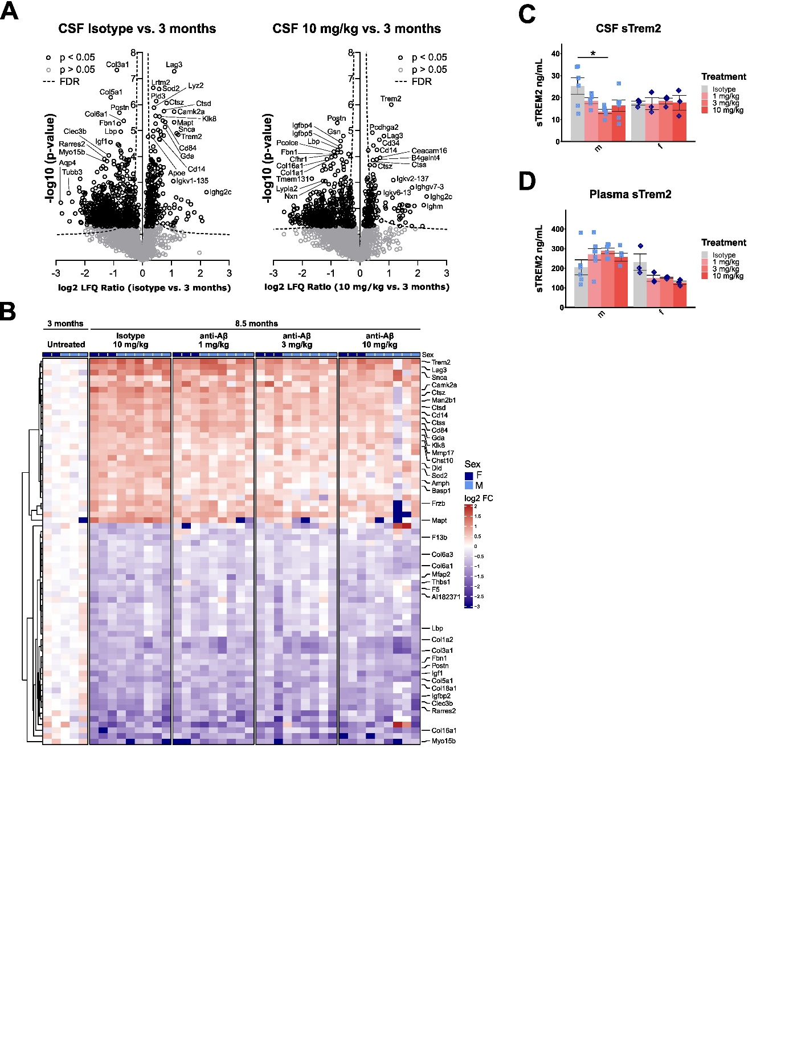

Figure S4: CSF proteome changes relative to pre-disease state
(A) Volcano plots showing upregulated and downregulated proteins in CSF comparing isotype or 10 mg/kg anti-Aβ-treated animals vs. 3-month-old untreated controls. (B) Heatmap showing significantly up- or downregulated proteins in isotype-treated 8.5-month-old mice relative to 3-month-old untreated mice (cut-off p<0.05, log₂FC < -0.5 or >0.5). (C) ELISA quantification of terminally-collected CSF Trem2. (D) ELISA quantification of terminally-collected plasma Trem2. *: P < 0.05. Two-way ANOVA with Tukey’s post hoc test (C, D). For (A, B): untreated n = 2 f, 3 m, isotype n = 3 f, 6 m, 1 mg/kg n = 3 f, 6 m, 3 mg/kg n = 3 f, 6 m, 10 mg/kg n = 3 f, 6 m (same samples as Fig. 2A, B, C, Fig. S2F). For (C, D): isotype n = 3 f, 6 m, 1 mg/kg n = 3 f, 6 m, 3 mg/kg n = 3 f, 6 m, 10 mg/kg n = 3 f, 4 m (same samples as Fig. 2A, B, C, Fig. S2F).

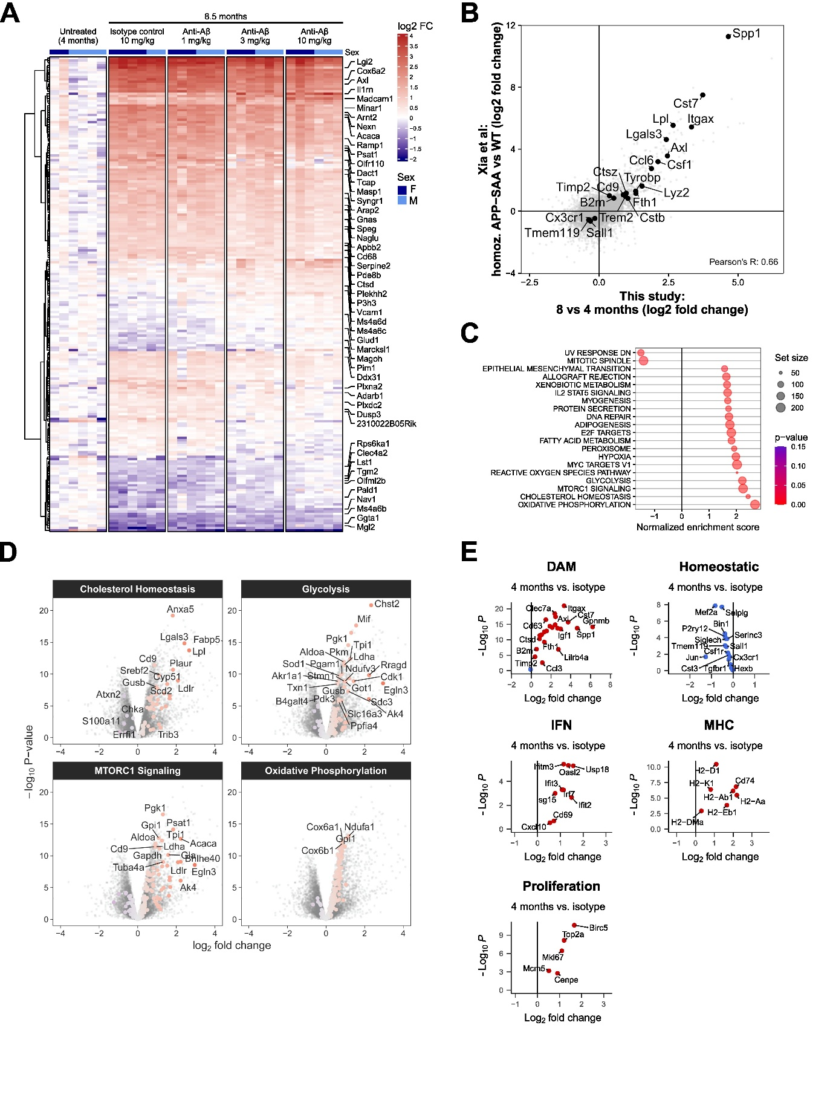

Figure S5: Microglial RNA-seq gene expression changes relative to pre-disease state
(A) Heatmap showing differentially expressed genes relative to 4-month-old untreated mice. (B) Correlation plot of p-values comparing gene expression changes in isolated microglia between WT vs. 8-month-old APP-SAA KI mice from Xia et. al 2022 and changes in this study between 4-month-old untreated vs. 8-month-old isotype-treated APP-SAA KI mice. (C) Gene set enrichment analysis (GSEA). (D) Volcano plots showing differentially expressed genes related to GSEA pathways. (E) Volcano plots showing differentially expressed genes related to microglial states from Chen and Colonna 2021. For (A, B, C, D, E): untreated n = 2 f, 4 m, isotype n = 4 f, 2 m, 1 mg/kg n = 3 f, 3 m, 3 mg/kg n = 3 f, 3 m, 10 mg/kg n = 3 f, 3 m (same samples as Fig. 3A, B, C, D, F, G).

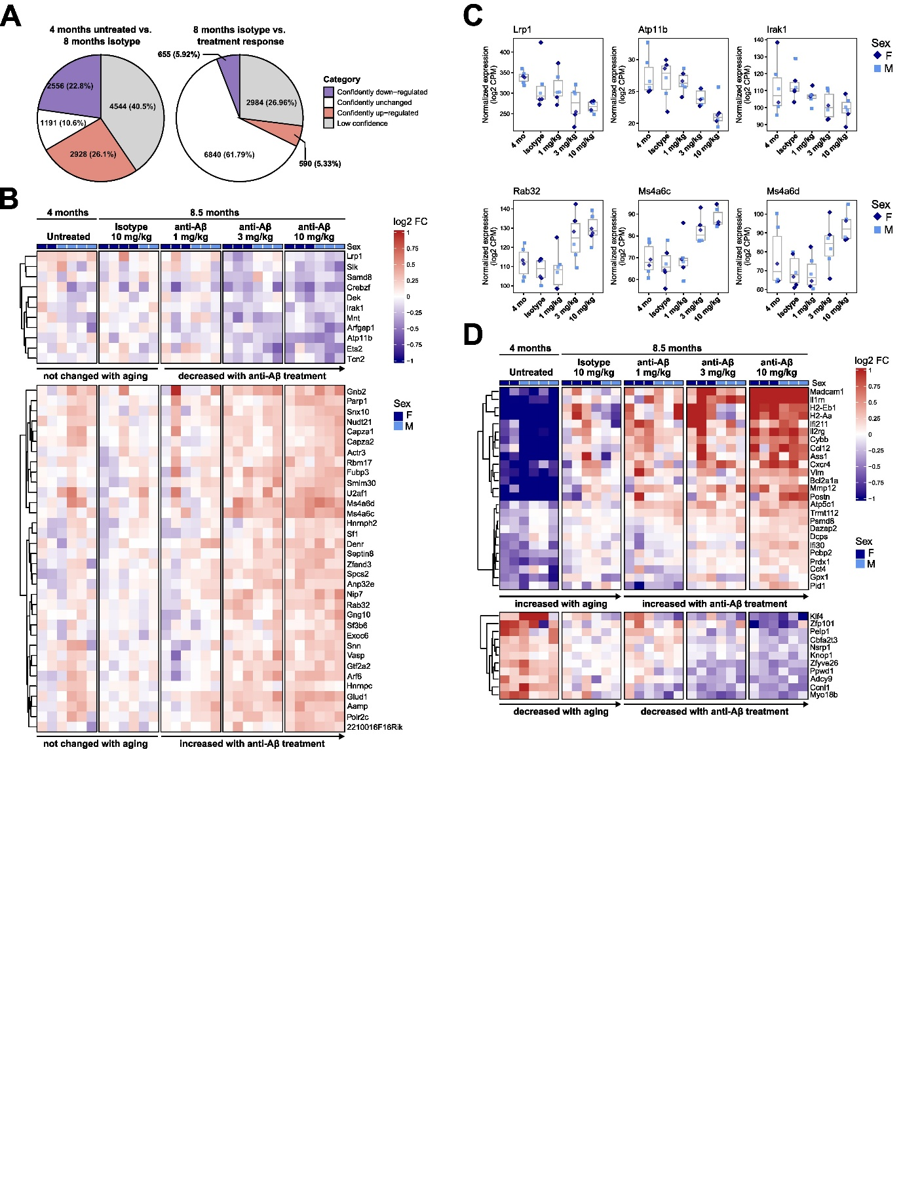

Figure S6: Identification of an anti-Aβ specific transcription signature
(A) Pie charts showing n-number and percentage of genes classified as “Confidently down-regulated” (purple), “Confidently unchanged” (white), “Confidently up-regulated” (pink), “Low confidence” (grey). (B) Heatmap showing 45 genes that are confidently unchanged with aging and confidently changed with anti-Aβ treatment. (C) Boxplots showing examples of genes that increase or decrease expression upon anti-Aβ treatment, but not with age. (D) Heatmap showing 36 genes that increase or decrease expression with age and further increase or decrease expression upon anti-Aβ treatment. Untreated n = 2 f, 4 m, isotype n = 4 f, 2 m, 1 mg/kg n = 3 f, 3 m, 3 mg/kg n = 3 f, 3 m, 10 mg/kg n = 3 f, 3 m.

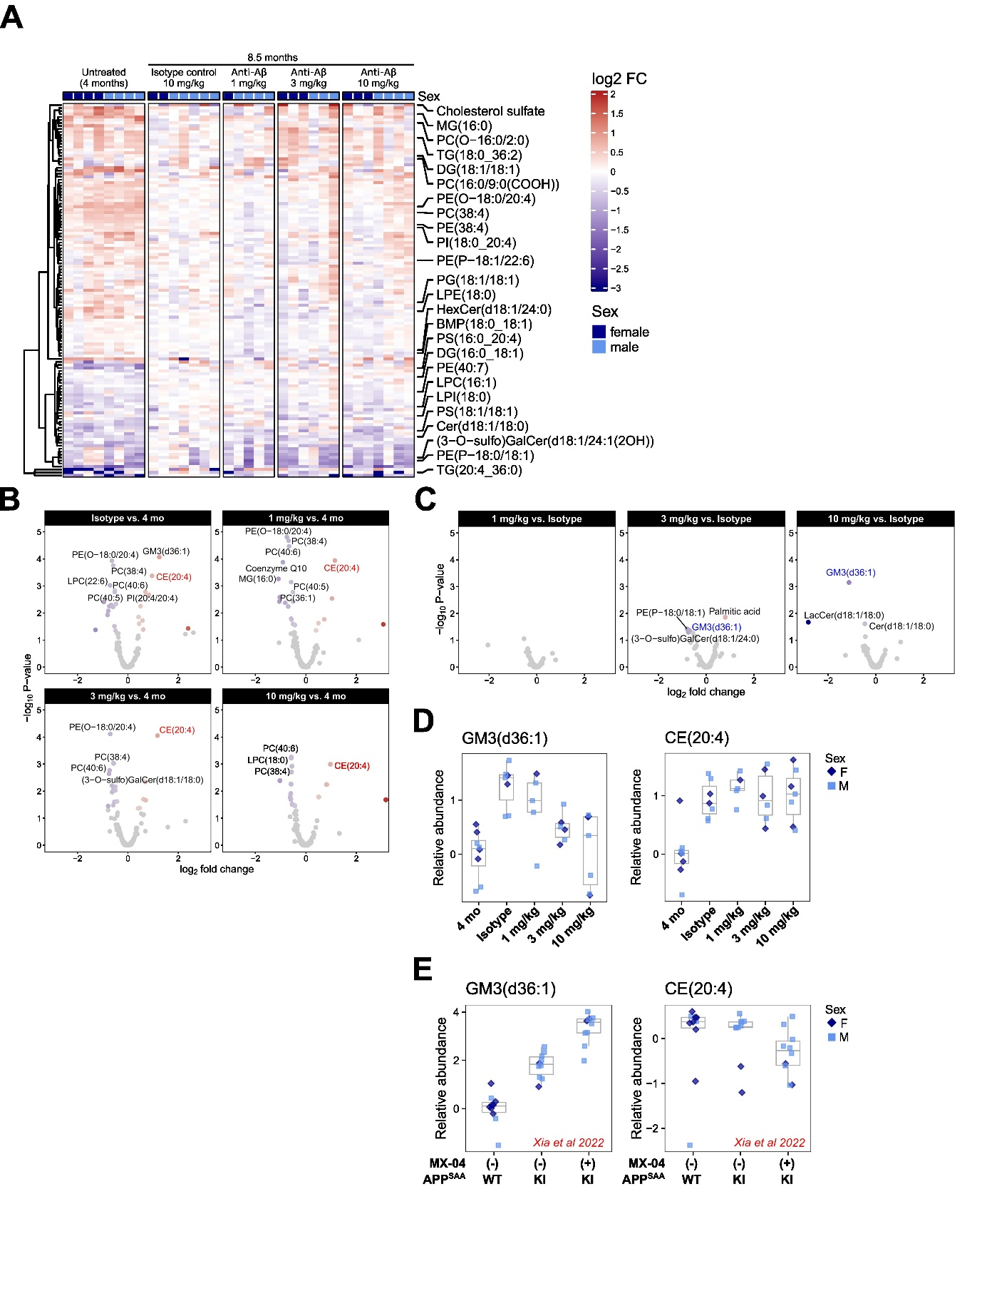

Figure S7: Chronic anti-Aβ treatment does not induce lipid changes in microglia
(A) Heatmap showing differentially regulated lipids relative to isotype control-treated mice. (B) Volcano plots showing lipid changes in isolated microglia comparing 8-month-old treated mice vs. 4-month-old APP-SAA KI mice (C) Volcano plots showing lipid changes in isolated microglia comparing 8-month-old treated mice vs. isotype-treated APP-SAA KI mice (D) Boxplots showing relative abundance of selected lipids (GM3 and CE). (E) Boxplots showing relative abundance of GM3 and CE from the dataset of Xia et al. 2022, who analysed sorted microglia from 8-month-old WT and APP-SAA mice sorted by MX-04⁻ or MX-04⁺. For (A, B, C, D): untreated n = 4 f, 4 m, isotype n = 2 f, 5 m, 1 mg/kg n = 1 f, 4 m, 3 mg/kg n = 3 f, 3 m, 10 mg/kg n = 3 f, 4 m. For (E): WT, MX-04⁻ n = 7 f, 3 m, HOM, MX-04⁻ n = 8 f, 2 m, HOM, MX-04⁺ n = 8 f, 2 m.

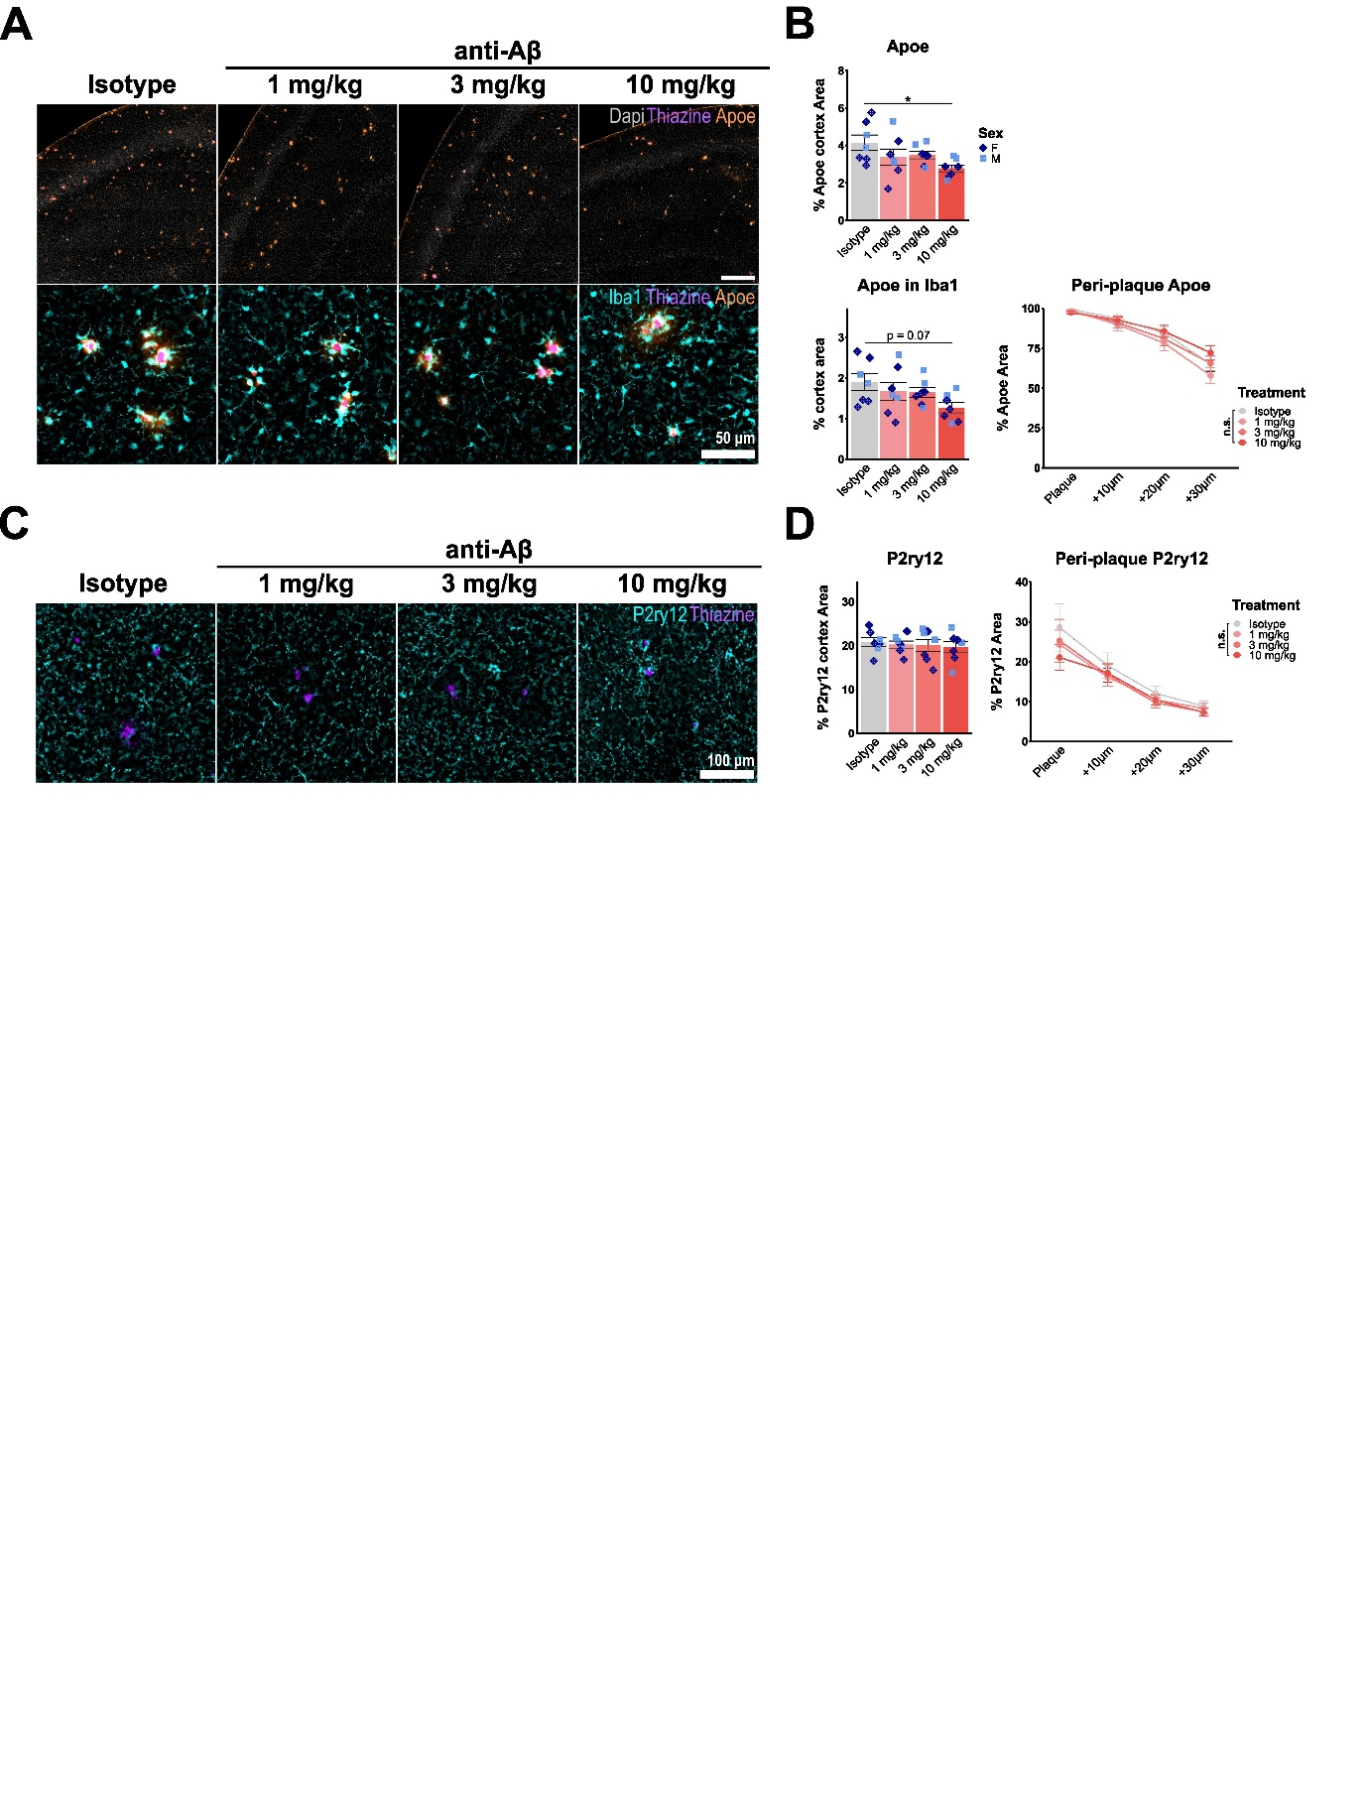

Figure S8: Chronic anti-Aβ treatment decreases microglial DAM activation
(A) Representative epifluorescence images of DAPI (grey), Iba1 (cyan), thiazine (purple), and ApoE (orange). (B) Quantification of percent cortical ApoE and ApoE in Iba1, as well as concentric plaque analysis of ApoE in Iba1. (C) Representative epifluorescence images of P2ry12 (cyan) and thiazine (purple) (D) Quantification of percent cortical P2ry12, as well as concentric plaque analysis of P2ry12. *: P < 0.05, **: P < 0.01, ***: P < 0.001. One-way ANOVA with Tukey’s post hoc test (B, D). For (B, D): isotype n = 5 f, 2 m, 1 mg/kg n = 4 f, 3 m, 3 mg/kg n = 4 f, 3 m, 10 mg/kg n = 4 f, 2 m.

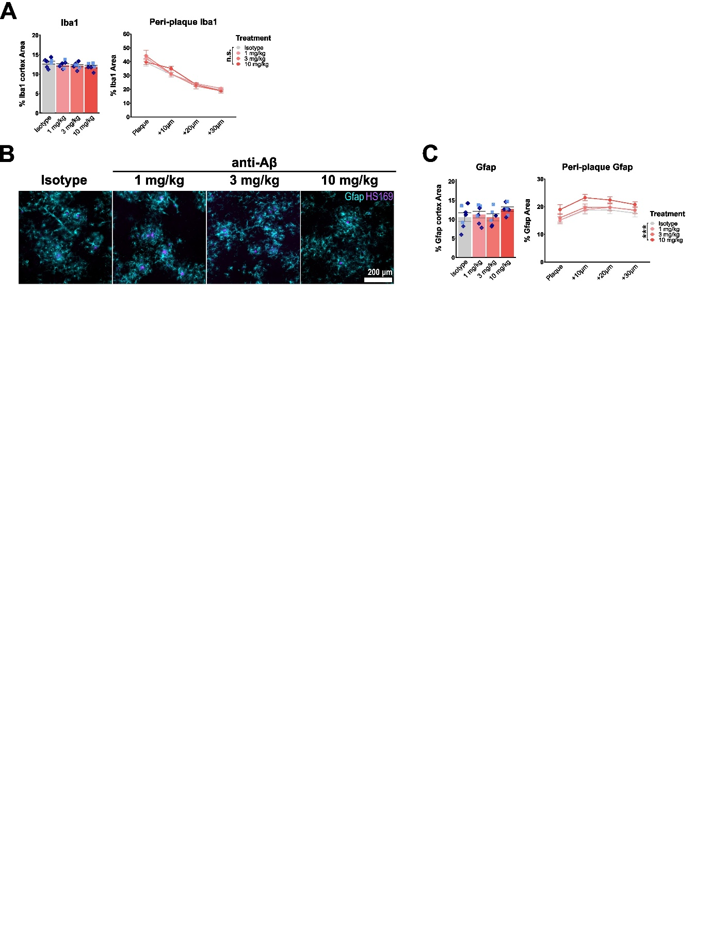

Figure S9: Chronic anti-Aβ treatment does not affect microgliosis and astrogliosis, but increases Gfap around residual plaques
(A) Quantification of percent cortical Iba1 and concentric-plaque analysis of Iba1. (B) Representative epifluorescence images of Gfap (cyan) and thiazine (purple). (C) Quantification of percent cortical Gfap, as well as concentric plaque analysis of Gfap. ***: P < 0.001. One-way ANOVA with Tukey’s post hoc test (A, C). For (A, C): isotype n = 5 f, 2 m, 1 mg/kg n = 4 f, 3 m, 3 mg/kg n = 4 f, 3 m, 10 mg/kg n = 4 f, 3 m.

