Supplementary Figures and Figure Legends:
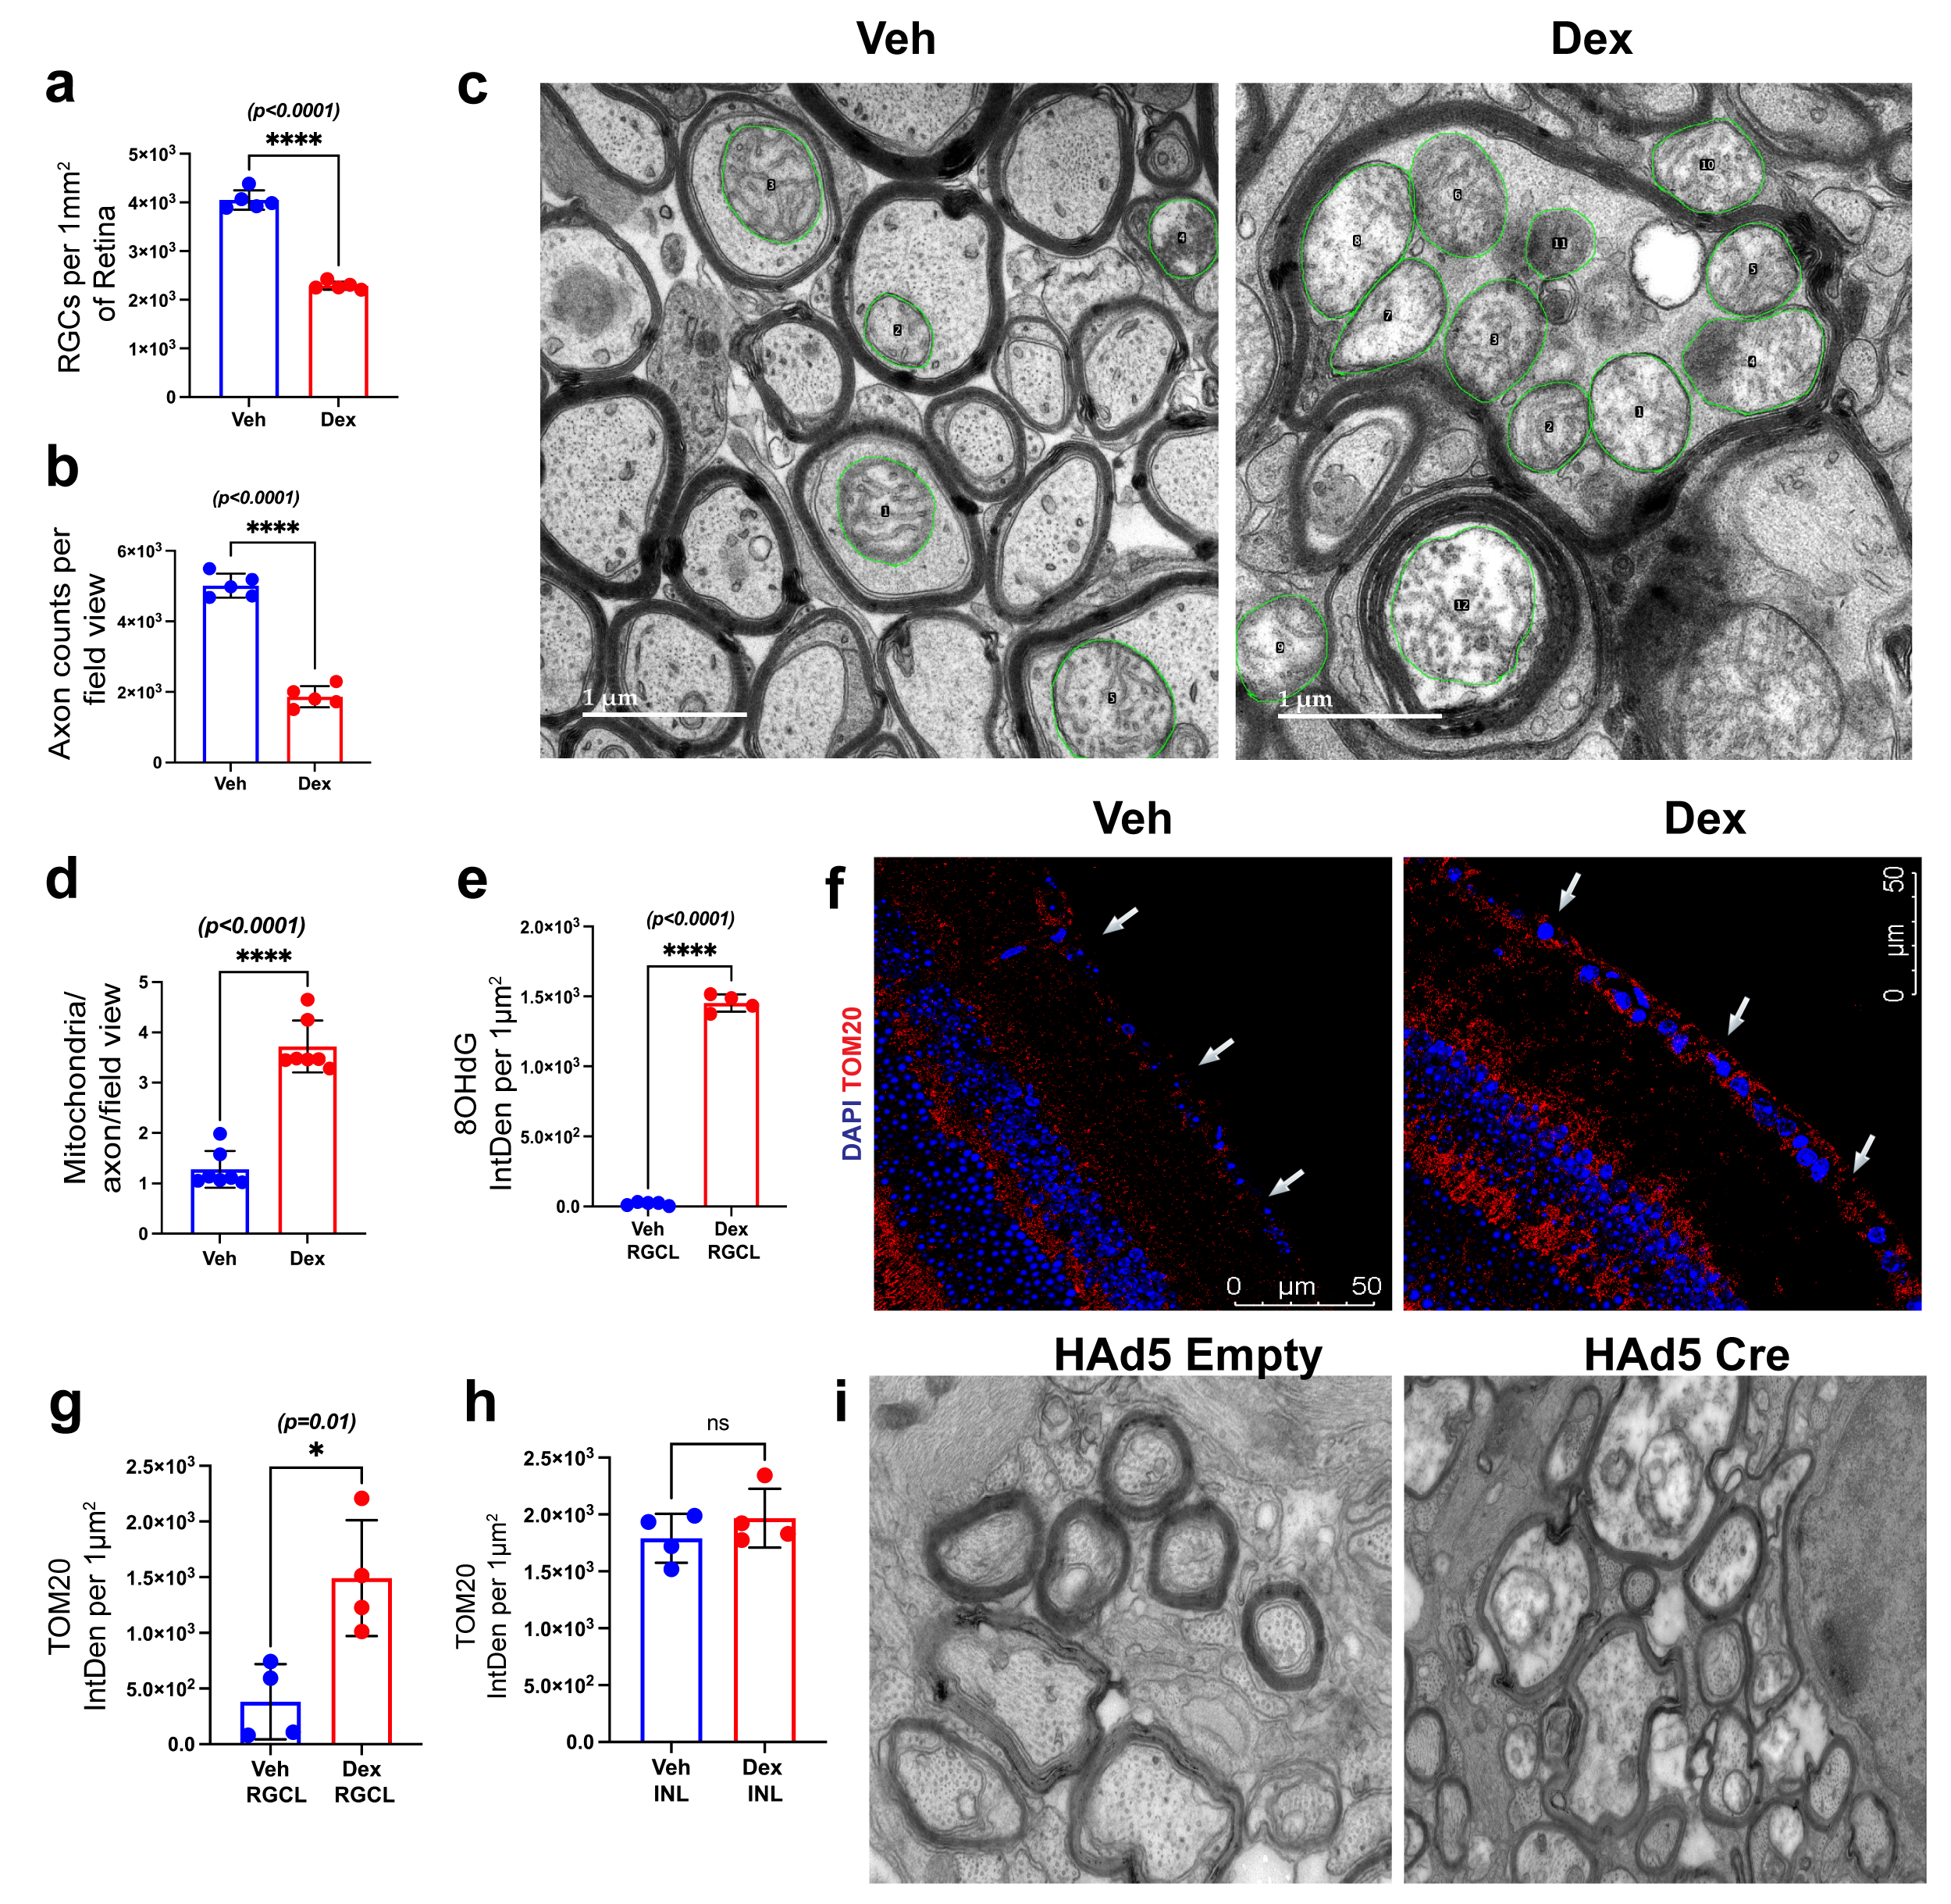
Supplementary Figure 1: OHT leads to accumulation of dysfunctional mitochondria.
a & b) Mice injected with Dex for 10 weeks show a significant reduction in the number of RBPMS-positive RGCs and healthy axons compared with Veh-injected mice, respectively (n = 5 per group). c) Representative TEM images showing mitochondria within ON axons from 10-week Veh- and Dex-injected eyes. Mitochondria (green circles) were traced using ImageJ for quantitative analysis of mitochondrial number, area, and circumference. d) Quantification of the total number of mitochondria per axon from 10-week Veh- and Dex-injected eyes (n = 7). e) Quantitative analysis of 8-OHdG staining. f -h) TOM20 expression and its quantitative analysis in the RGCL and INL of Dex-induced OHT eyes compared with Veh-injected eyes, respectively (n = 4). i) Representative TEM images of ON cross sections from Tg.Cre-MYOC^{Y437H} mice injected with HAd5-Cre or HAd5-empty vectors (n = 4 per group).

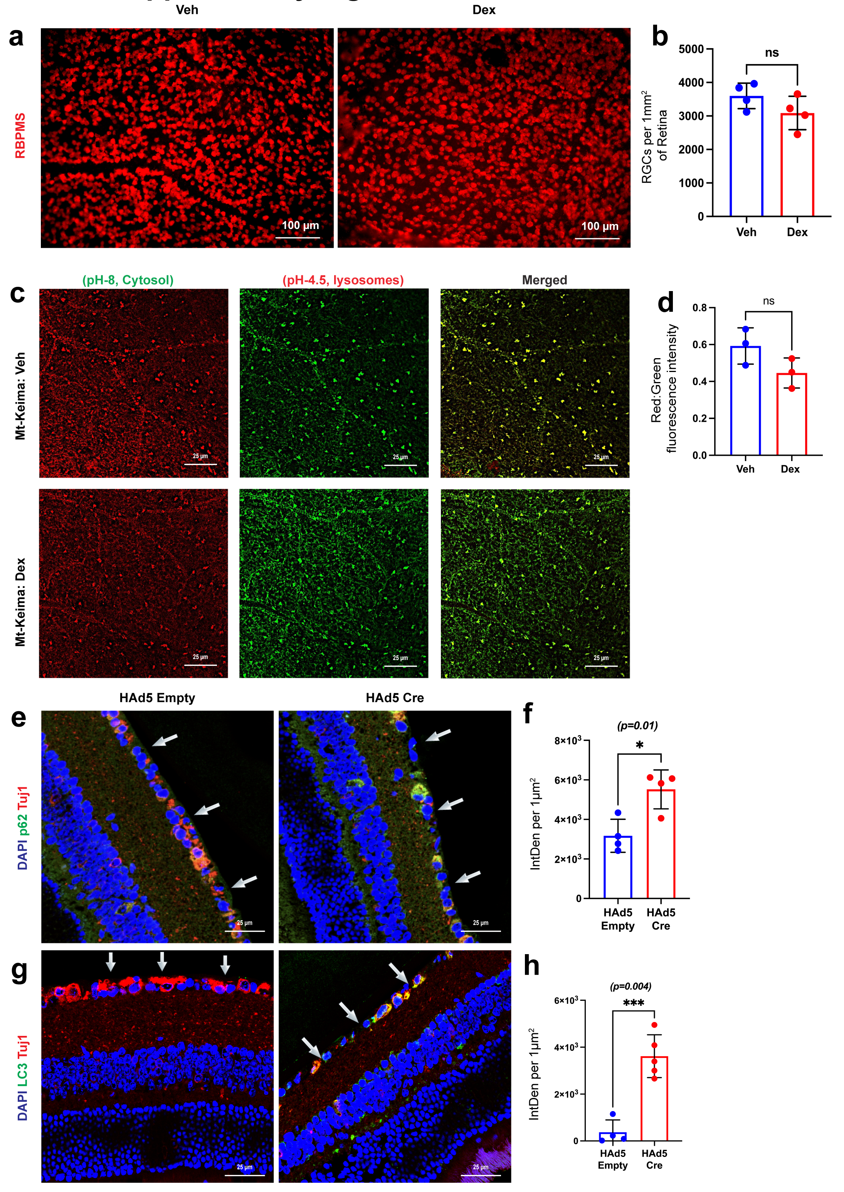
Supplementary Figure 2: OHT leads to impaired autophagy. a) Representative whole-mount retinal images stained with RBPMS and b) the corresponding dot plots showed no significant RGC loss between the 5-week Veh- and Dex-injected mice (n = 4 in each group). c & d) Mitophagy flux was assessed in flat-mounted retinas from Mt-Keima reporter mice injected with Veh or Dex for 5 weeks. A non-significant reduction in mitophagy flux was observed in Dex-injected OHT eyes compared to contralateral Veh-injected eyes (n = 3 in each group). Immunostaining and quantitative analyses showed increased expression of e & f) p62 and g & h) LC3B in the RGCL of HAd5-Cre-injected Tg.Cre-MYOC^{Y437H} mice compared to HAd5-empty-injected Tg.Cre-MYOC^{Y437H} littermates (n = 4-5 in each group; arrows indicate RGCL).

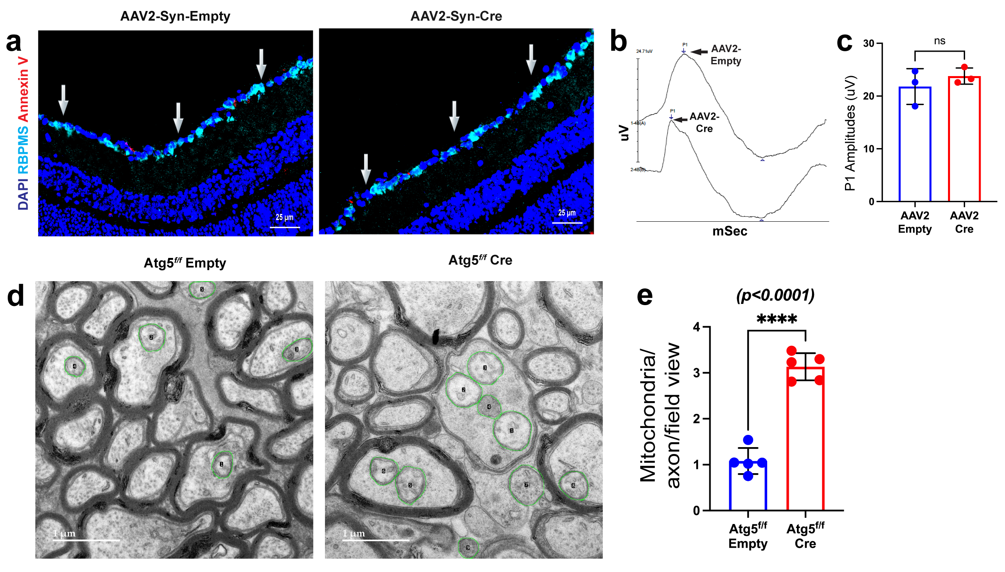
Supplementary Figure 3: Impaired autophagy leads to damaged mitochondrial accumulation. C57BL/6J wild-type mice were intravitreally injected with AAV2-Syn-empty in one eye and AAV2-Syn-Cre in the contralateral eye. Representative a) retinal cross-sections immunostained with Annexin V and b & c) PERG amplitudes showed no significant difference between the eyes. d) TEM images showing mitochondria within optic nerve (ON) axons from Atg5^{flox/flox} mice injected with AAV2-empty or AAV2-Syn-Cre. Mitochondria (green circles) were traced using ImageJ software for quantitative analysis of their number, area, and circumference. e) Quantification of the total number of mitochondria per axon from Atg5^{flox/flox} mice injected with AAV2-empty or AAV2-Syn-Cre (n = 5).

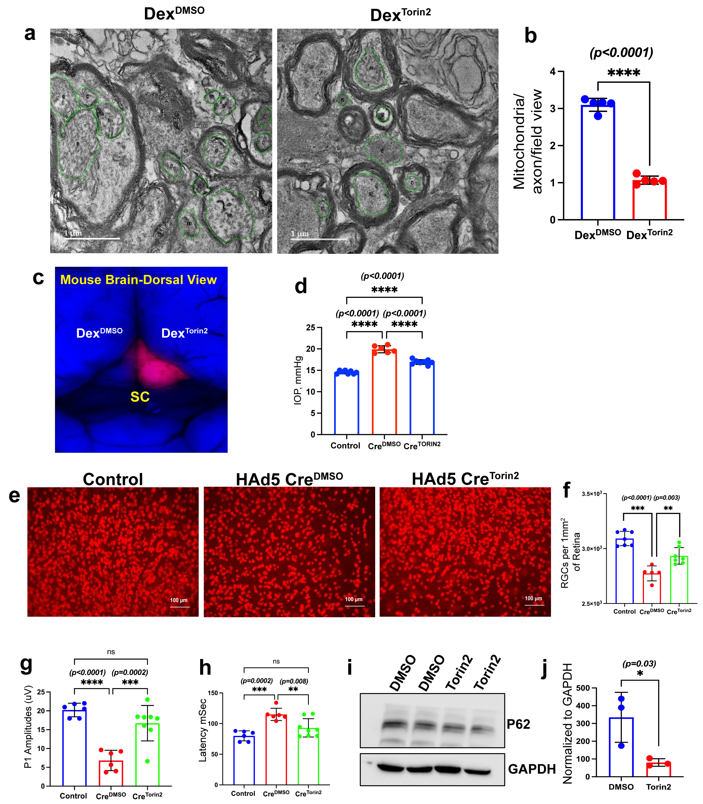
Supplementary Figure 4: Torin 2 treatment prevents glaucomatous neurodegeneration in mouse models of glaucoma. a) Representative TEM images showing mitochondria within ON axons from 10-week Dex-injected OHT eyes treated with DMSO or Torin 2. Mitochondria (green circles) were traced using ImageJ software for quantitative analysis of their number, area, and circumference. b) Quantification of the total number of mitochondria per axon in 10-week Dex-injected OHT eyes treated with DMSO or Torin 2 (n = 5). c) Anterograde transport of CTB to the superior colliculus in the mouse brain in 10-week Dex-injected OHT eyes treated with DMSO or Torin 2 (n = 3). d-h) In the Tg.Cre-MYOC^{Y437H} glaucoma model, Torin 2 treatment (d) reduced IOP, (e & f) prevented RGC loss, and (g & h) improved pERG amplitudes (n = 7-8 per group). I & j) Ex vivo retinal explants treated with Torin 2 for 12 hrs showed reduced p62 expression compared with controls (n = 3).

