LIST OF SUPPLEMENTARY MATERIALS
Figures S1–S6 description and figures included below
Table S1: List of marker genes, DEGs, and upstream pathway analyses for xenotransplanted human microglia. Related to Figure 3.
Table S2: List of marker genes and DEGs for hippocampal mouse astrocytes and oligodendrocytes. Related to Figure 4.
Table S3: List of marker genes and DEGs for thalamic mouse astrocytes and oligodendrocytes. Related to Figure 4.
Table S4: List of marker genes and DEGs for thalamic mouse excitatory neurons and inhibitory neurons. Related to Figure 5.
Table S5: Human control and FTD patient information and lists of marker genes and DEGs for human patient excitatory neurons and inhibitory neurons. Related to Figure 5.

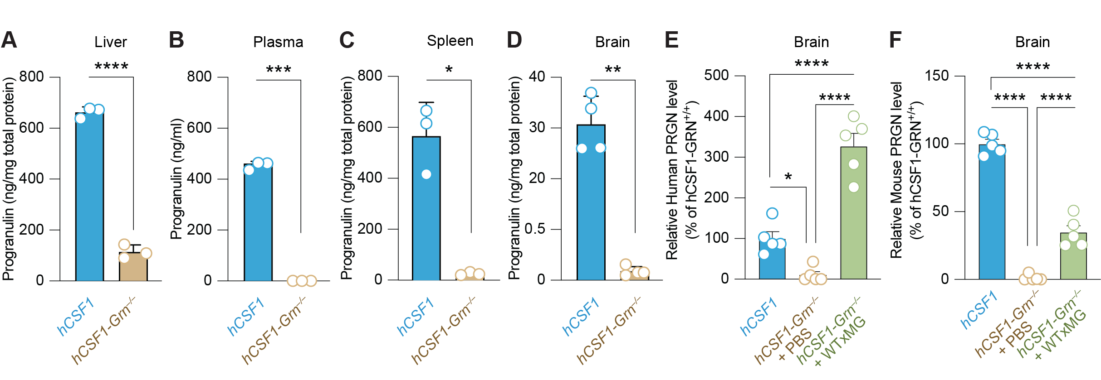

Figure S1. Progranulin protein levels within peripheral organs and the brain. Levels of murine progranulin within the liver (t=27.60, ****p < 0.0001) (A), plasma (t=96.25, ***p =0.0004) (B), and spleen (t=7.07, *p = 0.0192) (C) of hCSF1-WT and hCSF1-Grn–/– littermates were measured by ELISA. N = 3 mice/group, unpaired two-tailed t-test. (D) Progranulin levels measured within the brain (t=10.31, **p = 0.0015). N = 4–5 mice/group, respectively, unpaired two-tailed t-test. (E) Progranulin levels measured within the brain using a human-targeted ELISA, n = 5 samples/group, one-way ANOVA with Tukey’s multiple comparisons test (F_{2,12}=1.803, ****p < 0.0001, *p=0.0287). (F) Progranulin levels measured within the brain using a mouse-targeted ELISA, n = 5 samples/group, one-way ANOVA with Tukey’s multiple comparisons test (F2,12=2.80, ****p <0.0001).

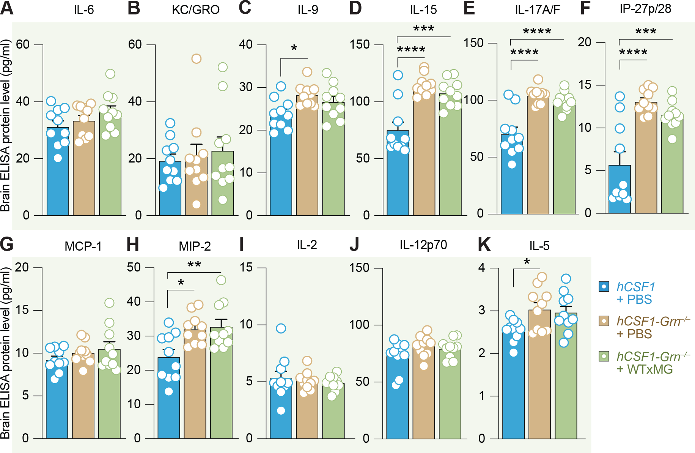

Figure S2. Mouse cytokine levels in the brain. A multiplex ELISA was used to concurrently examine protein levels of several murine cytokines and chemokines within the brains of hCSF1-PBS, hCSF1-Grn–/– +PBS, and hCSF1-Grn–/– +xMG engrafted mice. For each analyte, N = 10 mice/group were compared by one-way ANOVA with Tukey’s multiple comparisons test. No significant (ns) differences in IL-6 (A) or KC/GRO (B) were detected. (C) IL-9 levels (F_{2,27}= 4.411, *p = 0.02). (D) IL-15 levels (F_{2,27} = 18.69, ***p = 0.0002 and ****p < 0.0001). (E) IL-17A/F levels (F_{2,27} = 20.64, ****p < 0.0001). (F) IP-27p/28 levels (F_{2,27} = 16.73, ***p = 0.0006 and ****p < 0.0001). (G) MCP-1 levels, ns = nonsignificant. (H) MIP-2 levels (F_{2,27} = 6.54, *p = 0.0156 and **p = 0.0083). (I) IL-2 levels, ns = nonsignificant. (J) IL-12p70 levels, ns = nonsignificant. (K) IL-5 levels (F_{2,27} = 4.009, *p = 0.0367).

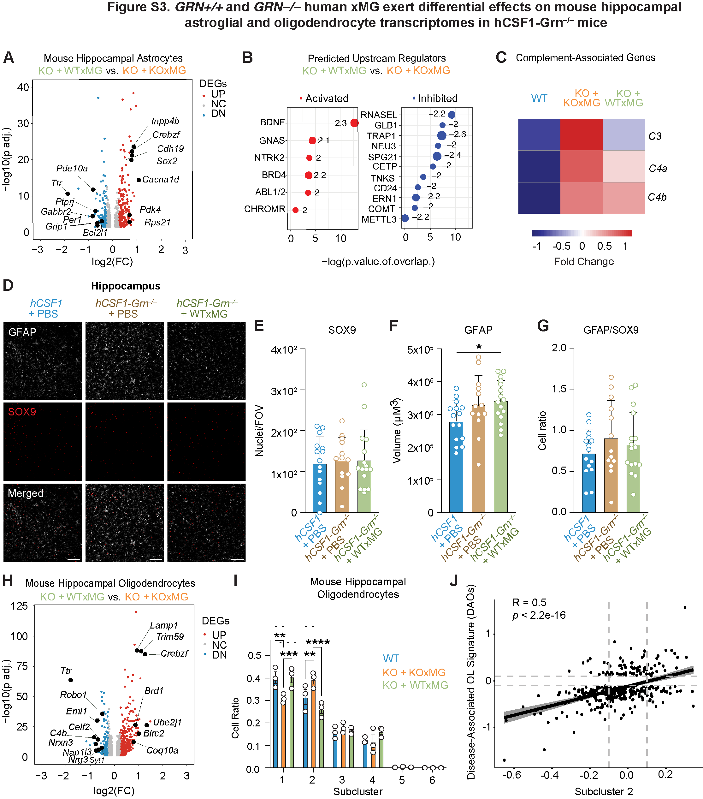

Figure S3. Xenografted human KOxMG or WTxMG exert differential effects on mouse hippocampal astrocyte and oligodendrocyte transcriptomes.

(A) Volcano plot of pseudobulk differentially expressed genes (DEGs) in hippocampal astrocytes between WTxMG and KOxMG groups shows significant upregulation and downregulation of multiple genes in the KOxMG group.

(B) Top predicted upstream regulators identified using Ingenuity Pathway Analysis (IPA).

(C) Heatmap of complement related genes.

(D) Representative confocal microscopy of xenografted GFAP-positive (white), SOX9 (red) in all experimental groups; scale bar: 100 µm.

(E) Quantification of SOX9 (nuclei/FOV) in the hippocampus of wild-type and transplanted mice showing no significant differences between any groups; p values from one-way ANOVA (Hippocampus: F_{2,41} = 0.07708; p=0.9259) with Tukey’s multiple comparisons tests. Data represented as mean value ± SEM (non-injected hCSF1 littermates, n=15; hCSF1-Grn^{-/-} + PBS, n=14; hCSF1-Grn^{-/-} + xMG, n=16) (Female, n=8 per group; male, n=6-8 per group).

(F) Quantification of GFAP (volume) in the hippocampus of wild-type and transplanted mice; p values from one-way ANOVA (Hippocampus: F_{2,41} = 3.269; *p=0.0482) with Tukey’s multiple comparisons tests. Data represented as mean value ± SEM (non-injected hCSF1 littermates, n=15; hCSF1-Grn^{-/-} + PBS, n=14; hCSF1-Grn^{-/-} + xMG, n=16) (Female, n=8 per group; male, n=6-8 per group).

(G) Quantification of GFAP/SOX9 cell ratio in the hippocampus of wild-type and transplanted mice; p values from one-way ANOVA (Hippocampus: F_{2,41} = 0.8583; p=0.4314) with Tukey’s multiple comparisons tests. Data represented as mean value ± SEM (non-injected hCSF1 littermates, n=15; hCSF1-Grn^{-/-} + PBS, n=14; hCSF1-Grn^{-/-} + xMG, n=16) (Female, n=8 per group; male, n=6-8 per group).

(H) Volcano plot of pseudobulk DEGs in hippocampal oligodendrocytes between WTxMG and KOxMG groups highlights significant transcriptional differences in the KOxMG group.

(I) Quantification of average cell ratios in each subcluster by group in hippocampal oligodendrocytes.

(J) Correlation between Subcluster 2 and Disease Associated Oligodendrocyte genes, R=0.5, p<2.2 e-16.

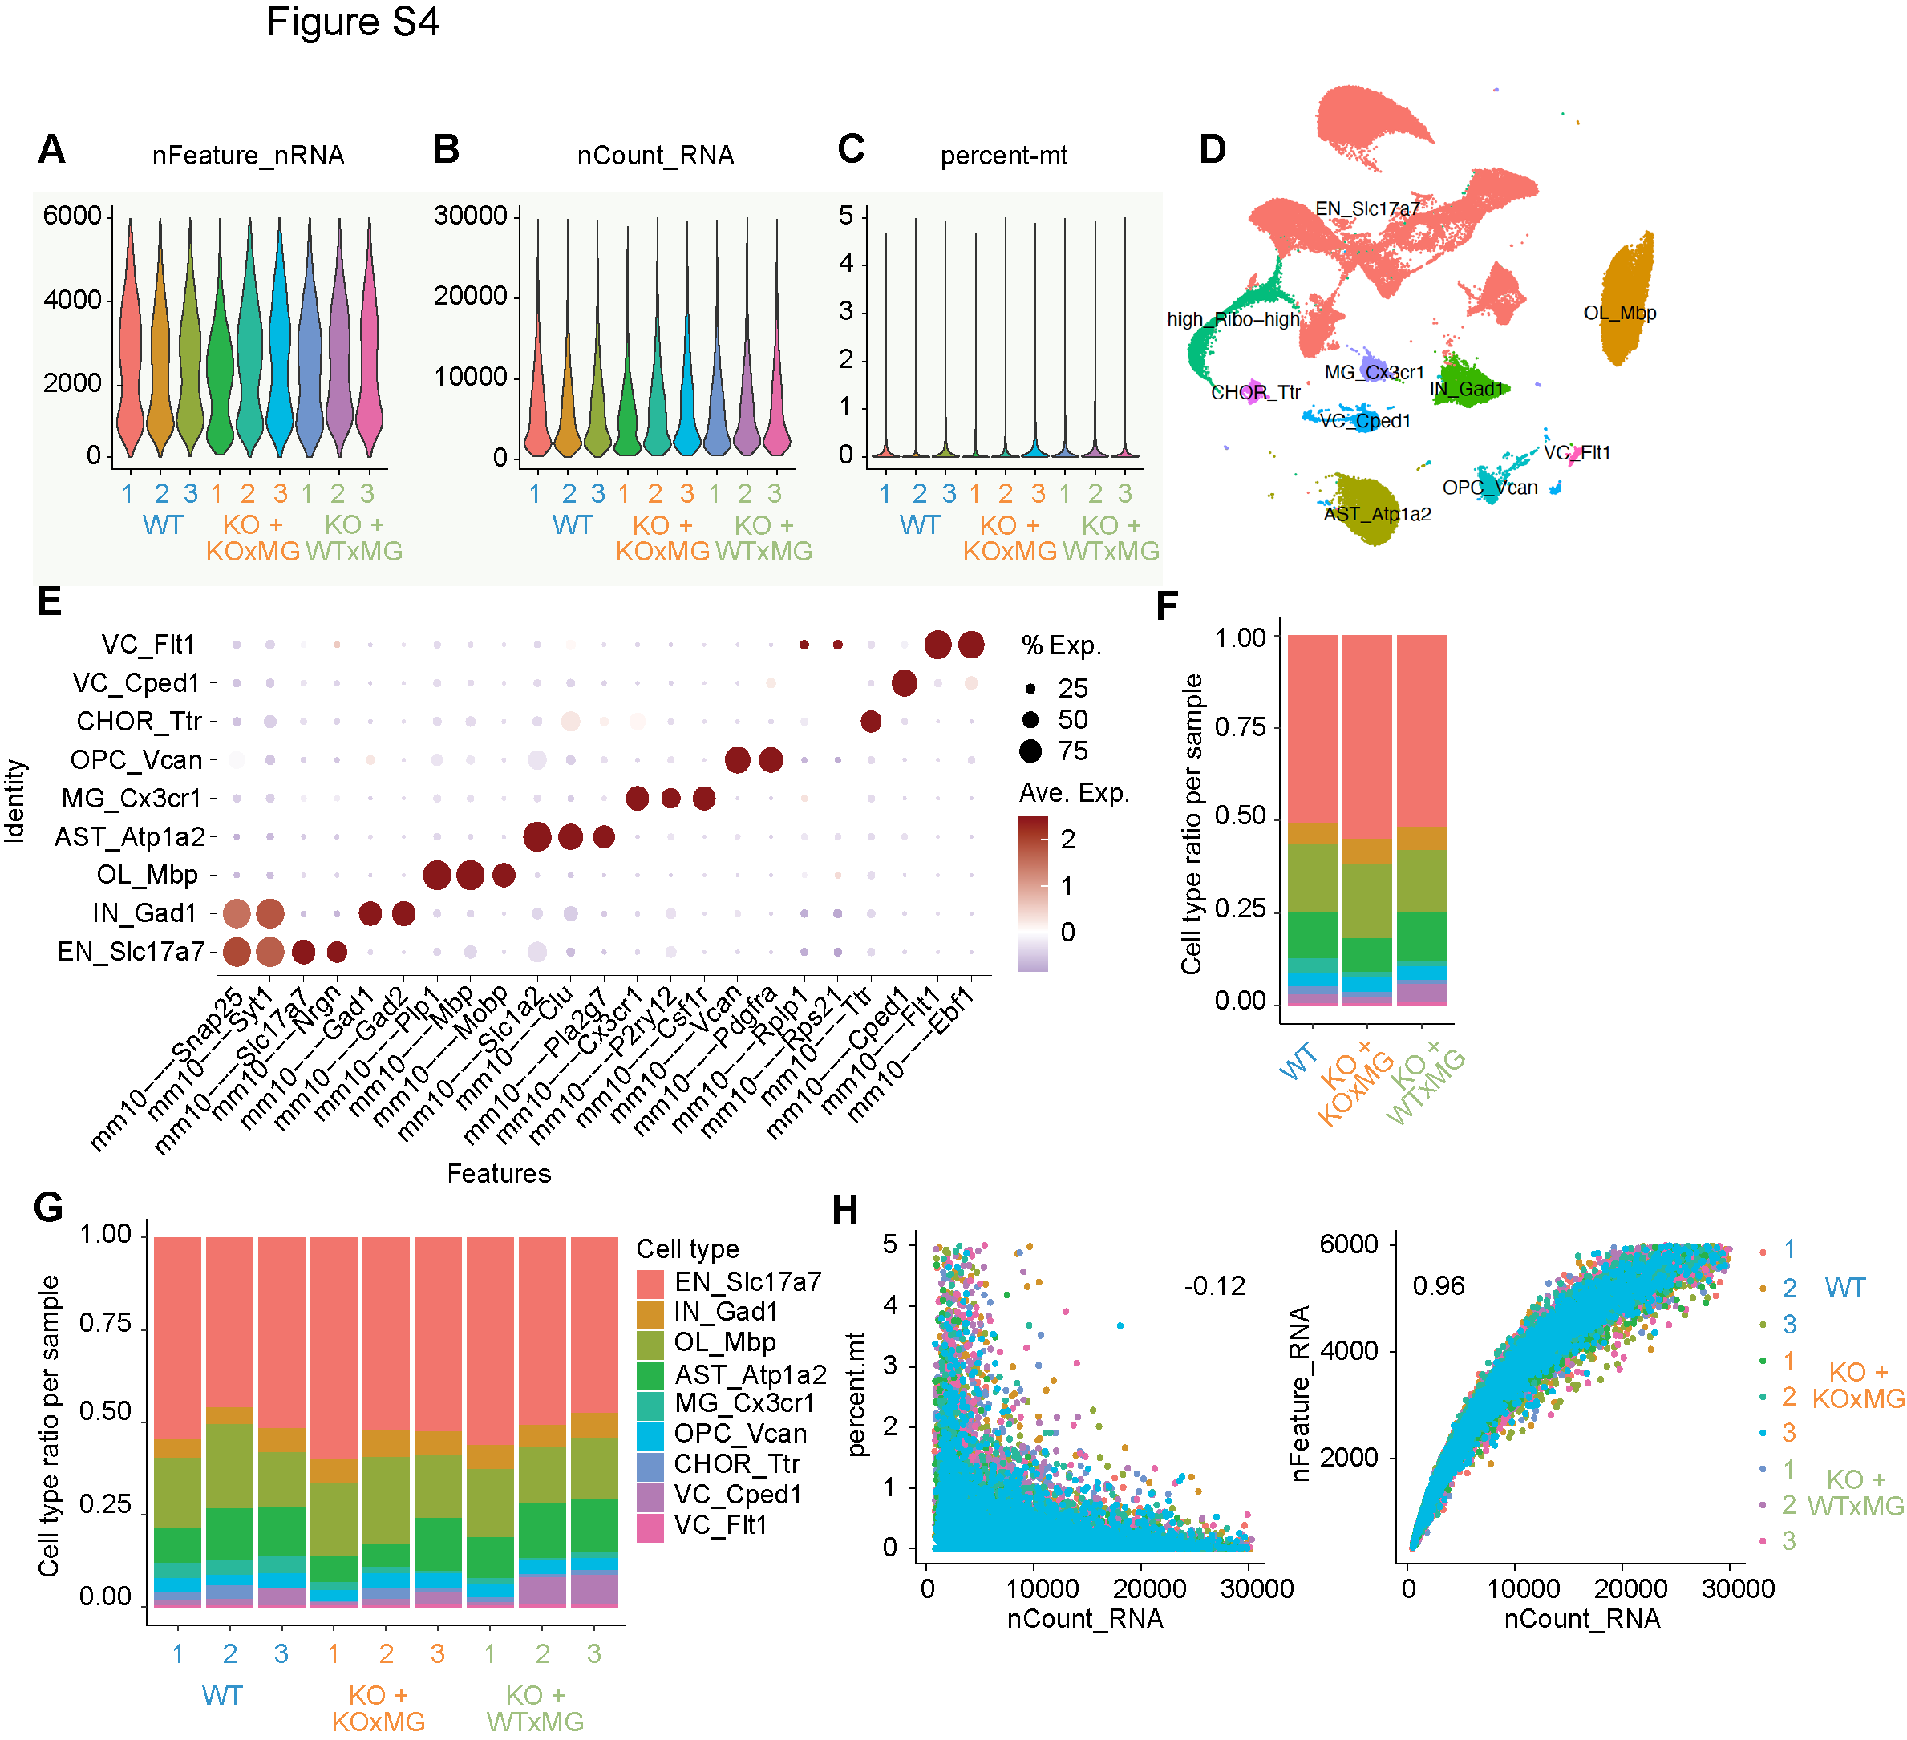
Figure S4. QC of sn-RNAseq analysis of hippocampus engrafted with GRN–/– or GRN^{+/+}
human microglia.
(A), (B) Quality-control plots showing equivalent amounts of total RNA features and total number of RNA counts, respectively.
(C) Violin plot showing percentage of mitochondrial genes detected per nucleus for each individual sample. (D) UMAP showing labeling of all cell types in the hippocampus.
(E) Dot plot showing expression of identity markers for each cell type.
(F) Proportion of each cell type within each genotype.
(G) Proportion of each cell type within individual samples. (H) Correlation between UMI counts and percentage of mitochondrial genes detected (left) or total gene counts (right) per nucleus for each individual sample.

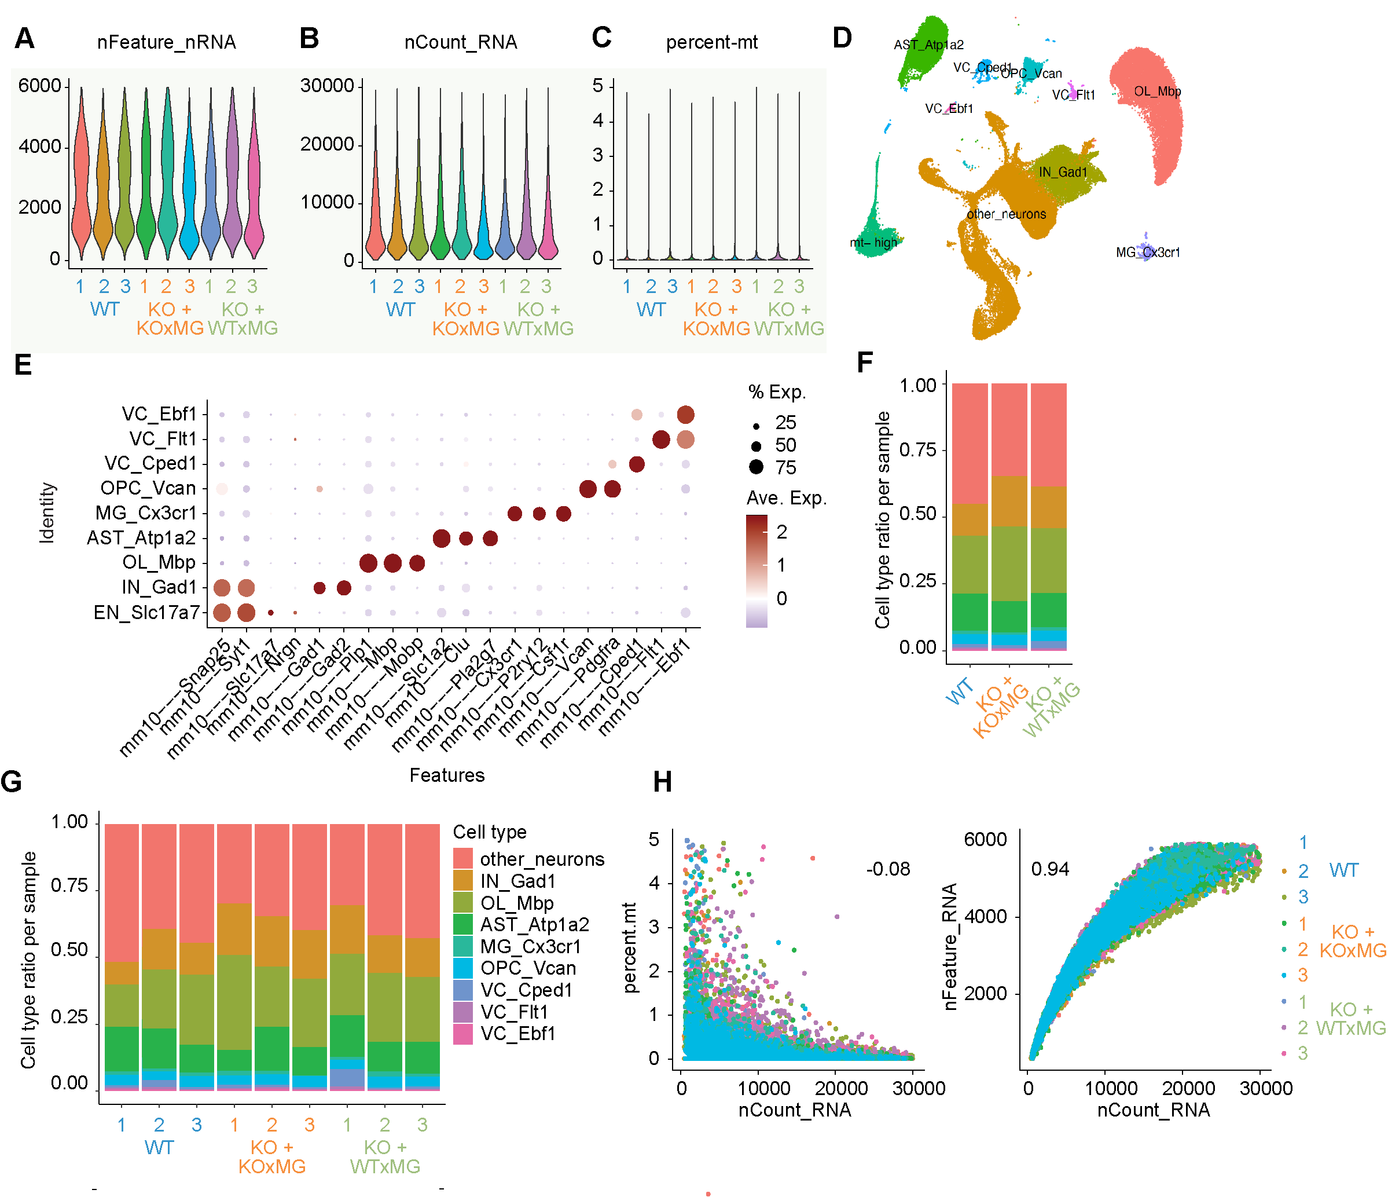
Figure S5. QC of sn-RNAseq analysis of thalamus engrafted with GRN–/– or GRN^{+/+}
human microglia.
(A), (B) Quality-control plots showing equivalent amounts of total RNA features and total number of RNA counts, respectively.
(C) Violin plot showing percentage of mitochondrial genes detected per nucleus for each individual sample. (D) UMAP showing labeling of all cell types in the thalamus.
(E) Dot plot showing expression of identity markers for each cell type.
(F) Proportion of each cell type within each genotype.
(G) Proportion of each cell type within individual samples.
(H) Correlation between UMI counts and percentage of mitochondrial genes detected (left) or total gene counts (right) per nuclei for each individual sample.

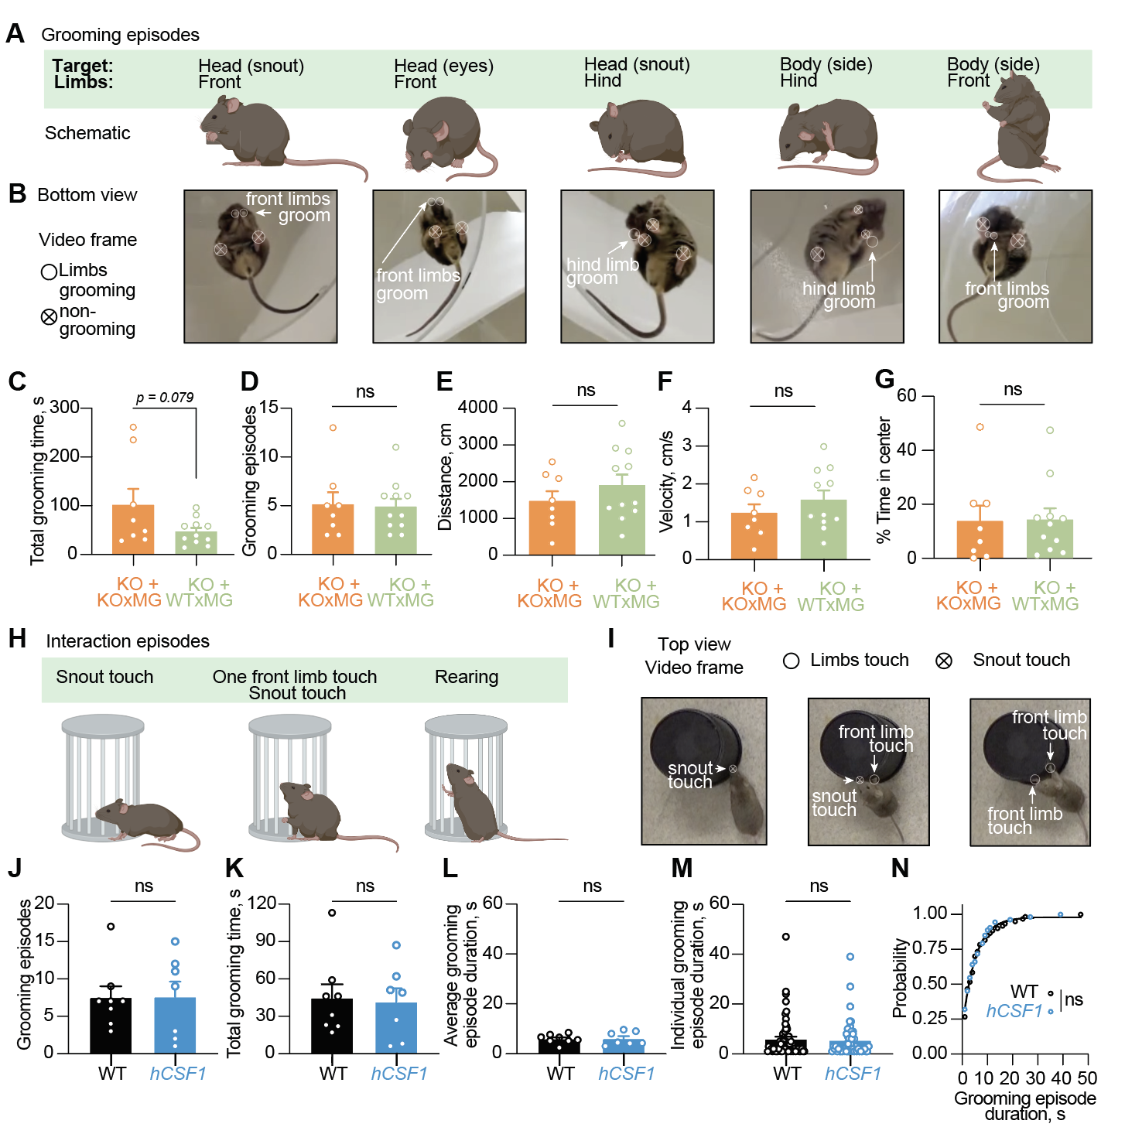
Figure S6. Grooming and social interaction behaviors in hCSF1-Grn–/–+KOxMG and hCSF1-Grn–/– +WTxMG mice.
(A) Grooming episodes as seen from a side view. Mice groomed both their head and body with front and hind limbs.
(B) Grooming episodes snapshots as a single video frame corresponding to schematics in B. Open circles denote grooming limbs, crossed—non-grooming.
(C) Quantification of total grooming time, p value from Student’s t-test (t(17) = 1.868, p = 0.079).
(D) Quantification of the number of grooming episodes, p value from Student’s t- test (t(17) = 0.1506, p = 0.8820).
(E) Quantification of the distance traveled, p value from Student’s t- test (t(17) = 1.042 p = 0.3118).
(F) Quantification of the velocity, p value from Student’s t- test (t(17) = 1.019, p = 0.3227). Data represented as mean ± SEM (hCSF1-Grn–/–+KOxMG, n = 8; hCSF1-Grn–/– +WTxMG, n= 11).
(G) Percent time spent in the center of the open field arena, Student's t-test (t(17) = 0.06290, p = 0.9506).
(H) Interaction episodes of social approach as seen from a side view. Mice approach the pencil wire cup with a 1) snout touch, 2) snout touch and one front limb touch, and 3) rearing (both front limbs touch).
(I) Interaction episodes snapshots as a single video frame corresponding to schematics in (G). Crossed circles denote snout, open—front limbs.
(J–N) Independent age-matched cohort comparison of grooming behavior in wild-type (WT) and hCSF1 mice.
(J) Number of grooming episodes, Student's t-test (t(13) = 0.02818, p = 0.9779).
(K) Total grooming time, Student's t-test (t(13) = 0.2029, p = 0.8423).
(L) Mean grooming episode duration per mouse, Student's t-test (t(13) = 0.1114, p = 0.9130).
(M) Individual grooming episode durations pooled across mice (n = 60 episodes from WT, 53 from hCSF1), Student's t-test (t(111) = 0.3419, p = 0.7330).
(N) Cumulative probability distribution of grooming episode durations, fit with an exponential plateau model and compared by extra sum-of-squares F test (F(3, 27) = 2.432, p = 0.0868).
n = 8 WT mice and 7 hCSF1 mice.

