No. | Chemical Name | Molecular Formula | Molecular Weight | Molecular Structure
1 | Luciduline | C₁₃H₂₁NO | 207 | 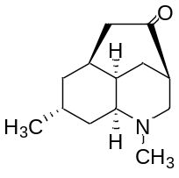
2 | Serratinine E | C₁₄H₂₃NO₃ | 253 | 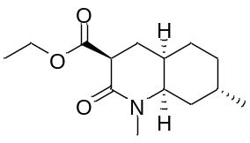
3 | N-methylhydroxypropyllycodine | C₂₀H₃₀N₂O | 314 | 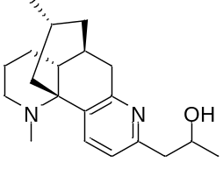
4 | N-Demethyl-α-obscurine | C₁₆H₂₄N₂O | 260 | 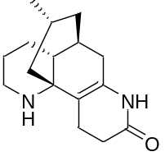
5 | N-Demethyl-β-obscurine | C₁₆H₂₂N₂O | 258 | 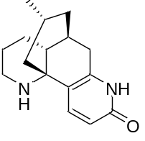
6 | Obscurumines A | C₁₆H₂₅NO₃ | 279 | 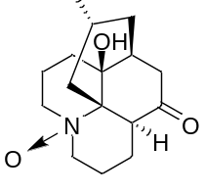
7 | Huperzine B | C₁₆H₂₀N₂O | 256 | 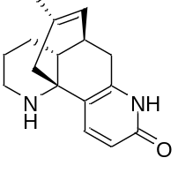
8 | Clavonoline | C₁₆H₂₅NO₂ | 263 | 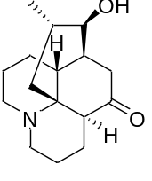
9 | 16-Hydroxylycodine | C₁₆H₂₂N₂O | 258 | 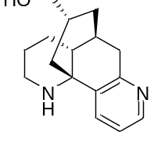
10 | Serratezomine E | C₁₈H₃₂N₂O | 292 | 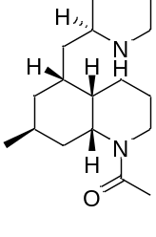
11 | Huperzine F | C₁₆H₂₁NO₃ | 275 | 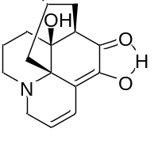
12 | Lycodine | C₁₆H₂₂N₂ | 242 | 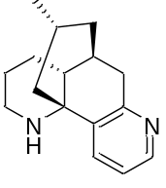
13 | DAR-12 | C₃₁H₄₂O₆ | 510 | 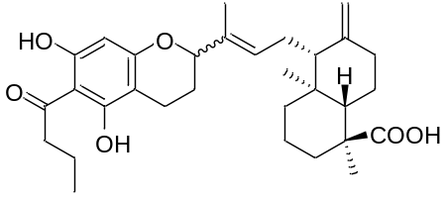
14 | DAR-19 | C₃₃H₄₆O₆ | 538 | 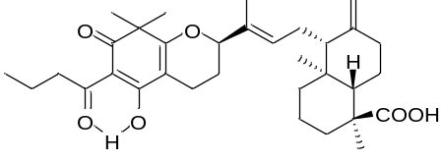
15 | DAR-26 | C₃₁H₄₂O₆ | 510 | 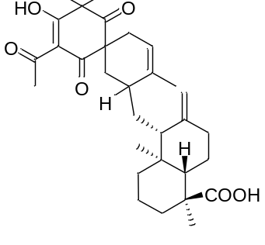
16 | Dryatraol B | C₂₃H₃₀O₄ | 370 | 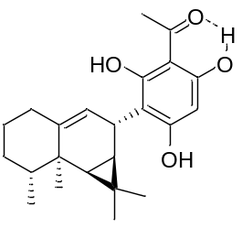
17 | (22E)-Stigmasta-4,6,8(14),22-tetraen-3-one | C₂₉H₄₂O | 406 | 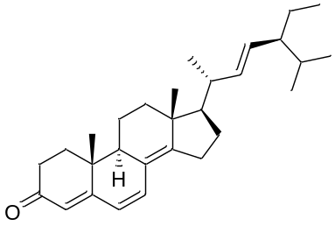
18 | Chlojapolide G | C₃₀H₃₂O₇ | 504 | 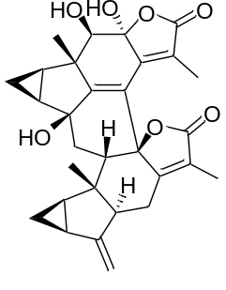
19 | Chloramultilide D | C₃₅H₄₀O₁₁ | 636 | 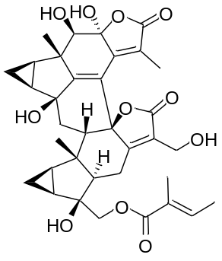
20 | Trichoacorenol C | C₁₅H₂₆O₃ | 254 | 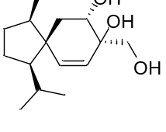
21 | 3,4,8a-trimethyl-4a,7,8,8a-tetrahydro-4a-naphto[2,3-b]furan-9-one | C₁₅H₁₈O₂ | 230 | 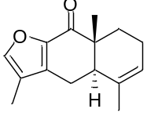
22 | Chlorantolide A | C₁₅H₂₀O₄ | 264 | 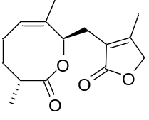
23 | Sarcandrolide D | C₃₇H₄₂O₁₂ | 678 | 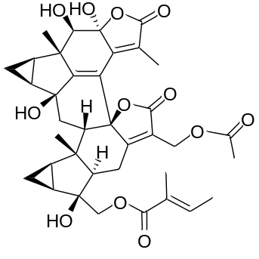
24 | Chloranholide G | C₃₅H₄₀O₁₀ | 620 | 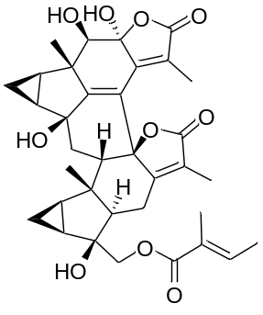
25 | 6-Oxaspiro[4.5]decane,2,4-hexadiyn-1-one deriv. | C₁₅H₁₆O₂ | 228 | 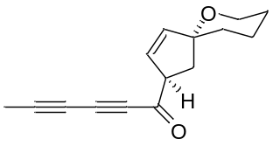
26 | (2S)-2-(3,5-Dihydroxyphenyl)-7-(β-D-glucopyranosyloxy)-2,3-dihydro-4H-1-benzopyran-4-one | C₂₁H₂₂O₁₀ | 434 | 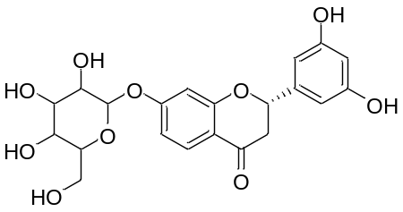
27 | Garciyunnanin F | C₃₃H₄₂O₇ | 550 | 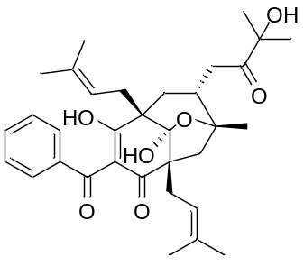
28 | Garcoblone D | C₃₈H₅₀O₇ | 618 | 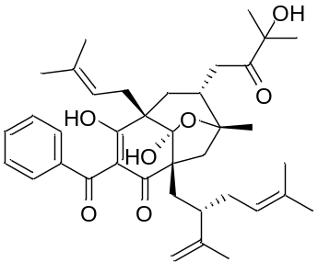
29 | Garcino | C₃₈H₅₀O₆ | 602 | 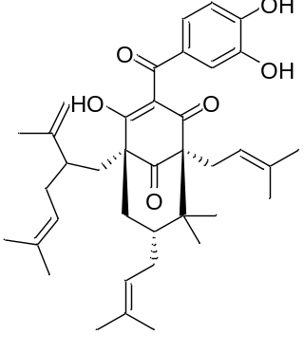
30 | Garcinol | C₃₈H₄₈O₆ | 600 | 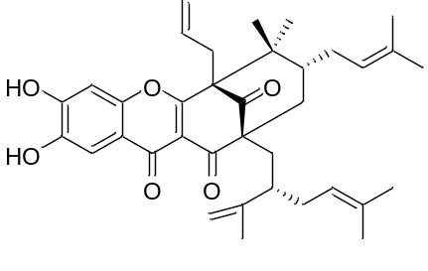
31 | Guttiferone E | C₃₈H₄₈O₆ | 600 | 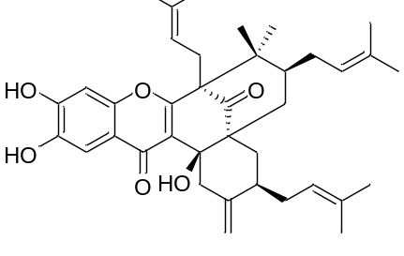
32 | (4S,4aR,6S,7R,7aS)-Octahydro-2,4,7-trimethyl-1H-cyclopenta[c]pyridin-6-ol | C₁₁H₂₁NO | 183 | 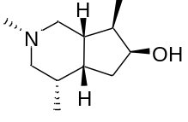
33 | Incarvillateine | C₄₁H₅₅N₂O₈ | 718 | 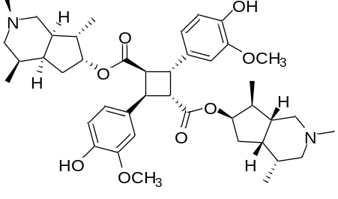
34 | Nornantenine | C₁₉H₁₉NO₄ | 325 | 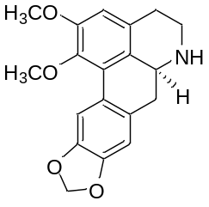
35 | Nantenine | C₂₀H₂₁NO₄ | 339 | 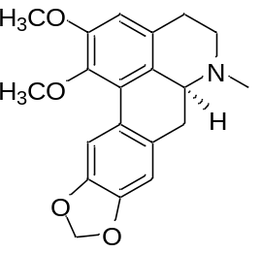
36 | 3-Oxo-11β-hydroxyfriedelane | C₃₀H₅₀O₂ | 442 | 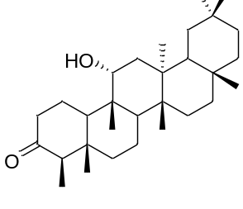
37 | QJT-15 | C₃₀H₄₆O₃ | 454 | 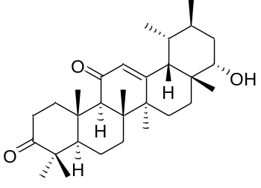
38 | 4,4′-[[(2R,3S,4S)-Tetrahydro-2-methoxy-3,4-furandiyl]bis(methylene)]bis[2-methoxyphenol] | C₂₁H₂₆O₆ | 374 | 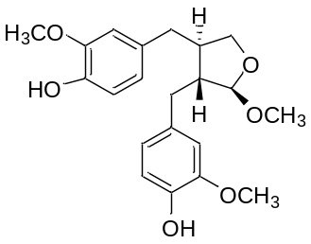
39 | Secoisolariciresinol | C₂₀H₂₆O₆ | 362 | 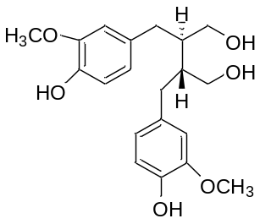
40 | 4-Methoxy-3-(2-methylbut-3-en-2-yl)-6-phenyl-2H-pyran-2-one | C₁₇H₁₈O₃ | 270 | 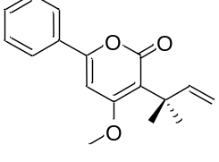
41 | 1,5,6-Trihydroxy-3-methoxyxanthone | C₁₄H₁₀O₆ | 274 | 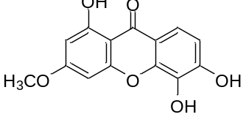
42 | Kaempferol | C₁₅H₁₀O₆ | 286 | 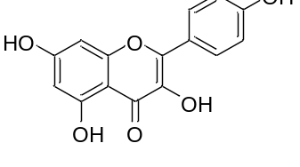
43 | Hypercohone G | C₃₃H₄₀O₅ | 516 | 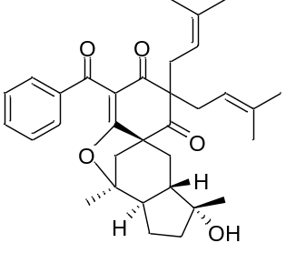
44 | Tomoeone B | C₃₀H₄₄O₆ | 500 | 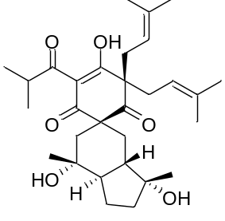
45 | 3α-Angeloyloxy-9β-hydroxy-ent-kaur-16-en-oic acid | C₂₅H₃₆O₅ | 416 | 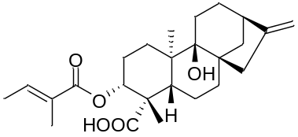
46 | 3α-Cinnnamoyloxy-9β-hydroxy-ent-kaur-16-en-19-oic acid | C₂₉H₃₆O₅ | 464 | 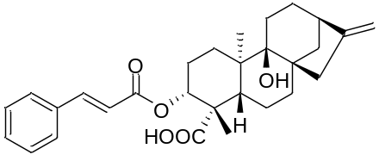
47 | β-D-Glucopyranoside,4-[[(2,5-dihydroxybenzoyl)oxy]methyl]phenyl | C₂₀H₂₂O₁₀ | 422 | 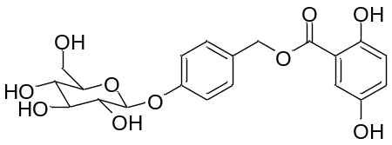
48 | Gracillin | C₄₅H₇₂O₁₇ | 884 | 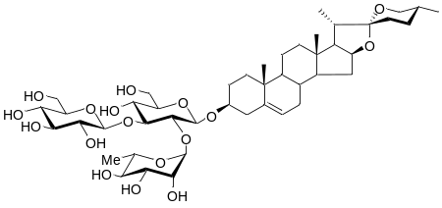
49 | Polyphyllin VI | C₃₉H₆₂O₁₃ | 738 | 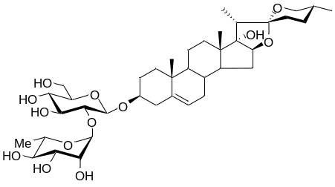
50 | Pennogenin 3-O-{O-α-L-rhamnopyranosyl-(1→4)-O-α-L-rhamnopyranosyl-(1→4)-β-D-glucopyranoside} | C₄₅H₇₂O₁₇ | 884 | 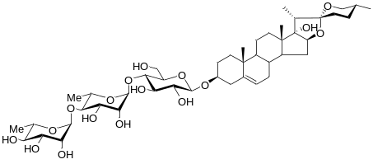
51 | Pariposide F | C₄₇H₈₀O₁₆ | 900 | 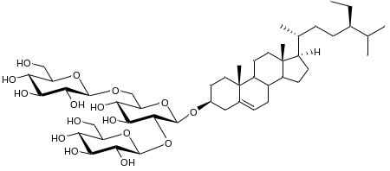
52 | Daucosterol | C₃₅H₆₀O₆ | 576 | 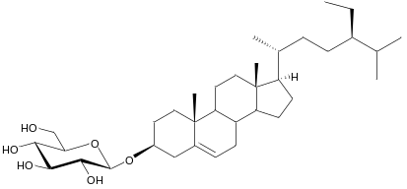
53 | Diosbulbin B | C₁₉H₂₀O₆ | 344 | 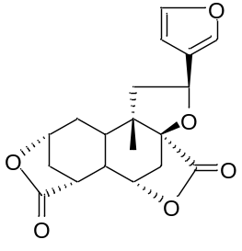
54 | Nobiletin | C₂₁H₂₂O₈ | 402 | 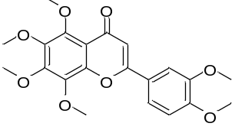
55 | Epicatechin | C₁₅H₁₄O₆ | 290 | 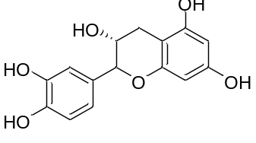
56 | Watsonianone A | C₂₅H₃₆O₆ | 432 | 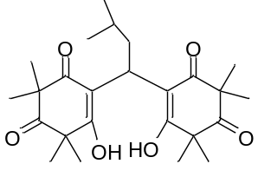
57 | 3α-Cinnamoyloxy-ent-kaur-16-en-19-oic acid | C₂₉H₃₆O₄ | 448 | 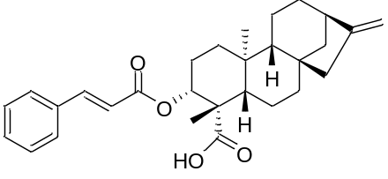
58 | 3α-Cinnnamoyloxy-9β-hydroxy-ent-kaur-16-en-19-oic acid | C₂₉H₃₆O₅ | 464 | 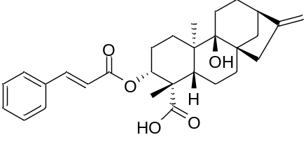
59 | 3α-Tigloyloxy-ent-kaur-16-en-oic acid | C₂₅H₃₆O₄ | 400 | 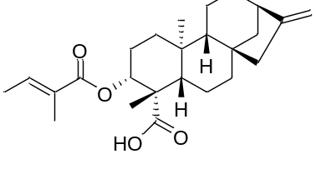
60 | 3α-Angeloyloxy-ent-kaur-16-en-oic acid | C₂₅H₃₆O₄ | 400 | 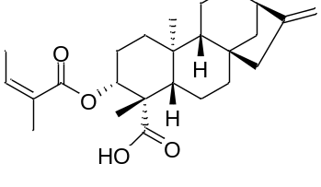
61 | (3α,4α)-3-Hydroxykaur-16-en-18-oic acid | C₂₀H₃₀O₃ | 318 | 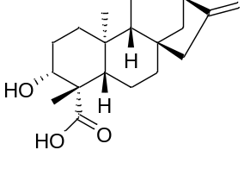
62 | Kaurenoic acid | C₂₀H₃₀O₂ | 302 | 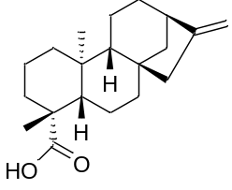
63 | Pterokaurane L3 | C₂₀H₃₀O₃ | 318 | 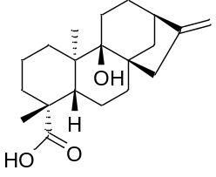
64 | Stigmasterol | C₂₉H₄₈O | 412 | 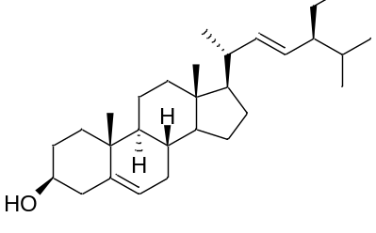
65 | Wedelolide D | C₂₇H₃₈O₈ | 490 | 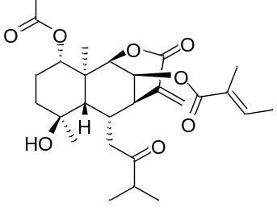
66 | Puerarin | C₂₁H₂₀O₉ | 416 | 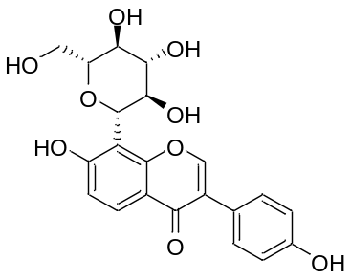
67 | Kaempferol | C₁₅H₁₀O₆ | 286 | 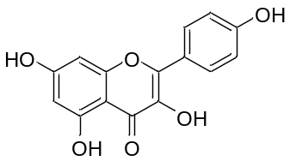
68 | deoxyelephantopin | C₁₉H₂₀O₆ | 344 | 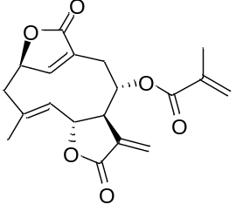
69 | Apigenin | C₁₅H₁₀O₅ | 270 | 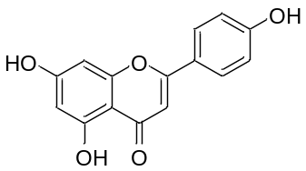
70 | Synephrine | C₉H₁₃NO₂ | 167 | 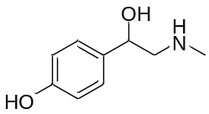
71 | Hesperidin | C₂₈H₃₄O₁₅ | 610 | 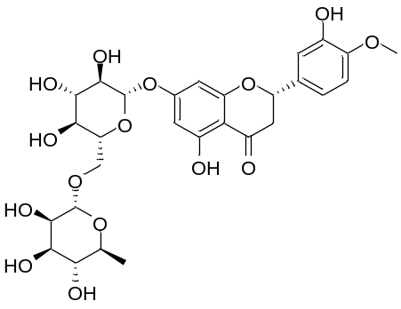
72 | Tangereti | C₂₀H₂₀O₇ | 372 | 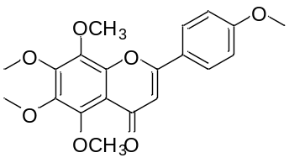
73 | Quercetin | C₁₅H₁₀O₇ | 302 | 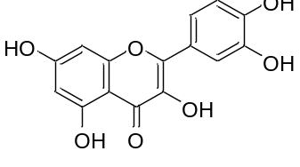
74 | Dcalycinumine A | C₂₃H₂₇NO₇ | 429 | 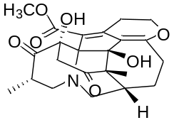
75 | 2,5-epoxy-2β-hydroxy-4α-methoxy-8α-[(E)-2-methylbut-2-enoyloxy]-4(15),10(14),11(13)-germacratrien-12,6α-olide | C₂₁H₂₈O₇ | 392 | 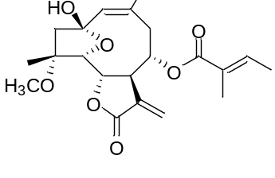
76 | Mallotucin D | C₂₁H₂₄O₇ | 388 | 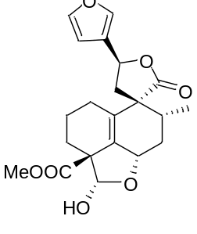
77 | Deoxyelephantopin | C₁₉H₂₀O₆ | 344 | 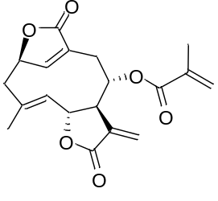
78 | Harmine | C₁₃H₁₂N₂O | 212 | 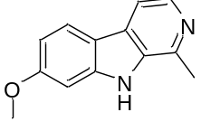
79 | (-)-Pegaharine B | C₁₉H₂₂N₂O₃ | 326 | 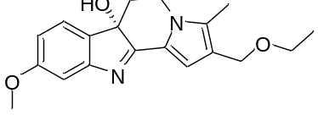
80 | Pegaharoline A | C₁₂H₁₆N₂O₃ | 236 | 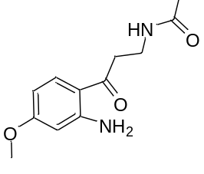
81 | Peganumione A | C₂₅H₃₀N₄O₆ | 482 | 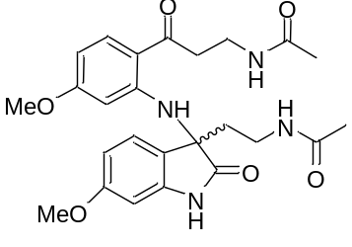
82 | 12α-hydroxygrandiflorenic acid | C₂₅H₃₆O₅ | 416 | 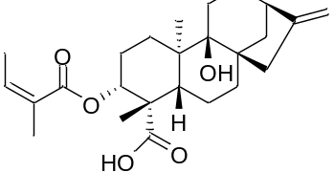
83 | Harmalacidine | C₁₂H₁₂N₂O₂ | 216 | 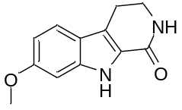
84 | (±)-peganumalines A | C₂₆H₃₀N₄O₆ | 494 | 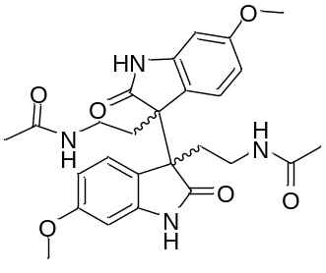
85 | Pegaharmine I | C₁₃H₁₄N₂O₂ | 230 | 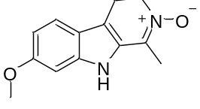
86 | Crassifolin A | C₂₁H₃₀O₄ | 346 | 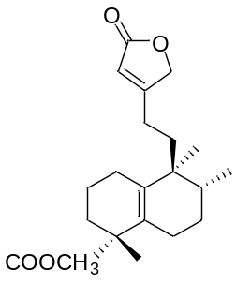
87 | Lysidiciside A | C₁₇H₂₄O₉ | 372 | 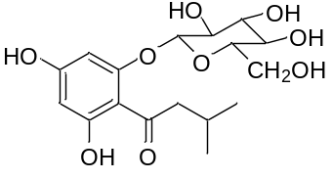
88 | (E)-Resveratrol 3-O-β-D-xylopyranoside | C₁₉H₂₀O₇ | 360 | 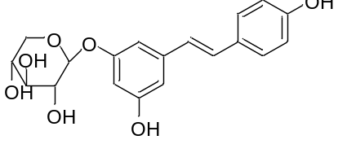
89 | (+)-Isoalantolactone | C₁₅H₂₀O₂ | 232 | 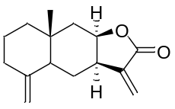
90 | 2α-O-trans-p-Coumaroylarjunolic acid | C₃₉H₅₄O₇ | 634 | 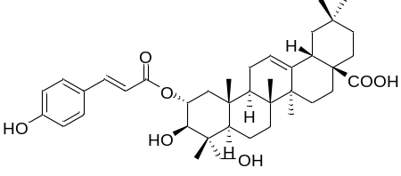
91 | 3β-O-trans-p-Coumaroylarjunolic acid | C₃₉H₅₄O₇ | 634 | 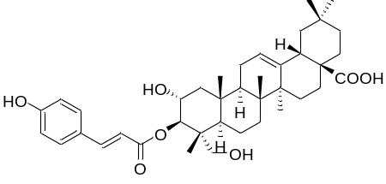
92 | 3β-O-cis-p-Coumaroylarjunolic acid | C₃₉H₅₄O₇ | 634 | 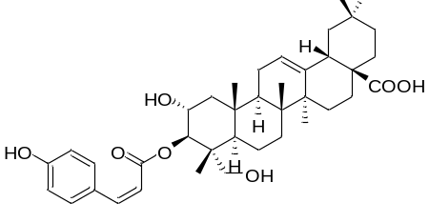
93 | Hederagenin | C₃₀H₄₈O₄ | 472 | 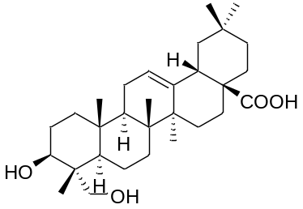
94 | Maslinic acid | C₃₀H₄₈O₄ | 472 | 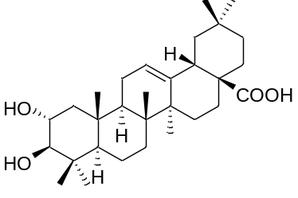
95 | Dehydroarjunolic acid | C₃₀H₄₆O₅ | 486 | 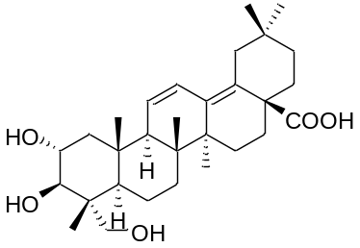
96 | Asperosaponin C | C₃₅H₅₆O₇ | 588 | 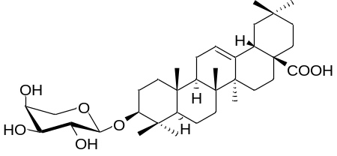
97 | p-Coumaric acid | C₉H₈O₃ | 164 | 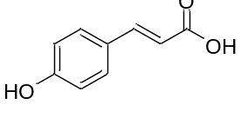
98 | 3-O-trans-p-coumaroyl-2α,3β,29-trihydroxy-olean-12-en-28-oic acid | C₃₉H₅₄O₇ | 634
99 | Garmultin E | C₃₈H₅₀O₇ | 618 | 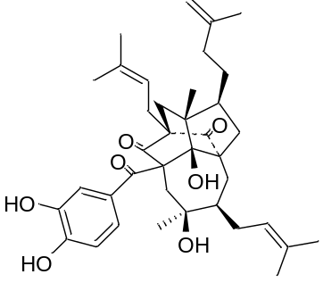
100 | Garcoblone F | C₃₈H₄₈O₆ | 600 | 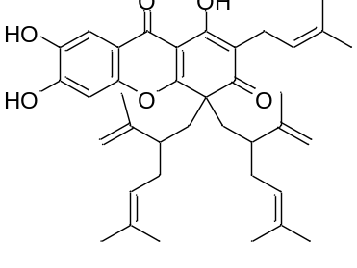
101 | Isogarcinol | C₃₈H₅₀O₆ | 602 | 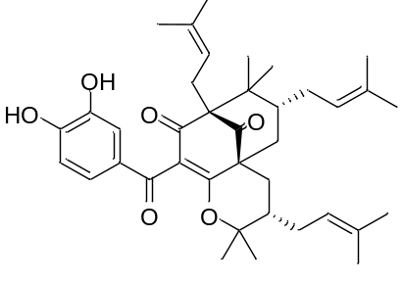
102 | Garcimulin A | C₃₈H₅₁O₆ | 602 | 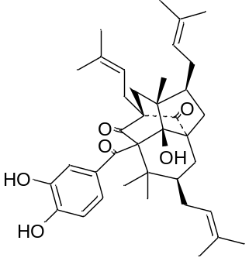
103 | 7β-sophoramine | C₁₅H₂₀N₂O | 244 | 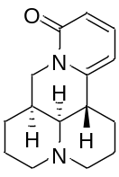
104 | Sophaloseedline I | C₁₅H₂₂N₂O₃ | 278 | 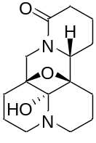
105 | Matrine | C₁₅H₂₄N₂O | 248 | 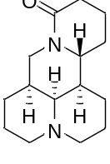
106 | (-)-Sophoramine | C₁₅H₂₀N₂O | 244 | 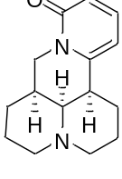
107 | 14β-Hydroxymatrine | C₁₅H₂₄N₂O₂ | 264 | 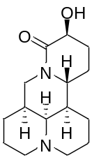
108 | (+)-7,11-Dehydromatrine | C₁₅H₂₂N₂O | 246 | 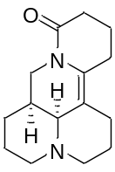
109 | (+)-allomatrine | C₁₅H₂₄N₂O | 248 | 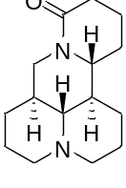
110 | (-)-Sophoridine | C₁₅H₂₄N₂O | 248 | 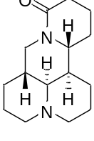
111 | (-)-Sophocarpine | C₁₅H₂₂N₂O | 246 | 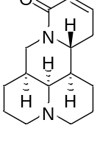
112 | K-48 | C₁₄H₁₈N₂O₂ | 246 | 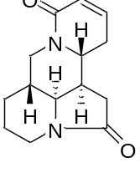
113 | alopecurine B | C₁₅H₂₂N₂O₄ | 294 | 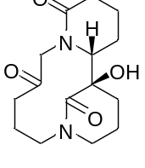
114 | Dihydroalbertine | C₁₅H₂₄N₂O₂ | 264 | 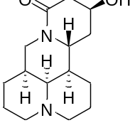
115 | sophtonkine C | C₁₅H₂₂N₂O₃ | 278 | 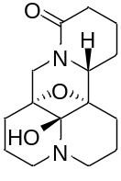
116 | Sophflarine A | C₁₅H₂₂N₂O₄ | 294 | 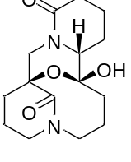
117 | (+)-Anagyrine | C₁₅H₂₀N₂O | 244 | 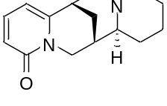
118 | Flavesine G | C₁₅H₂₀N₂O₂ | 260 | 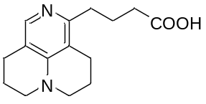
119 | Sophaline B | C₁₄H₂₀N₂O₂ | 248 | 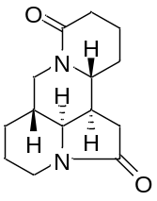
120 | Sophaloseedline E | C₁₅H₂₄N₂O₄ | 296 | 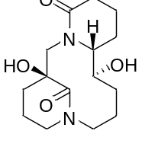
121 | Sophaloseedlines K | C₁₅H₂₂N₂O₄ | 294 | 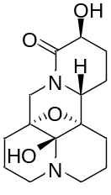
122 | Crassifolin C | C₂₁H₂₆O₄ | 342 | 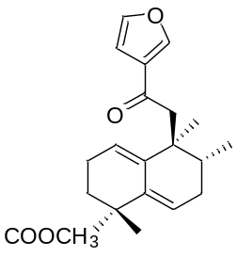
123 | Crassifolin D | C₂₂H₂₆O₅ | 370 | 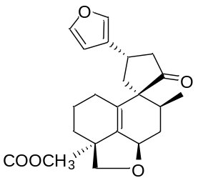
124 | Crassifolin E | C₂₀H₂₂O₆ | 358 | 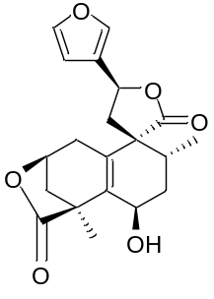
125 | Crassifolin F | C₂₄H₃₀O₆ | 414 | 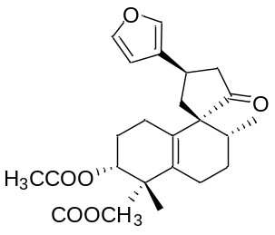
126 | Chettaphanin I | C₂₁H₂₆O₆ | 374 | 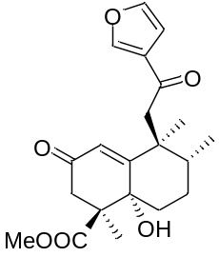
127 | 1,4-methano-3-benzoxepin-2(1H)-one | C₂₀H₂₄O₄ | 328 | 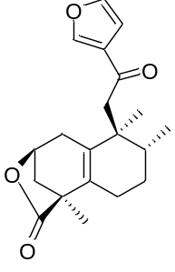
128 | Crassifolin J | C₂₀H₂₀O₅ | 340 | 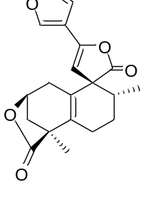
129 | Crassifolin K | C₂₁H₂₆O₆ | 374 | 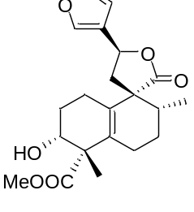
130 | Crassifolin L | C₂₁H₂₆O₆ | 374 | 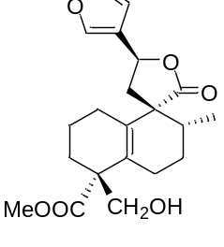
131 | Crassifolin M | C₂₁H₂₂O₇ | 386 | 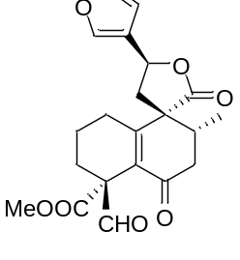
132 | Crassifoliusin A | C₂₁H₂₄O₅ | 356 | 