Supplementary Information

Disassembly of Mitochondrial Cristae Architecture Drives Neurodegeneration in Huntington’s Disease

Yutong Shang¹, Rihua Wang^{1,2}, Di Hu^{1,2}, Kyle McGill Percy¹, Xiaoyan Sun¹ and Xin Qi^{1,2*}

¹Department of Physiology & Biophysics, Case Western Reserve University School of Medicine, Cleveland, OH 44106, USA; ²Center for Mitochondrial Research and Therapeutics, Case Western Reserve University School of Medicine, Cleveland, OH 44106, USA

*Corresponding author: Xin Qi PhD, Email: xxq38@case.edu. Department of Physiology and Biophysics, Case Western Reserve University School of Medicine, 10900 Euclid Ave, E524, Cleveland, OH 44106-4970, USA

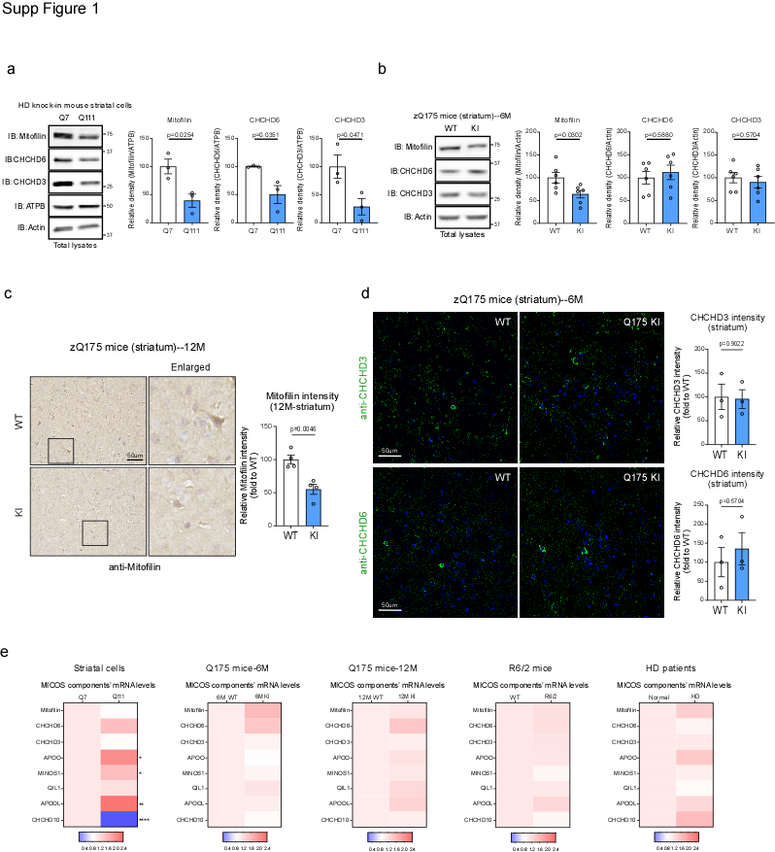

Supplementary Figure 1. Mitofilin is selectively decreases in HD models.
(a) Immunoblot (IB) analysis of mitofilin, CHCHD6, CHCHD3, ATPB and Actin in total lysate of HdhQ7 and HdhQ111 striatal cells. Histograms: relative density of mitofilin, CHCHD6 or CHCHD3 to ATPB. n = 3 independent experiments.
(b) Immunoblot (IB) analysis of mitofilin, CHCHD6, CHCHD3 and Actin in total lysate of striatum of 6-month-old WT and zQ175 KI mice. Histograms: relative density of mitofilin, CHCHD6 or CHCHD3 to Actin. n = 6 mice/group.
(c) Representative images (left) and quantification (right) of immunohistochemical staining of mitofilin in striatum of 12-month-old WT and zQ175 KI mice. n=4 mice/group.
(d) Representative images (left) and quantification (right) of immunofluorescent staining of CHCHD3 and CHCHD6 in striatum of 6-month-old WT and zQ175 KI mice. n=3 mice/group.
(e) RT-qPCR analysis of MICOS complex components in different HD models. Heat map analysis shows the mean of the genes analyzed. 1. mouse striatal cells (HdhQ7 vs. HdhQ111), *, p < 0.05; **, p < 0.01; ****, p < 0.0001. n = 6 independent experiments. 2. Striatum of 6-month-old WT and zQ175 KI mice. n = 6 mice/group. 3. Striatum of 12-month-old WT and zQ175 KI mice. n = 4 mice/group. 4. Striatum of 12-week-old WT and R6/2 mice. n = 4 mice/group. 5. Postmortem striatal tissue of normal subjects and HD patient. n=3 normal subjects, and n = 6 HD patients.
All data are presented as mean ± SEM. Data were compared using unpaired Student’s t-test in panels a-e.

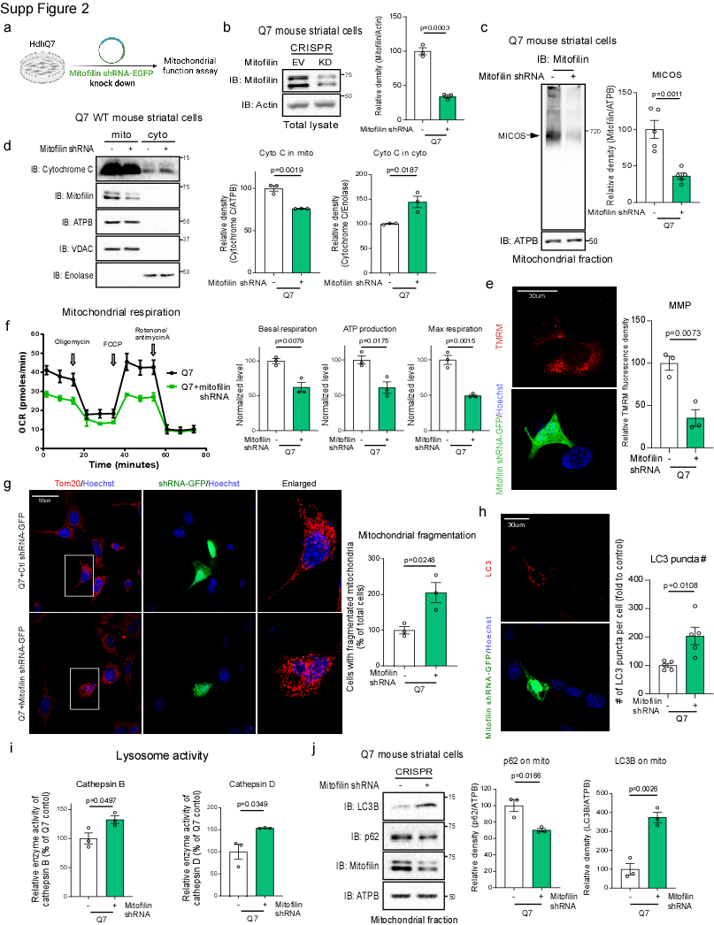

Supplementary Figure 2. Mitofilin loss induces cristae disruption and excessive mitophagy in WT HdhQ7 striatal cells.
(a) Experimental scheme for mitofilin knockdown in HdhQ7 cells. Cells were transfected with GFP-tagged mitofilin shRNA for 48 hours, followed by analysis of protein expression and mitochondria-related functions in b–j.
(b) IB analysis of mitofilin in total protein lysates of HdhQ7 cells expressing GFP-control shRNA or GFP-mitofilin shRNA. Histograms: relative density of mitofilin to Actin. n=3 independent experiments.
(c) BN-PAGE analysis of MICOS complexes in HdhQ7 cells transfected with GFP-control shRNA or GFP-mitofilin shRNA. Histograms: relative density of mitofilin to ATPB. n=5 independent experiments.
(d) Mitochondrial and mitochondria-depleted cytosolic fractions were isolated from HdhQ7 cells transfected with GFP-control shRNA or GFP-mitofilin shRNA. Protein lysates of mitochondria fraction and mitochondria-depleted cytosolic fraction were analyzed by IB with the indicated antibodies. Histograms: relative density of cytochrome C to ATPB in mitochondria fraction; and relative density of cytochrome C to Enolase in cytosolic fraction. n=3 independent experiments.
(e) HdhQ7 cells transfected with GFP-control shRNA or GFP-mitofilin shRNA were stained with tetramethylrhodamine (TMRM) fluorescence dye. TMRM relative fluorescence density indicates the extent of mitochondrial membrane potential (MMP). Histogram: the relative fluorescence density of TMRM. At least 150 cells per group were analyzed, and the data were from 3 independent experiments.
(f) Oxygen consumption rate (OCR) of HdhQ7 control cells and HdhQ7 cells with mitofilin knockdown were measured using a Seahorse XFP analyzer and a Mito stress kit., Basal respiration, ATP production, and Max respiration are quantified. n = 3 independent experiments.
(g) HdhQ7 cells transfected with GFP-control shRNA or GFP-mitofilin shRNA were stained with anti-Tom20 (red) and Hoechst (nuclei, blue). Mitochondrial morphology was visualized using a 60X oil lens in GFP-positive cells. Left: representative images. Right: histogram showing quantification of the percentage of cells exhibiting fragmented mitochondria relative to total cells. At least 77 cells were analyzed per group, and the data were from 3 independent experiments.
(h) HdhQ7 cells transfected with GFP-mitofilin shRNA were stained with anti-LC3B (red) and Hoechst (nuclei, blue). The number of LC3B puncta was quantitated and shown in the histogram. At least 78 cells were analyzed per group, and the data were from 5 independent experiments.
(i) Lysosomal activities of cathepsin B and cathepsin D were measured using assay kit in HdhQ7 cells transfected with GFP-control shRNA or GFP-mitofilin shRNA. n=3 independent experiments.
(j) Mitochondrial fractions were isolated from HdhQ7 cells transfected with GFP-control shRNA or GFP-mitofilin shRNA. Protein lysates of mitochondria fraction were analyzed by IB with the indicated antibodies. Histograms: relative density of p62 or LC3B to ATPB. n=3 independent experiments.
The data are presented as mean ± SEM and were compared using unpaired Student’s t test in panels b–j.

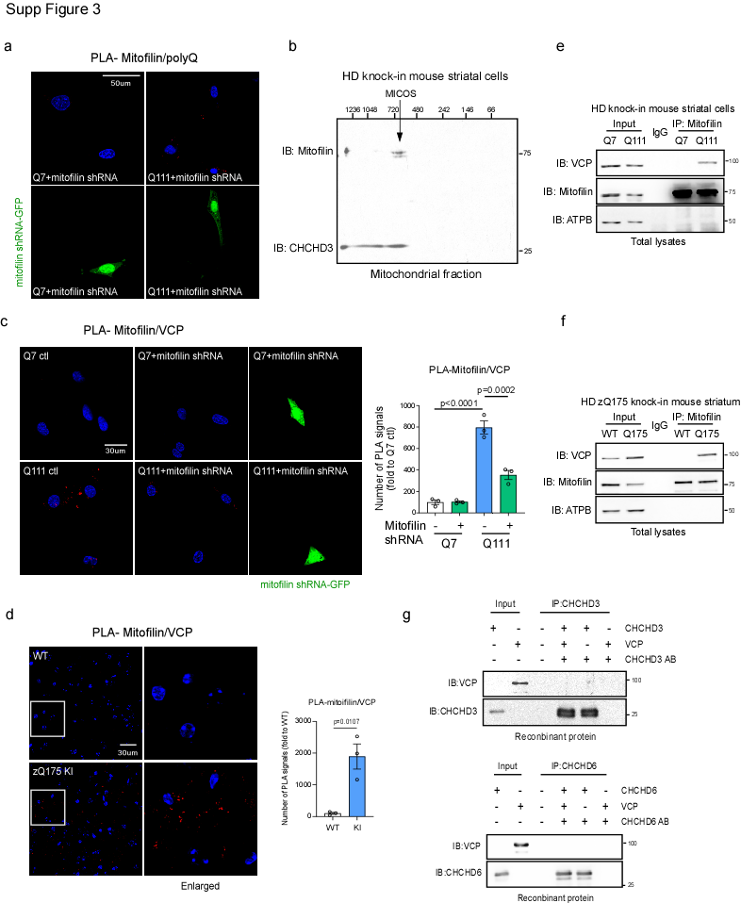

Supplementary Figure 3. mtHtt recruits VCP to the MICOS complex at mitochondrial contact sites
(a) Representative mitofilin–polyQ PLA images from HdhQ7 and HdhQ111 cells following mitofilin knockdown with mitofilin shRNA-GFP.
(b) Two-dimensional BN/SDS-PAGE analysis mitochondrial proteins from HdhQ111 cells. Native complexes were separated by BN-PAGE in the first dimension and resolved by SDS-PAGE in the second dimension, followed by immunoblotting with anti-mitofilin and anti-CHCHD3 antibodies. mitofilin- and CHCHD3- positive signals co-migrated and were detected at ~700 kDa, corresponding to the molecular weight of the intact MICOS complex. Representative image is shown from 4 independent experiments.
(c) HdhQ7 and HdhQ111 cells with or without mitofilin knocking down through overexpression of mitofilin shRNA-GFP were stained with anti-mitofilin and anti-VCP antibodies, and subjected to PLA analysis. Representative mitofilin–VCP PLA images (left). Histogram (right) shows the number of PLA-positive puncta (red). At least 120 cells/ group (for HdhQ7 and HdhQ111 cells without mitofilin shRNA-GFP overexpression) and 50 cells/group (for HdhQ7 and HdhQ111 cells with mitofilin shRNA-GFP overexpression) were analyzed. The data were from 3 independent experiments.
(d) Brain sections from 6-month-old WT and zQ175 KI mice (n = 3 mice/group) were stained with anti-mitofilin and anti-VCP antibodies (left), and subjected to PLA analysis. Representative mitofilin–VCP PLA images of striatum (left). Histogram (right): the number of PLA-positive puncta (red) was quantified from at least 6 separate fields of each sample.
(e) Total protein lysates of HdhQ7 and HdhQ111 cells were subjected to immunoprecipitation (IP) with anti-mitofilin antibody, followed by immunoblotting (IB) with indicated antibodies. Representative images are shown from 3 independent experiments for mitofilin, VCP, and ATPB. ATPB served as a negative control.
(f) Striatal lysates from 6-month-old WT and zQ175 KI mice were subjected to IP with an anti-mitofilin antibody, followed by IB with the indicated antibodies. Representative blots for mitofilin, VCP, and ATPB from 3 independent experiments are shown. ATPB served as a negative control.
(g) VCP recombinant protein (500 ng) was incubated with either CHCHD3 or CHCHD6 recombinant proteins (500 ng, each). Immunoprecipitates with anti-VCP antibody were analyzed by immunoblotting with the indicated antibodies. Data are representative of 2 independent experiments.
The data are presented as mean ± SEM. The data in panel c were compared by one-way ANOVA with Tukey’s post hoc test, and the data in panel d were compared by unpaired Student’s t test.

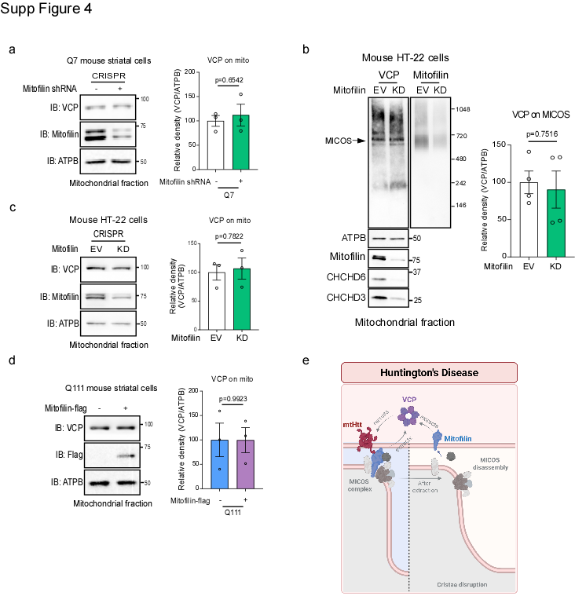

Supplementary Figure 4. Mitochondrial VCP recruitment is independent of mitofilin levels
(a) IB analysis of VCP in mitochondrial protein lysates of HdhQ7 cells expressing GFP-control shRNA or GFP-mitofilin shRNA. Histograms: relative density of VCP to ATPB. n=3 independent experiments.
(b) Mitochondria fractions were isolated from control and mitofilin knockdown (KD) HT-22 cells. VCP level on MICOS was analyzed by BN-PAGE followed by IB with VCP antibody. Histograms: relative density of VCP to ATPB. n=4 independent experiments.
(c) IB analysis of VCP in mitochondrial protein lysates of control and mitofilin knockdown (KD) HT-22 cells. Histograms: relative density of VCP to ATPB. n=3 independent experiments.
(d) IB analysis of VCP in mitochondrial protein lysates of HdhQ111 cells transfected with mitofilin-Flag plasmid. Histograms: relative density of VCP to ATPB. n=3 independent experiments.
(e) Graphic summary of VCP-mediated mitofilin extraction and MICOS disruption.
The data are presented as mean ± SEM. The data in panel a-d were compared by unpaired Student’s t test.

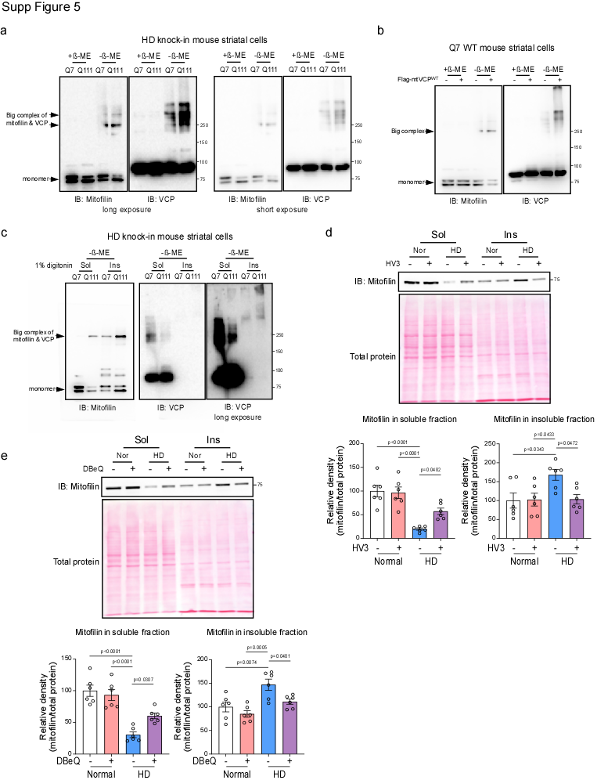

Supplementary Figure 5. Mitofilin Accumulates with mtHtt and VCP in Insoluble Assemblies
(a) Total lysates of HdhQ7 and HdhQ111 cells were analyzed by IB with anti-VCP and anti-mitofilin antibody in the presence or absence of β-ME. n=2 independent experiments.
(b) Total lysates of HdhQ7 cells transfected with Flag-mtVCP^{WT} were analyzed by IB with anti-VCP and anti-mitofilin antibodies in the presence or absence of β-ME. n=2 independent experiments.
(c) Digitonin-soluble and –insoluble fractions were isolated from HdhQ7 and HdhQ111 cells and were then subjected to IB analysis with anti-mitofilin and anti-VCP antibodies in the presence or absence of β-ME. n=2 independent experiments.
(d) Digitonin-soluble and –insoluble fractions were isolated from iPSC-Derived Striatal Neurons treated with HV3 peptide (1µM per day for 5 days). Protein lysates were then subjected to IB analysis with anti-mitofilin antibody. Histogram: the relative density of mitofilin to total protein in soluble or insoluble fraction. n = 6 independent experiments using three independent control iPSC lines and three independent HD iPSC lines, with two treatments performed for each line.
(e) Digitonin-soluble and –insoluble fractions were isolated from iPSC-Derived Striatal Neurons treated with DBeQ (10µM for 12h). Protein lysates were then subjected to IB analysis with anti-mitofilin antibody. Histogram: the relative density of mitofilin to total protein in soluble or insoluble fraction. n = 6 independent experiments using three independent control iPSC lines and three independent HD iPSC lines, with two treatments performed for each line.
The data are presented as mean ± SEM, and were compared by one-way ANOVA with Tukey’s post hoc test in panel d-e.

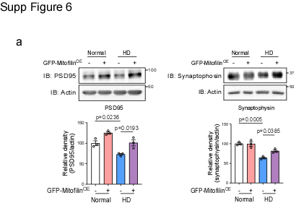

Supplementary Figure 6. Mitofilin restoration confers neuroprotection in HD patient iPSC-derived striatal neurons
(a) Total lysates from iPSC-derived striatal neurons with or without mitofilin overexpression were analyzed by IB with the indicated antibodies. Histograms: relative density of PSD95 or synaptophysin to Actin. n=3 independent experiments.
The data are presented as mean ± SEM, and were compared by one-way ANOVA with Tukey’s post hoc test in panel a.

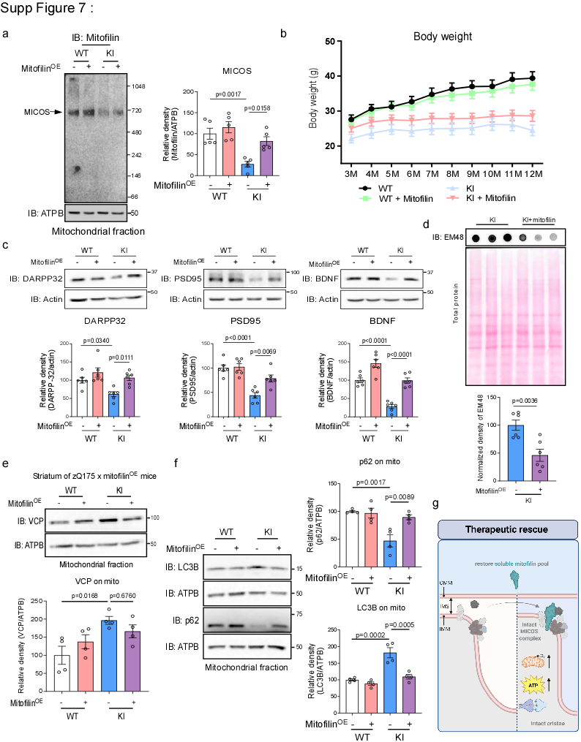

Supplementary Figure 7. Mitofilin reconstitution rescues neuropathology and motor dysfunction in HD mice
(a) BN-PAGE analysis of MICOS complexes in striatum of 12-month-old WT and zQ175 KI mice with and without mitofilin overexpression. Histograms: relative density of mitofilin-positive MICOS to ATPB. n=5 independent experiments.
(b) Body weight was recorded from the age of 3–12 months. WT (n = 13), WT+mitofilin^{OE} (n = 26), zQ175 KI (n = 15), and zQ175 KI+mitofilin^{OE} (n = 24) mice/group.
(c) Total protein lysates from striatum of 12-month-old WT and zQ175 KI mice with and without mitofilin overexpression were analyzed by IB with the indicated antibodies. Histograms: relative density of DARPP-32, PSD95 and BDNF to Actin. n=6 independent experiments.
(d) Striatum was harvested from zQ175 KI mice with and without mitofilin overexpression. mtHtt aggregates in triton-insoluble fractions were examined using an anti-mtHtt antibody (clone EM48) by dot blot assay. Histogram: the relative abundance of mtHtt protein aggregates. n = 6 mice/group.
(e) IB analysis of VCP in mitochondrial protein lysates from the striata of 12-month-old WT and zQ175 KI mice with or without mitofilin overexpression (mitofilin^{OE}). Histograms: relative density of VCP to ATPB. n=4 independent experiments.
(f) Mitochondrial fractions were isolated from the striata of 12-month-old WT and zQ175 KI mice with or without mitofilin overexpression (mitofilinOE). Protein lysates of mitochondria fraction were analyzed by IB with the indicated antibodies. Histograms: relative density of p62 or LC3B to ATPB. n=4 independent experiments.
(g) Graphic summary of mitofilin restoration in HD.
The data are presented as mean ± SEM. The data in panel a, c, e and f were compared by one-way ANOVA with Tukey’s post hoc test, and the data in panel d were compared by unpaired Student’s t test.

Supplementary Table 1: Human postmortem brain samples
Case Num | Age | Gender | Diagnosis | Brain region | Neuropathology Grade
5256 | 61 | Male | Normal | caudate nucleus
5214 | 61 | Male | Normal | caudate nucleus
5222 | 61 | Male | Normal | caudate nucleus
4283 | 77 | Male | HD | caudate nucleus | grade 1
4557 | 69 | Female | HD | caudate nucleus | grade 2
4239 | 73 | Female | HD | caudate nucleus | grade 2
2869 | 67 | Male | HD | caudate nucleus | grade 3
3573 | 51 | Male | HD | caudate nucleus | grade 3
2952 | 77 | Female | HD | caudate nucleus | grade 4

Supplementary Table 2: Primers used for qPCR
Gene name | Forwarded primer | Reverse primer
Hu D6 F | ACCAAGCACTCCAAGGCATC | GTGTCACGGCGTCTTAGCTC
Hu mitofilin | CGGGCCTGTCAGTTATCGG | CAATGGACGGAGGACAAACTT
Hu D3 | GCAAGCCAAGAAAGAATCCGA | TTCCTCCTCGCTACATATCCTC
Hu APOOL | CCAAAAAGCAGCTAGTGAAACC | AGTTGCAGTGCGGATGGAA
Hu APOO | TCCTGAGGGTCAATCGAAGTAT | CTCGCAATAGTGTCGGAGC
Hu QIL1 | TCAGCCAGTACGTGTGTCAG | GCCTGCATTCCAGGAGTCAC
Hu MINOS1 | GATGCGGTCGTGAAGATAGGT | CCAGAACCGAAGGCTAATGG
Hu CHCHD10 | GGGCTCATGGCTCAGATGG | CAGGAACTGCCTGATCTCGTA
Ms D6 | TGTCTGAAAGTGTTGTGAACCG | GATGGCTGGTAGAGGGACAGT
Ms mitofilin | GGAGGGATTGGTGGCACTATC | TTTGAGCTGCCCCTGTAGATG
Ms D3 | GCGGACGAGAACGAGAACAT | TCGCTGAGACTTAGAGCCAGA
Ms APOOL | ATGGCGGCCTTTAGGATGG | TCCGGTCTCACTAGCTGCT
Ms APOO | GGTTGTGGGGAGGATGAAGC | GCTGCATAGACTCTGAAGGTGA
Ms QIL1 | GTGGTCGCTAATGAGGTTCCT | GCTGGCACACATATTGGCTG
Ms MINOS1 | ACACGGTCGTGAAGCTAGGTA | CAGTTGGAGTAGGCCATTCCC
Ms CHCHD10 | CAGCCGGGTCTTATGGCTC | CAGGCTCTGAATTTCCCCCAC
Ms GAPDH | GACTTCAACAGCAACTCCCAC | TCCACCACCCTGTTGCTGTA
Hu GAPDH | GCGAGATCCCTCCAAAATCAA | GTTCACACCCATGACGAACAT

