Supplementary information
ICA1L stabilizes LRP1 to mitigate Aβ pathology in Alzheimer's Disease
Liang Chen et al.
*Corresponding author: Jie Zhang. Email: jiezhang@xmu.edu.cn; Weiwei Gao, E-mail: gaoww@fjmu.edu.cn; Jiechao Zhou, E-mail: jczhou@xmu.edu.cn; Kai Zhuang, E-mail: xmuzhuangkai@xmu.edu.cn;

This file includes:
Materials and methods
Supplementary Fig. 1 to 9
Supplementary table 1 and 2

Other Supplementary Materials for this manuscript include the following:
Additional file 1. Interactomics table.

Materials and methods
Western blotting: Hippocampal and cortical tissues were homogenized with RIPA buffer (Boster) containing protease inhibitors (Roche) and centrifuged at 12000 rpm for 10 min at 4°C. The supernatant was collected and quantified using the BCA Protein Assay Kit (Thermo Fisher). Samples (30 μg protein each lane) were separated using SDS-PAGE and subsequently transferred to PVDF membranes (0.45 μm; Millipore). The samples were then incubated overnight with anti-ICA1L (1:1000; proteintech; 18021-1-AP), ICA1L-specific antibody used in immunoprecipitation was generated against amino acid residues 266-411 of rat ICA1L, anti-GFAP (1:1000; CST; 80788S), anti-NeuN (1:1000; abcam; ab177487), anti-β-CTFs (1:1000; abcam; ab32136), anti-FLAG (1:1000; Sigma-Aldrich; 1804), anti-GFP (1:1000; santa cruz; sc-9996), anti-HA (1:2000; proteintech; 51064-2-AP), anti-Tuj1 (1:2000; abcam; ab18207), anti-BACE1 (1:1000; CST; 5606S), anti-Iba1 (1:1000; abcam; ab283319), anti-APP (1:1000; BBI; D160097), anti-LRP1 (1:2500; abcam; ab92544, clone EPR3724), anti-ubiquitin (1:1000; proteintech; 10201-2-AP), anti-ubiquitin (1:1000; selleck; F0527; F0528) primary antibody at 4°C. The membranes were then incubated with horseradish peroxidase-conjugated secondary antibodies (1:10000; Thermo Fisher) for 60 min at room temperature. Detection and quantification of specific bands were performed using Image J software (NIH, Bethesda).
Real-time PCR: Total RNA was extracted from tissues using TRIzol reagent (Thermo Fisher) according to the manufacturer’s instructions. Briefly, tissues were homogenized in TRIzol, followed by chloroform extraction and isopropanol precipitation. The RNA pellet was washed with 75% ethanol, air-dried, and dissolved in DEPC-treated water. RNA concentration and quality were assessed using a NanoDrop and Agilent 2100 Bioanalyzer (Thermo Fisher Scientific, MA, USA). Total RNA was reverse-transcribed using the ReverTra Ace® qPCR RT Kit (FSQ-101). Quantitative real-time PCR was performed using SYBR Green reagent (Roche). Samples were assayed in triplicate, and β-actin was used as the internal control. Primer sequences are listed in Table S2.
Immunofluorescence: Mice were perfused with 100 mL of saline solution. After removal, brains were fixed overnight in 4% paraformaldehyde (PFA). Brains were dehydrated in graded sucrose solutions (20%, 25%, 30%) for 24h at 4°C. Brain tissue sections were 15 μm thick and mounted on glass slides. Brain sections were blocked with blocking buffer (BSA, PBS, 0.2% Triton X-100) for 1 hour. Sections were incubated overnight with anti-ICA1L (1:500; proteintech; 18021-1-AP), anti-Aβ antibody, MOAB-2 clone (1:1000; abcam; ab126649), anti-NeuN (1:500; abcam; ab177487), anti-Iba1 (1:500; abcam; ab283319), anti-GFAP (1:500; CST; #3670s), anti-LRP1 (1:500; ab92544, clone EPR3724) primary antibody at 4°C for overnight. And then, sections were incubated with Alexa Fluor 488-labeled goat anti-rabbit secondary antibody (Thermo, A-11008), Alexa Fluor 488-labeled goat anti-mouse secondary antibody (Thermo, A-11001), Alexa Fluor 594-labeled donkey anti-rabbit secondary antibody (Thermo, A-21207) or Alexa Fluor 594-labeled goat anti-mouse secondary antibody (Thermo, A-11032) for 1 h. Nuclei were stained with DAPI (Thermo). Confocal microscopy images were taken on Evident FV3000.
Cell line culture and plasmid transfection
HEK293T cells were originally from ATCC (Manassas, Virginia, USA) and maintained in the laboratory. These cells were cultured in DMEM supplemented with 10% FBS at 37°C under 5% CO₂. Expression plasmids were constructed as follows: full-Length ICA1L, ICA1L-BAR, ICA1L-BAR (E38,40A), ICA1L-BAR (D210A), ICA1L-BAR (D265A) generated by inserting target genes into pcDNA3.1-FLAG vector; ICA1L (247-276aa) generated by inserting target genes into pcDNA3.1-GFP vector; LRP1-β-chain generated by inserting target genes into pCMV-HA vector; For transfection, cells at 70-80% confluency were transfected with 2 µg plasmid DNA using TurboFect reagent (Thermo Fisher Scientific, R0531) according to the manufacturer's lipid:DNA ratio recommendations Medium was replaced with fresh complete DMEM 5 h post-transfection followed by 48 h incubation for transgene expression prior to analysis.
Cycloheximide chase assays
Protein degradation was assessed using a CHX chase assay (Cell Signaling Technology, #2112). HEK293T cells were transfected with GFP-ICA1L (247–276) or GFP vector and then treated with cycloheximide (150 ng/μl) to block de novo protein synthesis. Primary neurons were collected at 0, 1, 2, 4, and 6 hours post-treatment, and HEK293T cells were collected at 0, 3, and 6 hours. Protein levels were analyzed by Western blotting.
Flow cytometry
HEK293T cells were seeded in 6-well plates and cultured until ~80% confluence. Cells were then treated with FITC-conjugated ICA1L peptide or scrambled control peptide (10 μM each) for 6 hours at 37 °C. Following incubation, cells were washed three times with cold PBS to remove unbound peptides and detached using 0.25% trypsin-EDTA. Cell suspensions were collected, centrifuged, and resuspended in PBS containing 2% FBS for flow cytometry analysis. Data acquisition was performed using a CytoFLEX LX flow cytometer (Beckman Coulter), and the data were analyzed using FlowJo software (BD Biosciences).
Biochemical and staining assays
Cell viability was assessed using the Cell Counting Kit-8 (CCK-8; Beyotime, #C0038). HEK293T cells were treated with FITC-conjugated ICA1L peptide or scrambled control peptide at 0, 1, 5, and 10 μM for 24 h, followed by incubation with CCK-8 solution for 2 h. Absorbance at 450 nm was measured using a Tecan Spark multimode microplate reader (Tecan Group Ltd., Switzerland). For Thioflavin S staining, brain sections were incubated with 0.002% Thioflavin S (Sigma-Aldrich, T1892-25G) in 50% ethanol for 8 min in the dark, washed with 50% ethanol and PBS, and mounted for imaging. Aβ₁₋₄₀ and Aβ₁₋₄₂ levels were measured using ELISA kits from Junxing Biological.
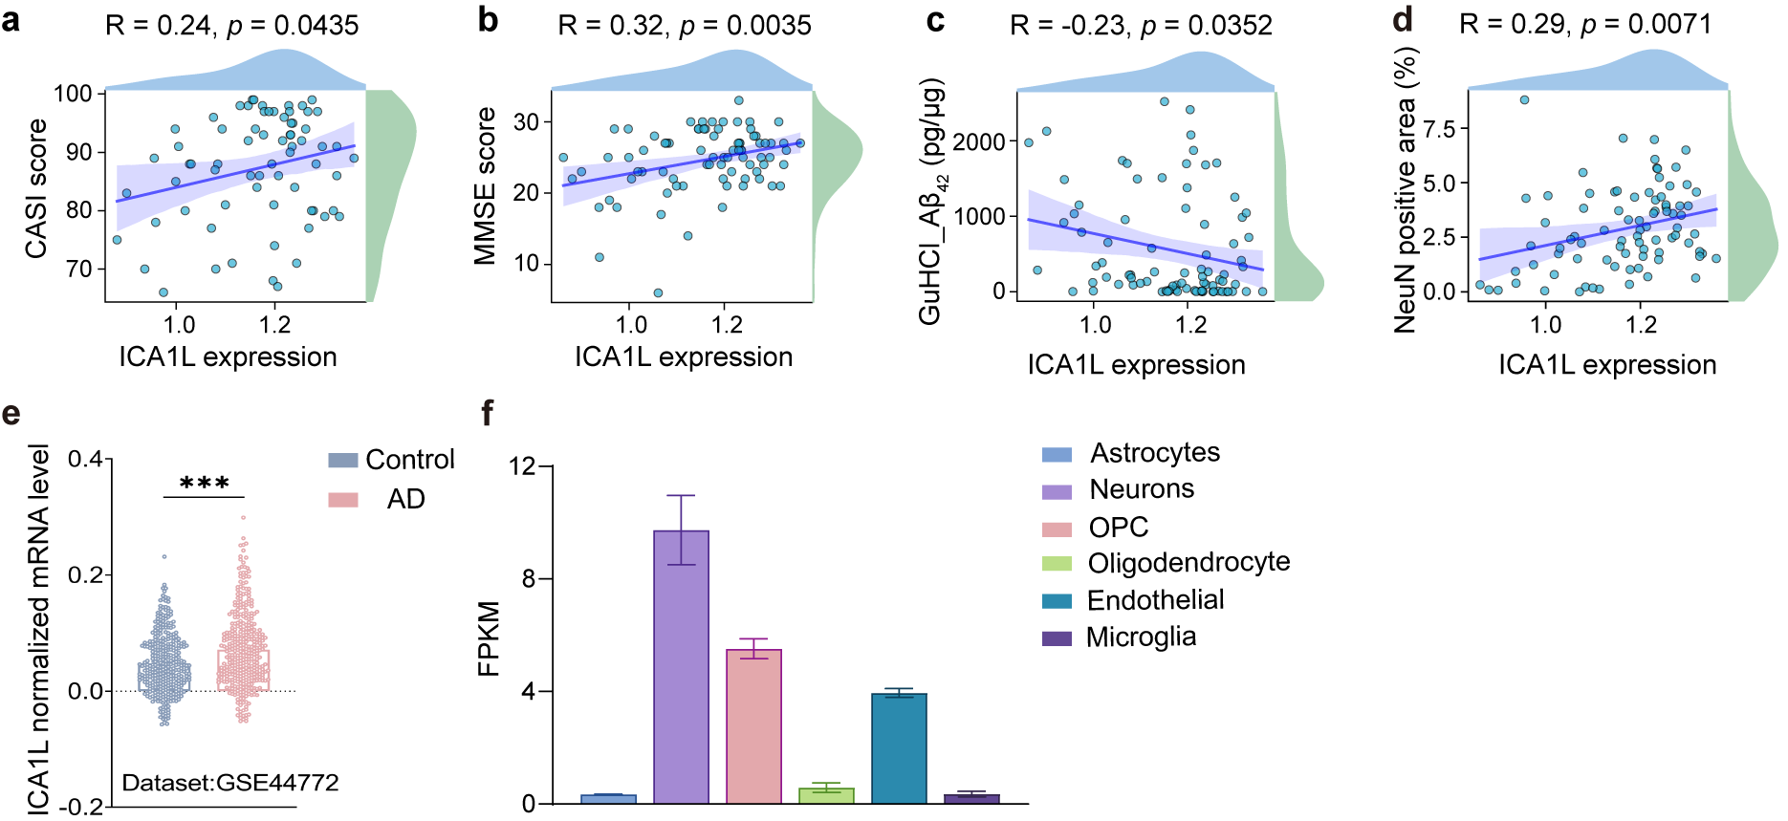
Supplementary Fig. 1 ICA1L expression correlates with neuronal markers and cognitive performance. (a-d) Pearson’s correlation between ICA1L expression levels and CASI scores (a), MMSE scores (b), GuHCl_Aβ₄₂ levels (c), and NeuN-positive areas (d). Single-cell RNA-seq data from the SEA-AD dataset were used for this analysis. (e) Transcription levels of ICA1L in the prefrontal cortex from AD and normal patients. Expression values in panel e were obtained from GSE44772 datasets. (f) ICA1L is highly expressed in neurons. Expression of ICA1L in different mouse brain cell types. Data are presented as mean ± SEM. statistical analyses were done using unpaired two-tailed Student’s t test (e). *** p < 0.001.

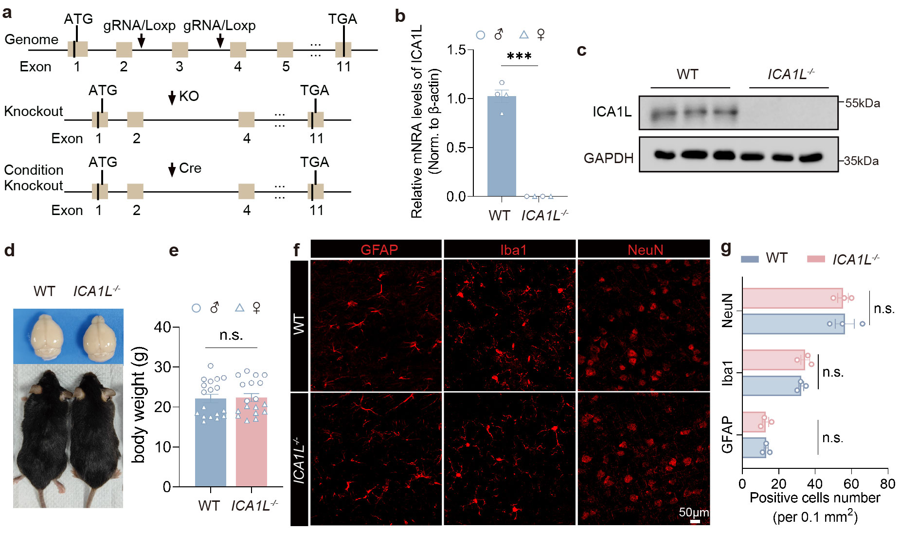
Supplementary Fig. 2 Generation of ICA1L knockout mice. (a) Schematic diagram of generation of ICA1L knockout mice by CRISPR/Cas9-mediated deletion of exon 3, and conditional knockout mice by flanking exon 3 with loxP sites for Cre-mediated excision. (b) ICA1L mRNA level is deleted in ICA1L knockout mice and age-matched WT mice. (n = 4 mice, with 2 males and 2 females). (c) ICA1L protein level is deleted in ICA1L knockout mice and age-matched WT mice. (n = 3 per group). (d) Observation of the overall body and brain morphologies of ICA1L^{-/-} mice and WT mice. (e) Comparison of body weight between ICA1L^{-/-} mice and their WT littermate controls at 3 months of age (n = 18 mice, with 9 males and 9 females). (f, g) Representative images (f) and quantification (g) of GFAP, Iba1, NeuN positive cells in the brains of WT and ICA1L^{-/-} mice (n = 6 slices from 3 mice, each value represents the mean of one mouse). Data represent mean ± SEM. statistical analyses were done using unpaired two-tailed Student’s t test (b, e), and two-way ANOVA with Tukey’s post hoc test (g). n.s. p > 0.05, *** p < 0.001.

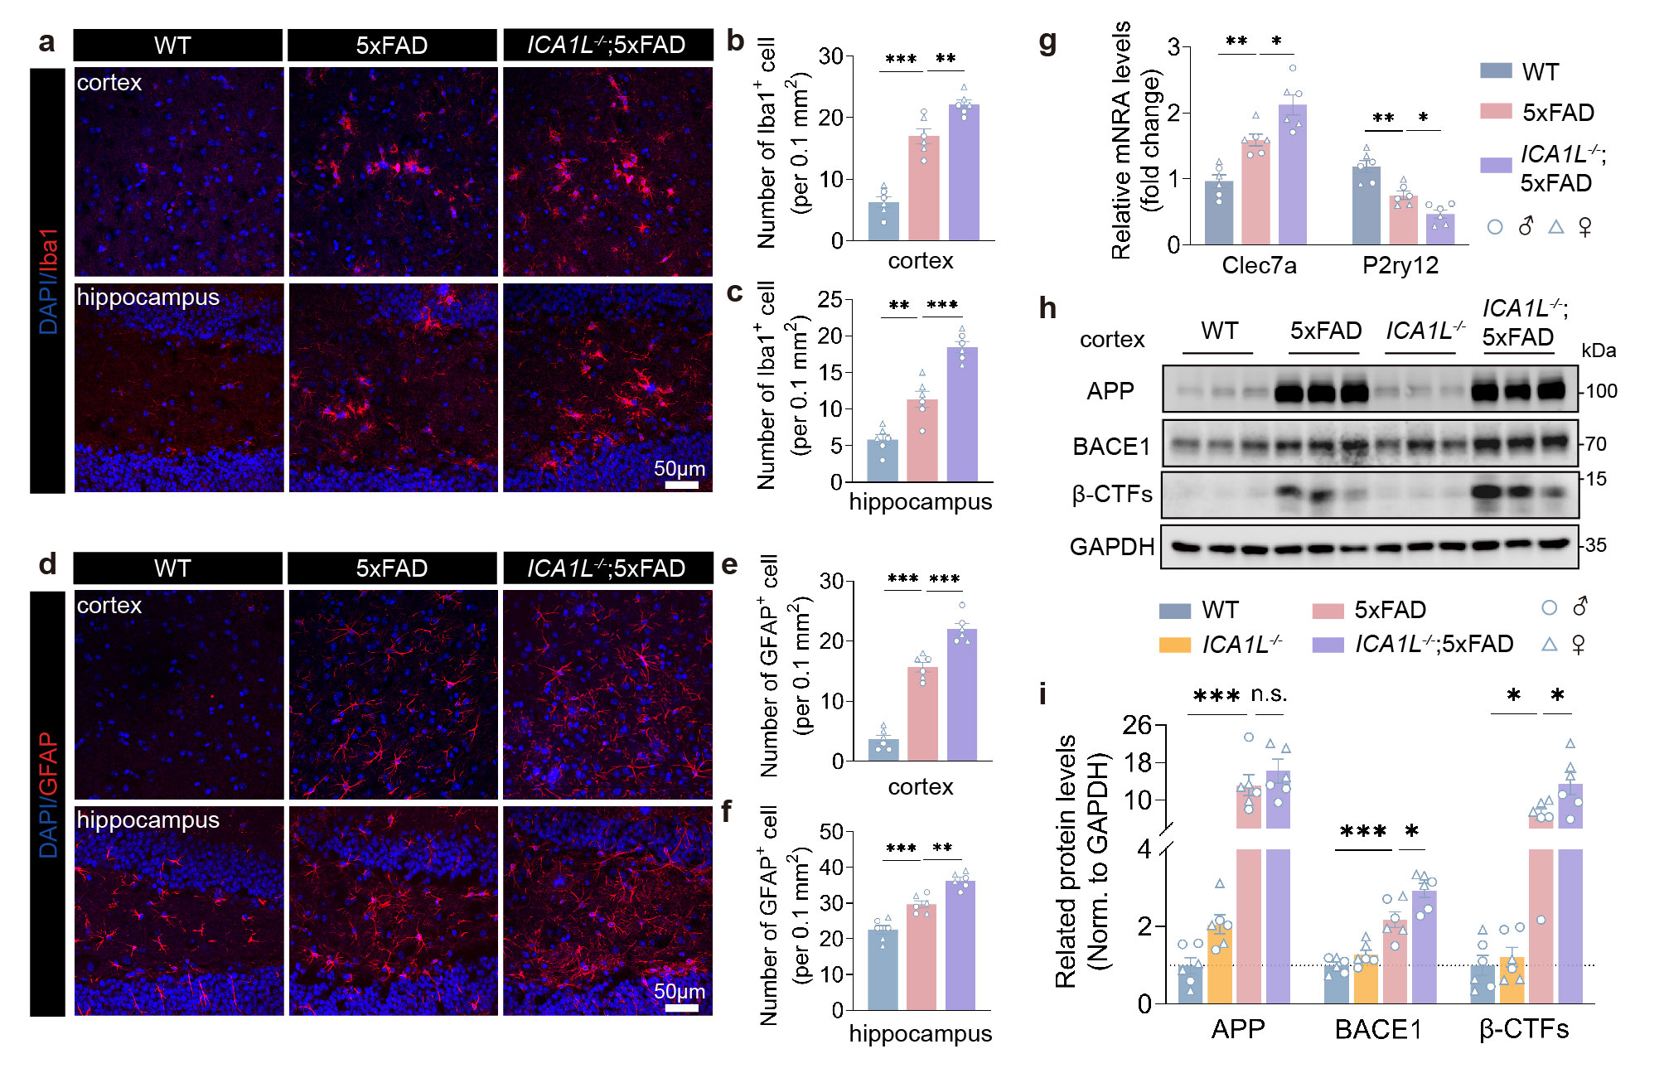
Supplementary Fig. 3 ICA1L deletion exacerbates neuroinflammation and upregulates BACE1 expression in 5xFAD mice. (a-c) Representative images (a) of Iba1 immunostaining in the cortex and hippocampus of WT, 5xFAD and ICA1L^{-/-};5xFAD mice. Quantification (b, c) of Iba1⁺ cells are shown on the right (n = 12 slices from 6 mice, with 3 males and 3 females; each value represents the mean of one mouse). Scale bar, 50 μm. (d-f) Representative images (d) of GFAP immunostaining in the cortex and hippocampus of WT, 5xFAD and ICA1L^{-/-};5xFAD mice. Quantification (e, f) of GFAP⁺ cells is shown on the right (n = 12 slices from 6 mice, with 3 males and 3 females; each value represents the mean of one mouse). Scale bar, 50 μm. (g) Quantitative analysis of Clec7a and P2ry12 mRNA levels. n = 6 mice, with 3 males and 3 females. (h, i) Western blot (h) analysis of APP, BACE1, and β-CTFs in the cortex, and quantification (i) of relative intensity is presented below (n = 6 mice, with 3 males and 3 females). Data represent mean ± SEM. statistical analyses were done using one-way ANOVA with Tukey’s post hoc test (b, c, e, f) and two-way ANOVA with Tukey’s post hoc test (g, i), * p < 0.05, ** p < 0.01, *** p < 0.001.

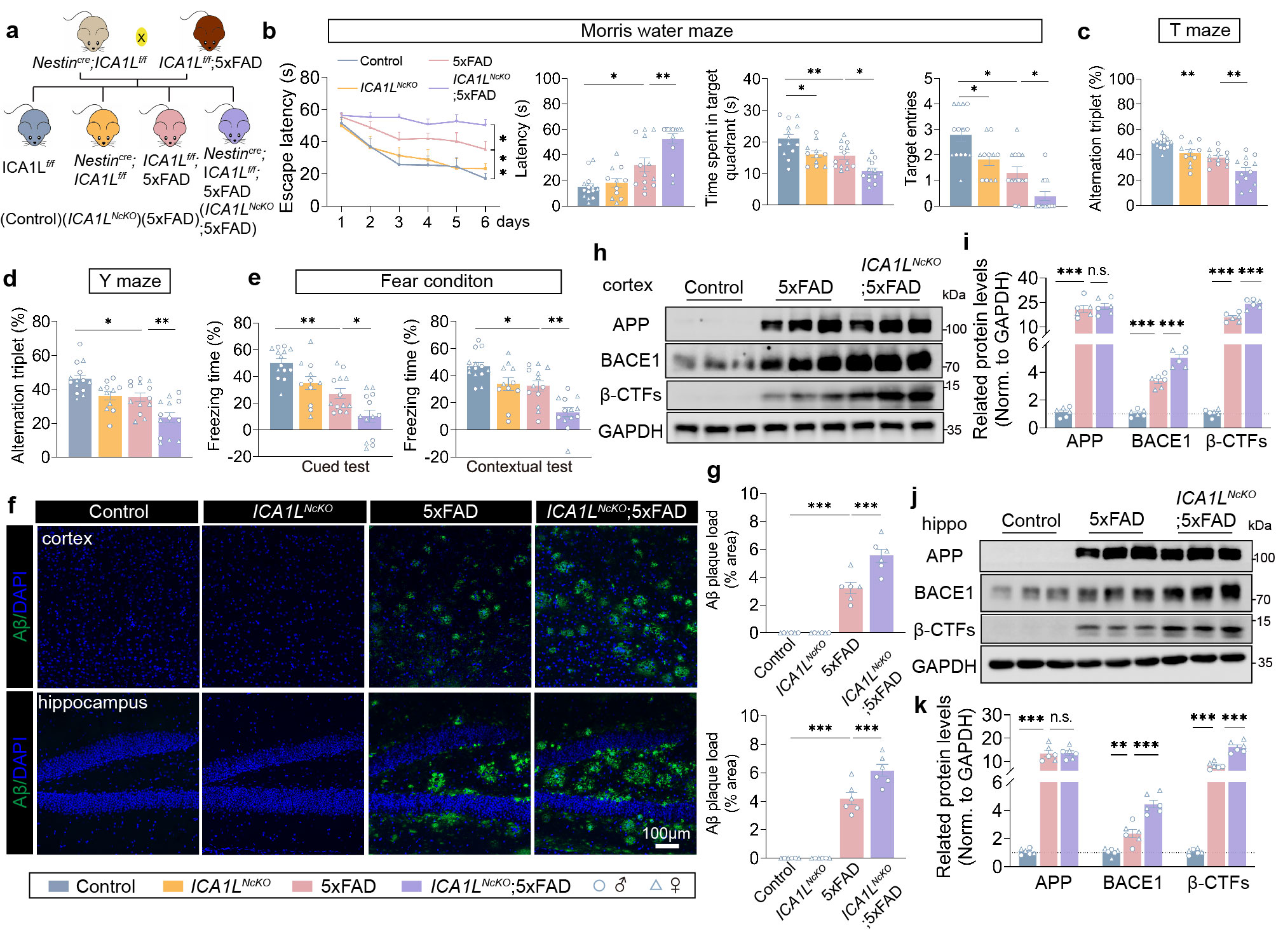
Supplementary Fig. 4 CNS-specific brain conditional knockout of ICA1L aggravates the cognitive impairments and Aβ burdens in 5xFAD mice. (a) Generation of ICA1L^{NcKO};5xFAD mice by crossing Nestin^{Cre};ICA1L^{f/f} with ICA1L^{f/f};5xFAD mice. (b) Morris water maze performance, including escape latency during training, escape latency in the probe trial, time spent in the target quadrant, and number of platform crossings during the probe trial (from left to right). (c, d) The spontaneous alternation in the T-maze (c) and Y-maze (d) test. (e) The cued and contextual fear conditioning tests (from left to right). The percentage of relative freezing time was used for evaluating contextual and cued memory. (f, g) Representative Aβ immunostaining (f) in the cortex and hippocampus of control, 5xFAD, ICA1L^{NcKO}, and ICA1L^{NcKO};5xFAD mice (Aβ antibody: MOAB2 clone), along with the statistical analysis (g) of Aβ burdens (n = 12 slices from 6 mice, with 3 males and 3 females; each value represents the mean of one mouse) were presented on the right. Scale bars, 100 μm. (h-k) Western blot and quantification of APP, BACE1, and β-CTFs protein levels in the cortex (h, i) and hippocampus (j, k) of Control, 5xFAD, and ICA1L^{NcKO};5xFAD mice (n = 6 mice, with 3 males and 3 females). Mouse numbers for behavioral tests: control, n = 14 mice, including 7 males and 7 females; 5xFAD, n = 13 mice, including 6 males and 7 females; ICA1L^{NcKO}, n = 11 mice, including 6 males and 5 females; ICA1L^{NcKO};5xFAD, n = 13 mice, including 6 males and 7 females. Data represent mean ± SEM. Statistical analyses were performed using one-way ANOVA with Tukey’s post hoc analysis (b, c, d, e, g) and two-way ANOVA with Tukey’s post hoc analysis (i, k). n.s. p > 0.05, * p < 0.05, ** p < 0.01, *** p < 0.001.

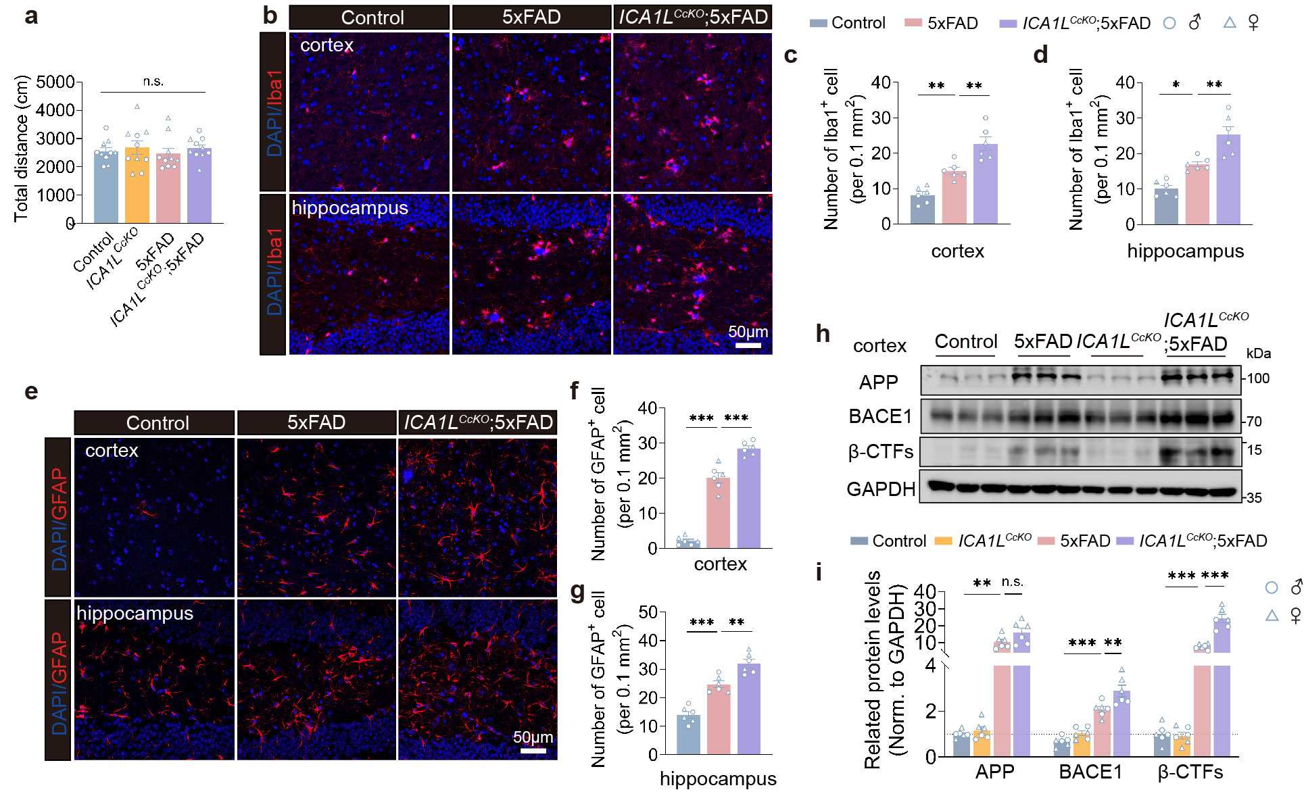
Supplementary Fig. 5 Deletion of ICA1L in excitatory neurons exacerbates neuroinflammation and upregulates BACE1 expression in 5xFAD mice. (a) Spontaneous locomotor activity in the open field test for Control, ICA1L^{CcKO}, 5xFAD, and ICA1L^{CcKO};5xFAD mice (n = 10 mice, with 5 males and 5 females). (b-d) Representative confocal images (b) of Iba1 immunostaining in the cortex and hippocampus of WT, 5xFAD and ICA1L^{CcKO};5xFAD mice. Quantification (c, d) of Iba1⁺ cells are shown on the right (n = 12 slices from 6 mice, with 3 males and 3 females; each value represents the mean of one mouse). Scale bar, 50 μm. (e-g) Representative immunofluorescence images (e) and quantification (f, g) of GFAP⁺ cells in the cortex and hippocampus of control, 5xFAD, and ICA1L^{CcKO};5xFAD mice (n = 12 slices from 6 mice, with 3 males and 3 females; each value represents the mean of one mouse). Scale bar, 50 μm. (h, i) Western blot (h) and quantification (i) of APP, BACE1, and β-CTFs in cortical lysates from WT, ICA1L^{CcKO}, 5xFAD, and ICA1L^{CcKO};5xFAD mice (n = 6 mice, with 3 males and 3 females). Data are presented as mean ± SEM. statistical analyses were done using one-way ANOVA with Tukey’s post hoc test (a, c, d, f, g) and two-way ANOVA with Tukey’s post hoc analysis (i). n.s. p > 0.05, * p < 0.05, ** p < 0.01, *** p < 0.001.

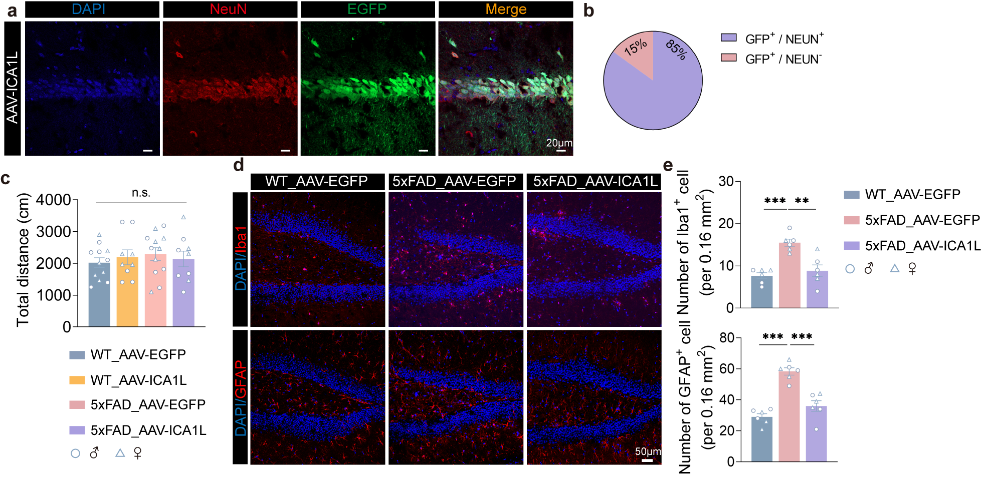
Supplementary Fig. 6 Overexpression of ICA1L attenuates neuroinflammation in 5xFAD mice. (a, b) Representative immunofluorescence images (a) and quantification (b) of EGFP and NeuN co-labeled cells in the AAV-ICA1L-injected brain region. (n = 3 mice per group with two slices per mouse). Scale bar, 20 μm. (c) Spontaneous locomotor activity was assessed in open field test for WT_AAV-EGFP, n = 12 (6 males, 6 females); WT_AAV-ICA1L, n = 9 (5 males, 4 females); 5xFAD_AAV-EGFP, n = 12 (6 males, 6 females); and 5xFAD_AAV-ICA1L, n = 9 (5 males, 4 females). (d, e) Representative images (d) of hippocampal Iba1 and GFAP immunostaining. Quantification (e) of Iba1⁺ and GFAP⁺ cell numbers is shown on the right (n = 12 sections from 6 mice, with 3 males and 3 females; each value represents the mean of one mouse). Scale bars: 50 μm. Data are presented as mean ± SEM. Statistical analyses were done using one-way ANOVA with Tukey’s post hoc test (c, e), n.s. p > 0.05, ** p < 0.01, *** p < 0.001.

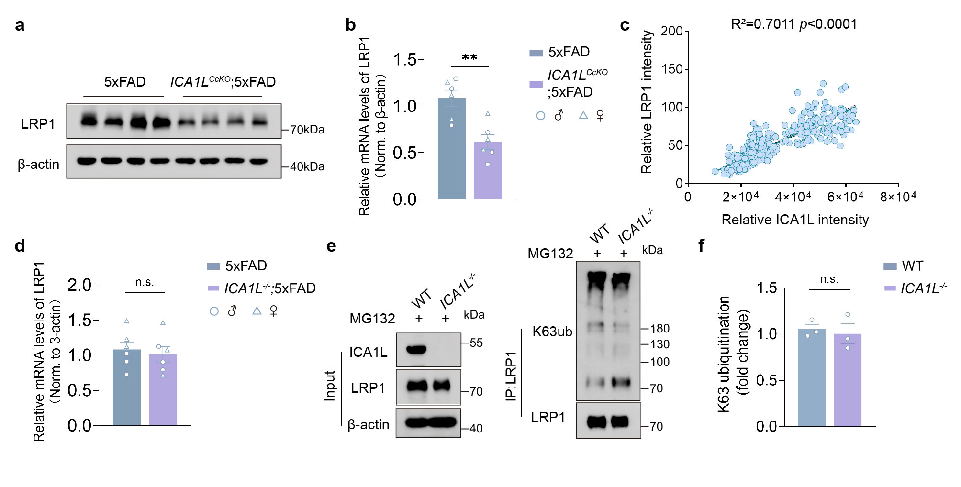
Supplementary Fig. 7 ICA1L deficiency leads to reduced LRP1 protein levels. (a, b) Western blot (a) and quantification (b) of hippocampal LRP1 protein levels in ICA1L^{CcKO};5XFAD and 5xFAD mice (n = 6 mice, with 3 males and 3 females). The LRP1 bands shown represent the β-chain. (c) Pearson’s r correlation coefficient of protein level of ICA1L with LRP1. n = 80 participants were included, and each participant was measured multiple times. (d) The mRNA levels of LRP1 in the hippocampus of ICA1L^{-/-};5xFAD and 5xFAD mice were measured (n = 6 mice, with 3 males and 3 females). (e, f) Co-IP and western blot analysis of K63-linked ubiquitination of WT and ICA1L^{-/-} primary neuron, and treated with MG132 (20 µM). n = 3 independent experiments. Data are presented as mean ± SEM. Statistical analyses were done using unpaired two-tailed Student’s t test (b, d, f). n.s. p > 0.05, ** p < 0.01.

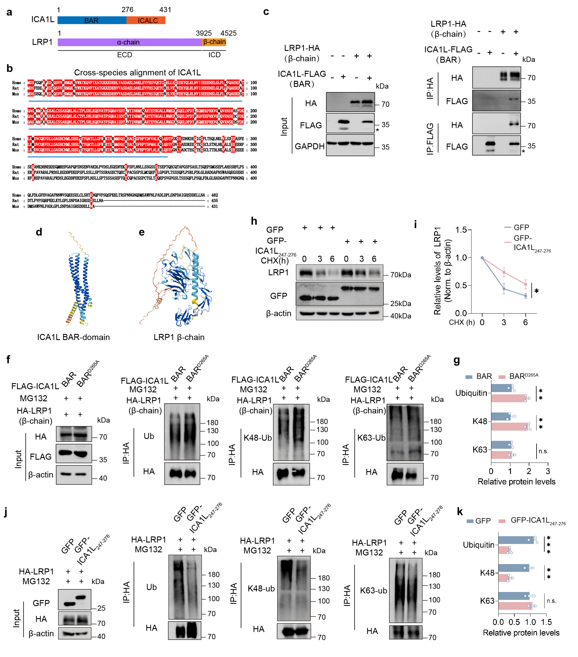
Supplementary Fig. 8 ICA1L interacts with LRP1 to modulate ubiquitination. (a) Schematic representations of the structures of ICA1L and LRP1. ICA1L consists of an N-terminal BAR domain and a C-terminal ICALC domain. LRP1 consists of an extracellular α-chain and an intracellular β-chain. (b) Sequence alignment of human, rat, and mouse ICA1L proteins. The alignment was performed using Clustal Omega and visualized with BoxShade. The BAR domain, predicted by SMART, is indicated by a blue bar and spans amino acids 1-276. Conserved amino acid residues are highlighted in red. (c) Representative Co-IP and western blot analysis of the interaction between LRP1 (β-chain) and ICA1L (BAR) in HEK293T cells (n = 3 independent experiments). The asterisk denotes a non-specific band. (d, e) Modelling spatial structure of ICA1L (BAR domian) and LRP1 (β-chain). (f, g) Co-IP and western blot analysis of total, K48-linked, and K63-linked ubiquitination in HEK293T cells co-transfected with LRP1 and either ICA1L-BAR or ICA1L-BAR^{D265A} plasmids, followed by MG132 treatment. (n = 3 independent experiments). (h, i) LRP1 expression in HEK293T cells transfected with GFP-ICA1L₂₄₇₋₂₇₆ fragment or GFP control following CHX treatment at the indicated time points (n = 3 per group). The LRP1 bands shown represent the β-chain. (j, k) Co-IP and western blot analysis of total, K48-linked, and K63-linked ubiquitination in HEK293T cells co-transfected with LRP1 and either GFP or GFP-ICA1L_{247–276} plasmids, followed by MG132 treatment. (n = 3 independent experiments). Data represent mean ± SEM. statistical analyses were done using two-way ANOVA with Tukey’s post hoc test (g, i, k). * p < 0.05, ** p < 0.01, *** p < 0.001.
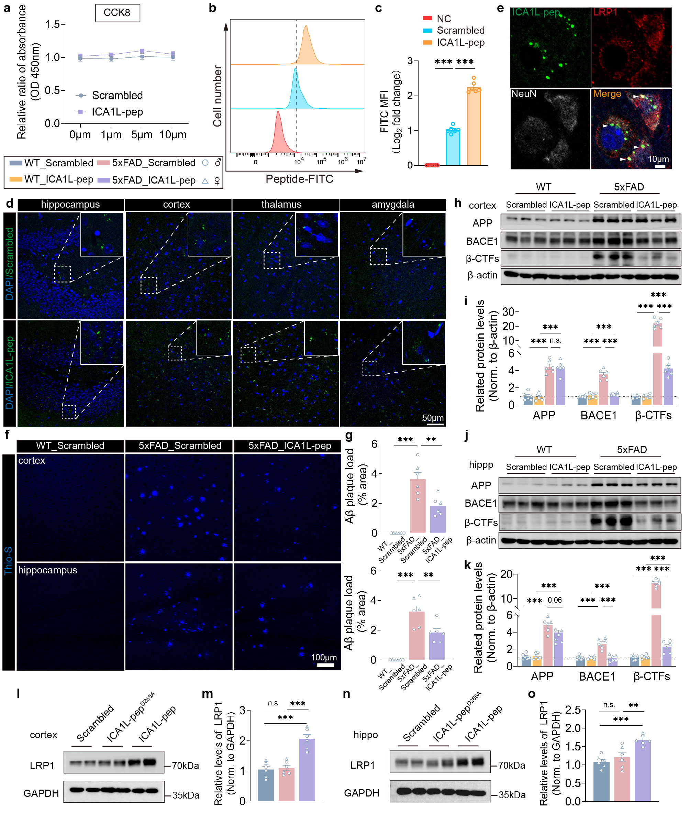
Supplementary Fig. 9 The ICA1L-peptide penetrates the brain parenchyma and ameliorates Aβ deposition in 5xFAD mice. (a) Cytotoxicity of the ICA1L-peptide and scrambled control on HEK293T cells measured by CCK-8 assay (n = 6 per group). (b, c) FITC fluorescence in HEK293T cells treated with ICA1L-peptide, scrambled peptide, or negative control was quantified by flow cytometry (b) and fluorescence intensity analysis (c) (n = 6 per group). (d) Distribution of ICA1L-peptide and scrambled control in different brain regions. Scale bars, 50 μm. (e) Colocalization of FITC-labeled ICA1L-peptide (green) with LRP1 (red) and NeuN (gray) in brain sections from ICA1L-peptide injected mice. LRP1 and NeuN were detected by immunostaining. Scale bar, 10 μm. (f, g) Thioflavin S staining (f) and quantification (g) of Aβ deposition in 7-month-old WT and 5xFAD mice injected with ICA1L-peptide or scrambled control (n = 12 slices from 6 mice, with 3 males and 3 females; each value represents the mean of one mouse). Scale bar, 100 μm. (h-k) Western blot and quantification of APP, BACE1, and β-CTFs protein levels in the cortex (h, i) and hippocampus (j, k) of WT and 5xFAD mice treated with ICA1L-peptide or scrambled control (n = 6 mice, with 3 males and 3 females). (l-o) Western blot analysis and quantification of LRP1 protein expression in the cortex (l, m) and hippocampus (n, o) of mice treated with ICA1L-peptide, ICA1L-peptideD265A, or scrambled peptide. n = 6 mice, with 3 males and 3 females. The LRP1 bands shown represent the β-chain. Data are presented as mean ± SEM. Statistical analyses were performed using one-way ANOVA with Tukey’s post hoc test (c, m, o) and two-way ANOVA with Tukey’s post hoc test (g, i, k). *p < 0.05; **p < 0.01; ***p < 0.001.

Supplement table 1. Information on human brain samples
No. | Sample ID | Disorder | Age | Gender | Braak Stage | PMI (min)
1 | 2019CBB009 | HC | 72 | Male | - | 460
2 | 2022CBB040 | HC | 87 | Male | - | 556
3 | 2020CBB036 | HC | 87 | Female | - | 718
4 | 2021CBB013 | HC | 92 | Male | - | 340
5 | 2017CBB001 | AD | 91 | Female | Ⅲ | 520
6 | 2022CBB031 | AD | 86 | Male | Ⅲ | 215
7 | 2021CBB028 | AD | 89 | Female | Ⅲ | 243
8 | 2016CBB029 | AD | 83 | Male | Ⅳ | 270
AD = Alzheimer’s disease; HC = Healthy Control; PMI = Post Mortem Interval.
Supplementary table 2. Primer sequences
Gene | Primer sequences
β-actin | Forward：5'-CTGAGAGGGAAATCGTGCGT-3'
β-actin | Reverse: 5'-TGTTGGCATAGAGGTCTTTA-3'
ICA1L | Forward: 5'- CAGGAGACATGCAATGAACT -3'
ICA1L | Reverse: 5'- CCGCTCTGCTTGAAACTTTA -3'
LRP1 | Forward: 5'- TCCCCAACCGCTGGCTCTGT -3'
LRP1 | Reverse: 5'- GGTGGGGTAGGCGCATGAGG -3'
P2ry12 | Forward: 5'- ATGGATATGCCTGGTGTCAACA -3'
P2ry12 | Reverse: 5'- AGCAATGGGAAGAGAACCTGG -3'
Clec7a | Forward: 5'- TGAGGGCAGCTCAACAATAC -3'
Clec7a | Reverse: 5'- AGTCTCCAGCTTGGCTTTCC -3'

