Table. S1 primer sequence of 16 candidate methylation genes.
Gene | Forward primer | Reverse primer
GFRA1 | GGGTTTAATTCGAGACGTTGAAC | CCACCGAAAACTCGAACTCC
MIR124-2 | TGGTGATGGAGGAGGTTTAGTAAGT | CGTAAAAATATAAACGATACGTATACCTACGT
ASCL1 | GTCGTAGCGGTAGCGTAGAGC | CGTTTACAACGCATCAATTCG
CCDC181 | TTGAGGATATTGTATGCGTTTGC | GACACCTACCTCCGCGACA
EPB41L3 | GGGATAGTGGGGTTGACGC | ATAAAAATCCCGACGAACGA
JAM3 | GGGATTATAAGTCGCGTCGC | CGAACGCAAAACCGAAATCG
PAX1 | TATTTTGGGTTTGGGGTCGC | CCCGAAAACCGAAAACCG
SORCS1 | GGTGCGTAGCGTAGTTCGGTC | CCAAATTACGCCGCGATAAA
PCDHA13 | CGTTTTCGAGGAAGTAAAATACGG | GTATCTTTTAAACGCCACCCGAA
LOC100289333 | GTTTCGGTTTTAGTTTCGGCG | CACTACTCCTCCCACGCACG
BOLL | GAGACGTTTCGGTTCGGAGTT | CGTCGCCTCGAATAACAAATAA
FAM19A4 | AGTCGGGCGGTTCGGTTA | CGTAAAAATATAAACGATACGTATACCTACGT
MIR129-2 | CGGCGGCGAATCGAAG | GAATACGCCCTCCGCAAATAC
ZIC1 | TCGGGTTTTACGAGTAGGTTGTC | GCGAACTAATCACCTAACCGTACTA
SOX1 | TTGTAGTTTTCGAGTTGGAGGTC | AAAACGATACGCTAAACCCG
ACTB | TGGTGATGGAGGAGGTTTAGTAAGT | TGGTGATGGAGGAGGTTTAGTAAGT

Table. S2. Sensitivity, specificity, and cut-off of candidate gene DNA methylation markers differentiated between CIN2- and CIN3+ detection.
Gene | sensitivity |  | specificity |  | Cut-off
 | 95% CI |  | 95% CI
GFRA1 | 75.0% (60.1-85.9%) |  | 79.4% (61.6-90.7%) |  | 10.94
MIR124-2 | 77.1% (62.3-87.5%) |  | 94.1% (78.9-99.0%) |  | 9.89
ASCL1 | 52.1% (37.4-66.5%) |  | 94.1% (78.9-99.0%) |  | 10.93
CCDC181 | 56.3% (41.3-70.2%) |  | 94.1% (78.9-99.0%) |  | 4.45
EPB41L3 | 39.6% (26.1-54.7%) |  | 97.1% (82.9-99.8%) |  | 4.99
JAM3 | 68.8% (53.6-80.9%) |  | 91.2% (75.2-97.7%) |  | 9.22
PAX1 | 58.3% (43.3-72.1%) |  | 91.2% (75.2-97.7%) |  | 8.69
SORCS1 | 58.3% (43.3-72.1%) |  | 91.2% (75.2-97.7%) |  | 9.37
PCDHA13 | 58.3% (43.3-72.1%) |  | 97.1% (82.9-99.8%) |  | 3.68
SST | 50.0% (35.4-64.6%) |  | 91.2% (75.2-97.7%) |  | 4.48
LOC100289333 | 79.2% (64.6-89.0%) |  | 85.3% (68.2-94.5%) |  | 6.20
BOLL | 66.7% (51.5-79.2%) |  | 91.2% (75.2-97.7%) |  | 4.69
FAM19A4 | 70.8% (55.7-82.6%) |  | 79.4% (61.6-90.7%) |  | 6.47
MIR129-2 | 64.6% (49.4-77.4%) |  | 88.2% (71.6-96.2%) |  | 7.74
ZIC1 | 70.8% (55.7-82.6%) |  | 97.1% (82.9-99.8%) |  | 3.29
SOX1 | 68.8% (53.6-80.9%) |  | 94.1% (78.9-99.0%) |  | 5.25
Fig. S1. Sixteen genes methylation positivity in cervical scrapings (n = 82). The distribution of the methylation positivity of the 16 candidate markers in ≤CIN1, CIN2, CIN3, and CC group.

Table. S3. Sensitivity and specificity of cytology and DNA methylation for detecting CIN3+ in hrHPV-positive women.
 | sensitivity |  | specificity |  | AUC
 | 95% CI |  | 95% CI |  | 95% CI
Cytology | 66.7% (24.2-94.0%) |  | 9.1% (0.48-42.9%) |  | 0.379 (0.081-0.677)
Methylation markersª
miR124-2^{m}  JAM3^{m}  LOC100289333^{m}  ZIC1^{m}  SOX1^{m} | 66.7% (24.2-94.0%)  33.3% (6.0-75.9%)  66.7% (24.2-94.0%)  66.7% (24.2-94.0%)  83.3% (36.5-99.1%) |  | 72.7% (39.3-92.7%)  100.0% (67.9-100%)  90.9% (57.1-99.5%)  90.9% (57.1-99.5%)  81.8% (47.8-96.8%) |  | 0.697 (0.423-0.971)  0.667 (0.369-0.964)  0.788 (0.533-1.000)  0.788 (0.533-1.000)  0.826 (0.603-1.000)
ªUsing a threshold for positivity at a methylation ratio of 8.56 for MIR124-2, 5.94 for JAM3, 6.27 for LOC100289333, 3.29 for ZIC1, and 5.25 for SOX1. ^{b}The performance of each marker in cervical scrapes was evaluated by AUC with 95% (CI).
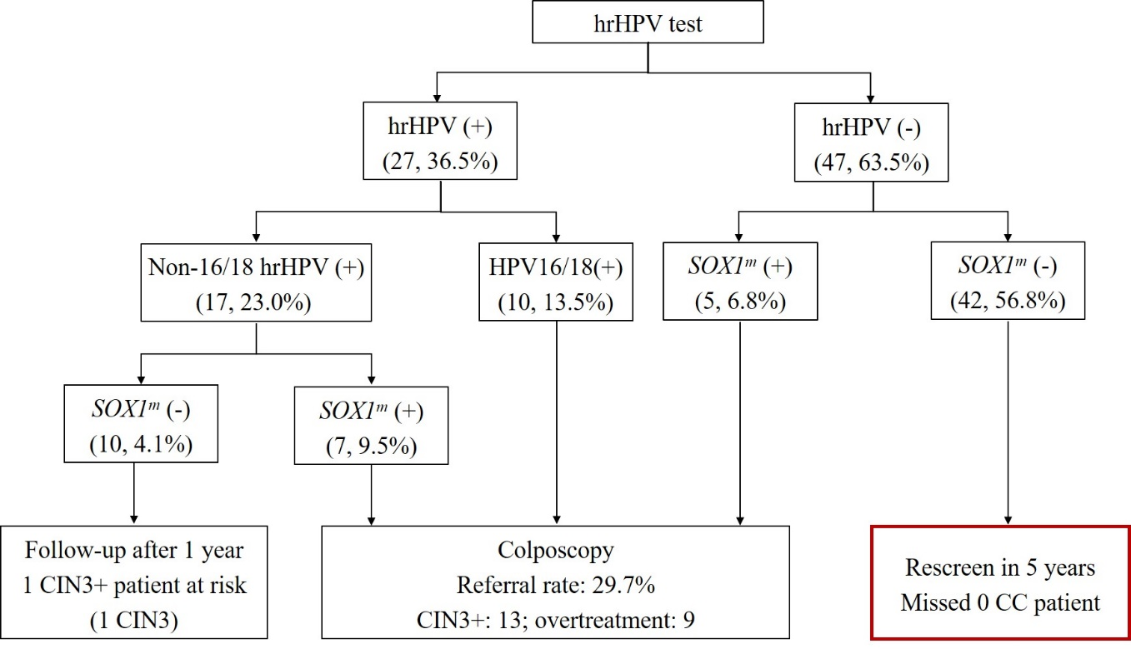
Fig. S2 SOX1^{m} analysis in the Chinese cohort

