Supplementary Table 1 Searching strategy by database
Database | Search string | Number of entries
Pubmed | ("human papillomavirus"[tiab] OR HPV[tiab] OR "cervical cancer"[tiab] OR "uterine cervical neoplasms"[Mesh]) AND (Cameroon[tiab] OR "Cameroon"[Mesh]) | 121
Scopus | TITLE-ABS-KEY (("human papillomavirus" OR HPV OR "uterine cervical neoplasm") AND (Cameroon OR Cameroonian)) | 120
Web of sciences | TS= ("human papillomavirus" OR HPV OR "cervical cancer" OR OR "uterine cervical cancer") AND TS= (Cameroon OR Cameroonian) | 217
Embase | ('human papillomavirus':ti,ab,kw OR 'HPV':ti,ab,kw OR 'cervical cancer':ti,ab,kw OR 'uterine cervical neoplasms':ti,ab,kw) AND ('Cameroon':ti,ab,kw OR 'Cameroonian':ti,ab,kw) | 196
Cochrane Library | (human papillomavirus OR HPV OR cervical cancer) AND (Cameroon OR Cameroun) | 37
AJOL | (human papillomavirus OR HPV OR cervical cancer) AND (Cameroon OR Cameroun) | 33
Health Sciences and Disease | (human papillomavirus OR HPV OR cervical cancer) AND (Cameroon OR Cameroun) | 9

Subgroup analysis of high-risk HPV infection prevalence
Study period
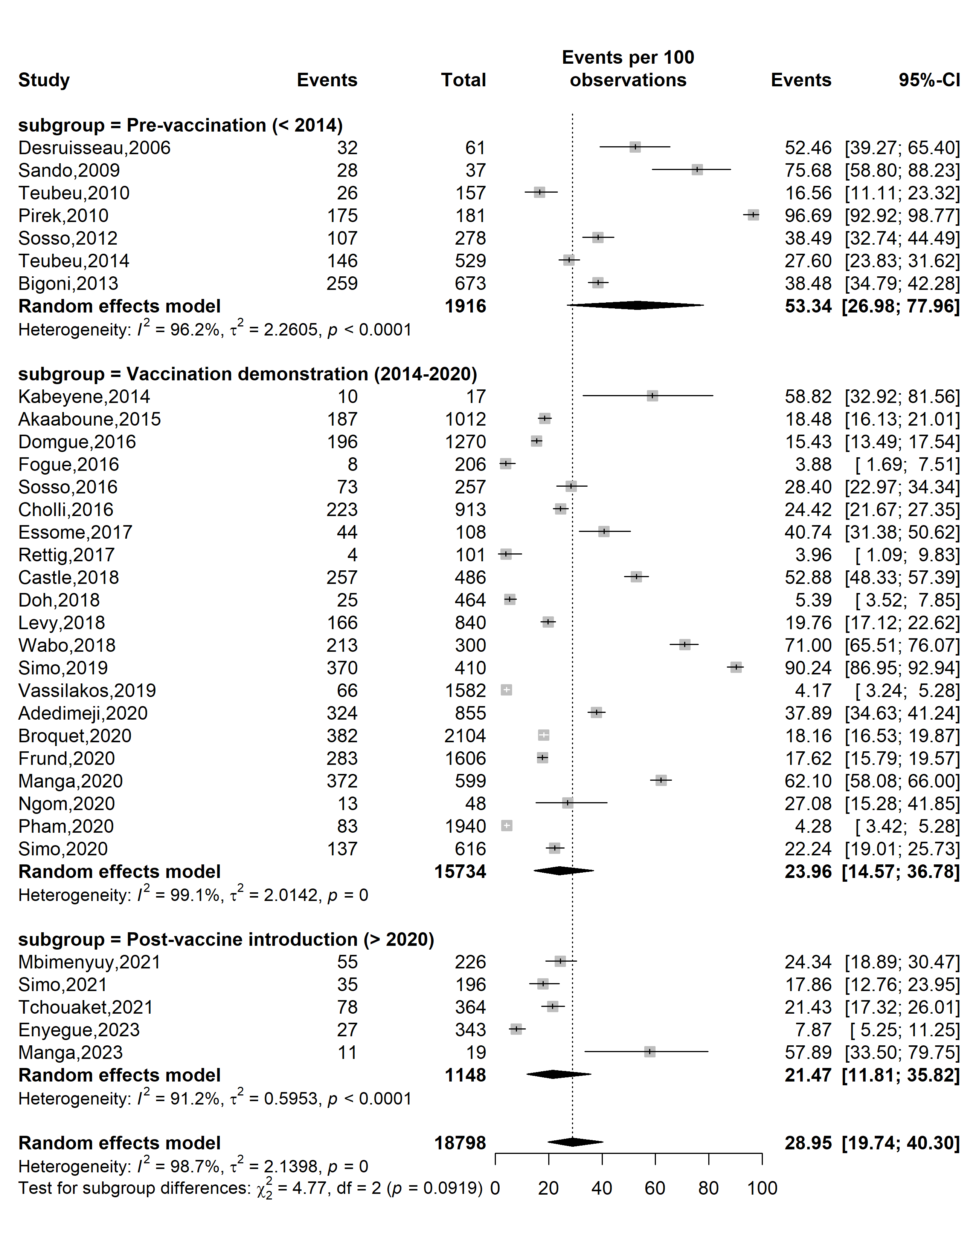
Supplementary Fig. 1 Pooled high-risk HPV prevalence according to specific HPV vaccine introduction timeframe in Cameroon

Study design
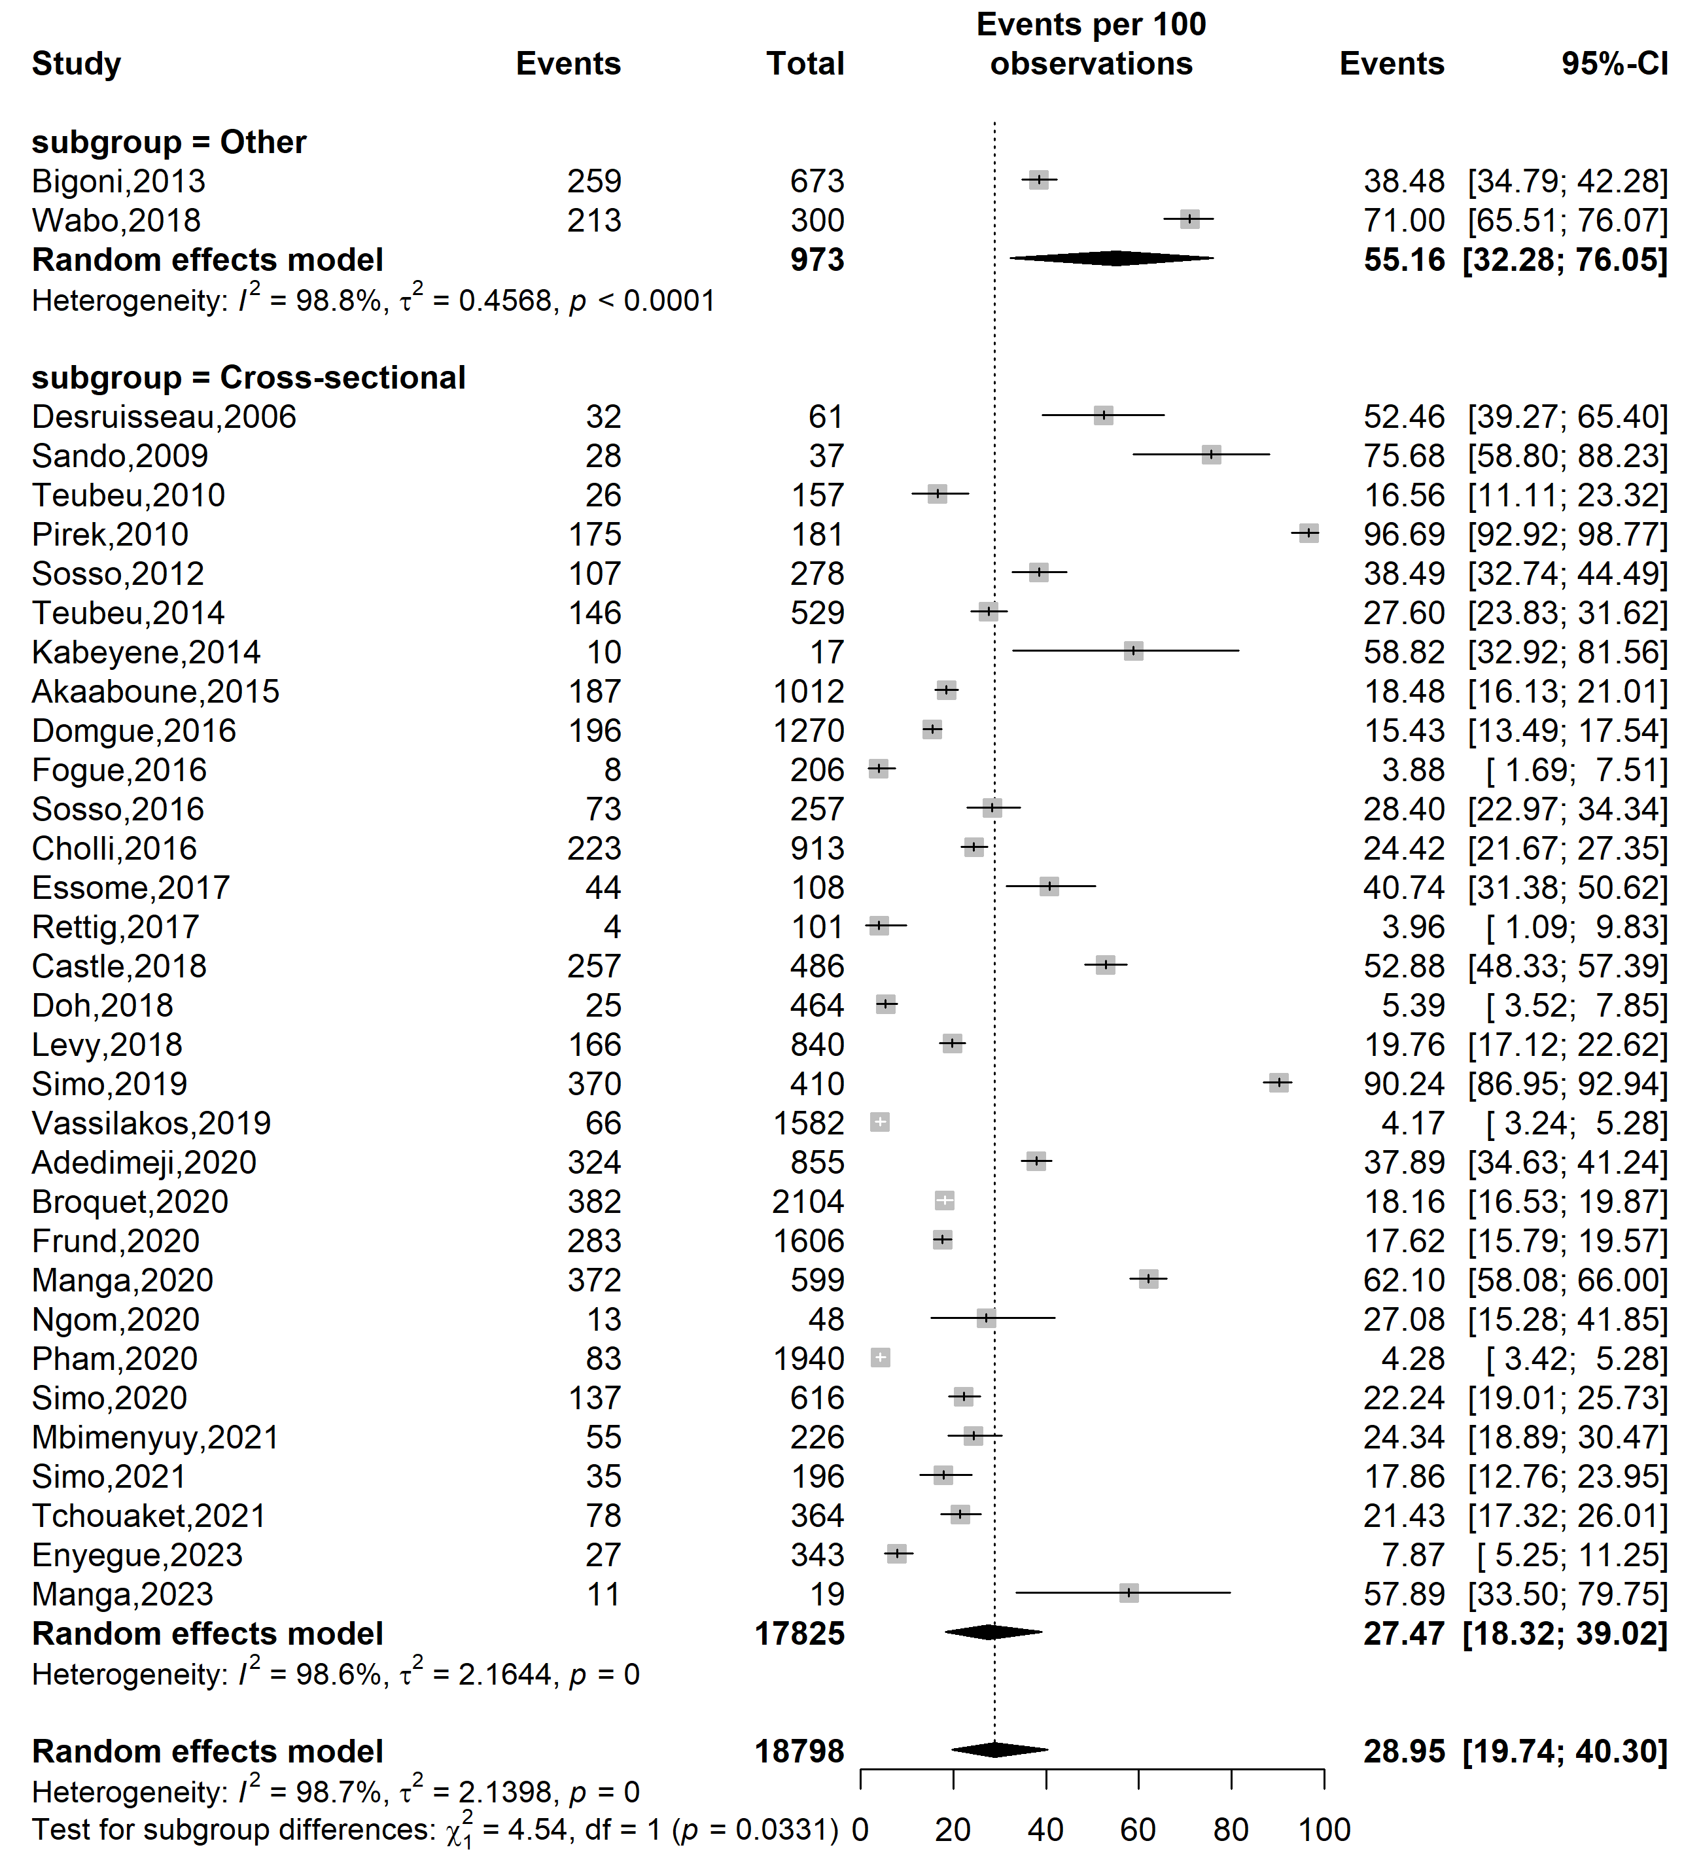
Supplementary Fig. 2 Pooled high-risk HPV prevalence in Cameroon by study design

Study setting
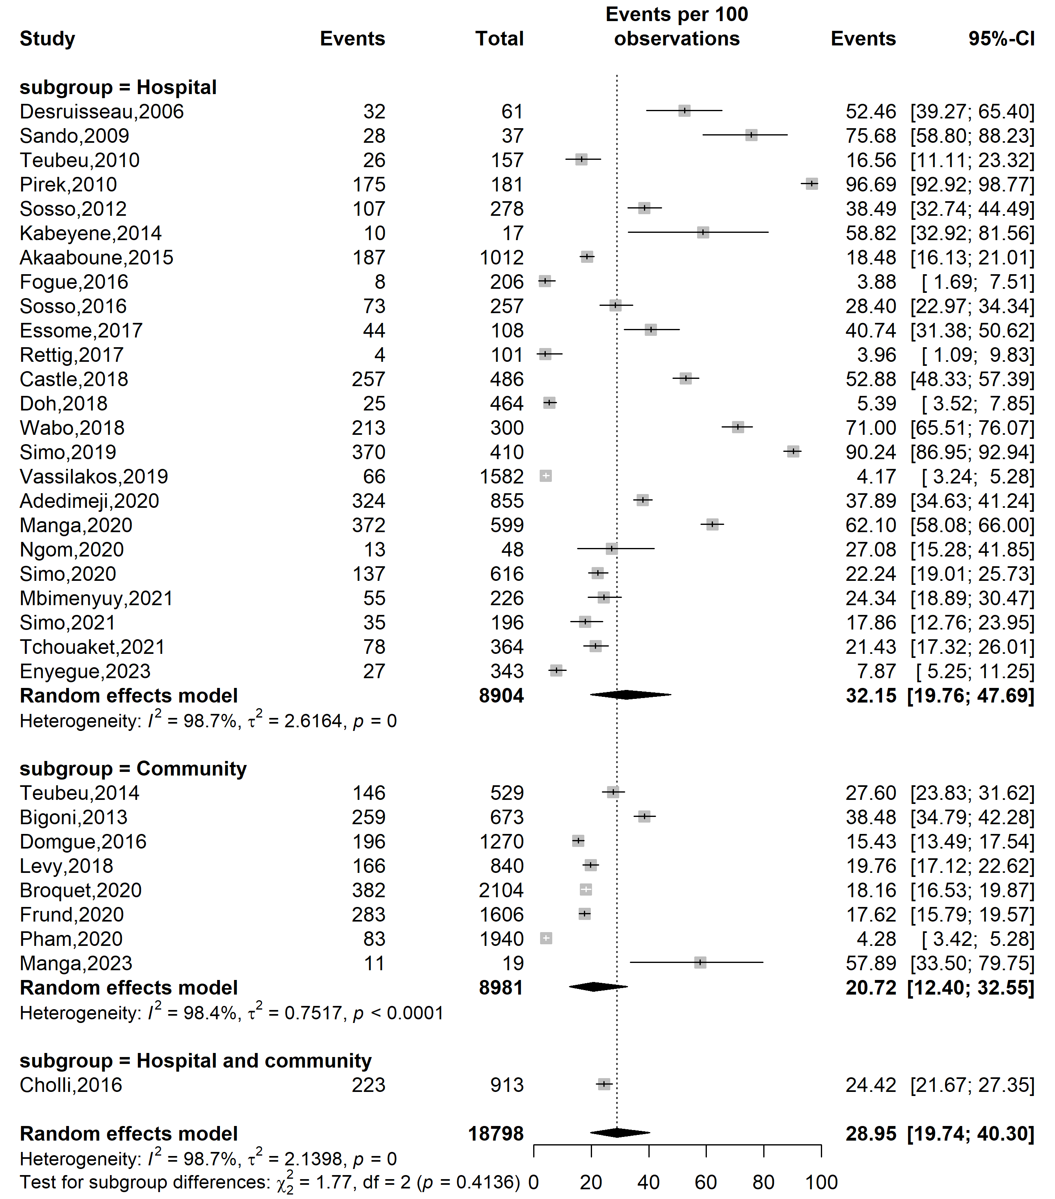
Supplementary Fig. 3 Pooled high-risk HPV prevalence in Cameroon by study setting

Study site
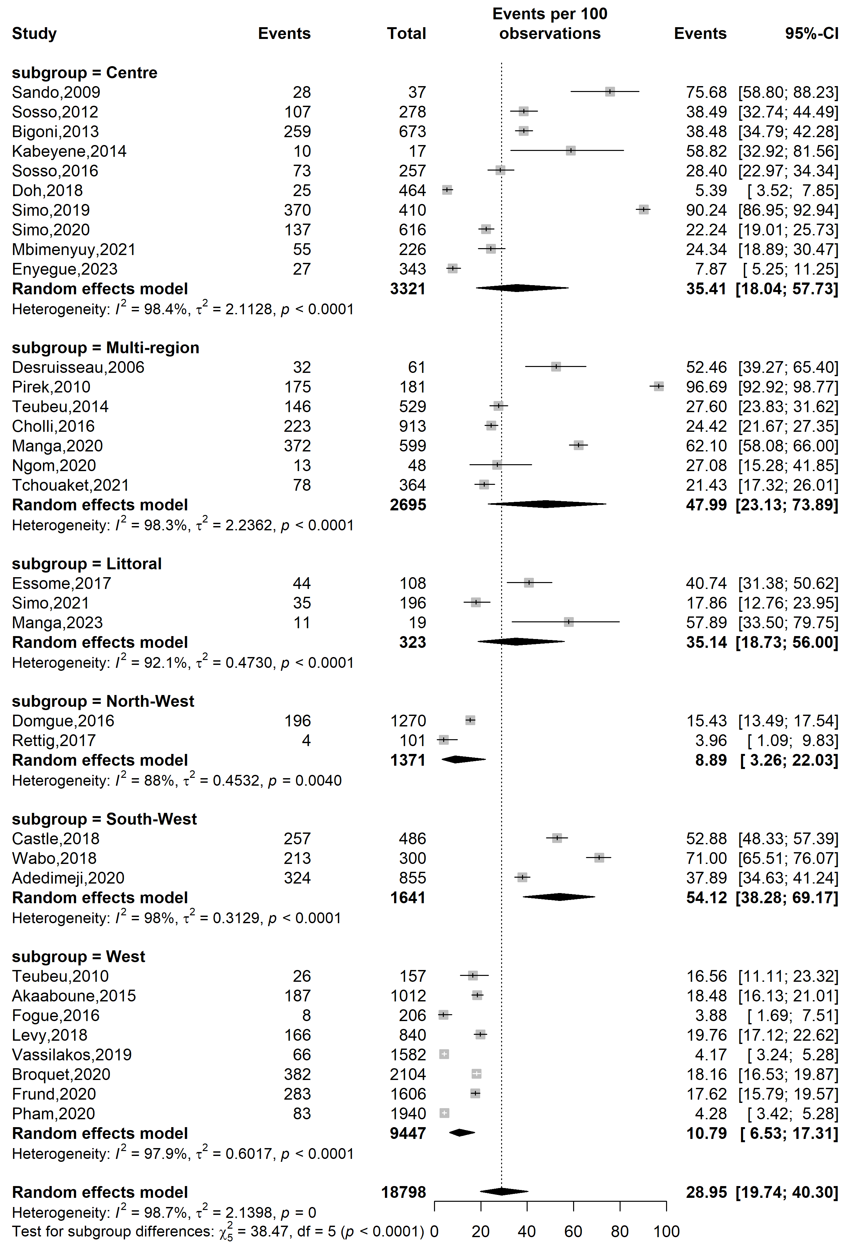
Supplementary Fig. 4 Pooled high-risk HPV prevalence in Cameroon by study site 1
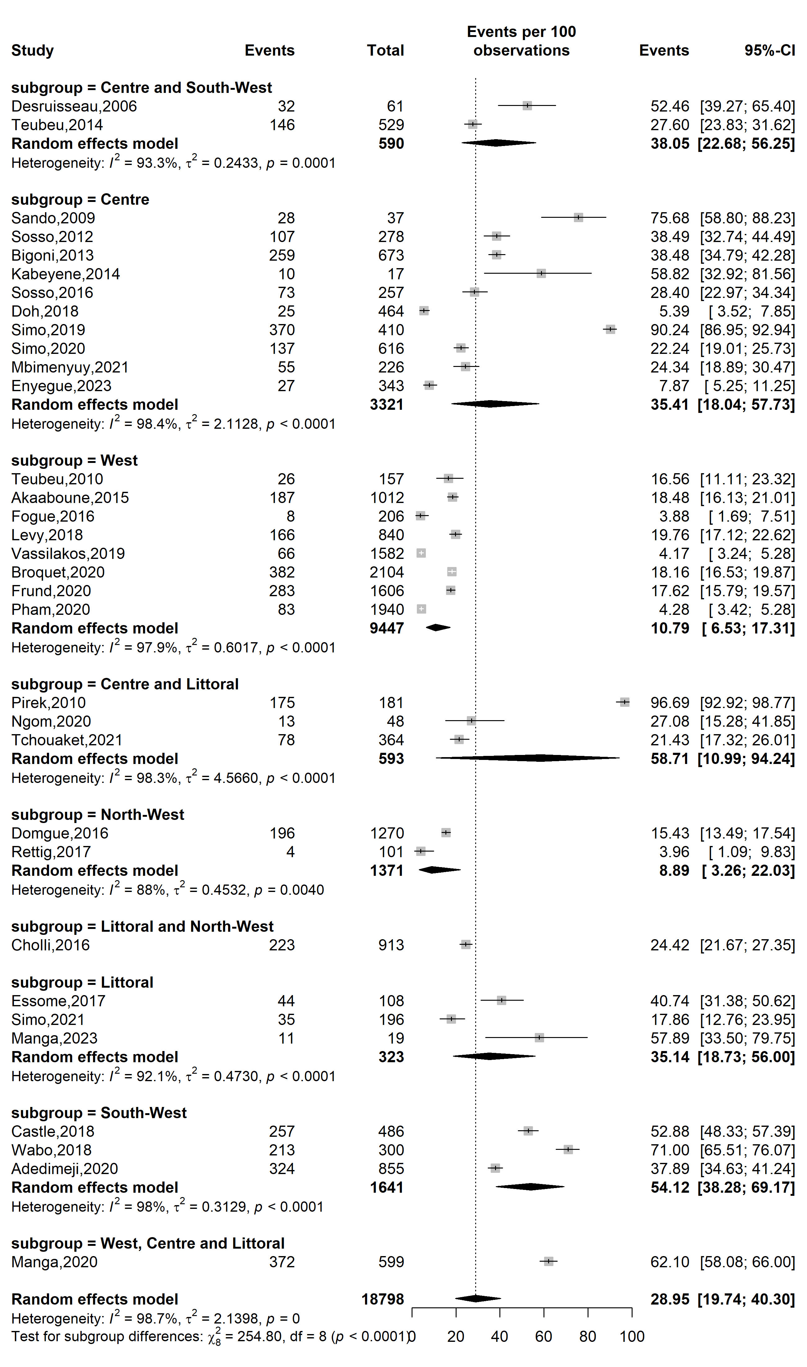
Supplementary Fig. 5 Pooled high-risk HPV prevalence in Cameroon by study site 2
Sampling method
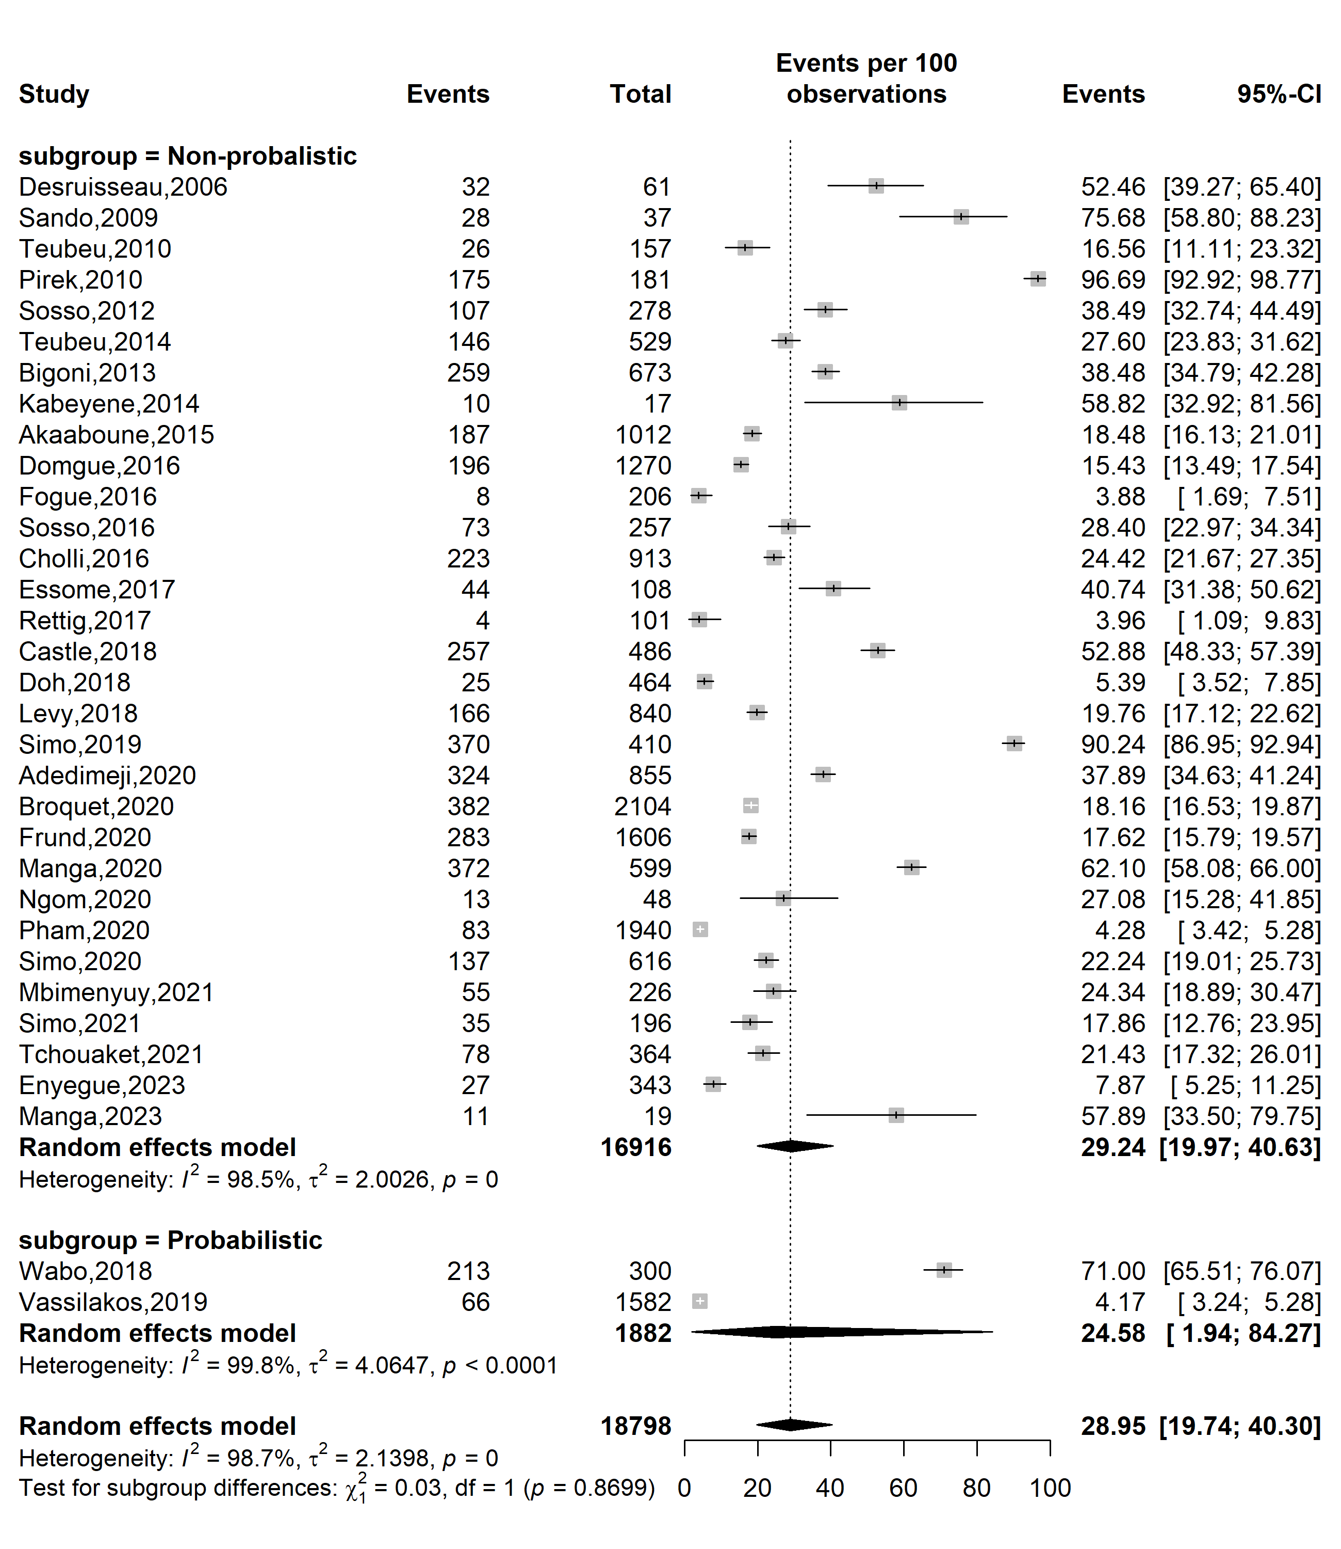
Supplementary Fig. 6 Pooled high-risk HPV prevalence in Cameroon by sampling method

Participant
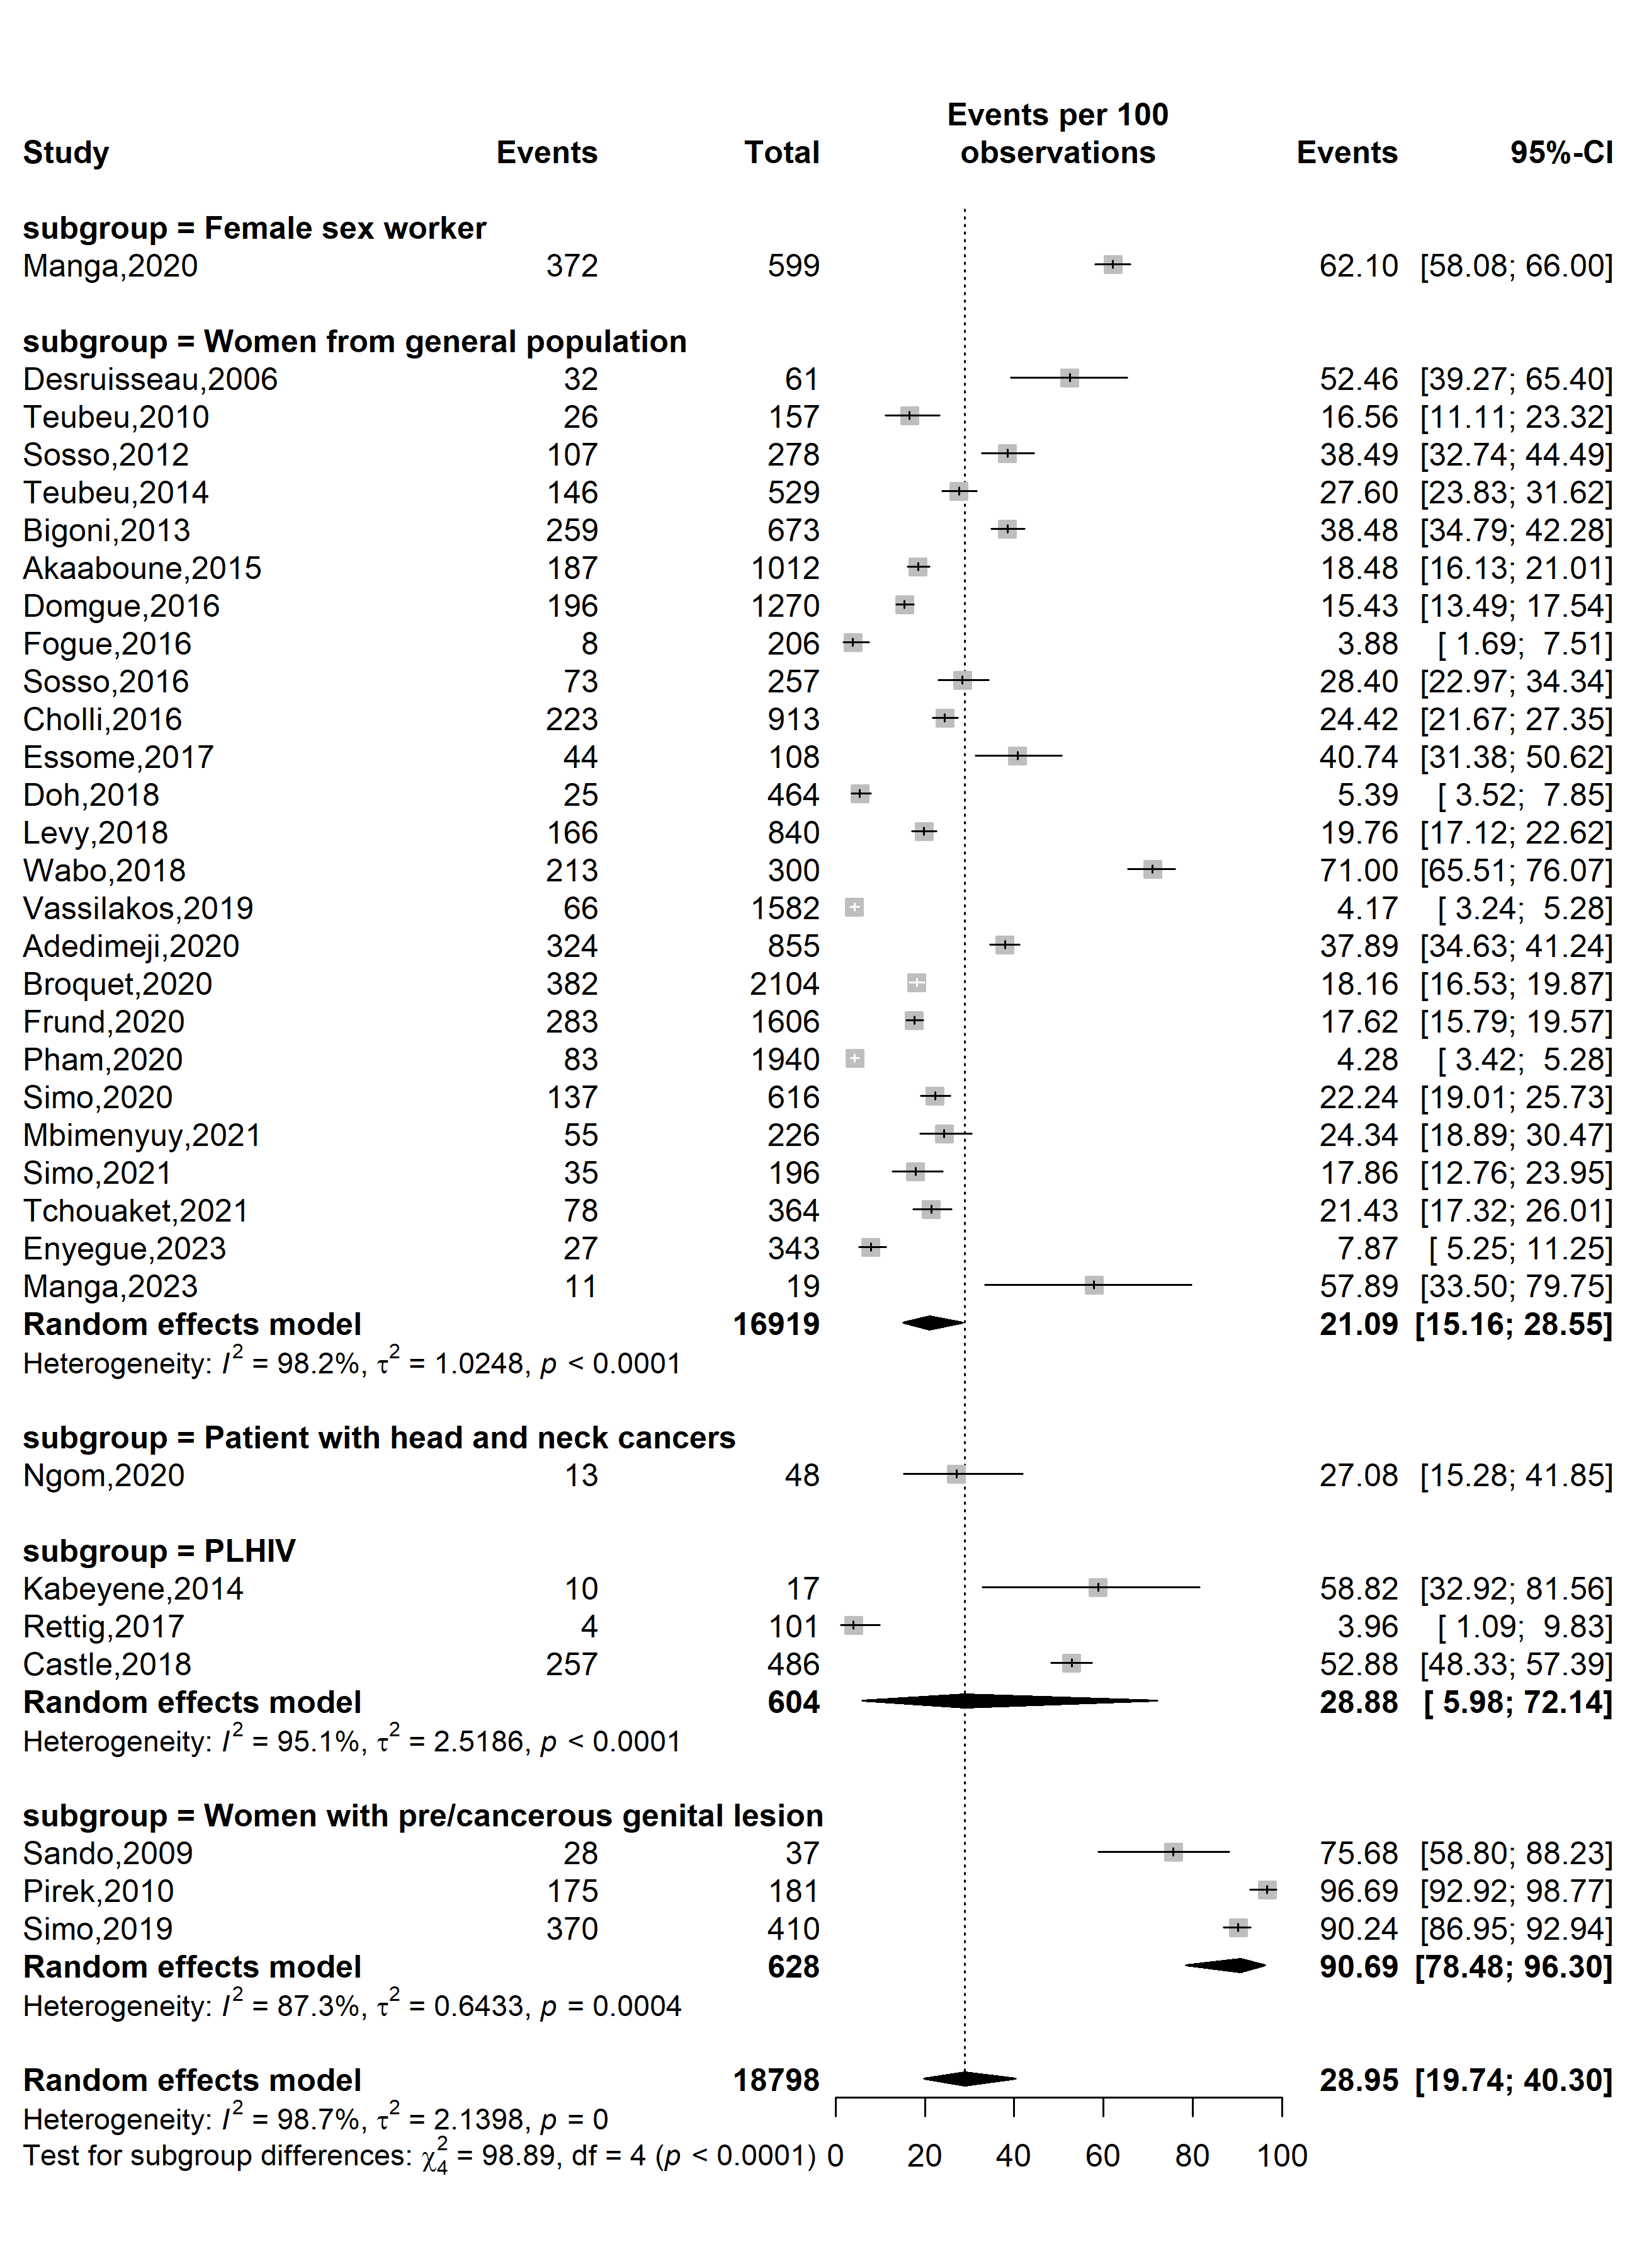
Supplementary Fig. 7 Pooled high-risk HPV prevalence in Cameroon by type of participants

Sensitivity analysis
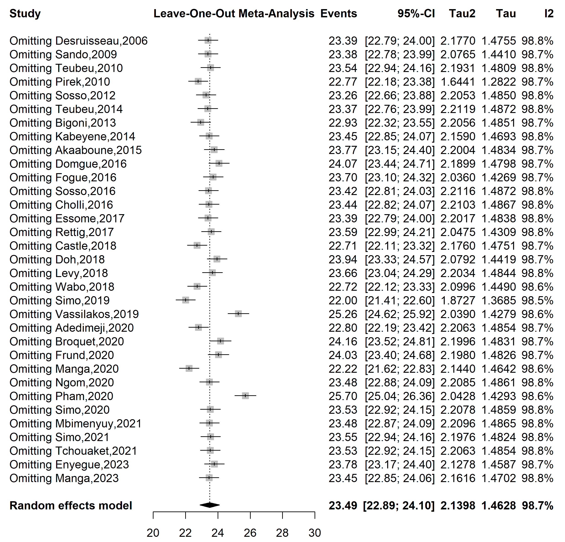
Supplementary Fig. 8 Sensitivity analysis of high-risk HPV prevalence in Cameroon

Publication bias assessment
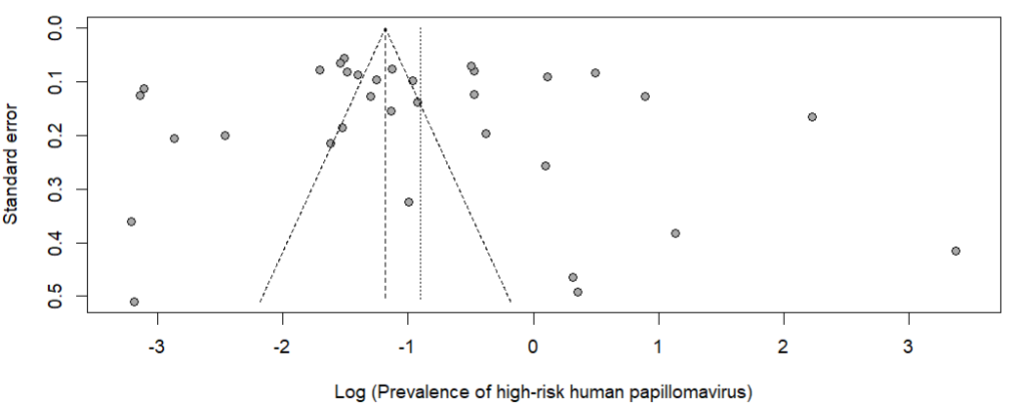
Egger’s test p-value = 0.570
Begg’s test p-value = 0.495

Supplementary Fig. 9 Funnel plot assessing publication bias among studies assessing the high-risk prevalence in Cameroon

Subgroup analysis of HIV infection prevalence among HPV-positive cases
Study year
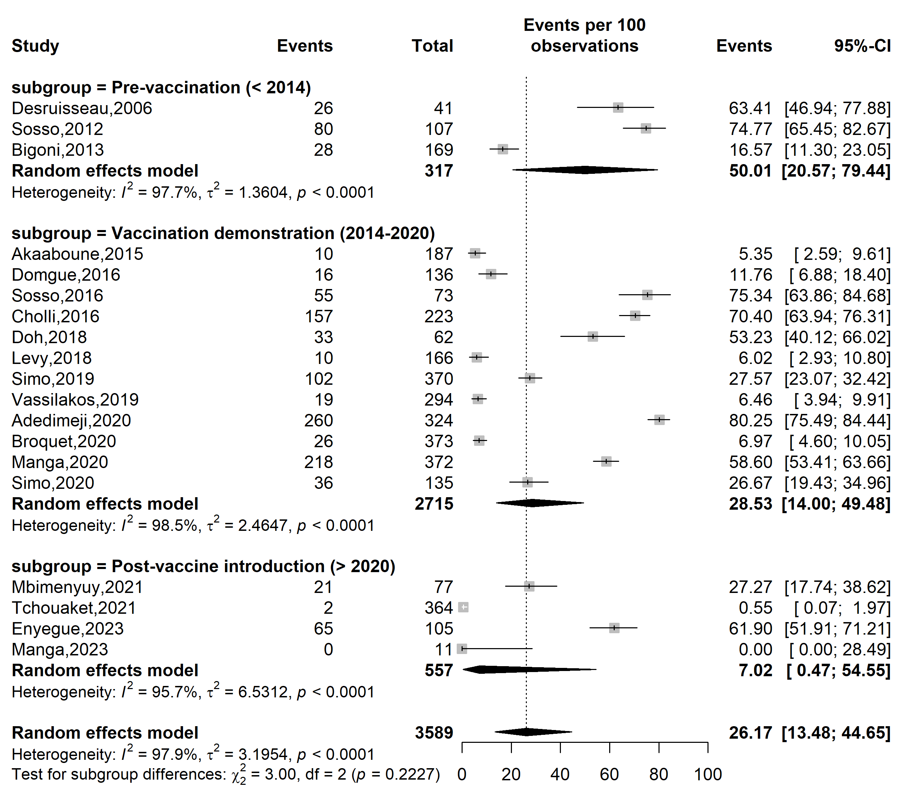
Supplementary Fig. 10 Pooled HIV infections among HPV-positive cases according to vaccine introduction timeframe in Cameroon

Study design
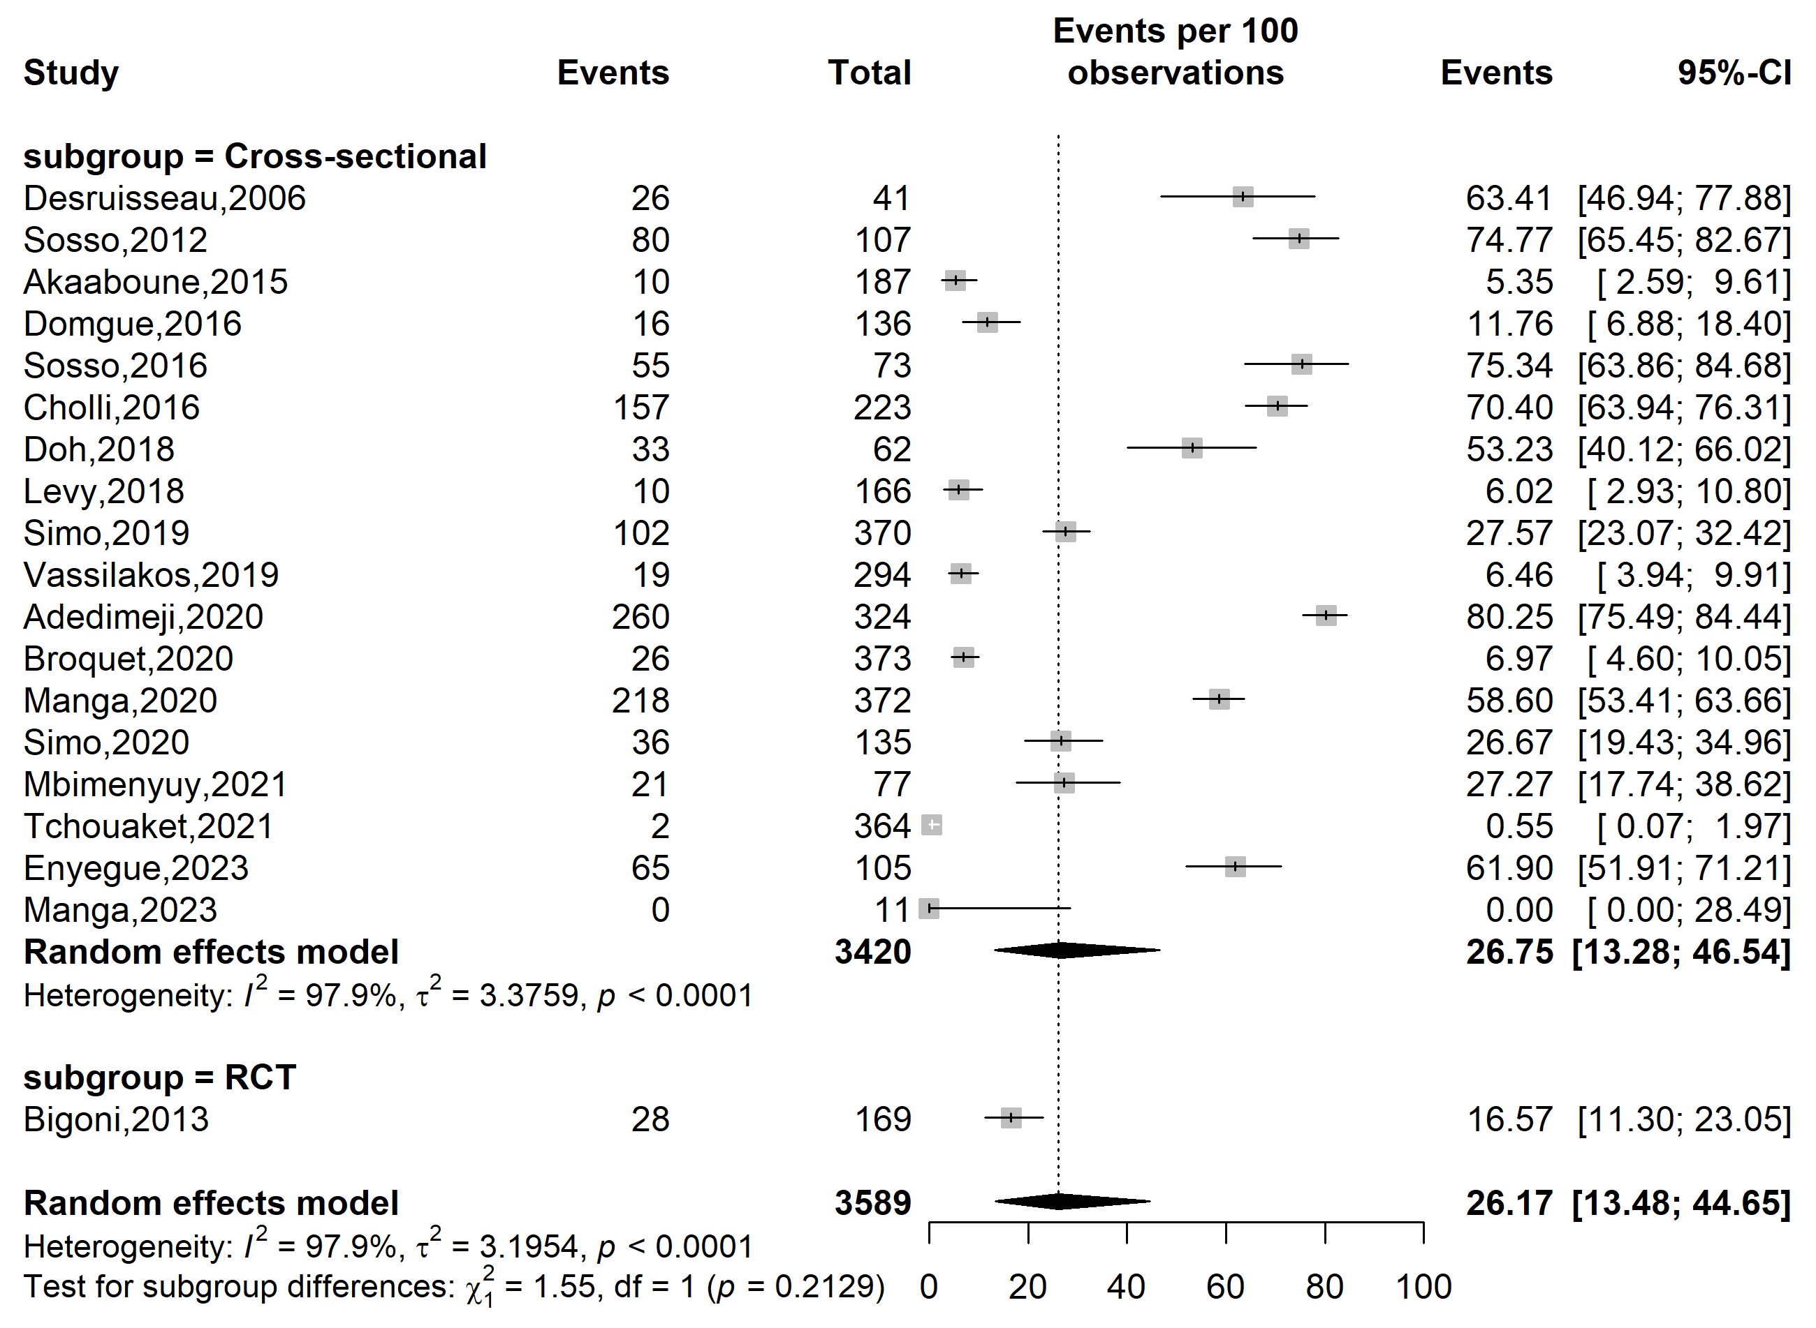
Supplementary Fig. 11 Pooled HIV infections among HPV-positive cases in Cameroon by study designs (RCT: randomized control trial)

Study setting
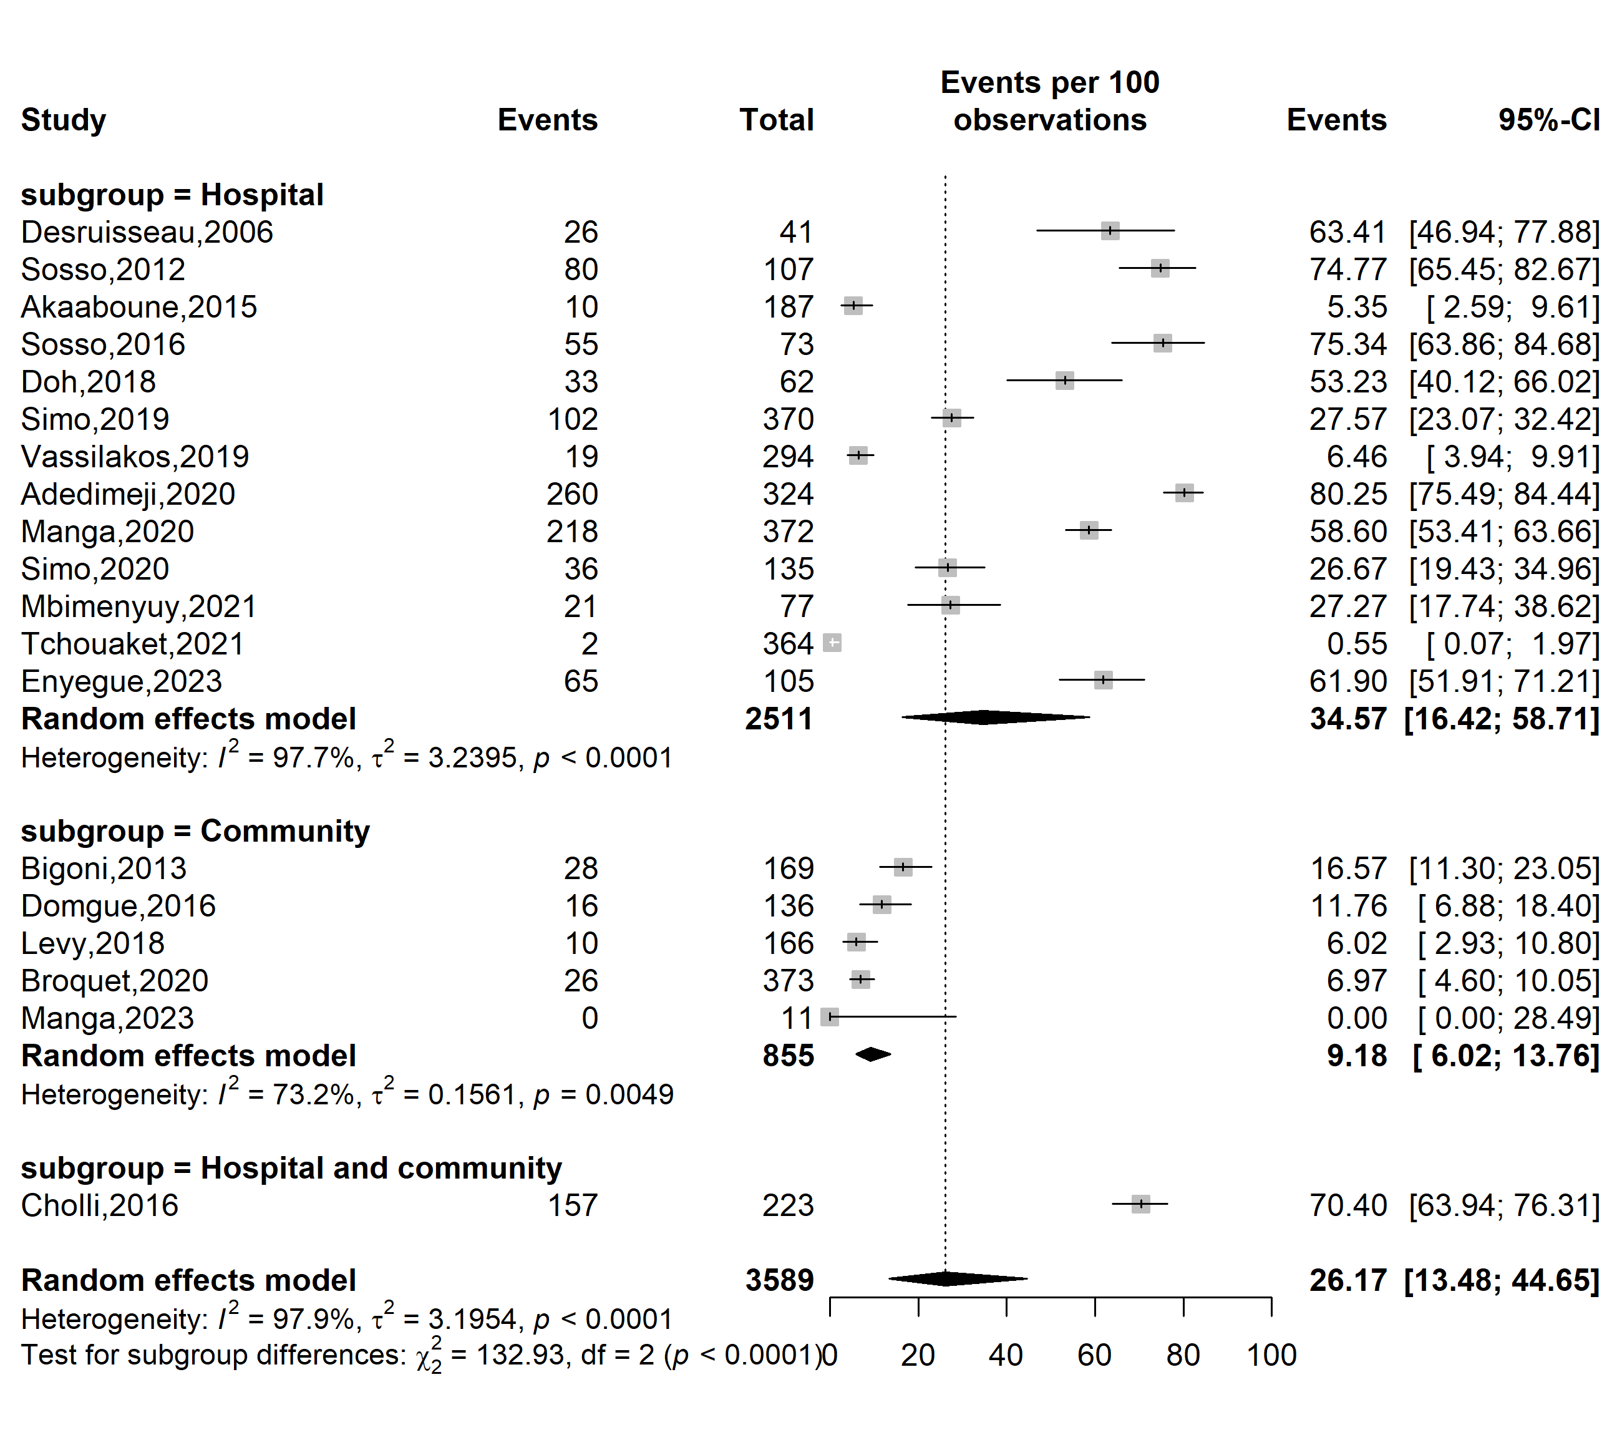
Supplementary Fig. 12 Pooled HIV infections among HPV-positive cases in Cameroon by study settings

Study site
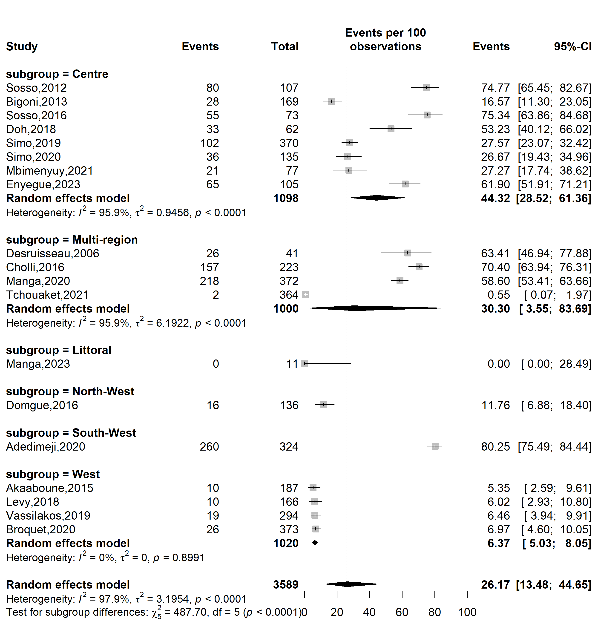
Supplementary Fig. 13 Pooled HIV infections among HPV-positive cases in Cameroon by study site 1

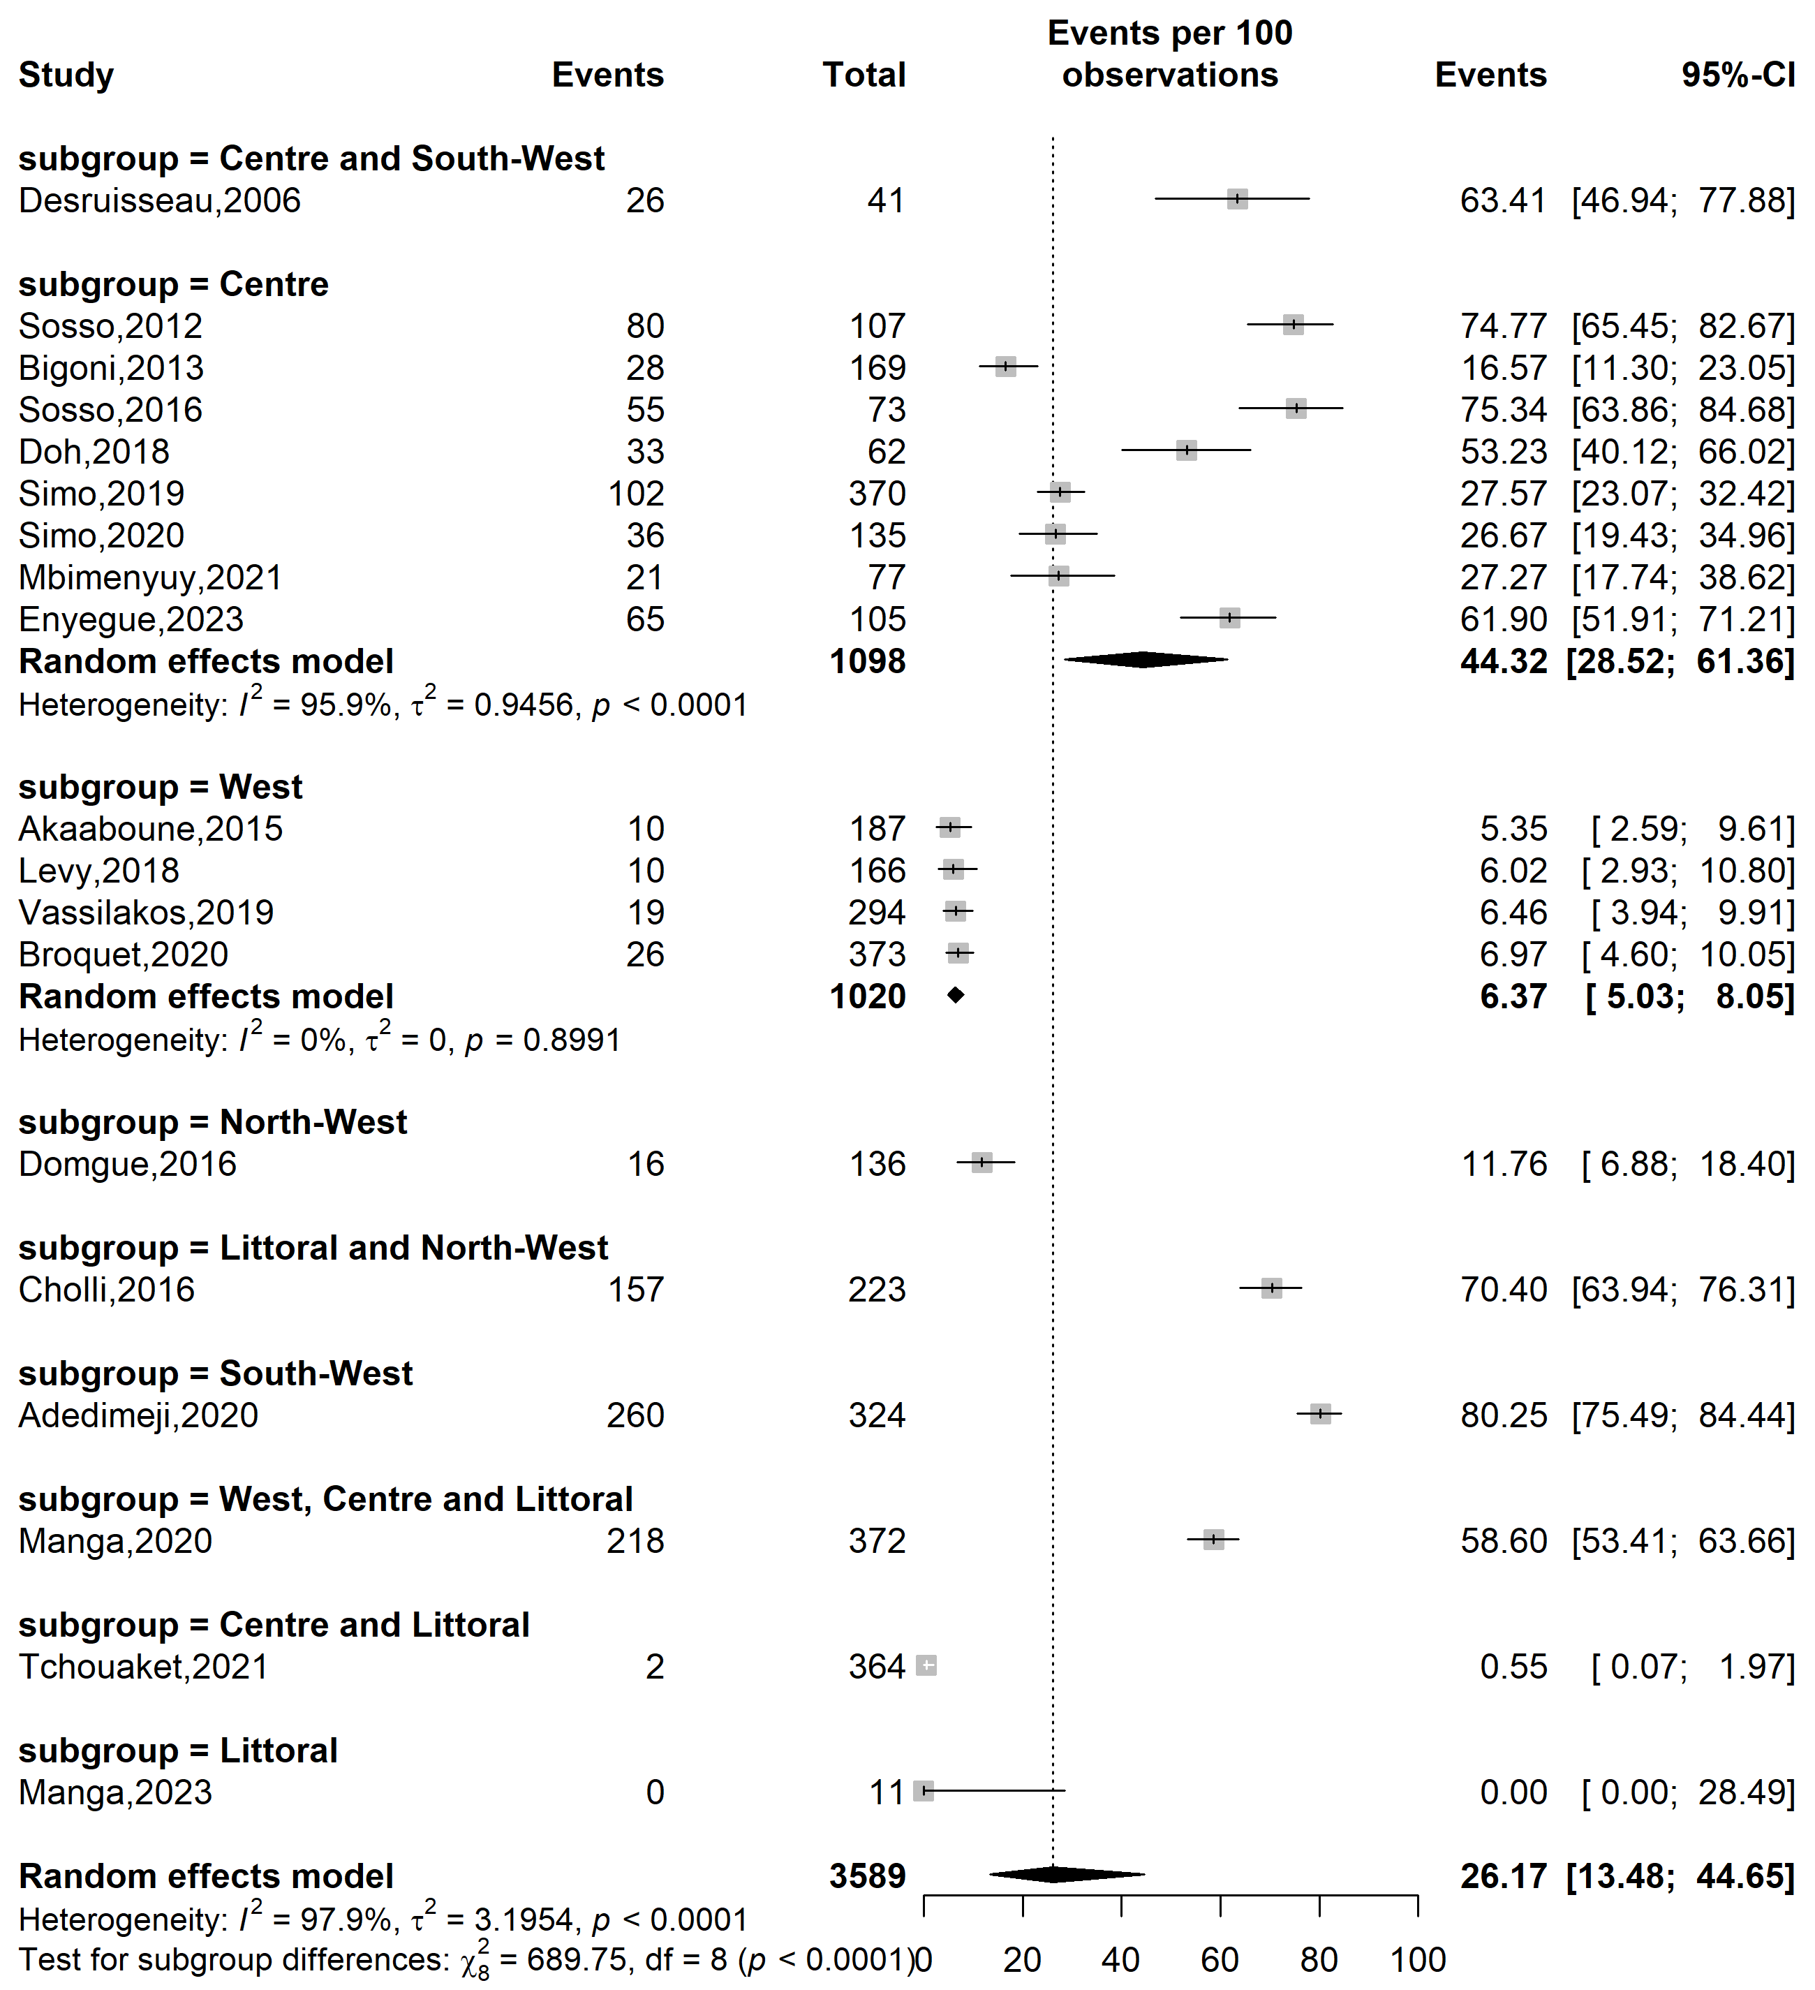
Supplementary Fig. 14 Pooled HIV infections among HPV-positive cases in Cameroon by study site 2

Sampling method
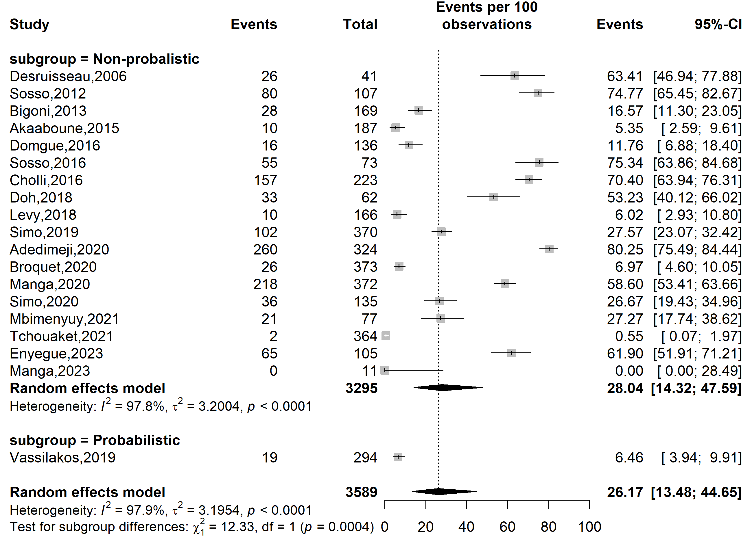
Supplementary Fig. 15 Pooled HIV infections among HPV-positive cases in Cameroon by sampling method

Participants
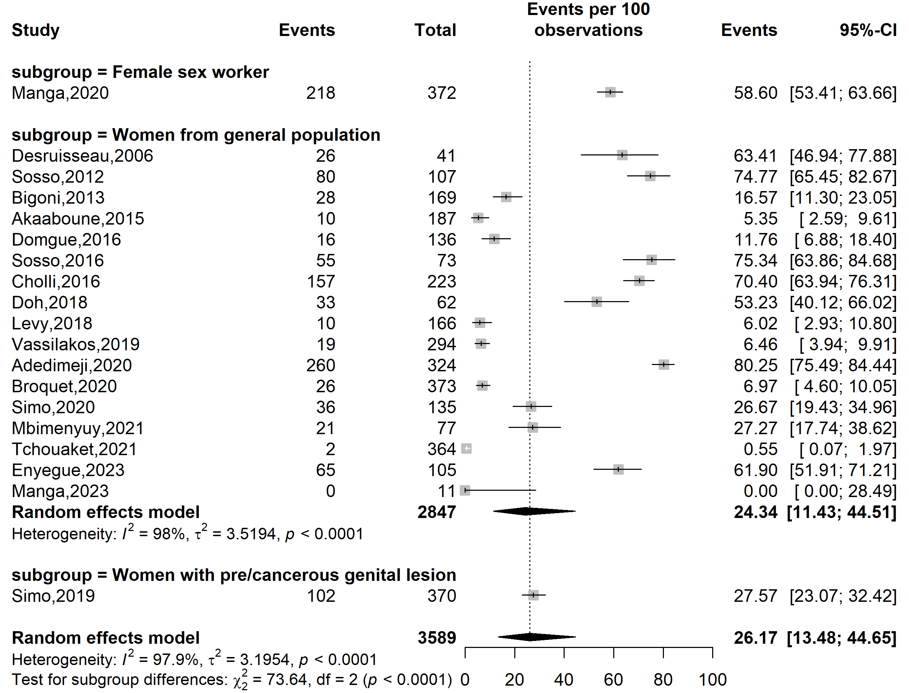
Supplementary Fig. 16 Pooled HIV infections among HPV-positive cases in Cameroon by study participants

Sensitivity analysis
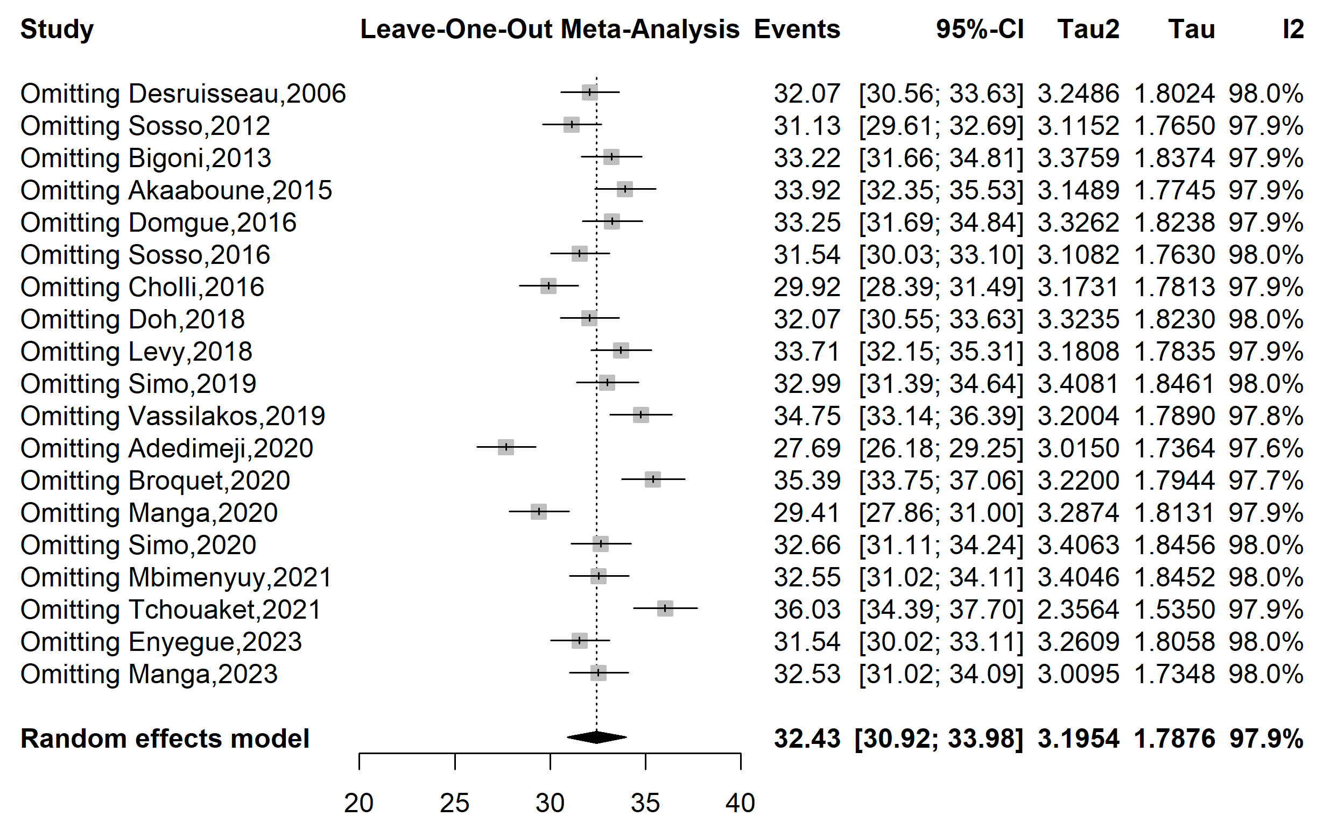
Supplementary Fig. 17 Sensitivity analysis of the pooled HIV infections among HPV-positive cases in Cameroon
Publication bias assessment

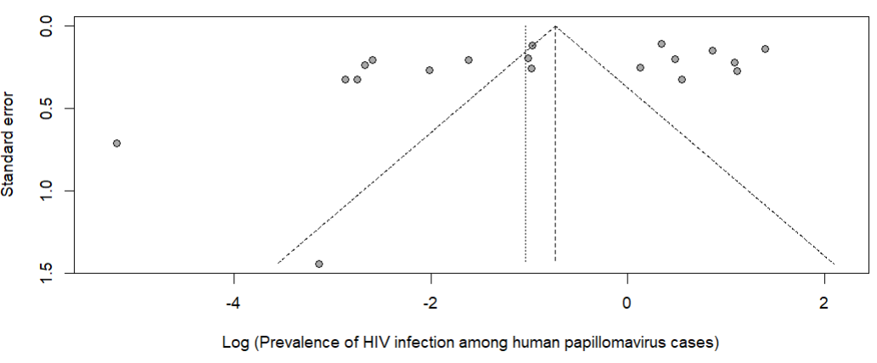
Egger’s test p-value = 0.071
Begg’s test p-value = 0.100

Supplementary Fig. 18 Funnel plot assessing publication bias among studies assessing the HIV prevalence among HPV-positive individuals in Cameroon

Sensitivity analysis
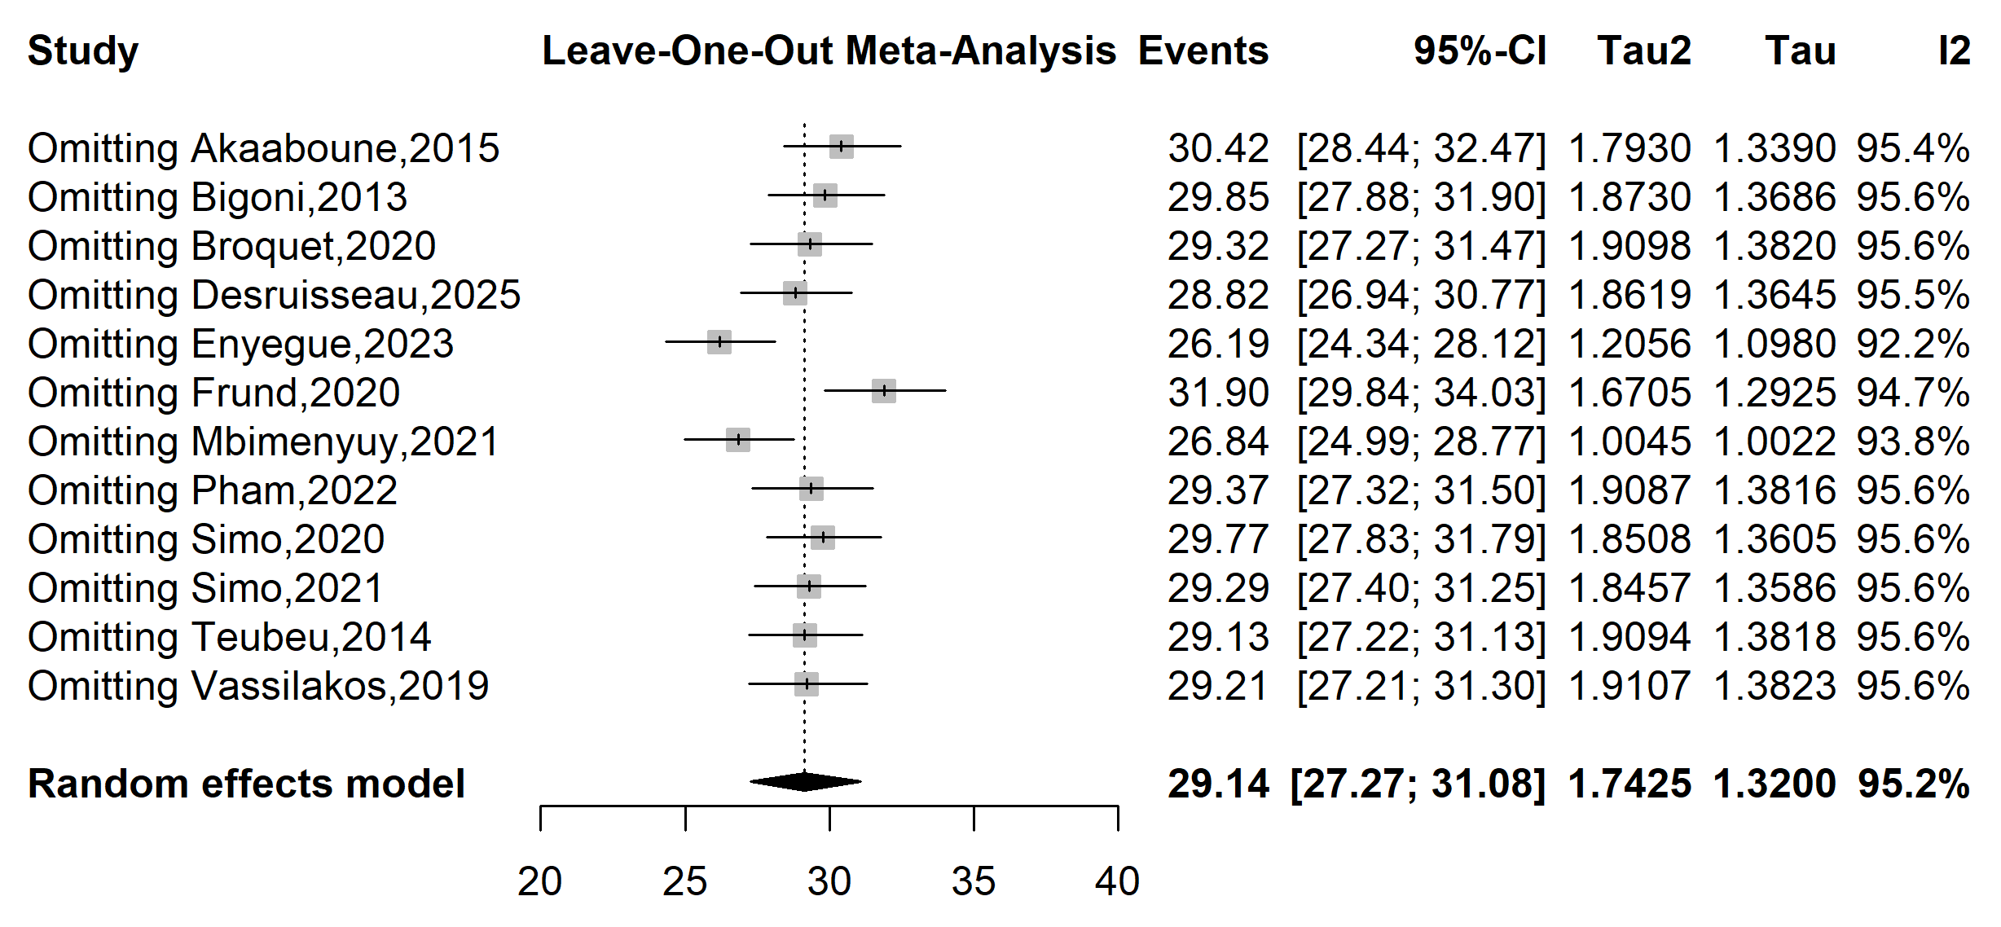

Supplementary Fig. 19 Sensitivity analysis of the pooled HIV infections among HPV-positive cases in Cameroon

Publication bias assessment
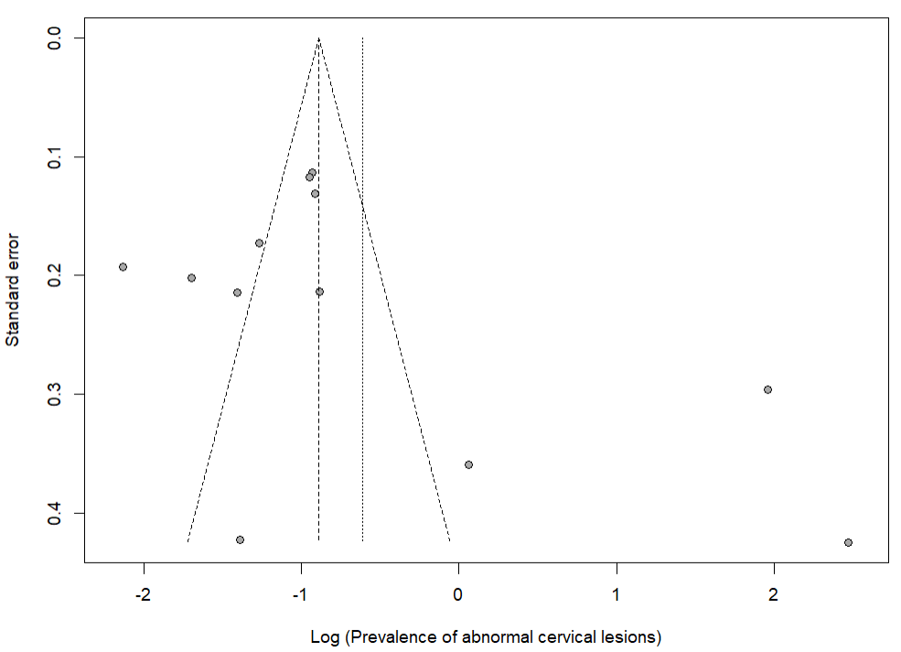
Egger’s test p-value = 0.214
Begg’s test p-value = 0.337

Supplementary Fig. 18 Funnel plot assessing publication bias among studies assessing the prevalence of abnormal cervical lesions among HPV-positive women in Cameroon

