Figure S1 Hotspot genes
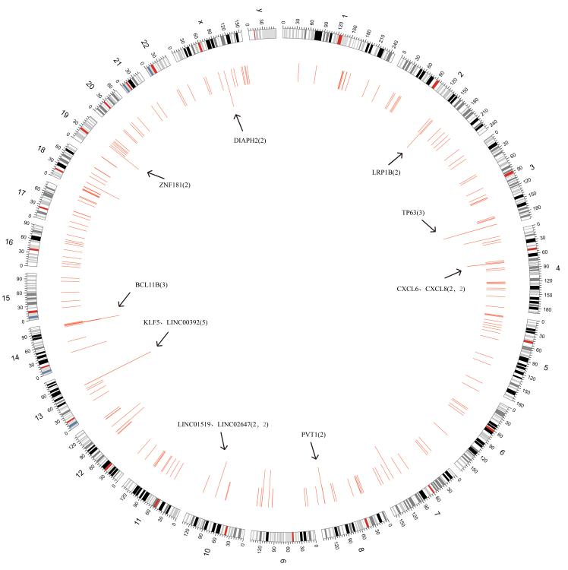

Figure S2 25 integration genes that were associated with the overall survival of CC patients
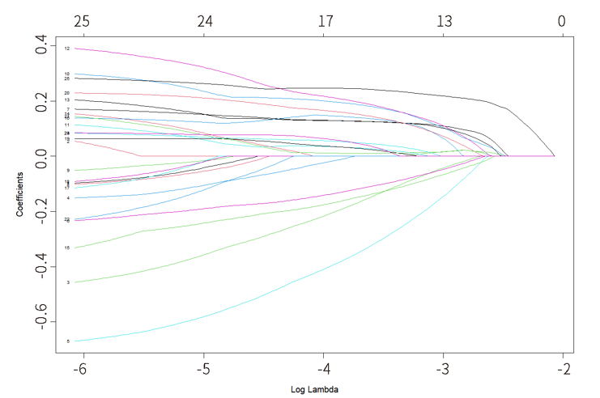

Figure S3 16 key genes
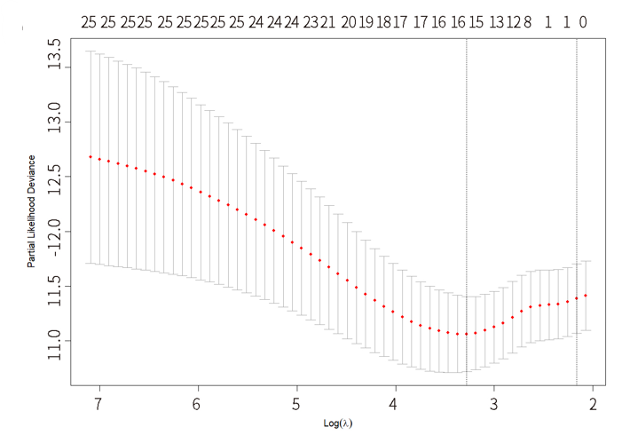

Table S1 List of 318 integration genes in the human gennome
Integaration Gene | Integaration Number | Integaration Gene | Integaration Number | Integaration Gene | Integaration Number
ABCG1 | 1 | INPP4B | 1 | OAZ1 | 1
ACTL7B | 1 | INSIG1 | 1 | ONECUT3 | 1
ADPRH | 1 | INTU | 1 | OPCML | 1
AFF2 | 1 | IPMK | 1 | OTUD7B | 1
AGBL1 | 1 | KCND2 | 2 | P3H2 | 2
ANKRD12 | 1 | KCNIP4 | 1 | PARD3B | 1
ANKS1B | 2 | KIAA1109 | 1 | PARP14 | 1
ANO2 | 1 | KLF4 | 2 | PARP15 | 1
ANP32B | 1 | KLF5 | 5 | PCDH18 | 1
ANXA5 | 1 | KRR1 | 1 | PDE4D | 1
APP | 1 | KYNU | 1 | PDLIM3 | 1
AQP9 | 1 | LCN2 | 1 | PGBD2 | 1
ARHGAP30 | 1 | LCP1 | 1 | PGLYRP4 | 1
ARL13B | 1 | LINC00374 | 1 | PHKB | 1
ARMH4 | 1 | LINC00376 | 1 | PHLDA1 | 1
ATP2B2 | 1 | LINC00392 | 5 | PHLDB2 | 1
AZIN1-AS1 | 1 | LINC00470 | 1 | PIBF1 | 2
BCL11B | 3 | LINC00507 | 1 | PKD1P4-NPIPA8 | 1
BCL2 | 1 | LINC00508 | 1 | PKHD1 | 1
BCL7A | 1 | LINC00513 | 1 | PLA1A | 1
BRCC3 | 1 | LINC00687 | 1 | PLCXD1 | 1
C14orf177 | 2 | LINC01091 | 1 | PLCXD2 | 1
C17orf99 | 1 | LINC01254 | 1 | PLEKHG4B | 1
C4orf36 | 1 | LINC01288 | 1 | POP1 | 1
C5orf17 | 1 | LINC01370 | 1 | POU3F4 | 1
C5orf34 | 1 | LINC01377 | 1 | PPFIA2 | 1
C9orf16 | 1 | LINC01509 | 2 | PPP2R5C | 1
CAMKMT | 1 | LINC01519 | 2 | PRDM9 | 1
CASC21 | 1 | LINC01550 | 2 | PRKD1 | 2
CASC3 | 1 | LINC01572 | 1 | PRLR | 1
CASC8 | 1 | LINC01622 | 1 | PROM1 | 1
CASP12 | 1 | LINC01626 | 1 | PSMB7 | 1
CCDC187 | 1 | LINC01790 | 1 | PTPN13 | 1
CCDC25 | 1 | LINC01895 | 1 | PTPRD | 1
CCDC59 | 1 | LINC01951 | 1 | PVT1 | 2
CCDC6 | 1 | LINC01973 | 1 | RAB11FIP2 | 1
CCDC90B | 1 | LINC01986 | 1 | RANGAP1 | 1
CCSER1 | 1 | LINC02039 | 1 | RASSF6 | 2
CD38 | 1 | LINC02064 | 1 | RBFOX1 | 1
CD99L2 | 1 | LINC02093 | 1 | RFLNB | 1
CDH11 | 1 | LINC02109 | 1 | RIMS1 | 1
CDH26 | 1 | LINC02149 | 1 | RNF213 | 1
CDH8 | 1 | LINC02240 | 1 | RP1 | 1
CDR1 | 1 | LINC02292 | 1 | S100A8 | 1
CEP250 | 1 | LINC02393 | 1 | S100A9 | 1
CHEK2P2 | 1 | LINC02426 | 2 | SCARA3 | 1
CHL1-AS2 | 1 | LINC02447 | 1 | SDHAF3 | 1
CLPTM1L | 1 | LINC02511 | 1 | SDK1 | 1
COLEC12 | 1 | LINC02552 | 1 | SERPINB12 | 1
CPPED1 | 1 | LINC02647 | 2 | SERPINB7 | 1
CWF19L2 | 1 | LINC02720 | 1 | SETD3 | 2
CXCL6 | 2 | LINC-PINT | 1 | SGK1 | 1
CXCL8 | 2 | LIPC | 1 | SH3BGRL | 1
CYYR1-AS1 | 1 | LL22NC01-81G9.3 | 1 | SLC10A6 | 1
DCUN1D5 | 1 | LOC100129034 | 1 | SLC25A51P1 | 1
DENR | 1 | LOC100507377 | 1 | SLC35F4 | 1
DGKB | 1 | LOC101927245 | 1 | SLC39A10 | 1
DIAPH2 | 2 | LOC101927691 | 1 | SLC4A4 | 1
DIAPH3 | 1 | LOC105370068 | 1 | SLC6A18 | 1
DKFZP434A062 | 1 | LOC105374620 | 1 | SLC6A19 | 1
DLG2 | 1 | LOC339593 | 1 | SLC8A1-AS1 | 1
DNAJC5 | 1 | LOC440311 | 1 | SMCHD1 | 1
DPH6-DT | 1 | LRP1B | 2 | SNX29 | 1
DRD1 | 1 | LYPLAL1 | 1 | SORCS2 | 2
DUS2 | 1 | LYPLAL1-AS1 | 1 | SPANXN3 | 1
DUSP26 | 1 | MACROD2-AS1 | 1 | SPANXN4 | 1
ECH1 | 1 | MAFB | 1 | SPATA16 | 1
ECT2 | 1 | MAOB | 1 | SPEF2 | 1
EFNA5 | 1 | MAP2K6 | 1 | SSB | 1
ELAC2 | 1 | MCL1 | 1 | SYNE3 | 1
EML4 | 1 | MCTP2 | 1 | TAC1 | 1
EMX2 | 1 | MECOM | 1 | TCF3 | 1
EMX2OS | 1 | METTL4 | 1 | TERC | 1
ENSA | 1 | MGAT5 | 1 | TESMIN | 1
ERBB2 | 1 | MIB1 | 1 | TFAP2B | 1
ERC2 | 1 | MIR2054 | 1 | THUMPD2 | 1
EYS | 1 | MIR320D2 | 1 | TIMMDC1 | 1
EZH2 | 1 | MIR3622B | 1 | TMEM155 | 1
F11R | 1 | MIR3672 | 1 | TNRC6C | 1
FAM83B | 1 | MIR4300HG | 1 | TP63 | 3
FBXL7 | 1 | MIR4318 | 1 | TRIT1 | 1
FHIT | 1 | MIR4457 | 1 | TRPC3 | 1
FNIP2 | 1 | MIR5093 | 1 | TSPAN18 | 1
FTLP10 | 1 | MIR548AE1 | 1 | TTLL7 | 1
G2E3-AS1 | 2 | MIR924HG | 1 | TUFT1 | 1
GABBR2 | 1 | MKNK2 | 1 | UBE2L6 | 1
GAL | 1 | MMP13 | 1 | UBXN2A | 1
GASAL1 | 1 | MMP20 | 1 | UMODL1 | 1
GATA6 | 1 | MMP27 | 1 | UNC5D | 1
GATA6-AS1 | 2 | MROH1 | 1 | VANGL2 | 1
GC | 1 | MROH9 | 1 | VAPA | 1
GPR156 | 1 | MTUS2 | 1 | VPS53 | 1
GRIA3 | 1 | MVP | 1 | VSIG10L | 1
GRWD1 | 1 | NAALADL2 | 1 | WDR13 | 1
GSE1 | 1 | NANS | 1 | WRN | 1
HCAR1 | 1 | NDUFV2 | 1 | XKR4 | 1
HCRTR2 | 1 | NEK6 | 2 | XYLT1 | 1
HDAC4 | 1 | NF1 | 1 | YWHAG | 1
HDAC9 | 1 | NFATC3 | 1 | YY1 | 1
HERC2P3 | 1 | NFIB | 1 | ZBTB7C | 1
HMGB3 | 1 | NIPAL2 | 1 | ZNF181 | 2
HNRNPL | 1 | NLGN1 | 1 | ZNF227 | 1
HSPB1 | 1 | NOTCH1 | 1 | ZNF233 | 1
HTR2C | 1 | NR5A1 | 1 | ZNF512 | 1
HTR5A | 1 | NR6A1 | 1 | ZNF550 | 1
IDS | 1 | NUP35 | 1 | ZNF692 | 1

Table S2 Multivariate Cox regression analysis of eight independent prognostic integration genes

Gene | coef | exp(coef) | se(coef) | z | pvalue
CCDC187 | -0.271603 | 0.762157 | 0.10125 | -2.683 | 0.00731
MCTP2 | 0.055747 | 1.05733 | 0.017801 | 3.132 | 0.00174
NEK6 | 0.021266 | 1.021494 | 0.006963 | 3.054 | 0.00226
NLGN1 | 0.124881 | 1.133014 | 0.056102 | 2.226 | 0.02602
PARP15 | -0.238106 | 0.788119 | 0.106957 | -2.226 | 0.026
PCDH18 | 0.018166 | 1.018332 | 0.006813 | 2.667 | 0.00766
SERPINB7 | 0.004774 | 1.004786 | 0.001677 | 2.847 | 0.00442
YWHAG | 0.004103 | 1.004112 | 0.00134 | 3.062 | 0.0022

