Supplementary Material
Dynamic, transition and variation of cervicovaginal microbiome and HPV infection and cervical dysplasia and cancer: a systematic review

Authors
Gbenankpon Mathias Houvessou¹, Nerys Wendy Antonieta Alfane², Manuel Mahoche²˒³*
¹Gertrude H. Sergievsky Center, Vagelos College of Physicians and Surgeons, Columbia University Irving Medical Center, New York, NY, United States of America; ²School of Public Health, University of São Paulo, Av. Dr. Arnaldo, 715, São Paulo, SP, 01246-904, Brazil; ³Department of Epidemiology, Faculty of Sciences, Lúrio University (UNILÚRIO), Nampula, Mozambique
Corresponding Author: Manuel Mahoche*, School of Public Health, University of São Paulo, Av. Dr. Arnaldo, 715, São Paulo, SP, 01246-904, Brazil, E-mail: manuelmahoche@gmail.com

Table S1. Semi-quantitative evidence consistency for microbiome factors and cervical outcomes
Table S2. Newcastle-Ottawa Scale quality assessment of included studies
Figure S1. Overview of included studies
Figure S2. CST transition patterns and conceptual model

Table S1. Semi-quantitative evidence consistency for microbiome factors and cervical outcomes.
Microbiome factor | HPV clearance | HPV persistence | CIN regression | CIN progression
Lactobacillus-dominated CST at baseline | ++ | - | ++ | -
L. crispatus dominance (CST I) | ++ | - | ++ | -
L. iners dominance (CST III) at baseline | +/- | +/- | +/- | +/-
Lactobacillus-depleted CST (CST IV) | - | ++ | - | ++
Low alpha-diversity at baseline | ++ | - | + | -
Elevated alpha-diversity at follow-up | - | ++ | - | +
Gardnerella vaginalis abundance | - | + | - | +
Prevotella / Atopobium abundance | - | ++ | - | +
High CST temporal stability | ++ | - | + | -
High CST transition rate | - | ++ | - | +
Note: ++ consistent association in 3 or more studies; + in 1-2 studies; +/- conflicting evidence; - absent or negative association. Green fill = protective/favourable; yellow = conflicting; red = harmful/unfavourable.

Table S2. Newcastle-Ottawa Scale quality assessment of included studies (n = 12).
Study | Selection (0-4) | Comparability (0-2) | Outcome (0-3) | Total | Quality tier
Moscicki et al. [25] | 4 | 2 | 3 | 9 | High
Usyk et al. [21] | 4 | 2 | 3 | 9 | High
Brotman et al. [19] | 4 | 2 | 3 | 9 | High
Mitra et al. [20] | 3 | 2 | 2 | 7 | High
Molina et al. [22] | 3 | 1 | 2 | 6 | Moderate
Berggrund et al. [18] | 3 | 1 | 2 | 6 | Moderate
Van de Wijgert et al. [24] | 3 | 1 | 2 | 6 | Moderate
Zhang et al. [23] | 3 | 1 | 2 | 6 | Moderate
Mitra et al. [27] | 3 | 1 | 2 | 6 | Moderate
Caselli et al. [28] | 3 | 1 | 2 | 6 | Moderate
Li et al. [26] | 2 | 1 | 2 | 5 | Moderate
Wang et al. [29] | 2 | 1 | 1 | 4 | Low
Note: studies scoring >=7 classified as high quality; 5-6 as moderate; <=4 as low. Green fill = high quality; blue = moderate; orange = low.

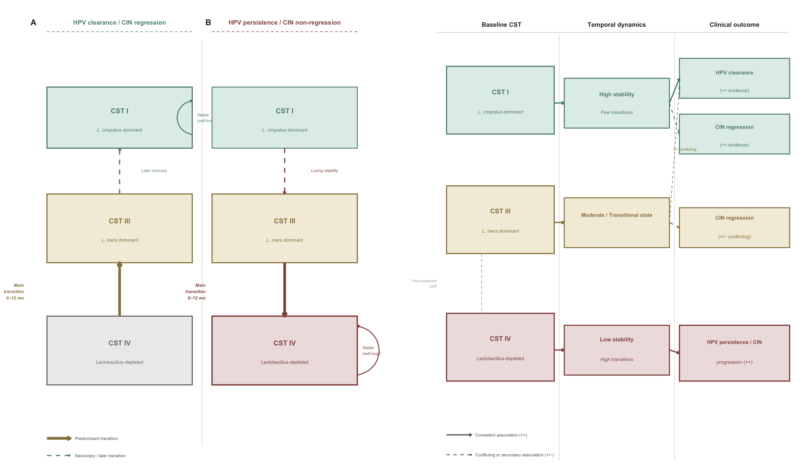
Figure S2. i) CST transition patterns stratified by clinical outcome group; ii) Conceptual diagram of baseline CST trajectories, temporal dynamics, and associated clinical outcomes.
Panel 1.A: favourable outcomes (HPV clearance / CIN regression) showing predominant CST IV to CST III to CST I stepping-stone progression. Panel 2.B: unfavourable outcomes (HPV persistence / CIN progression) showing CST I to CST III to CST IV dysbiotic drift. Arrow thickness indicates frequency of transition. CST = community state type; ++ = consistent evidence in 3 or more studies; +/- = conflicting evidence; arrows indicate predominant transition direction. Dashed arrow indicates contested association.

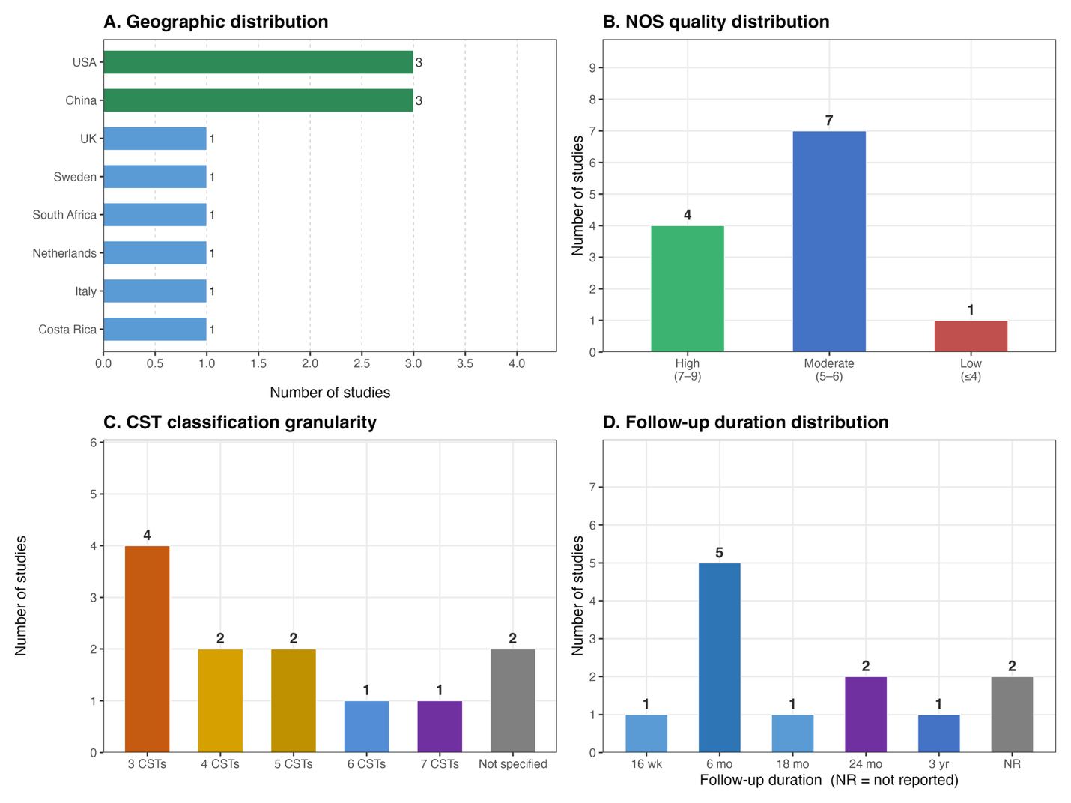
Figure S1. Overview of included studies: geographic distribution (A), NOS quality distribution (B), CST classification granularity (C), and follow-up duration (D).
NR = not reported; wk = weeks; mo = months; yr = years. Green bars = high-quality studies (NOS 7-9); blue = moderate (5-6); red = low (<=4).

