Supplementary file 1:

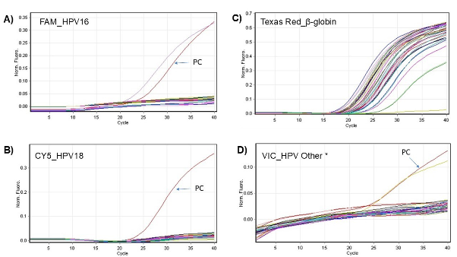
Representative amplification profiles for high-risk HPV detection across four fluorescence channels. A) FAM (top left): Specific for HPV16. The two curves represent amplification from sample positive for HPV16 and positive control. B) Cy5 (bottom left): Specific for HPV18. Only the positive control (PC) showed amplification. No clinical sample in this study tested positive for HPV18. C) Texas Red (top right): indicates successful amplification of the β-globin internal control across all samples, confirming DNA quality and extraction efficiency. D) VIC (bottom right): Detects HPV Other, a pooled signal for 13 non-16/18 high-risk HPV genotypes. Two curves represent amplification from sample positive for HPV Other and positive control. The positive control (PC) is indicated. These plots represent normalized fluorescence versus cycle number. Positive amplification curves indicate presence of the target HPV genotype, while flat curves reflect absence of detectable target.

Supplementary file 2:

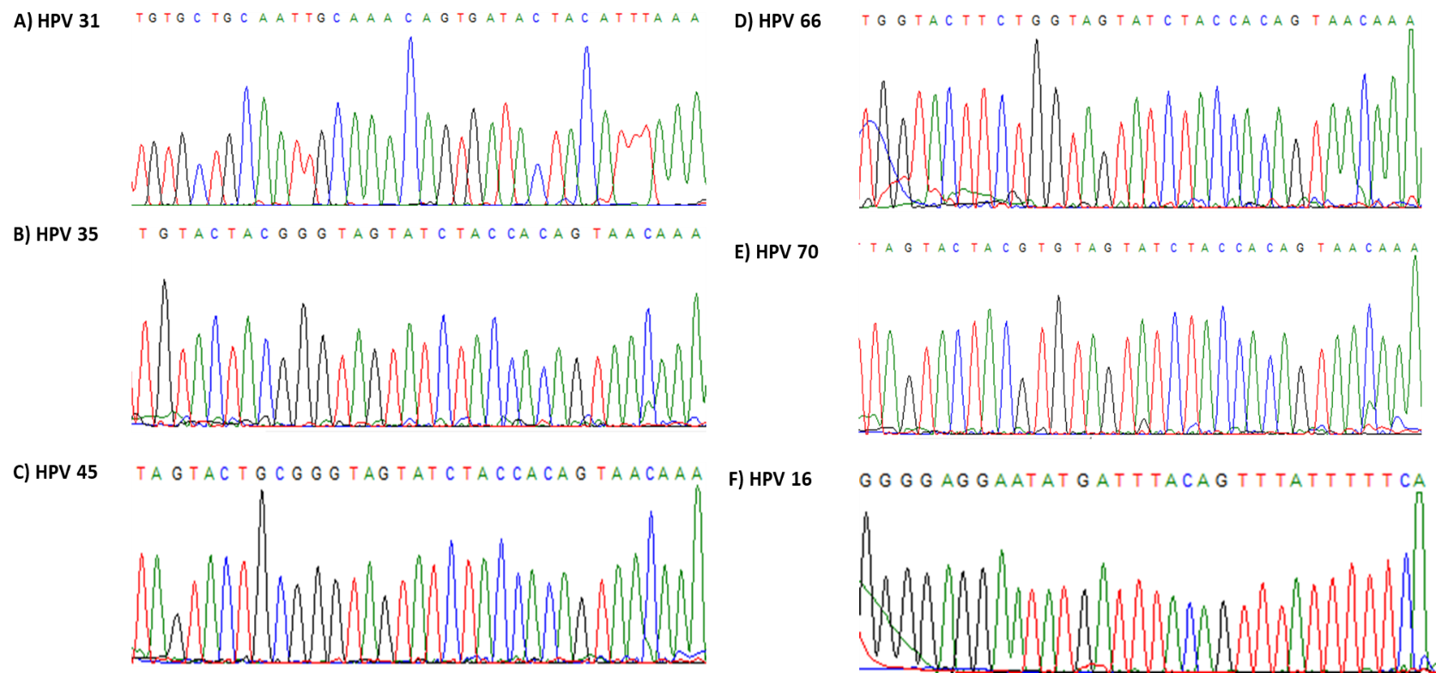

Figure 2. Representative electropherograms showing partial L1 gene sequences of high-risk HPV genotypes identified in this study: (A) HPV31, (B) HPV35, (C) HPV45, (D) HPV66, and (E) HPV70, (F) HPV16. Sequences were obtained by Sanger sequencing and analyzed using the NCBI BLAST tool for genotype confirmation.

