Supplementary Figure S1. Flow diagram of patient screening and cohort selection.
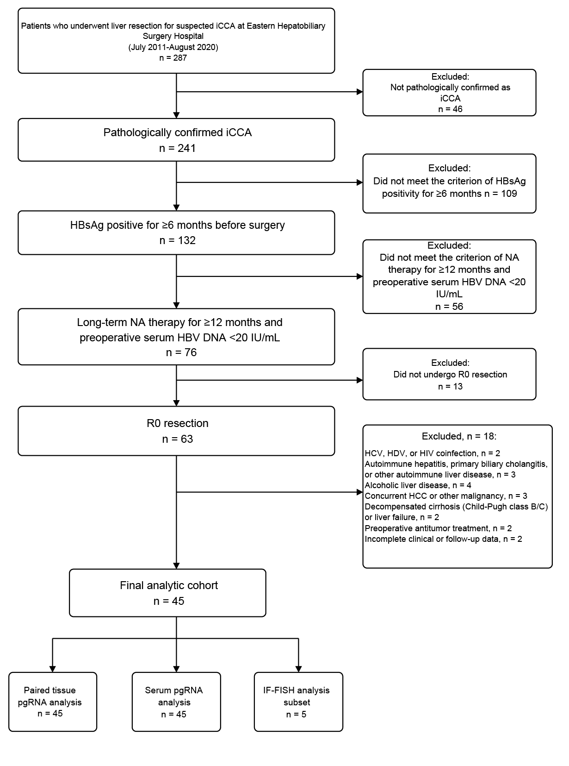
A total of 287 patients were screened, and 45 patients were included in the final analytic cohort according to the predefined eligibility criteria. HBsAg, hepatitis B surface antigen; HBV, hepatitis B virus; HCV, hepatitis C virus; HDV, hepatitis D virus; HIV, human immunodeficiency virus; NA, nucleos(t)ide analogue.

Supplementary Figure S2. Associations between serum pgRNA and tissue levels in HBV-related iCCA.
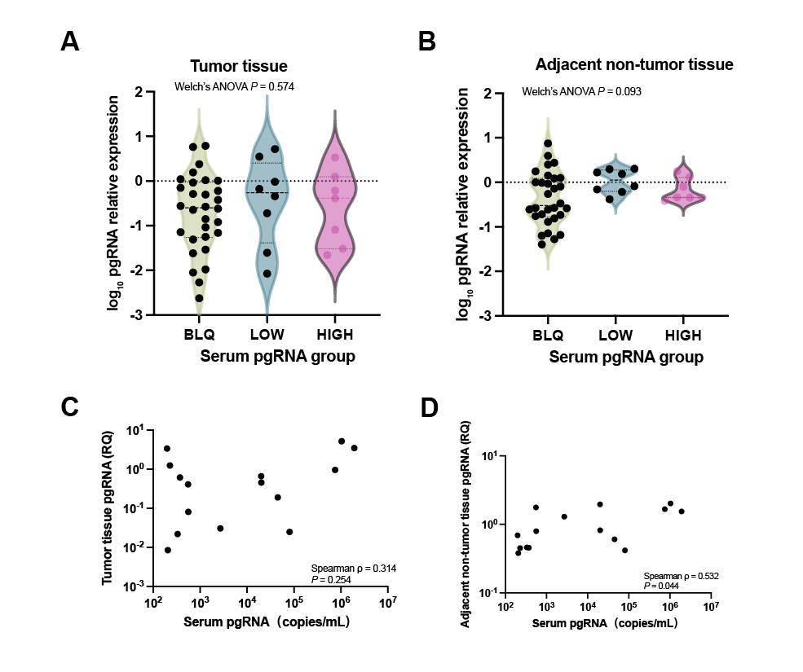
(A,B) Tumor (A) and adjacent non-tumor tissue (B) pgRNA expression across serum pgRNA groups. Relative expression was calculated using the 2^−ΔCt method and displayed on the log₁₀ scale; group comparisons were performed on ΔCt values using Welch’s one-way ANOVA. (C,D) Spearman correlations of serum pgRNA with tumor (C) and adjacent non-tumor tissue (D) pgRNA expression among patients with quantifiable serum pgRNA (n = 15). Each point represents one patient. BLQ, below the lower limit of quantification.

Supplementary Figure S3. Time-varying associations between tumor-tissue pgRNA expression and postoperative outcomes.
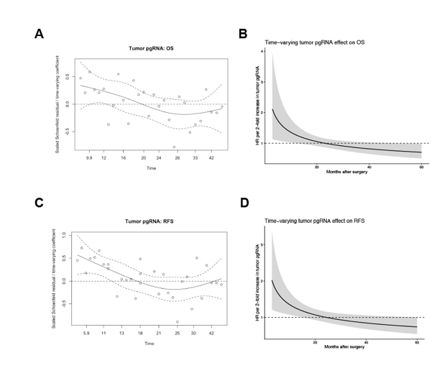
(A,C) Scaled Schoenfeld residual plots for tumor-tissue pgRNA in tumor-size-adjusted Cox models for OS (A) and RFS (C); the proportional hazards assumption was violated for tumor-tissue pgRNA (OS, P = 0.011; RFS, P = 0.005). (B,D) Time-varying HRs for OS (B) and RFS (D) per two-fold increase in tumor-tissue pgRNA expression, adjusted for tumor size. Time interactions were significant for OS (P = 0.018) and RFS (P = 0.010). Shaded areas indicate 95% CIs and dashed lines indicate HR = 1.RFS was defined as the interval from surgery to the first occurrence of documented recurrence or death from any cause, whichever occurred first; patients alive and recurrence-free were censored at their last valid recurrence-free follow-up.

Supplementary Table S1. Univariable Cox proportional hazards analyses for overall and recurrence-free survival.
Variable | OS HR (95% CI) | P value | RFS HR (95% CI) | P value
Serum pgRNA group
LOW vs BLQ | 1.65 (0.64–4.27) | 0.303 | 1.64 (0.67–4.00) | 0.278
HIGH vs BLQ | 7.59 (2.79–20.65) | <0.001 | 5.63 (2.15–14.74) | <0.001
Age, per year | 1.02 (0.97–1.07) | 0.405 | 1.00 (0.96–1.05) | 0.872
Male vs female | 1.33 (0.54–3.27) | 0.535 | 1.51 (0.62–3.66) | 0.368
Tumor size, per 1-cm increase | 1.22 (1.09–1.37) | <0.001 | 1.23 (1.10–1.37) | <0.001
Multiple vs solitary tumors | 1.59 (0.75–3.41) | 0.229 | 1.45 (0.69–3.03) | 0.324
T category
T2 vs T1 | 1.59 (0.60–4.22) | 0.356 | 1.36 (0.53–3.48) | 0.525
T3 vs T1 | 4.80 (1.78–12.92) | 0.002 | 4.20 (1.68–10.53) | 0.002
T4 vs T1 | 7.05 (2.19–22.71) | 0.001 | 7.64 (2.44–23.96) | <0.001
N1 vs N0 | 2.37 (0.92–6.10) | 0.073 | 2.29 (0.91–5.77) | 0.079
AJCC 8th edition stage
Stage II vs Stage I | 1.56 (0.50–4.83) | 0.440 | 1.28 (0.43–3.76) | 0.659
Stage III vs Stage I | 5.78 (2.33–14.32) | <0.001 | 4.83 (2.10–11.07) | <0.001
AFP, per doubling | 0.91 (0.71–1.16) | 0.439 | 0.86 (0.67–1.10) | 0.234
CA19-9, per doubling | 1.32 (1.11–1.57) | 0.001 | 1.25 (1.06–1.47) | 0.007
Abbreviations: OS, overall survival; RFS, recurrence-free survival; HR, hazard ratio; CI, confidence interval; pgRNA, pregenomic RNA; BLQ, below the lower limit of quantification; AJCC, American Joint Committee on Cancer; AFP, alpha-fetoprotein; CA19-9, carbohydrate antigen 19-9.
Notes: Reference categories were BLQ, female sex, solitary tumor, T1, N0, and AJCC stage I, as applicable. Tumor size was modeled per 1-cm increase; AFP and CA19-9 were modeled on the log₂ scale and are expressed per doubling.

Supplementary Table S2. Serum pgRNA characteristics of the five patients included in the IF-FISH analysis.
IF-FISH case | Serum pgRNA (copies/mL) | Serum pgRNA stratum
Case 1 | <100 | BLQ
Case 2 | 20040 | HIGH
Case 3 | 1924000 | HIGH
Case 4 | 552 | LOW
Case 5 | 206 | LOW
Note: Patient identifiers were anonymized using study case numbers. BLQ, <100 copies/mL; LOW, 100–2700 copies/mL; HIGH, >2700 copies/mL. The representative IF-FISH image in Fig. 1A was obtained from Case 3 (HIGH).

Supplementary Table S3. Tests of the proportional hazards assumption for the primary multivariable Cox models.
Variable | df | OS χ² | OS P value | RFS χ² | RFS P value
Serum pgRNA group | 2 | 0.475 | 0.788 | 5.561 | 0.062
Tumor size | 1 | 1.346 | 0.246 | 0.138 | 0.710
Global test | 3 | 2.780 | 0.427 | 5.855 | 0.119
Abbreviations: OS, overall survival; RFS, recurrence-free survival; pgRNA, pregenomic RNA.
Notes: The proportional hazards assumption was assessed using Schoenfeld residuals. The serum pgRNA group term represents a joint 2-df test of LOW and HIGH versus BLQ.

Supplementary Table S4. Sensitivity analyses of the association between serum pgRNA and overall and recurrence-free survival.
Endpoint | Sensitivity model | Variable | HR (95% CI) | P value
OS | HIGH vs BLQ/LOW + tumor size | HIGH vs BLQ/LOW | 4.95 (1.82–13.48) | 0.002
 |  | Tumor size, per 1-cm increase | 1.20 (1.06–1.36) | 0.004
 | Detectable vs BLQ + tumor size | Detectable (LOW/HIGH) vs BLQ | 1.94 (0.87–4.32) | 0.104
 |  | Tumor size, per 1-cm increase | 1.18 (1.05–1.33) | 0.006
 | Continuous serum pgRNA + tumor size | Serum pgRNA, per doubling | 1.16 (1.07–1.26) | <0.001
 |  | Tumor size, per 1-cm increase | 1.17 (1.04–1.33) | 0.011
 | Serum pgRNA group + AJCC stage | LOW vs BLQ | 2.88 (1.02–8.10) | 0.045
 |  | HIGH vs BLQ | 7.18 (2.51–20.48) | <0.001
 |  | AJCC stage III vs I–II | 5.95 (2.46–14.42) | <0.001
 | Serum pgRNA group + CA19-9 | LOW vs BLQ | 1.40 (0.53–3.75) | 0.499
 |  | HIGH vs BLQ | 7.35 (2.63–20.51) | <0.001
 |  | CA19-9, per doubling | 1.32 (1.10–1.58) | 0.002
 | Serum pgRNA group + tumor size + CA19-9 | LOW vs BLQ | 1.26 (0.48–3.32) | 0.637
 |  | HIGH vs BLQ | 5.04 (1.71–14.85) | 0.003
 |  | Tumor size, per 1-cm increase | 1.19 (1.05–1.36) | 0.007
 |  | CA19-9, per doubling | 1.33 (1.11–1.60) | 0.002
 | Continuous serum pgRNA + tumor size + CA19-9 | Serum pgRNA, per doubling | 1.13 (1.04–1.23) | 0.004
 |  | Tumor size, per 1-cm increase | 1.19 (1.05–1.35) | 0.008
 |  | CA19-9, per doubling | 1.28 (1.07–1.54) | 0.008
RFS | HIGH vs BLQ/LOW + tumor size | HIGH vs BLQ/LOW | 3.35 (1.29–8.75) | 0.013
 |  | Tumor size, per 1-cm increase | 1.20 (1.06–1.35) | 0.003
 | Detectable vs BLQ + tumor size | Detectable (LOW/HIGH) vs BLQ | 1.67 (0.75–3.69) | 0.208
 |  | Tumor size, per 1-cm increase | 1.19 (1.06–1.34) | 0.004
 | Continuous serum pgRNA + tumor size | Serum pgRNA, per doubling | 1.14 (1.05–1.25) | 0.003
 |  | Tumor size, per 1-cm increase | 1.17 (1.04–1.32) | 0.010
 | Serum pgRNA group + AJCC stage | LOW vs BLQ | 2.61 (1.01–6.74) | 0.048
 |  | HIGH vs BLQ | 5.41 (2.02–14.46) | <0.001
 |  | AJCC stage III vs I–II | 5.22 (2.33–11.68) | <0.001
 | Serum pgRNA group + CA19-9 | LOW vs BLQ | 1.43 (0.57–3.55) | 0.447
 |  | HIGH vs BLQ | 5.90 (2.24–15.56) | <0.001
 |  | CA19-9, per doubling | 1.27 (1.06–1.50) | 0.008
 | Serum pgRNA group + tumor size + CA19-9 | LOW vs BLQ | 1.15 (0.45–2.91) | 0.769
 |  | HIGH vs BLQ | 3.78 (1.35–10.54) | 0.011
 |  | Tumor size, per 1-cm increase | 1.20 (1.05–1.36) | 0.006
 |  | CA19-9, per doubling | 1.28 (1.07–1.54) | 0.008
 | Continuous serum pgRNA + tumor size + CA19-9 | Serum pgRNA, per doubling | 1.14 (1.04–1.24) | 0.004
 |  | Tumor size, per 1-cm increase | 1.18 (1.04–1.33) | 0.009
 |  | CA19-9, per doubling | 1.25 (1.05–1.48) | 0.012
Abbreviations: OS, overall survival; RFS, recurrence-free survival; HR, hazard ratio; CI, confidence interval; pgRNA, pregenomic RNA; BLQ, below the lower limit of quantification; AJCC, American Joint Committee on Cancer; CA19-9, carbohydrate antigen 19-9.
Notes: BLQ was the reference category for categorical pgRNA models. HIGH vs BLQ/LOW compares HIGH with the combined BLQ and LOW groups; detectable vs BLQ compares LOW/HIGH with BLQ. Serum pgRNA and CA19-9 were modeled on the log₂ scale; tumor size was modeled per 1-cm increase.

Supplementary Table S5. Restricted mean survival time analyses at 18 and 24 months.
Endpoint | τ (months) | Comparison | RMST, first group (95% CI) | RMST, second group (95% CI) | Difference, second − first (95% CI) | Raw P value | Holm-adjusted P value
OS | 18 | BLQ vs LOW | 17.23 (16.47–18.00) | 16.86 (15.28–18.43) | -0.38 (-2.13–1.37) | 0.672 | 0.672
OS | 18 | BLQ vs HIGH | 17.23 (16.47–18.00) | 12.95 (10.11–15.80) | -4.28 (-7.23– -1.33) | 0.004 | 0.013
OS | 18 | LOW vs HIGH | 16.86 (15.28–18.43) | 12.95 (10.11–15.80) | -3.90 (-7.16– -0.65) | 0.019 | 0.038
RFS | 18 | BLQ vs LOW | 16.21 (14.86–17.55) | 16.83 (15.22–18.45) | 0.63 (-1.47–2.73) | 0.559 | 0.559
RFS | 18 | BLQ vs HIGH | 16.21 (14.86–17.55) | 11.49 (7.91–15.07) | -4.72 (-8.54– -0.89) | 0.016 | 0.031
RFS | 18 | LOW vs HIGH | 16.83 (15.22–18.45) | 11.49 (7.91–15.07) | -5.34 (-9.27– -1.41) | 0.008 | 0.023
OS | 24 | BLQ vs LOW | 21.92 (20.38–23.47) | 21.09 (17.78–24.39) | -0.84 (-4.49–2.81) | 0.652 | 0.652
OS | 24 | BLQ vs HIGH | 21.92 (20.38–23.47) | 13.85 (9.92–17.79) | -8.07 (-12.30– -3.84) | <0.001 | <0.001
OS | 24 | LOW vs HIGH | 21.09 (17.78–24.39) | 13.85 (9.92–17.79) | -7.23 (-12.37– -2.09) | 0.006 | 0.012
RFS | 24 | BLQ vs LOW | 20.01 (17.85–22.17) | 21.13 (17.77–24.50) | 1.12 (-2.87–5.12) | 0.582 | 0.582
RFS | 24 | BLQ vs HIGH | 20.01 (17.85–22.17) | 12.35 (7.72–16.97) | -7.67 (-12.77– -2.56) | 0.003 | 0.008
RFS | 24 | LOW vs HIGH | 21.13 (17.77–24.50) | 12.35 (7.72–16.97) | -8.79 (-14.50– -3.07) | 0.003 | 0.008
Abbreviations: OS, overall survival; RFS, recurrence-free survival; RMST, restricted mean survival time; CI, confidence interval; BLQ, below the lower limit of quantification.
Notes: RMST was estimated at truncation times of 18 and 24 months. RMST differences were calculated as the second-listed group minus the first-listed group. P values were adjusted for the three pairwise comparisons within each endpoint and truncation time using the Holm method.

Supplementary Table S6. Conventional Cox regression analyses of tissue pgRNA expression and postoperative outcomes.
Tissue source | Endpoint | Univariable HR (95% CI) | P | Adjusted HR (95% CI)† | P | PH test for pgRNA, P | Global PH test, P
Tumor tissue | OS | 1.05 (0.91–1.20) | 0.523 | 1.02 (0.89–1.17) | 0.779 | 0.011 | 0.021
Tumor tissue | RFS | 1.12 (0.98–1.28) | 0.108 | 1.08 (0.94–1.23) | 0.271 | 0.005 | 0.019
Adjacent non-tumor tissue | OS | 1.30 (1.03–1.66) | 0.030 | 1.25 (0.95–1.66) | 0.117 | 0.826 | 0.263
Adjacent non-tumor tissue | RFS | 1.29 (1.02–1.62) | 0.030 | 1.24 (0.95–1.61) | 0.112 | 0.479 | 0.767
Notes: HRs are expressed per two-fold increase in tissue pgRNA expression. Adjusted models included tumor size. The PH assumption was assessed using Schoenfeld residuals. Because the PH assumption was violated for tumor-tissue pgRNA, conventional Cox estimates should not be interpreted as constant effects over follow-up; time-varying analyses are shown in Supplementary Table S7.

Supplementary Table S7. Time-varying association between tumor-tissue pgRNA expression and postoperative outcomes.
Panel A. Time-varying coefficient Cox models
Endpoint | HR at 12 months (95% CI)† | P | Time-varying coefficient, β | P for time interaction | Tumor size HR (95% CI) | P
OS | 1.27 (1.01–1.61) | 0.045 | −0.367 | 0.018 | 1.20 (1.07–1.34) | 0.002
RFS | 1.27 (1.05–1.54) | 0.016 | −0.336 | 0.010 | 1.18 (1.05–1.32) | 0.005
Panel B. Estimated time-specific HRs for tumor-tissue pgRNA
Time after surgery | OS HR (95% CI) | RFS HR (95% CI)
6 months | 1.64 (1.08–2.50) | 1.60 (1.14–2.26)
12 months | 1.27 (1.01–1.61) | 1.27 (1.05–1.54)
18 months | 1.10 (0.94–1.28) | 1.11 (0.96–1.28)
24 months | 0.99 (0.85–1.14) | 1.01 (0.87–1.16)
36 months | 0.85 (0.69–1.04) | 0.88 (0.72–1.07)
48 months | 0.76 (0.58–1.01) | 0.80 (0.62–1.03)
Panel C. 24-month piecewise Cox sensitivity analysis
Endpoint | Follow-up period | HR per 2-fold increase (95% CI) | P | P for early-vs-late interaction
OS | 0–24 months | 1.21 (0.98–1.48) | 0.070 | 0.006
 | >24 months | 0.85 (0.70–1.04) | 0.117
RFS | 0–24 months | 1.19 (0.98–1.43) | 0.072 | 0.091
 | >24 months | 0.92 (0.73–1.15) | 0.442
Notes: Tumor-tissue pgRNA was modeled as log₂-transformed relative expression; HRs therefore represent the change in hazard per two-fold increase. Time-varying Cox models were adjusted for tumor size and specified β(t) = β₁₂ + βtime × log(t/12). Time-specific HRs were derived from the same fitted model. The 24-month piecewise Cox model was performed as a sensitivity analysis. HRs <1 during later follow-up should not be interpreted as protective because their 95% CIs included 1.

