Characteristics | n (%)
Sex
Male | 89 (71.2%)
Female | 36 (28.8%)
Age (year,median (IQR) ) | 63.4 ± 7.64
Marital status
Single | 3 (2.4%)
Married | 122 (97.6%)
Occupation
Worker | 25 (20.0%)
Farmer | 26 (20.8%)
Teacher | 3 (2.4%)
Management/technical personnel | 6 (4.8%)
Doctor | 4 (3.2%)
Student | 0 (0.0%)
Freelancer | 61 (48.8%)
Education level
Compulsory education stage | 87 (69.6%)
High school | 28 (22.4%)
College and above | 10 (8.0%)
Gastrointestinal symptoms within last 1 year
No | 36 (28.8%)
Yes | 89 (71.2%)
Helicobacter pylori status
Negative | 7 (5.6%)
Positive | 118 (94.3%)
Atrophic gastritis
Mild (C0,C1) | 23 (18.4%)
Moderate (C2,C3) | 54 (43.2%)
Severe (O1,O2,O3) | 48 (38.4%)
No. of infected family members
0 | 5 (4.0%)
1 | 44 (35.2%)
2 | 42 (33.6%)
3 | 18 (14.4%)
4 | 11 (8.8%)
5 | 3 (2.4%)
6 | 2 (1.6%)

Supplementary Table 1. Baseline Characteristics of 125 Early Gastric Cancer Patients.

Supplementary Table 2. Count-model sensitivity analyses for the association between the current H. pylori infection status of the EGC index patient and the number of infected family members.
Model | Effect measure | Estimate (95% CI) | P value
Poisson mixed-effects model | IRR | 1.18 (0.52–2.68) | 0.687
Negative-binomial mixed-effects model | IRR | 1.18 (0.52–2.68) | 0.687
IRR, incidence rate ratio; CI, confidence interval.

Supplementary Table S3. Firth penalized logistic regression sensitivity analysis for factors associated with Helicobacter pylori infection.
Characteristic | Firth OR | 95% CI | P value
Age, per year | 1.05 | 1.03–1.08 | 5.93 × 10⁻⁶
Occupation
Worker | Reference | — | —
Farmer | 3.15 | 1.20–8.56 | 0.019
Teacher | 1.17 | 0.27–4.67 | 0.826
Management/technical personnel | 0.88 | 0.32–2.39 | 0.809
Doctor | 1.56 | 0.29–8.36 | 0.600
Student | 13.95 | 0.42–271.74 | 0.130
Freelancer | 1.99 | 1.03–3.94 | 0.042
Education level
Compulsory education stage | Reference | — | —
High school | 1.06 | 0.20–4.94 | 0.941
College and above | 1.17 | 0.21–6.06 | 0.858
No. of infected family members exposed
0 | Reference | — | —
1 | 5.47 | 3.03–10.19 | 6.36 × 10⁻⁹
2 | 43.76 | 16.33–135.11 | 2.68 × 10⁻¹⁸
3 | 103.10 | 27.91–576.05 | 9.60 × 10⁻¹⁹
4 | 26.58 | 6.51–159.00 | 5.57 × 10⁻⁷
5 | 24.59 | 4.43–261.57 | 7.19 × 10⁻⁵
Gastrointestinal symptoms within last 1 year
No | Reference | — | —
Yes | 4.48 | 2.55–8.10 | 8.37 × 10⁻⁸
CI, confidence interval; OR, odds ratio.

Supplementary Table S4. Age-adjusted sensitivity analysis of cohabitation duration and joint Helicobacter pylori infection among couples.
Model | OR per higher cohabitation-duration category | 95% CI | P value
Unadjusted | 1.51 | 1.03–2.21 | 0.033
Adjusted for mean spousal age | 1.37 | 0.74–2.51 | 0.316
Adjusted for mean spousal age and absolute age difference | 1.30 | 0.70–2.44 | 0.405
Joint infection was defined as both partners testing positive.Cohabitation duration was modelled as an ordered variable (<5, 5–14, 15–29, and ≥30 years), using the shorter reported household-residence category of the two spouses as the couple-level value. Logistic regression used household-clustered robust standard errors.
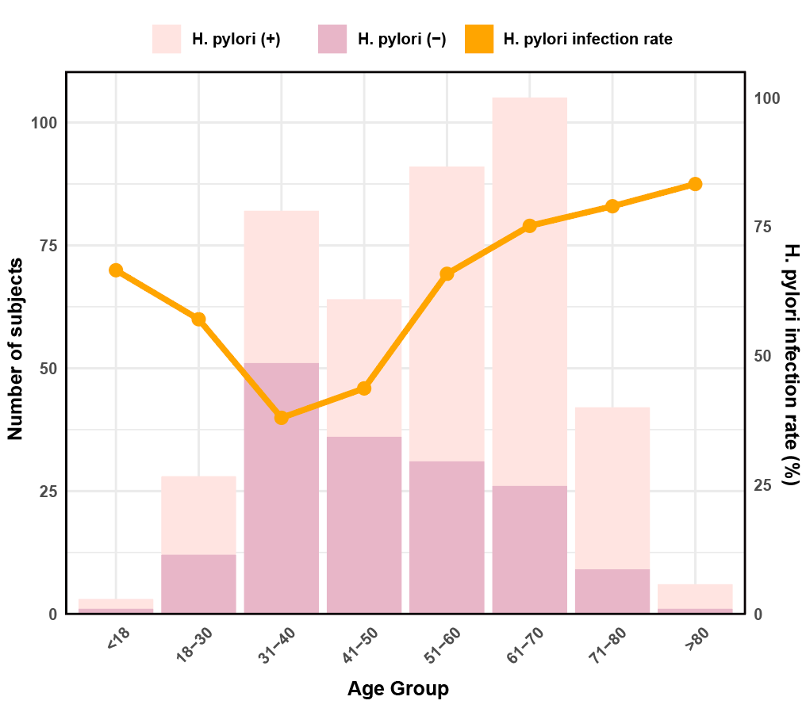

Supplementary Fig.1 H. pylori Infection Distribution and Rates Across Different Age Groups Among Enrolled Participants
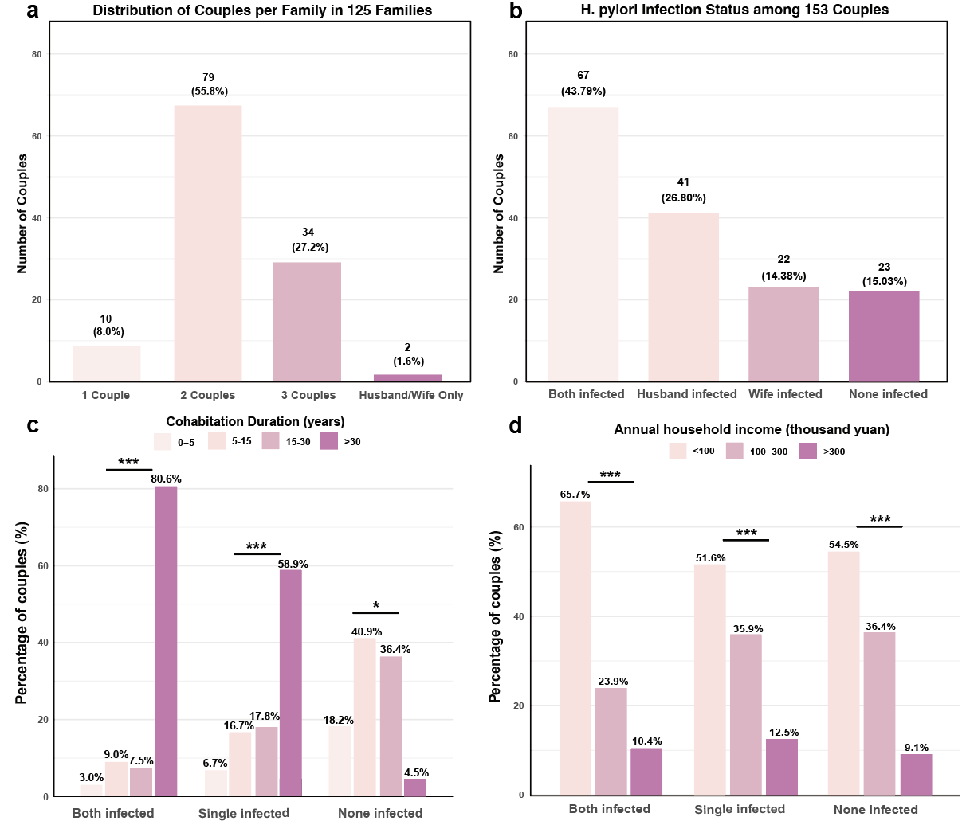
Supplementary Fig.2 Stratified analysis of H. pylori infection in the enrolled couples (a) Distribution of couples number per household in 125 enrolled families (b) Infection status of the total 153 couples (c) Correlation of couple cohabitation time and H. pylori infection rate of 153 couples (d) Correlation of annual household income and couple infection status
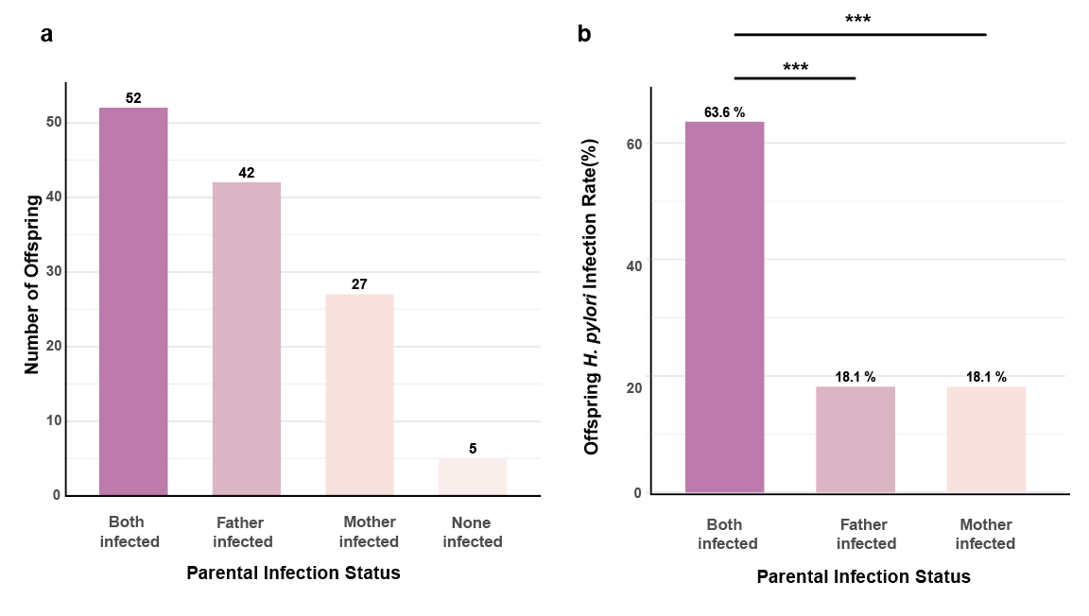
Supplementary Fig.3 Stratified analysis of H. pylori in offspring (a) Parental infection status of 127 offspring (b) Correlation of parental infection status and offspring infection rate

