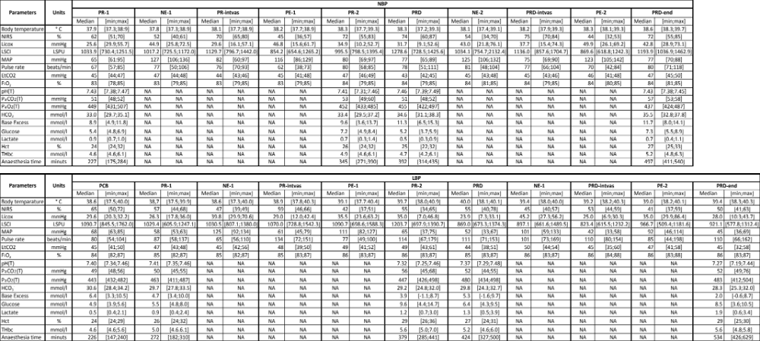

Cerebral perfusion and oxygenation readings, physiological and haemodynamic data, blood gas data, and anaesthesia time at all time points throughout the experiment. PCB: Pre-Caval block; PR-1: baseline during propofol-remifentanil; NE-1: Norepinephrine during propofol-remifentanil; PR-intvas: after norepinephrine and wash-out period during propofol-remifentanil; PE-1: Phenylephrine during propofol-remifentanil; PR-2: after phenylephrine wash-out period/pre-dexmedetomidine during Propofol-remifentanil; PRD: Propofol-remifentanil-dexmedetomidine; NE-2: Norepinephrine during propofol-remifentanil;PRD-intvas: after norepinephrine and wash-out period during propofol-remifentanil-dexmedetomidine; PE-2: Phenylephrine during propofol-remifentanil-dexmedetomidine; PRD-end: after phenylephrine and wash-out period during propofol-remifentanil-dexmedetomidine (end of experiment); NIRS: Near infra red spectroscopy; LSCI: Laser speckle contrast imaging; MAP: mean arterial pressure; EtCO₂: End-tidal carbon dioxide; FiO₂: Fraction of inspired oxygen; (T): data corrected for body temperature; PaCO₂: Partial pressure of arterial carbon dioxide; PaO₂: Partial pressure of arterial oxygen; HCO₃: Hydrogen bicarbonate; Hct: Haematocrit; THbc: Total haemoglobin concentration.

