eUTOPIA User Manual
with Sample Data Analysis

Contents
About eUTOPIA 3
Sample Data 4
Setup 5
Launch 6
Initialize 7
Workflow Interface 8
Phenotype Specification 9
Remove Samples 14
Raw Data 14
Quality Control 15
Filter Probes 15
Normalization 16
Normalization Plots 17
Technical Variation 19
Batch Correction 23
Known Batch Correction 23
Technical Variation After Known Correction 26
Unknown Batch Correction 27
Technical Variation After Unknown Correction 30
Annotation 30
Differential Analysis 33
Differential Results 35
Intersection Plot 37
Volcano Plot 39
Visualize Expression/Methylation 40
Reporting 47
Terminate eUTOPIA Session 49
eUTOPIA dependencies 50
References 51

About eUTOPIA
eUTOPIA is designed to perform preprocessing and analysis of microarray data from different microarray platforms.
- Agilent 2-color
- Agilent 1-color
- Affymetrix expression
- Illumina methylation (450k, EPIC)
eUTOPIA processes the microarray raw data through a guided workflow with defined steps that are executed by the user from the graphical interface. The workflow is designed to be intuitive and enables the user to make decisions at important steps to best suit their analytical goals.
Preprocessing involves quality control reporting of raw data, filtering poor quality probes, normalization of raw data to account for expression distributions from different arrays. Most importantly user can perform correction of technical variability not represented by the biological variables. Correction of data can be performed for known technical variables, while surrogate variables not known beforehand can be identified for correction. Data correction must be performed with care and eUTOPIA’s workflow allows the user to understand the representation of the known and surrogate variables by representing the technical variation graphically in plots. Annotation matching the raw microarray data must be provided by the user alternatively eUTOPIA can use the annotation from the raw data to aggregate the probes to genomic annotation features. The user can choose to export preprocessed data at different levels of processing.
Differential analysis of preprocessed data is performed by defining the model to use in limma analysis with the specification of the variable of interest and additive covariates, in addition to this the user defines the comparisons for differential analysis from the variable of interest. Results from differential analysis can be filtered by specifying the logFC and p.value thresholds. These results are supplemented with different graphical representations to see; the intersection of features identified in different comparisons, representation of features by logFC and p.value as volcano plot, representation of differential features as heatmap to see the grouping of samples. These results can be exported by the user and the graphical representation can be exported as a PDF report of plots generated at different levels of preprocessing and analysis.

Sample Data

Sample Expression Data
https://www.ncbi.nlm.nih.gov/geo/query/acc.cgi?acc=GSE92900.
Distinct sets of genes representing overlapping biological functions are altered by intrinsic properties of carbon nanomaterials in vitro and in vivo [mouse], GEO (Barrett et al., 2013) accession GSE92900 (Kinaret et al., 2017). Raw data download link.

Phenotype Information
SampleID | group | dye | slide | area | array | RIN | Qubit_conc | dye_conc | dye_activity | n.mice | operator | date | file
full_23 | Fullerene | cy3 | s252800520993 | 1_1 | 252800520993_1_1 | 8.6 | 422.8 | 325.25 | 18.263 | 2 | natm | 17.9.2014 | US11263921_252800520993_S01_GE2_1105_Oct12_1_1.txt
gnf_16 | GNF | cy3 | s252800520993 | 1_2 | 252800520993_1_2 | 8.5 | 286.32 | 349.14 | 17.815 | 2 | natm | 17.9.2014 | US11263921_252800520993_S01_GE2_1105_Oct12_1_2.txt
bayt_17 | Baytubes | cy3 | s252800520993 | 1_3 | 252800520993_1_3 | 8.7 | 512.61 | 226.49 | 15.453 | 2 | natm | 17.9.2014 | US11263921_252800520993_S01_GE2_1105_Oct12_1_3.txt
tcnt_8 | tCNT | cy3 | s252800520993 | 2_1 | 252800520993_2_1 | 9.1 | 335.01 | 299.57 | 0 | 2 | natm | 17.9.2014 | US11263921_252800520993_S01_GE2_1105_Oct12_2_1.txt
ses_12 | SES | cy3 | s252800520993 | 2_3 | 252800520993_2_3 | 8.6 | 315.98 | 303.43 | 0.165 | 3 | natm | 17.9.2014 | US11263921_252800520993_S01_GE2_1105_Oct12_2_3.txt
bayt_18 | Baytubes | cy3 | s252800520993 | 2_4 | 252800520993_2_4 | 8.7 | 212.93 | 308.33 | 14.757 | 2 | natm | 17.9.2014 | US11263921_252800520993_S01_GE2_1105_Oct12_2_4.txt
ctrl_3 | Ctrl | cy3 | s252800520994 | 1_1 | 252800520994_1_1 | 8.9 | 124.26 | 340.16 | 18.932 | 2 | natm | 22.9.2014 | US11263921_252800520994_S01_GE2_1105_Oct12_1_1.txt
ses_10 | SES | cy3 | s252800520994 | 1_2 | 252800520994_1_2 | 8.7 | 298.68 | 299.16 | 24.97 | 2 | natm | 22.9.2014 | US11263921_252800520994_S01_GE2_1105_Oct12_1_2.txt
gnf_14 | GNF | cy3 | s252800520994 | 1_4 | 252800520994_1_4 | 8.5 | 280.89 | 304.96 | 18.002 | 2 | natm | 22.9.2014 | US11263921_252800520994_S01_GE2_1105_Oct12_1_4.txt
ctrl_1 | Ctrl | cy3 | s252800520994 | 2_1 | 252800520994_2_1 | 9 | 220.83 | 193.02 | 18.962 | 2 | natm | 22.9.2014 | US11263921_252800520994_S01_GE2_1105_Oct12_2_1.txt
rcnt_5 | rCNT | cy3 | s252800520995 | 1_1 | 252800520995_1_1 | 9.1 | 467.62 | 197.3 | 25.291 | 2 | tsui | 6.10.2014 | US11263921_252800520995_S01_GE2_1105_Oct12_1_1.txt
full_24 | Fullerene | cy3 | s252800520995 | 2_3 | 252800520995_2_3 | 8.5 | 289.37 | 339.05 | 23.448 | 2 | tsui | 6.10.2014 | US11263921_252800520995_S01_GE2_1105_Oct12_2_3.txt
gnf_15 | GNF | cy5 | s252800520993 | 1_1 | 252800520993_1_1 | 8.5 | 278.86 | 334.62 | 19.814 | 2 | natm | 17.9.2014 | US11263921_252800520993_S01_GE2_1105_Oct12_1_1.txt
rcnt_4 | rCNT | cy5 | s252800520993 | 1_2 | 252800520993_1_2 | 8.7 | 253.34 | 162.21 | 14.487 | 3 | natm | 17.9.2014 | US11263921_252800520993_S01_GE2_1105_Oct12_1_2.txt
tcnt_7 | tCNT | cy5 | s252800520993 | 1_3 | 252800520993_1_3 | 8.4 | 267.68 | 252.83 | 20.132 | 3 | natm | 17.9.2014 | US11263921_252800520993_S01_GE2_1105_Oct12_1_3.txt
ses_11 | SES | cy5 | s252800520993 | 2_1 | 252800520993_2_1 | 8.8 | 243.79 | 330.15 | 2.151 | 2 | natm | 17.9.2014 | US11263921_252800520993_S01_GE2_1105_Oct12_2_1.txt
bayt_19 | Baytubes | cy5 | s252800520993 | 2_3 | 252800520993_2_3 | 8.7 | 345.04 | 231.78 | 1.898 | 2 | natm | 17.9.2014 | US11263921_252800520993_S01_GE2_1105_Oct12_2_3.txt
ctrl_2 | Ctrl | cy5 | s252800520993 | 2_4 | 252800520993_2_4 | 8.9 | 225.7 | 362.35 | 19.705 | 3 | natm | 17.9.2014 | US11263921_252800520993_S01_GE2_1105_Oct12_2_4.txt
bayt_20 | Baytubes | cy5 | s252800520994 | 1_1 | 252800520994_1_1 | 8.7 | 316.62 | 382.83 | 26.853 | 2 | natm | 22.9.2014 | US11263921_252800520994_S01_GE2_1105_Oct12_1_1.txt
full_22 | Fullerene | cy5 | s252800520994 | 1_2 | 252800520994_1_2 | 8.5 | 299.59 | 363.73 | 27.108 | 2 | natm | 22.9.2014 | US11263921_252800520994_S01_GE2_1105_Oct12_1_2.txt
rcnt_6 | rCNT | cy5 | s252800520994 | 1_4 | 252800520994_1_4 | 9.2 | 554.125 | 326.2 | 23.237 | 2 | natm | 22.9.2014 | US11263921_252800520994_S01_GE2_1105_Oct12_1_4.txt
gnf_13 | GNF | cy5 | s252800520994 | 2_1 | 252800520994_2_1 | 8.5 | 256.89 | 3.69 | 37.94 | 2 | natm | 22.9.2014 | US11263921_252800520994_S01_GE2_1105_Oct12_2_1.txt
full_21 | Fullerene | cy5 | s252800520995 | 1_1 | 252800520995_1_1 | 8.3 | 365.75 | 271.99 | 21.582 | 2 | tsui | 6.10.2014 | US11263921_252800520995_S01_GE2_1105_Oct12_1_1.txt
tcnt_9 | tCNT | cy5 | s252800520995 | 2_3 | 252800520995_2_3 | 9 | 347.57 | 356.21 | 21.346 | 2 | tsui | 6.10.2014 | US11263921_252800520995_S01_GE2_1105_Oct12_2_3.txt

Phenotype Table Description
Column Name | Column Description
SampleID | Unique identifier for the samples
group | Grouping variable for samples by nanomaterial exposure
dye | Microarray dye information. Cy5 for red channel and Cy3 for the green channel
slide | Identifier for the microarray slide
area | Identifier for the area in the slide
array | Identifier for the array from a specific slide
RIN | RNA Integrity Number as a quantitative measure of RNA quality from Agilent BioAnalyzer
Qubit_conc | RNA integrity measure from Qubit assay
dye_conc | Dye concentration reported by NanoDrop quantification
dye_activity | Specific activity determined from the NanoDrop quantification
n.mice | Number of mouse samples
operator | Code of the person responsible for the microarray experiment
date | Microarray experiment date
File | Filename for the microarray raw data file (base filename without directory path)

Color Code
Array Information | Information about microarray
Sample Information. | Information about samples associated with microarrays
RNA quality & Sample Preparation | Experimental quality estimation of RNA extracted from samples
Technical Information | Technical information associated with samples
Experiment Information | Information associated with microarray experimentation

Setup

Install R Dependencies
#Install impute dependency
source("http://bioconductor.org/biocLite.R")
biocLite("impute")

#Install CRAN dependencies
cran_pkgs <- c("swamp", "infotheo", "gplots", "RColorBrewer", "shiny", "shinyjs", "shinyBS", "shinydashboard", "shinyFiles",
"DT", "shinycssloaders", "ggplot2", "ggrepel", "WriteXLS", "rmarkdown", "VennDiagram", "grid", "futile.logger", "reshape2",
"htmlTable", "devtools", "httr", "randomcoloR")
cran_pkgs.inst <- cran_pkgs[!(cran_pkgs %in% rownames(installed.packages()))]
if(length(cran_pkgs.inst)>0){
print(paste0("Missing ", length(cran_pkgs.inst), " CRAN Packages:"))
for(pkg in cran_pkgs.inst){
print(paste0("Installing Package:'", pkg, "'..."))
install.packages(pkg, repo="http://cran.rstudio.org", dependencies=TRUE)
print("Installed!!!")
}
}

#Install latest version of rhandsontable from GitHub
print("Installing rhandsontable from GitHub!")
devtools::install_github("jrowen/rhandsontable")

#Install latest version of UpSetR from GitHub
print("Installing UpSetR from GitHub!")
devtools::install_github("hms-dbmi/UpSetR")

#Install Bioconductor dependencies
source("http://bioconductor.org/biocLite.R")
bioc_pkgs <- c("limma", "sva", "Biobase", "biomaRt", "affy", "affyQCReport", "arrayQualityMetrics", "made4", "vsn", "GEOquery", "minfi",
"IlluminaHumanMethylation450kmanifest", "IlluminaHumanMethylation450kanno.ilmn12.hg19", "IlluminaHumanMethylationEPICmanifest",
"IlluminaHumanMethylationEPICanno.ilm10b2.hg19", "affyio", "simpleaffy", "yaqcaffy", "GO.db", "shinyMethyl")
bioc_pkgs.inst <- bioc_pkgs[!(bioc_pkgs %in% rownames(installed.packages()))]
if(length(bioc_pkgs.inst)>0){
source("http://bioconductor.org/biocLite.R")
print(paste0("Missing ", length(bioc_pkgs.inst), " Bioconductor Packages:"))
for(pkg in bioc_pkgs.inst){
print(paste0("Installing Package:'", pkg, "'..."))
biocLite(pkg, suppressUpdates=TRUE)
print("Installed!!!")
}
}

#Install latest version of GOSemSim from GitHub
print("Installing GOSemSim from GitHub!")
devtools::install_github("GuangchuangYu/GOSemSim")

Launch

Run eUTOPIA From GitHub
# Load 'shiny' library
library(shiny)

# Using runGitHub
runGitHub("eUTOPIA", "Greco-Lab", subdir="eUTOPIA-app")

# Using the archived file
runUrl("https://github.com/Greco-Lab/eUTOPIA/archive/master.tar.gz", subdir="eUTOPIA-app")
runUrl("https://github.com/Greco-Lab/eUTOPIA/archive/master.zip", subdir="eUTOPIA-app")

Download eUTOPIA and Run Locally
# Clone the git repository
git clone https://github.com/Greco-Lab/eUTOPIA eUTOPIA_clone

# Start R session and run by using runApp()
setwd("./eUTOPIA_clone")
library(shiny)
runApp("eUTOPIA-app/")

Launch eUTOPIA from R console
An instance of eUTOPIA can be started locally by 1. Starting the R console, 2. Attaching the R library shiny library(shiny), and 3. Submitting command runApp(“eUTOPIA-app”), where ‘eUTOPIA-app’ is the path of the directory eUTOPIA-app that contains the required R shiny script.
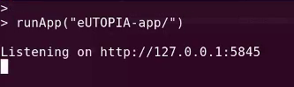

Initialize

Welcome Screen
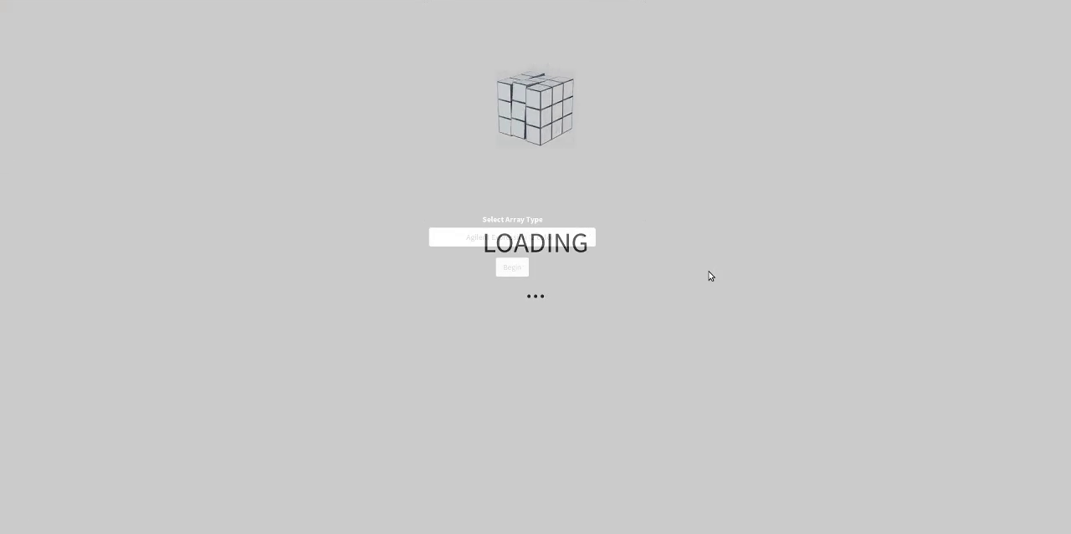

Platform Selection
INfORM supports Agilent two color, Agilent one color, Affymetrix Expression, and Illumina Methylation platforms for pre-processing and preliminary analysis.
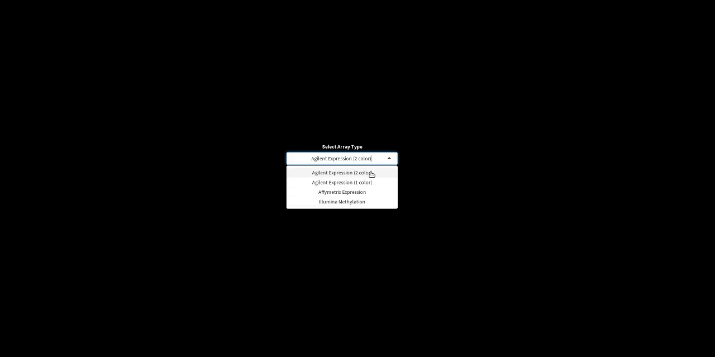

Begin Analysis
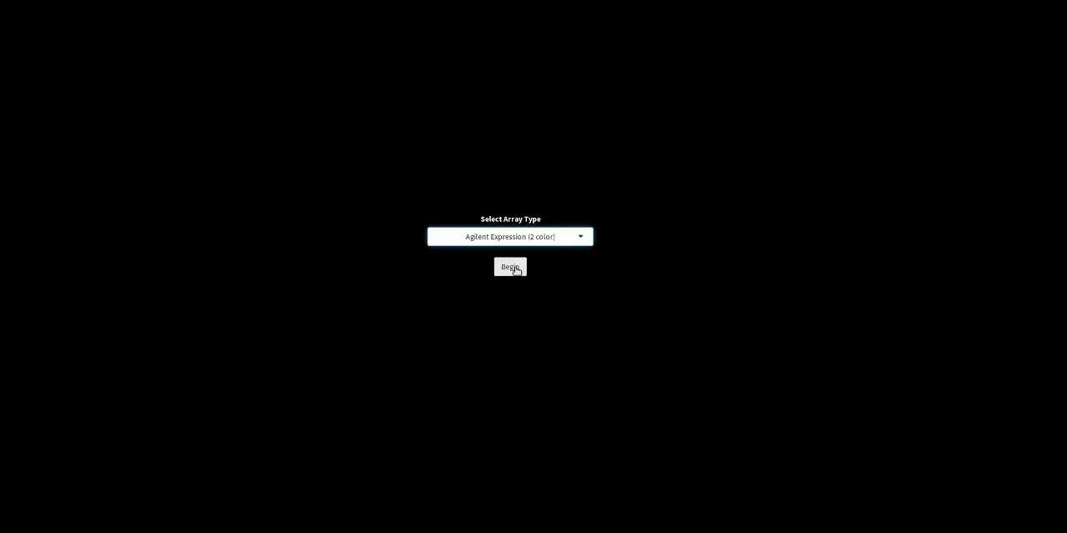

Workflow Interface
The workflow interface layout has a sidebar with input controls to configure and execute various steps (marked with green outline) and the output of the steps are visualized from the main display area (marked with red outline). The input controls in the sidebar are altered according to the chosen platform. This example analysis is for Agilent two-color platform data.
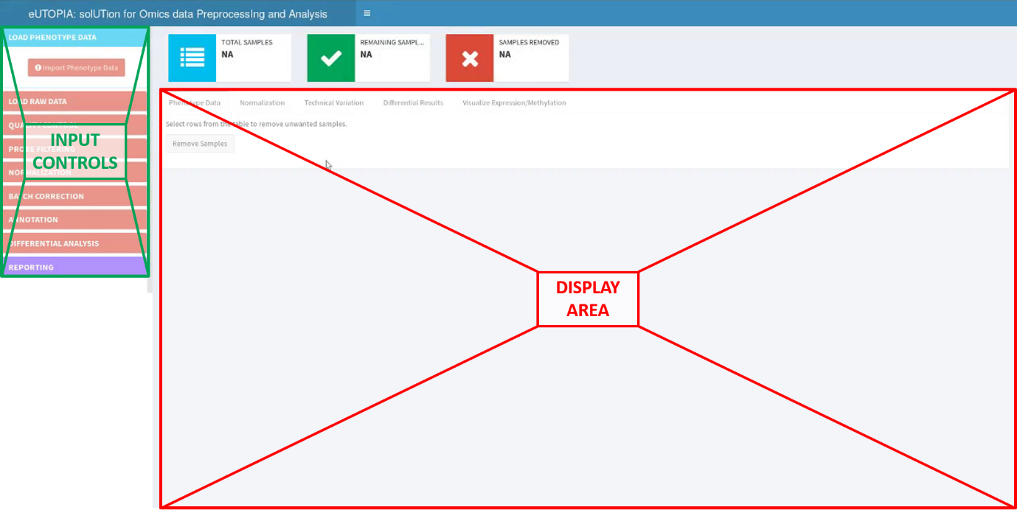

Phenotype Specification
The phenotype file is a table that contains information about the arrays used in the experimentation and the phenotype information of the samples associated with those arrays. The array information will vary according to the chose microarray platform, it is compulsory that phenotype file contains the array raw data file names (without directory structure), unique identifiers for the samples, and the dye information for the two-color experiment data. For Affymetrix expression, Agilent 1-color, and Agilent 2-color platforms the raw data file names must contain name of the file with extension (.txt or .CEL), while for Illumina methylation (450k and EPIC) platform file basename without the extension must be provided as there are two separate dye specific files for each basename that are identified internally by the pipeline.

Load Phenotype
Launch a popup window containing controls to configure the phenotype file import.
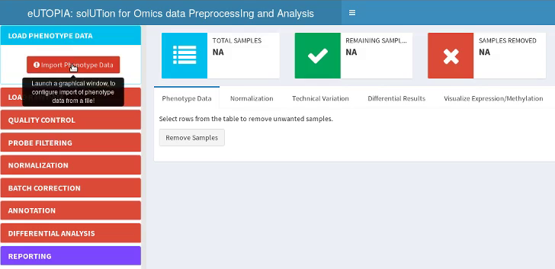

Select Phenotype File
Browse the file directories and select the file containing the phenotype information.
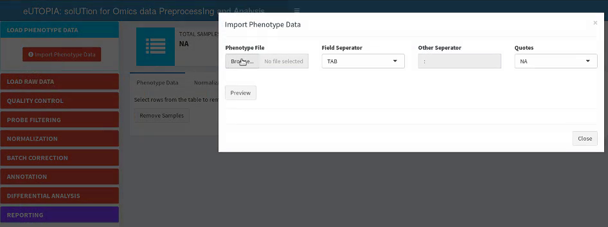

Specify Field Separator
Field Separator options allow the user to specify either tab, comma, semi-colon, space, or other as a separator of columns.
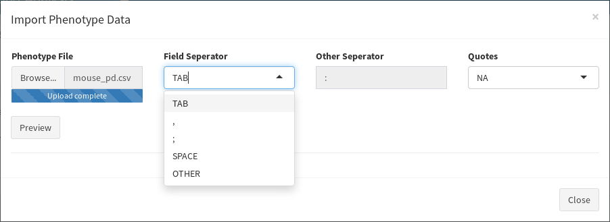

Custom Field Separator
OTHER option enables a free text Other Separator input box, where the user can specify any other operator which is not predefined in Field Separator.
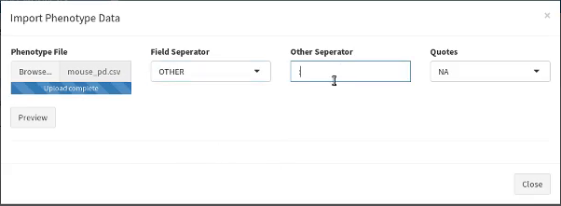

Specify Quotation Type
In case the input file contains quotations to specify field boundaries then the user can specify either single or double quotes from the Quotes input control.
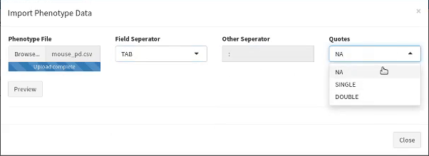

Phenotype Preview
Preview of the phenotype file displays the columns from the phenotype file as variables. Each variable has an associated R class character, numeric, or integer and data representation type as factor or vector. Number of samples and variables are reported as text labels above the preview.
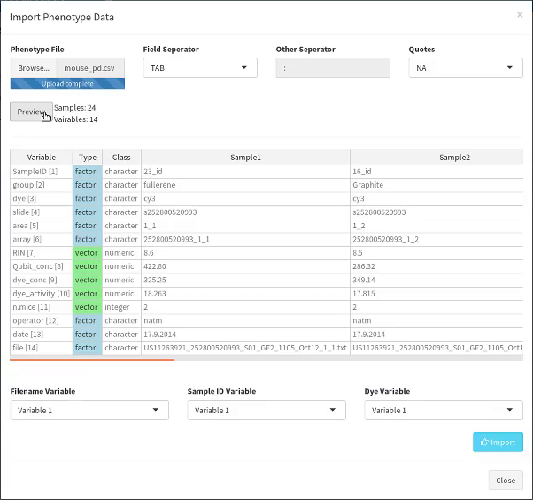

Configure Variable R Format
The user can change the default data representation type by double-clicking on the representative cell and selecting the alternative option.
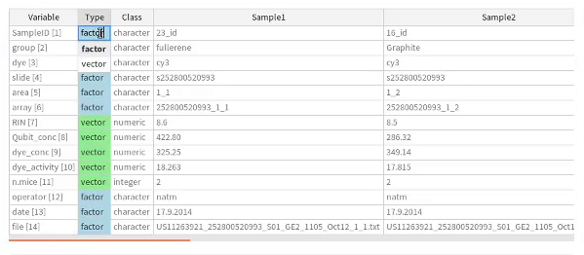

Specify Filename, Sample ID, and Dye Variables
Platform-specific variables are specified by the corresponding variable index from the phenotype preview.
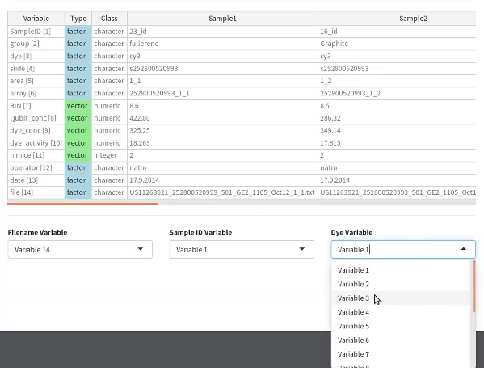

Import Phenotype
Finally, click on the Import button to import configured phenotype file.
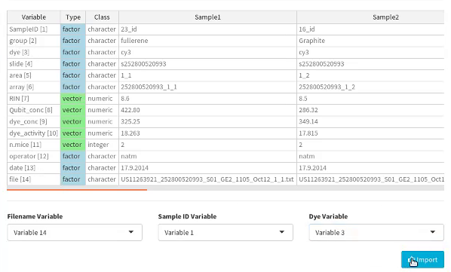

Phenotype View
The imported phenotype file is displayed in the main display area in the main tab Phenotype Data.
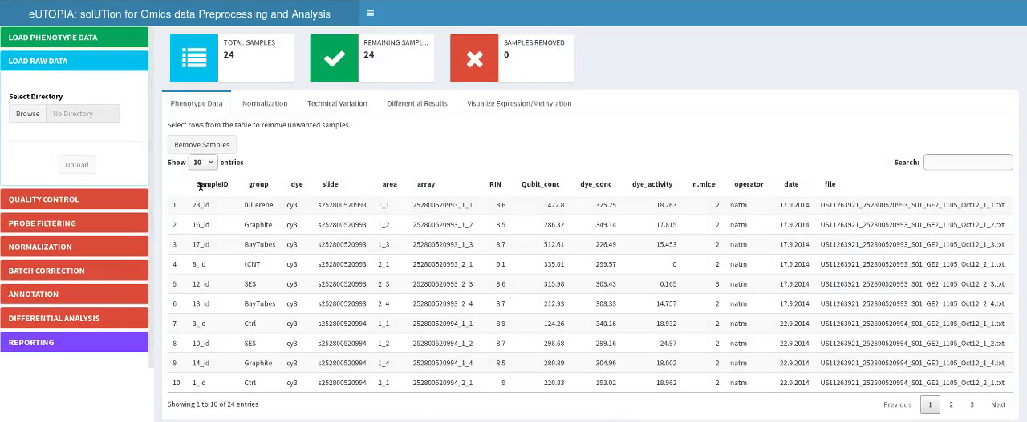

Remove Samples

Select Samples and Remove
Unwanted samples can be removed from the analysis by selecting the corresponding samples and clicking on Remove Samples button.
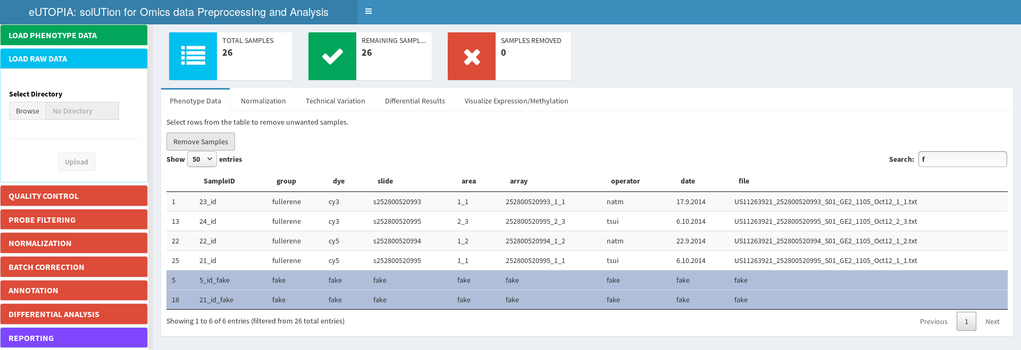

Samples Removed
Sample counts are displayed via the information boxes above the display area.
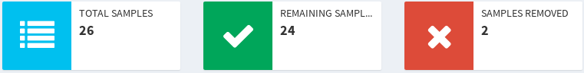

Raw Data
Raw data is uploaded by selecting the directory containing the raw data files. Raw data filenames are obtained from the phenotype file uploaded previously. A directory browser window is launched by clicking on the Browse button of the Select Directory input control. The user can traverse the directory structure by clicking on the arrowhead symbols to show/hide child directories. Select the directory from the Directories pane, the contents of the selected directory are displayed in the adjacent Content pane, click on the Select button to confirm the selection. Finally, click on the Upload button to start the upload process. This step has an added annotation specification section for Affymetrix data (not shown here).
Browse Directory | Select Raw Data Directory | Upload Raw Data
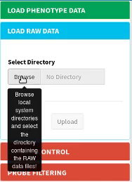 | 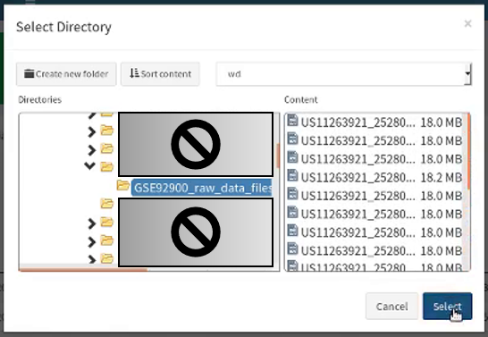 | 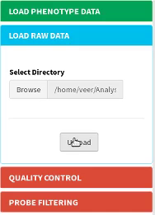

Quality Control
QC report can be generated as PDF or an archived HTML report; alternately the user can choose to skip the QC step.
Perform QC or Skip | Save QC Report
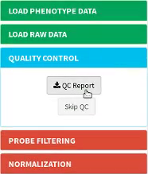 | 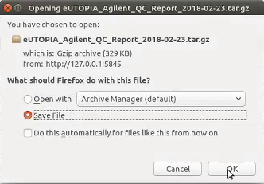

Filter Probes

Filtering Options
Control probe-based filter is provided for Agilent platforms. The user can set filter parameter Quantile Based Cutoff to set the expression value in negative control probes corresponding to the specified quantile as the cutoff value for validation of normal probes. Percentage of Samples parameter specifies the percentage of samples over which the probe should be validated to be greater than or equal to the specified cutoff expression value. Eg., Quantile Base Cutoff 0.75 means set the 75th percentile of the expression value distribution in negative control probes is used as the cutoff, Percentage of Samples 75 means check that at least 75% samples have expression value greater than or equal to the cutoff value for each normal probe. Normal probes failing this filter are removed and the filtered set is taken forward for analysis. Different options are provided for filtering Illumina methylation platform data (not shown here).
Specify Expression Quantile | Specify Percentage of Samples | Perform Filtering
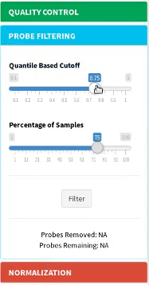 | 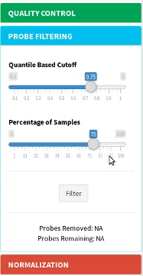 | 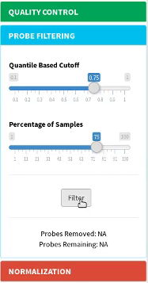

Filtering in Progress
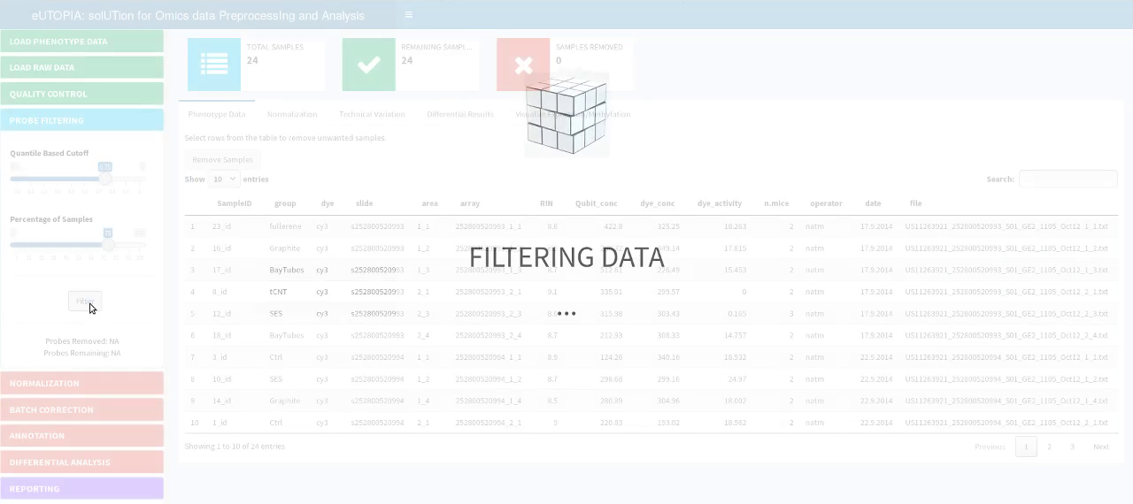

Normalization

Normalization Options
Methods from Limma R package are provided for normalization of data. The parameter Normalization Type provides the user with four options; if the user chooses Between Arrays option, then further method specification can be specified in the Method parameter.
Select Normalization Type | Select Normalization Method | Run Normalization
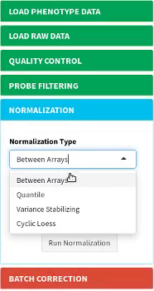 | 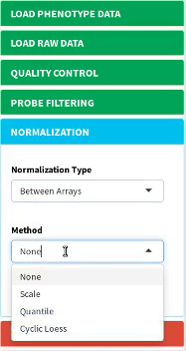 | 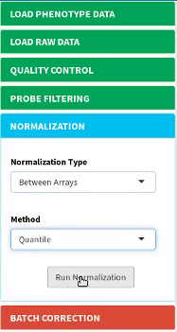

Normalization in Progress
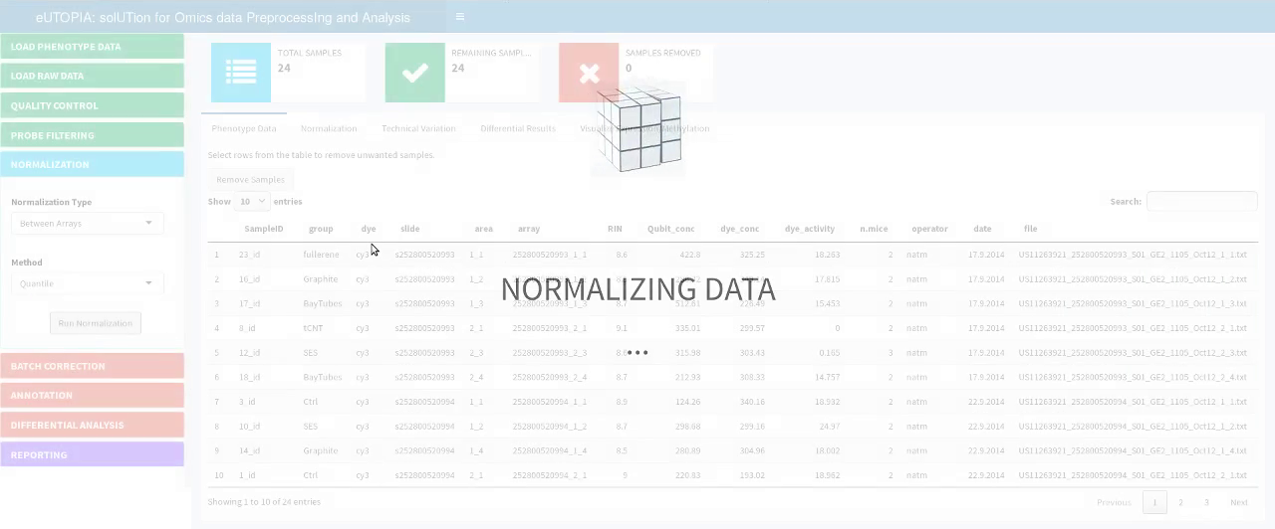

Normalization Plots

Box Plots
Box plots for the expression values before and after normalization can be viewed from the sub-tab Box Plot nested within the Normalization tab.
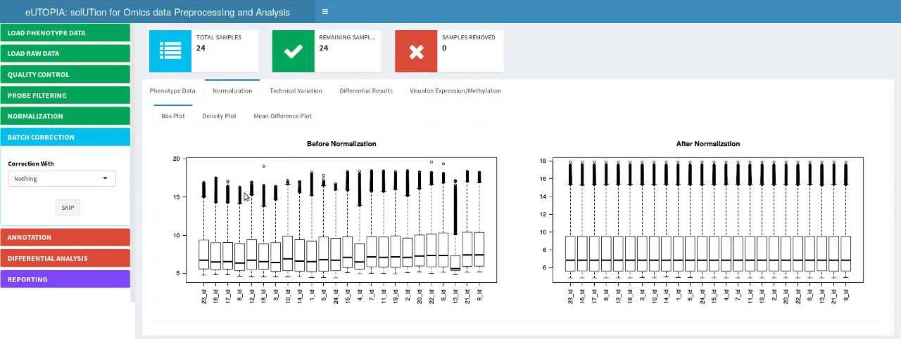

Density Plots
Density plots for the expression values before and after normalization can be viewed from the sub-tab Density Plot nested within the Normalization tab. For Agilent 2-color platform this plot shows the expression density in red and green channels, for Illumina methylation (450k and EPIC) platform it shows the density of the Beta values (Methylated signal over total Methylated+Unmethylated signal). This plot is not available for Agilent 1-color and Affymetrix expression platforms.
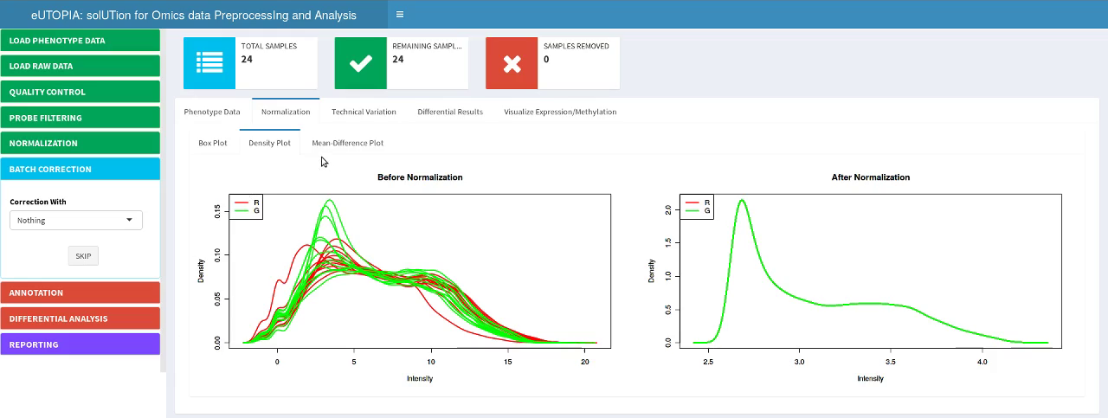

Mean Difference Plots
Mean Difference plots for the expression values before and after normalization can be viewed from the sub-tab Mean Difference Plot nested within the Normalization tab.
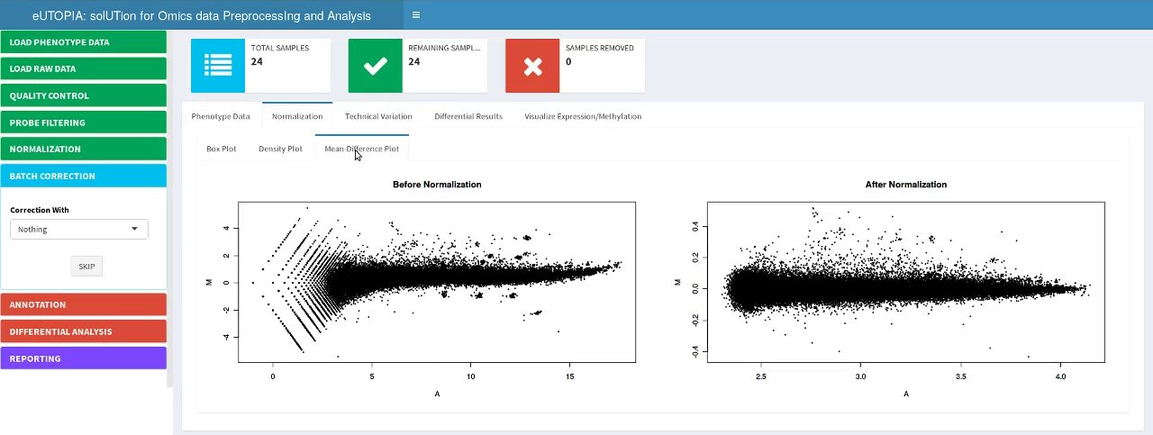

Technical Variation

Confounding Plot
Confounding plot displays the interrelatedness between the variables of the phenotype data; this is represented as a heatmap with correlation p.value represented as text and color gradient where red is highly correlated and white is non-correlated. This plot can be viewed from the sub-tab Confounding Plot nested within the Technical Variation tab. The p-value of interrelatedness is printed as text label in each cell and it is also represented as the color corresponding to the heatmap scale.
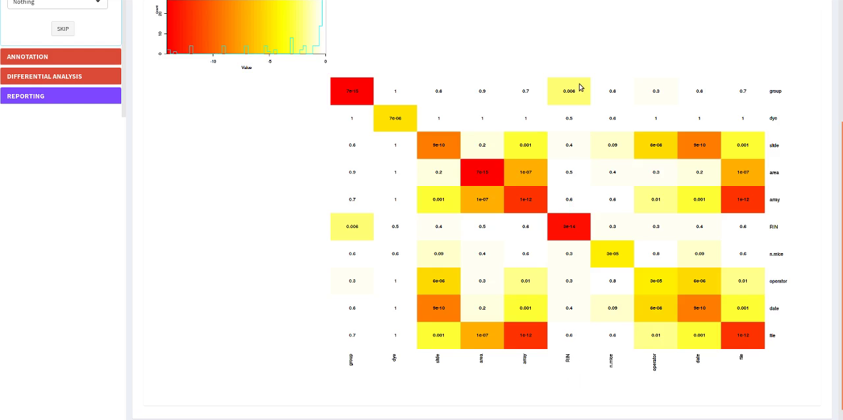

Prince Plot
Prince plot displays the association between the phenotype variables and the principal components; this is represented as a heatmap where principal components are on the x-axis and phenotype variables on the y-axis, the correlation p.value is presented as text and color gradient where red is highly correlated and white is non-correlated. On the x-axis principal component label contains the percentage of variability associated to them in brackets, this information along with correlation p.value is used to identify the phenotype variables representing the most variability. This plot can be viewed from the Before Correction tab nested within the sub-tab Prince Plot nested within the Technical Variation tab. The heatmap displays the p-value computed by linear regression as text label in each cell and it is also represented as the color corresponding to the heatmap scale.
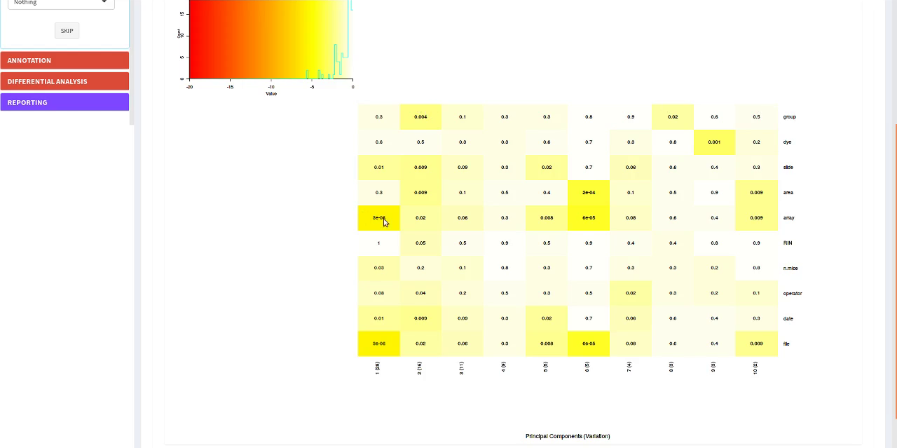

Hierarchical Clustering Plot
Hierarchical clustering plot displays the clustering of the samples based on the expression profile, sample annotation provided in the phenotype variables is plotted below the cluster as color-coded bars. The color code is used to see the distribution of groups in the phenotype variables, groups in the phenotype variable of interest should be separated discretely. This plot can be viewed from the Before Correction tab nested within the sub-tab Hierarchical Clustering nested within the Technical Variation tab.

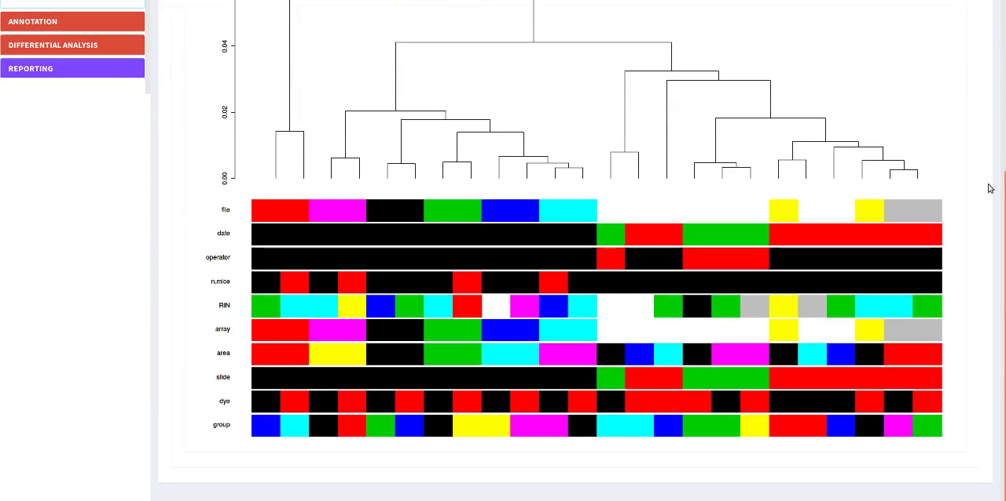

Multi-Dimensional Scaling (MDS) Plot
Multi-Dimensional Scaling plot displays the distance between each pair of samples; it represents the log2 fold change between the samples as observed by the top selected genes. The two-dimensional scatterplot can be represented with phenotype variables as label text and label color. Samples from the same group in the phenotype variable of interest should be closer together while the samples from other groups in the phenotype variable should be distant which would represent the differential expression profile of the genes in these two groups of samples. This plot can be viewed from the Before Correction tab nested within the sub-tab MDS Plots nested within the Technical Variation tab.

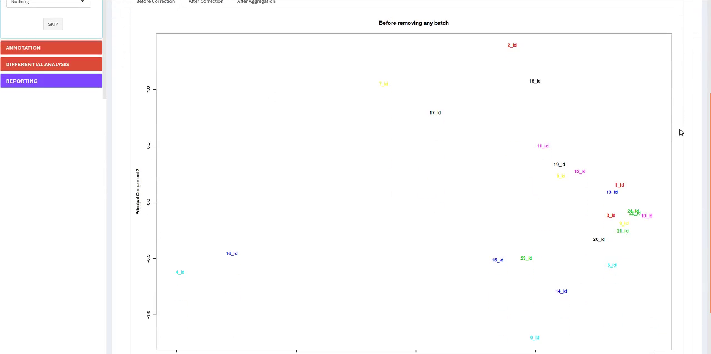

MDS Plot Options
The label text can be specified from the MDS Label Name input and label color representation can be specified from the MDS Label Color input control.
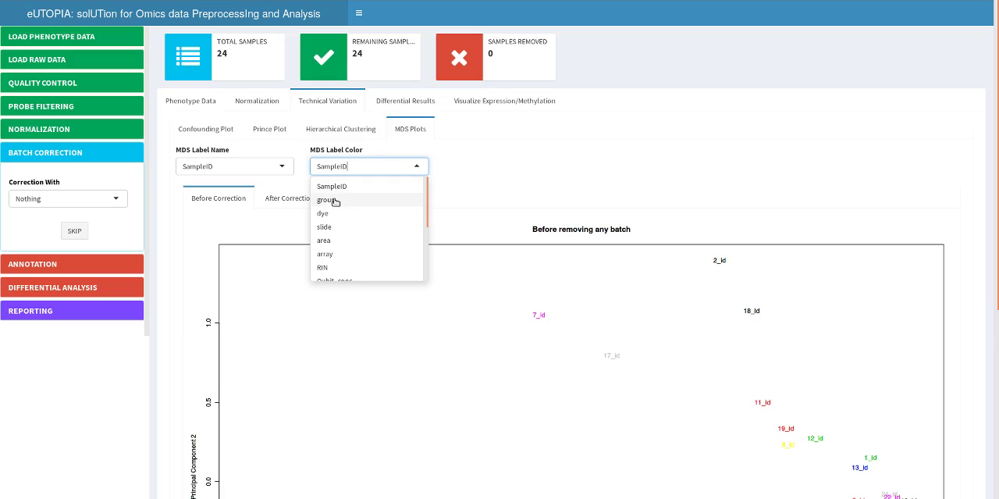

Batch Correction

Batch Correction Options
Batch correction is performed by ComBat for known variables or surrogate variables identified by SVA. The user has four different strategies to choose from Nothing, SVA+ComBat, ComBat, and SVA. Nothing option skips this step, SVA+ComBat option enables Launch SVA Module and Launch ComBat Module buttons, while SVA and ComBat options enables their corresponding Launch Module buttons. ComBat option is for correction of known variables, SVA option identifies surrogate variables that can be used as covariates in limma model definition while performing differential analysis, and SVA+ComBat option is used to first identify surrogate variables by SVA followed by correction of surrogate variables by ComBat.
Different Options | ComBat Option | SVA+ComBat Option | SVA Option
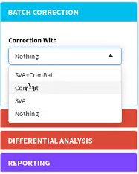 | 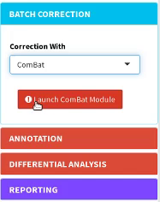 | 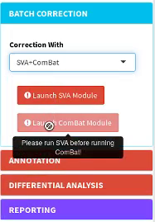 | 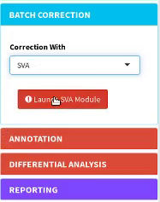

Known Batch Correction

ComBat Configuration
In the ComBat module window, user can specify the variable of interest, co-variates, and batches for correction.
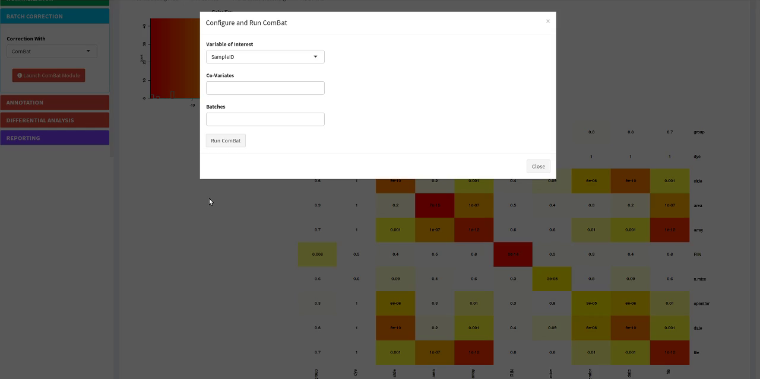

ComBat Variable of Interest
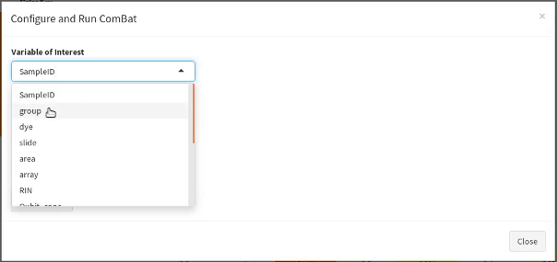

ComBat Batches
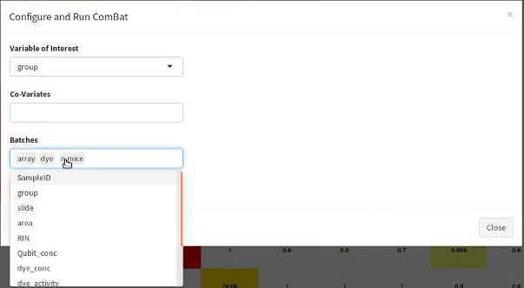

Perform Batch Correction
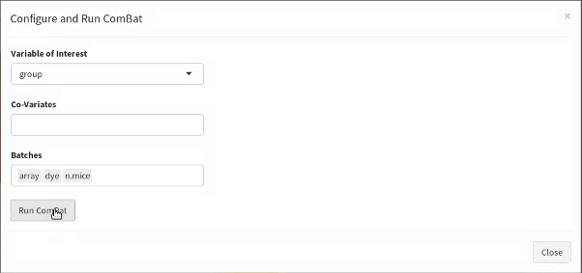

Batch Correction in Progress
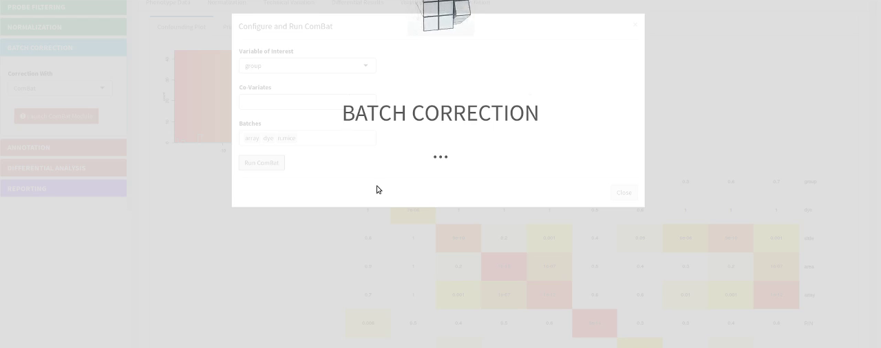

Technical Variation After Known Correction

MDS Plot
Multi-Dimensional Scaling plot displaying the distance between samples from the batch corrected data can be viewed from the After Correction tab nested within the sub-tab MDS Plots nested within the Technical Variation tab.
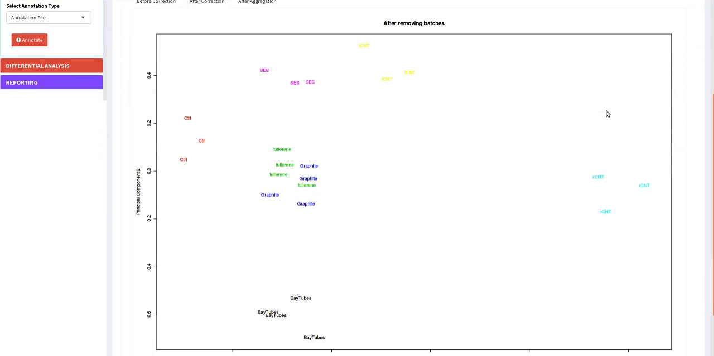

Prince Plot
Prince plot displaying the association between the phenotype variables and the principal components from the batch corrected data can be viewed from the After Correction tab nested within the sub-tab Prince Plot nested within the Technical Variation tab.
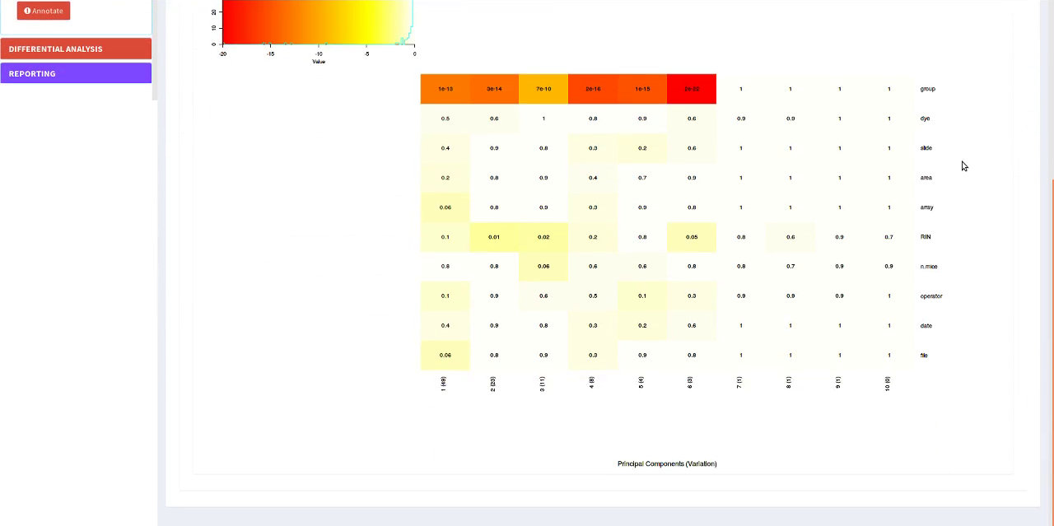

Hierarchical Clustering Plot
Hierarchical clustering plot displaying the clustering over the batch corrected data can be viewed from the After Correction tab nested within the sub-tab Hierarchical Clustering nested within the Technical Variation tab.
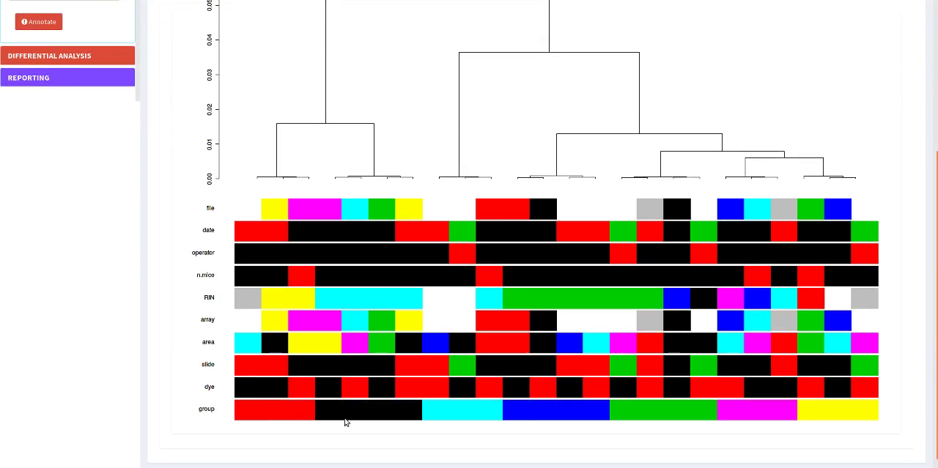

Unknown Batch Correction

Configure and Run SVA
In the SVA module window, user can specify the variable of interest and co-variates for identification of surrogate variables.
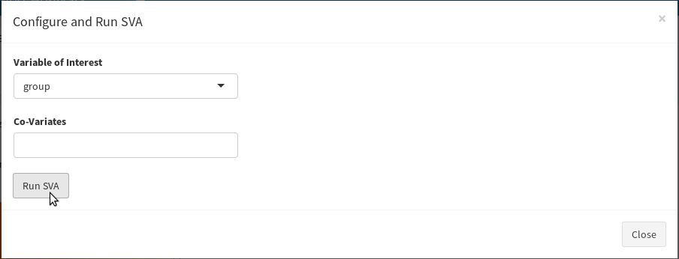

Confounding Plot with SVA Variables
After completion of the SVA step, the Confounding Plot is updated with the identified surrogate variables to show the relatedness of the surrogate variables as well.
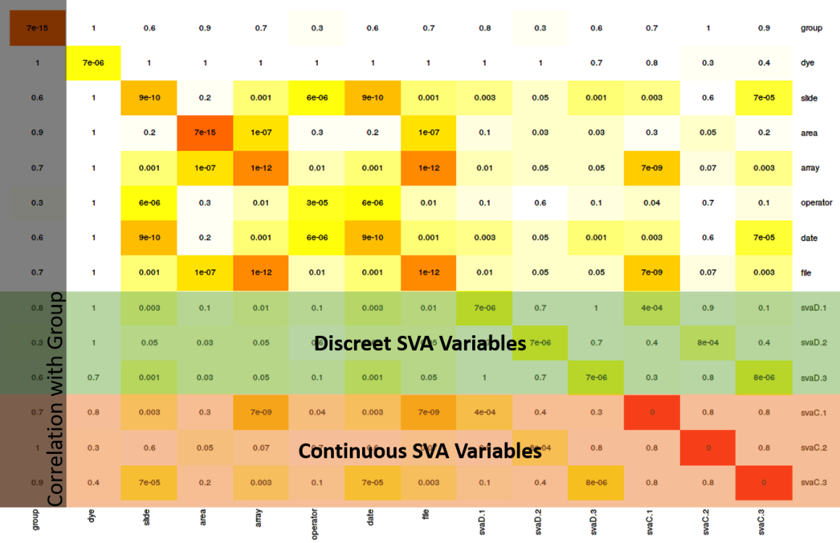

Prince Plot with SVA Variables
After completion of the SVA step, the prince plot is updated with the identified surrogate variables to show their association with the principal components.
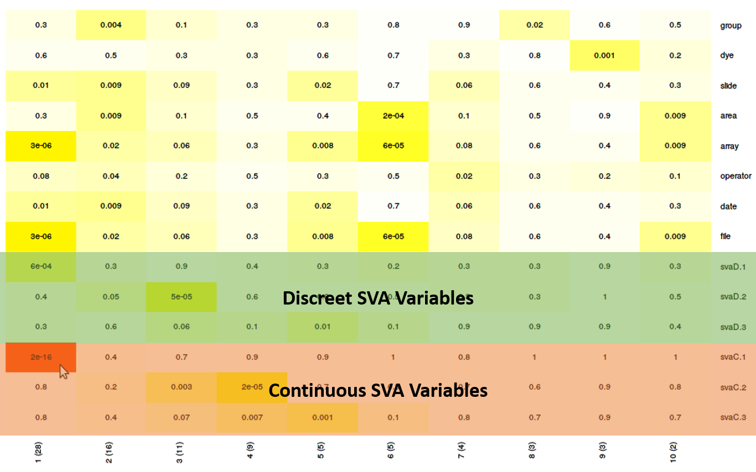

Batch Correction with SVA Variables
ComBat module window display after SVA restricts the Batches option to discreet surrogate variables only, the Variable of Interest and Co-Variates options use the known variables.
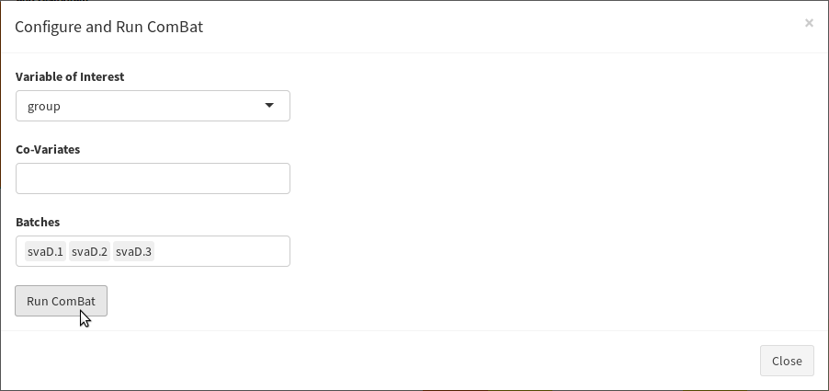

Batch Correction in Progress
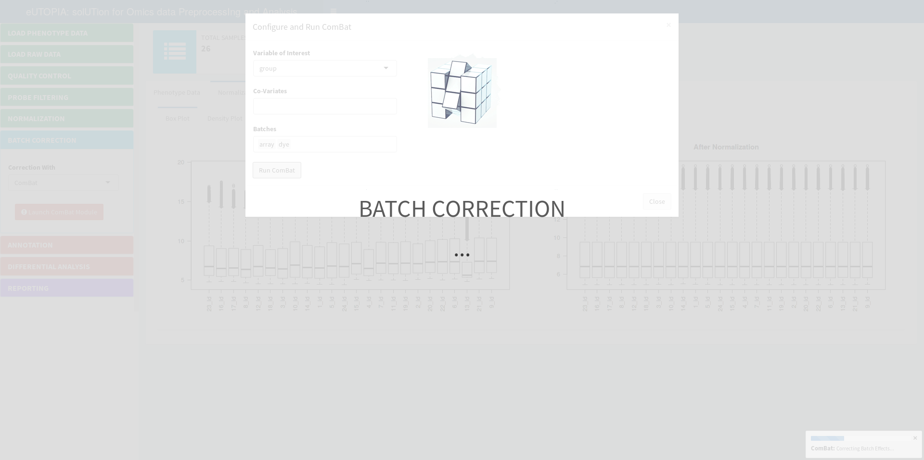

Technical Variation After Unknown Correction

Prince Plot
Prince plot after batch correction by using surrogate variables.
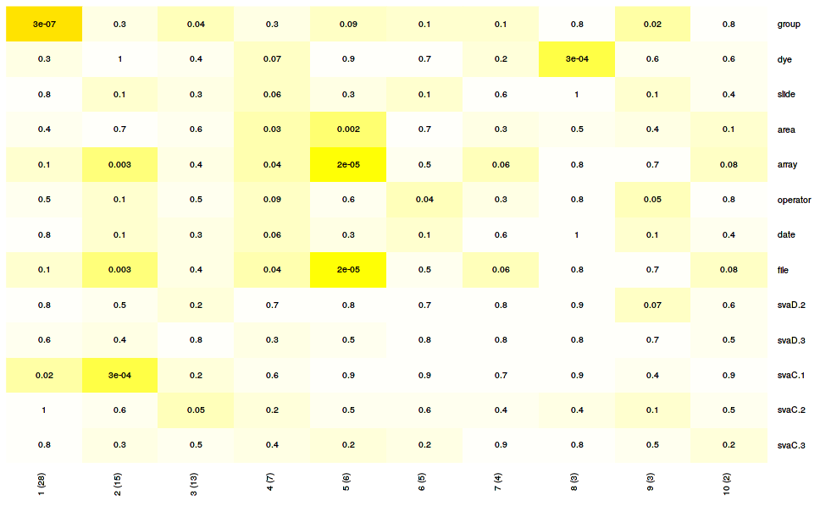

Annotation

Annotation Options
The user can provide array specific annotation file for the Agilent platforms, alternately intrinsic annotation of the array can be obtained from the raw data. Illumina methylation platform takes intrinsic array annotation by default and CDF annotations are used for Affymetrix expression arrays which are provided while uploading raw data (not shown here).
Available Options | Use Annotation from Raw Data | Upload Annotation File
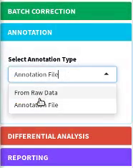 | 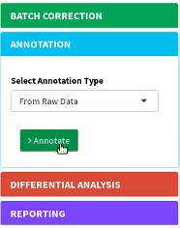 | 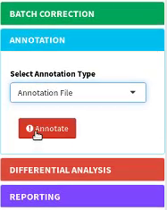

Select Annotation File
Annotation File option from the Select Annotation Type input launches Input Annotation window that lets the user configure and import the annotation file.
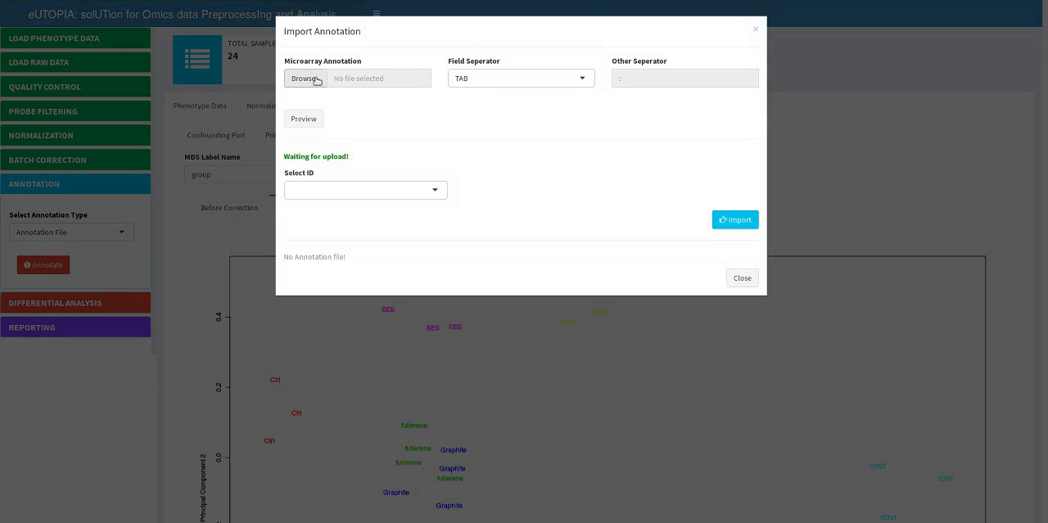

Preview and Import
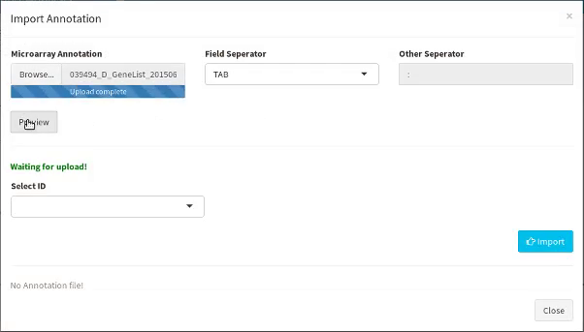

Annotation in Progress
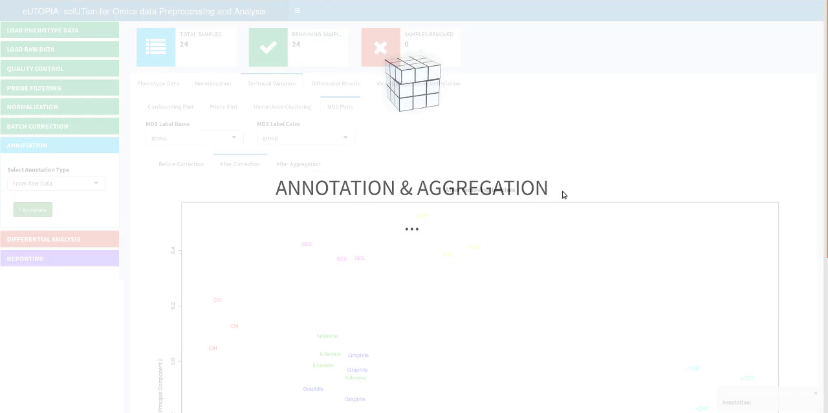

MDS Plot After Aggregation
Multi-Dimensional Scaling plot displaying the distance between samples from the data aggregated by annotation can be viewed from the After Aggregation tab nested within the sub-tab MDS Plots nested within the Technical Variation tab.
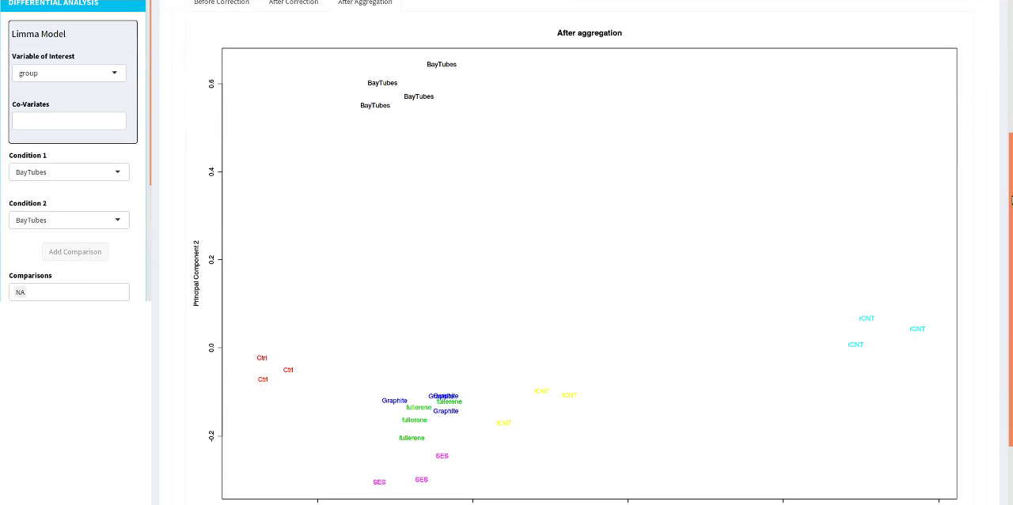

Differential Analysis

Configure Limma Model
Differential Analysis step has Limma Model configuration parameters Variable of Interest and Co-Variates. Limma contrasts can be created by specifying Condition 1 and Condition 2 followed by Add Comparison. The user can remove any excess contrasts from the Comparison input. P-value adjustment methods from Limma are provided as options in P.value Adjustment Method input control.
Variable of Interest | Covariates | SVA Strategy: Covariates | Select Conditions
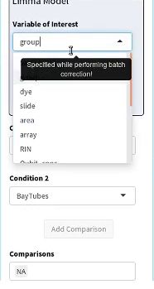 | 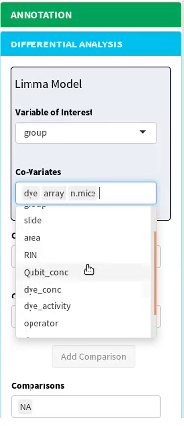 | 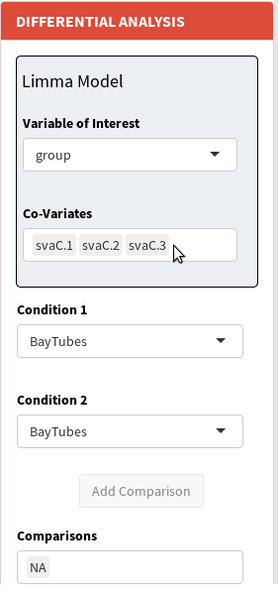 | 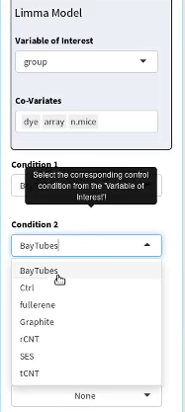

Create Comparison | Add/Remove Created Comparison | Specify PValue Adjustement Method
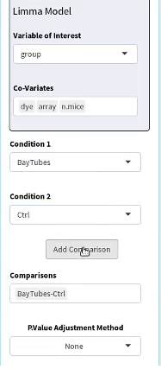 | 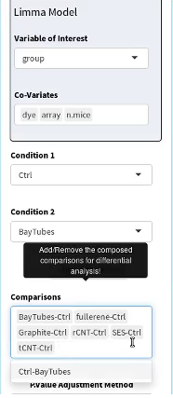 | 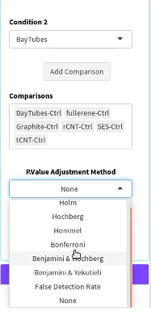

Perform Differential Analysis
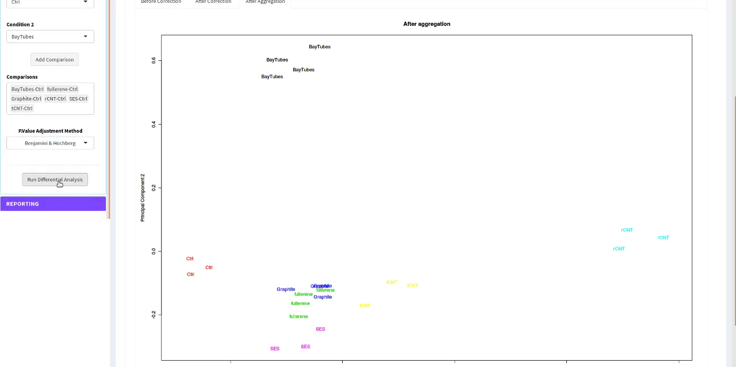

Differential Analysis in Progress
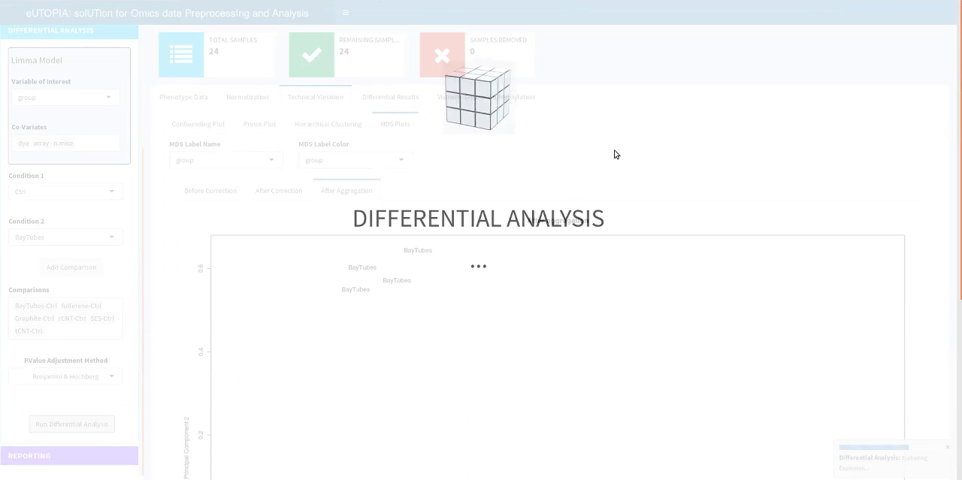

Differential Results
Results of the differential analysis are displayed in the Differential Results tab in the main display area.
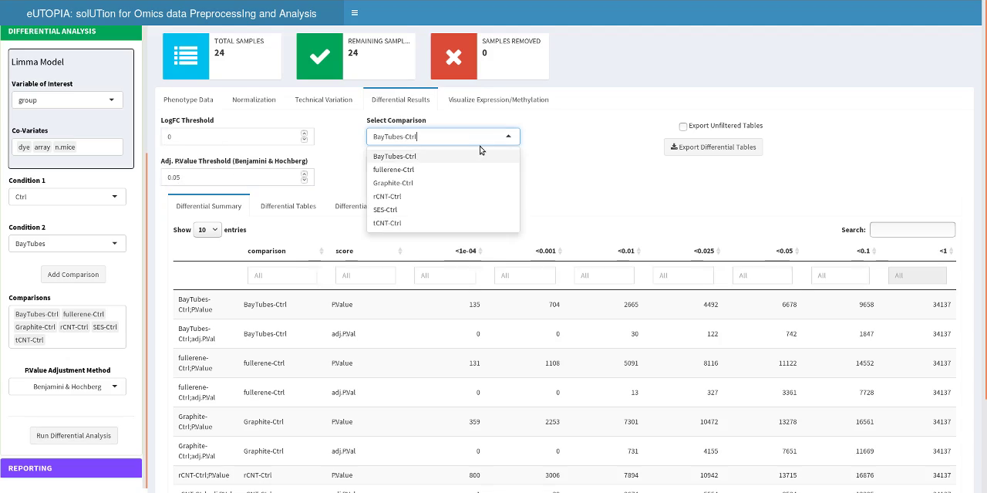

Differential Results Summary
Differential Summary sub-tab displays the summary of the differential features by different thresholds of P.Value and adj.PVal. This summary table is updated on changing logFC threshold.
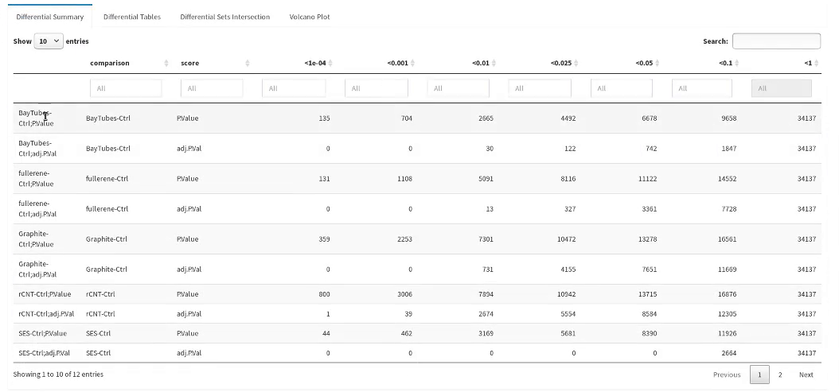

Differential Results Table
Differential Tables sub-tab displays the table of the differential features obtained by Limma differential analysis. It shows results filtered by logFC and P.value thresholds for the specific comparison.
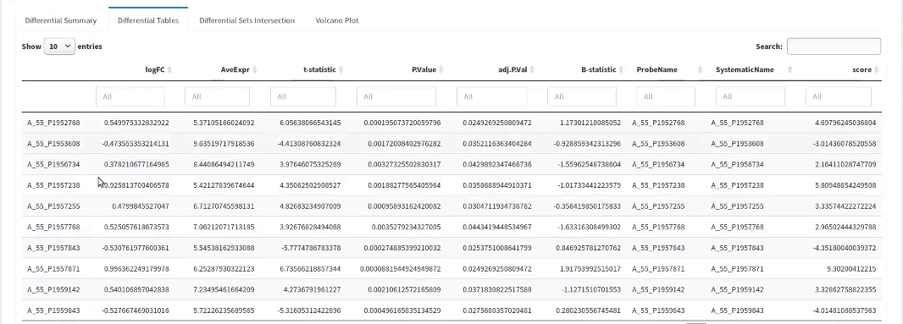

Filter and Export Differential Tables
Differential Results can be filtered by using the LogFC Threshold, Adj.P.Value Threshold, and Select Comparison parameters. Differential results can be exported as single combined spreadsheet by clicking on Export Differential Tables button; the user can also choose the Export Unfiltered Tables option to export tables without filtering by logFC and Adj.P.Value.
Filter Differential Results | Export Differential Tables | Save Differential Tables as XLS
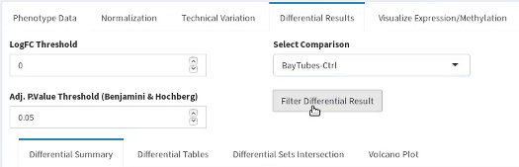 | 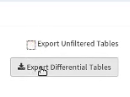 | 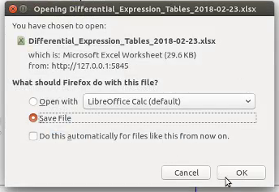

Exported XLS
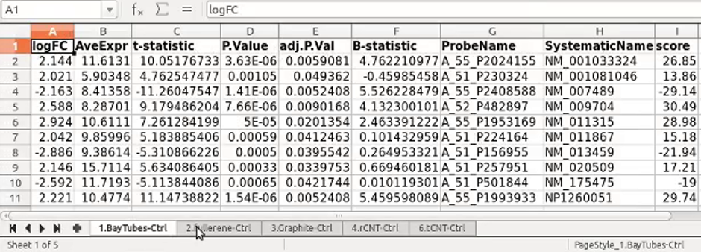

Intersection Plot
Differential Sets Intersection sub-tab displays the intersection between the set of differential features between chosen comparisons specified in Sets to Intersect multi-select input box. The intersections are represented in two separate forms which are chosen based on the number of chosen sets from intersection.

UpSet Plot (>4 sets)
For greater than 4 feature sets intersections are represented as an UpSet plot. The intersections are plotted as a bar plot with vertical bars representing the distinct intersections and the intersection size is represented on the y-axis. The feature sets are plotted below as horizontal bars and set size is represented on the corresponding x-axis. The sets to intersection correlation is reported as dot plot where the sets participating in the intersection are highlighted as dark dots and are connected by a thin line.
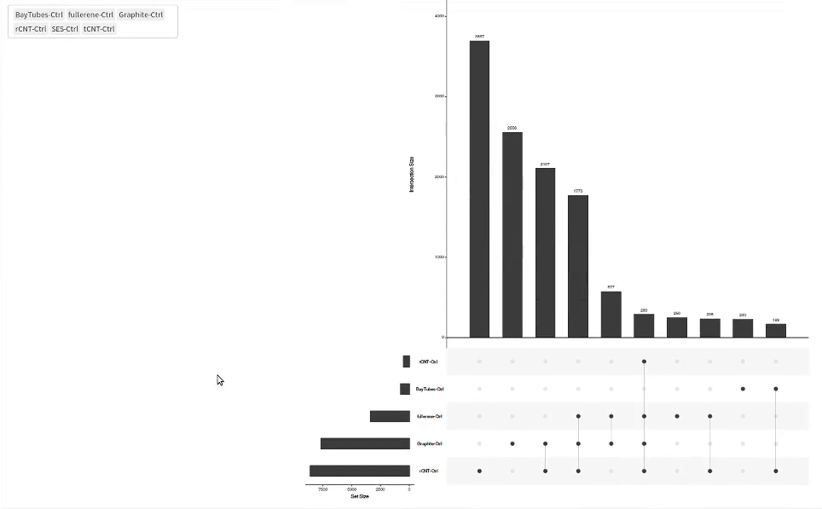

Venn Diagram (<=4 sets)
For 4 or lesser number of feature sets the intersections are represented as a Venn diagram. The sets are plotted as elliptical circles which overlap to form closed curves that represent the logical relationship between the sets. The numbers in each closed curve represent the number of features present in all sets that participate in the formation of that closed curve.
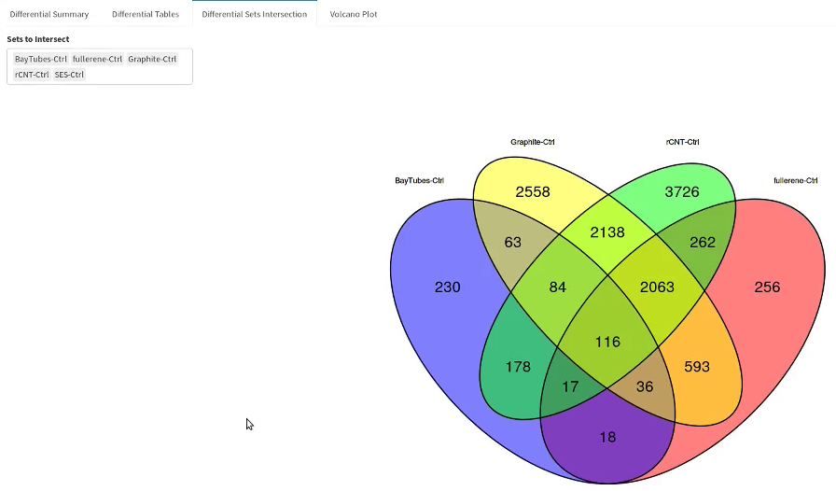

Volcano Plot
Volcano Plot sub-tab displays the volcano plot representation of features with logFC on the x-axis and -log10(P.Value) on the y-axis. LogFC threshold is represented by two vertical blue lines, P.Value threshold is represented by the horizontal red line. Features outside of these threshold lines are represented by red colored dots; these red highlighted features are differential features passing the logFC and P.Value thresholds.
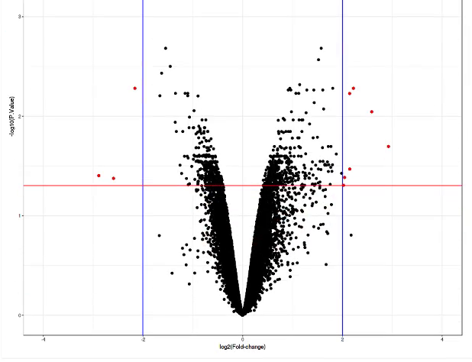

Volcano Plot Controls
The user can customize the display boundaries by adjusting X Axis Bounds and Y Axis Bounds parameters that control the extent of the x-axis and y-axis to be displayed.
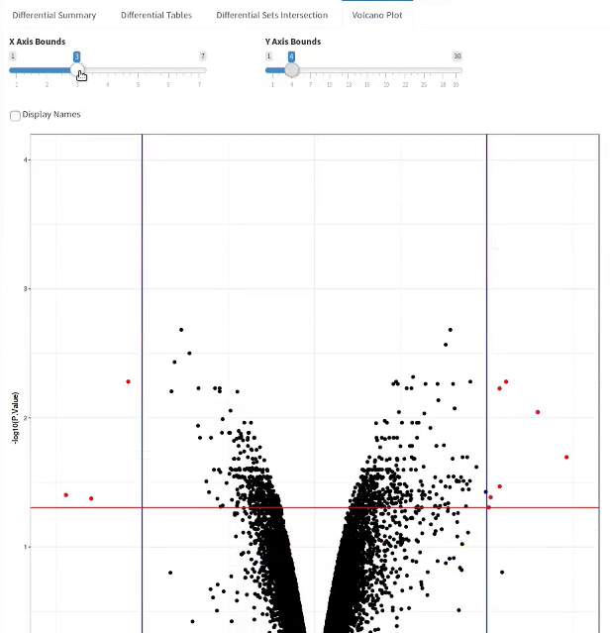

Volcano Plot Feature Names
The user can choose to display the names of the features outside the threshold lines. This is helpful when the filtered features are few in numbers and can be visually inspected.
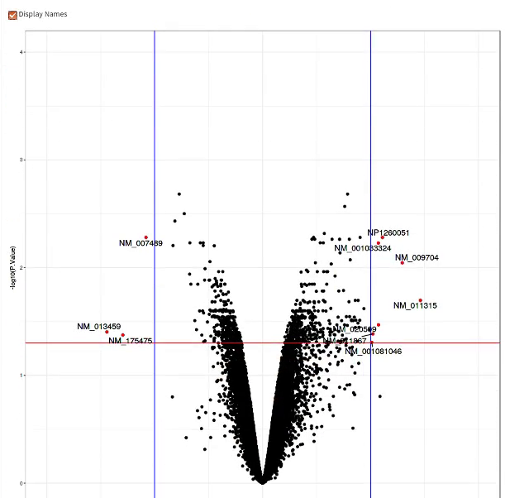

Visualize Expression/Methylation

Box Plot
Expression/Methylation values can be viewed as box plot from the Box Plot sub-tab nested in the Visualize Expression/Methylation main tab. The latest adjusted data values are used to create the box plots. The user can setup box plot by using three parameters.
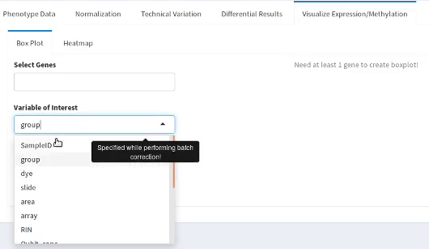

Box Plot Gene Selection
The user can specify the Variable of Interest which populates the distinct components from the specified variable in the Select Conditions multi-select input box. Chosen conditions from Select Conditions in combination with chosen features from Select Genes specify the distribution of expression values associated with a feature in selected conditions as box plot.
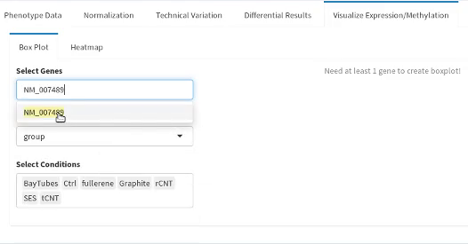

Box Plot Gene Lookup
The Select Genes multi-select input box supports auto-lookup of features by typing the prefix of the feature name to assist in search and selection of features from the complete list of feature. One boxplot per condition per feature is plotted with a distinct color.
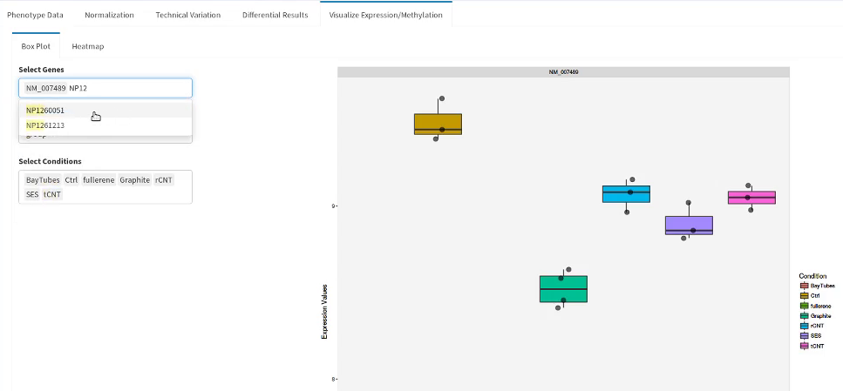

Box Plot (One Gene)
This box plot can be generated for a single feature.
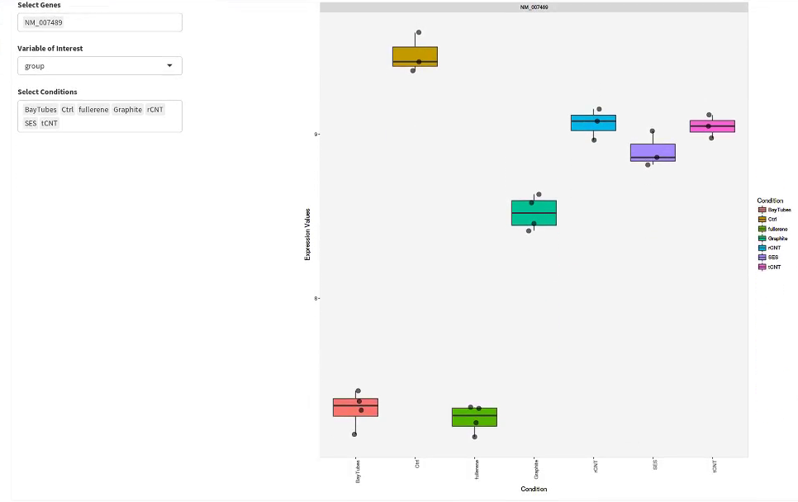

Box Plot (Two Genes)
Multiple feature are represented with a plot per feature adjacent to each other.
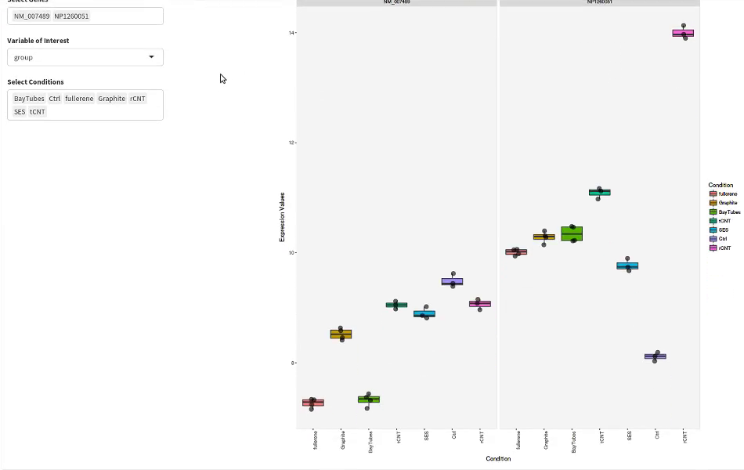

Box Plot (Conditions)
Specific conditions can be chosen to get meaningful representation of the expression value distribution.
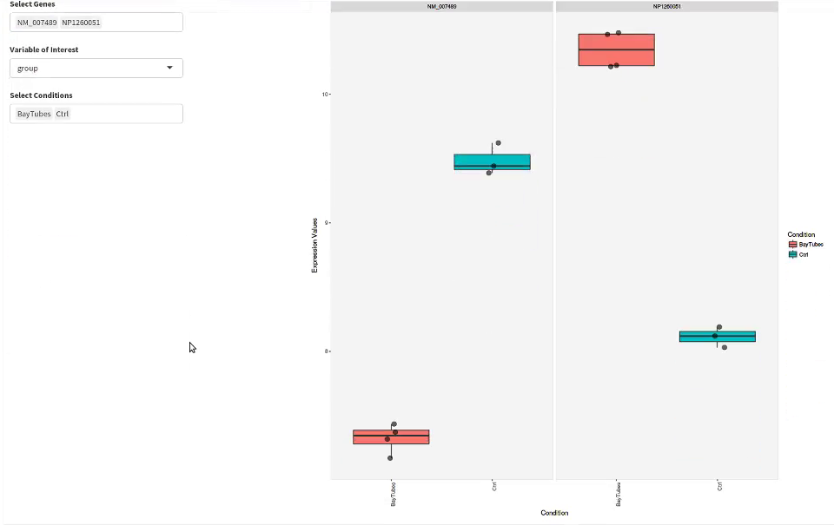

Box Plot (Dye)
This boxplot can be used to explore values distribution in different phenotypic variables for inspection and confirmation.
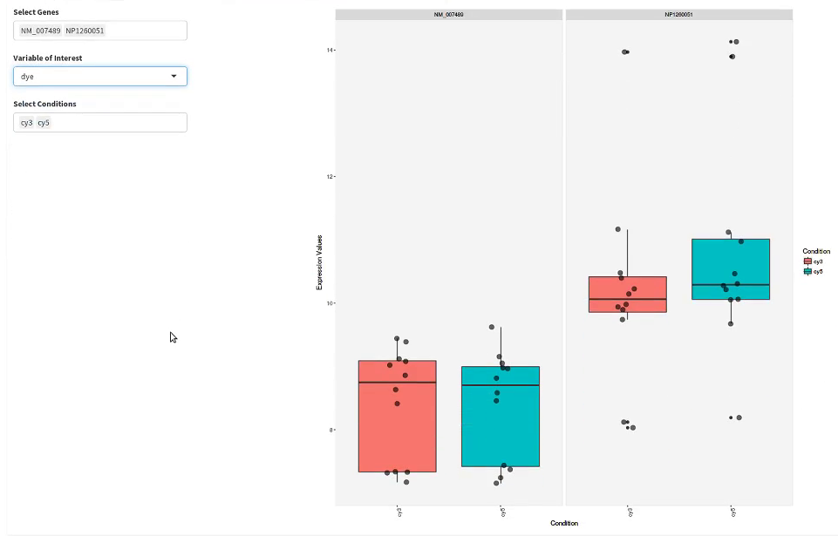

Box Plot (Array)
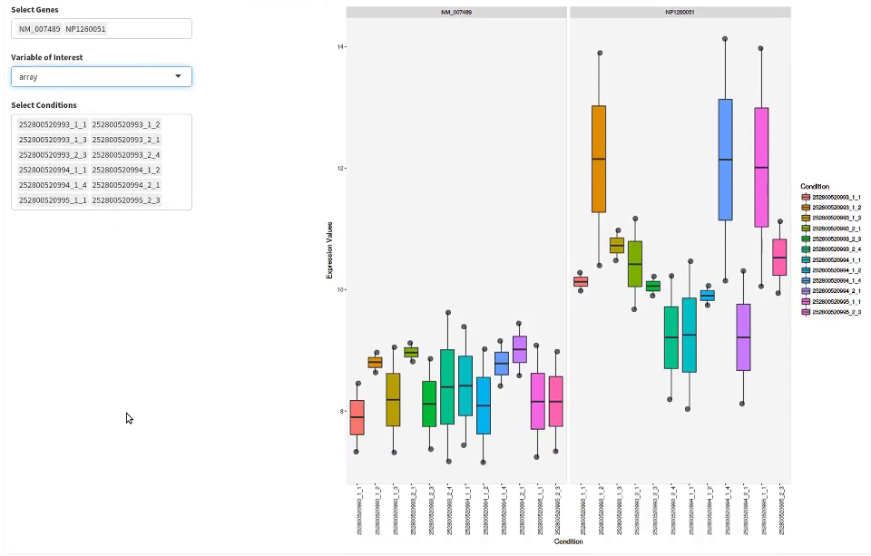

Box Plot (Area)
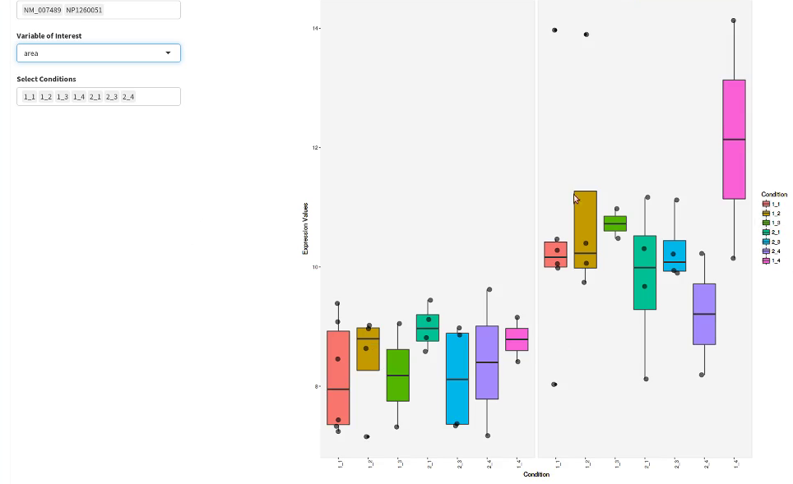

Heatmap
Heatmap of differential features can be viewed from the Heatmap sub-tab nested in the Visualize Expression/Methylation main tab. The user can setup the heatmap representation by adjusting Percentage of Highly Differential Genes, For Comparison(s), and Select Conditions parameters. Differential analysis contrasts are specified in For Comparison(s) and the conditions from the variable of interest are provided in Select Conditions.
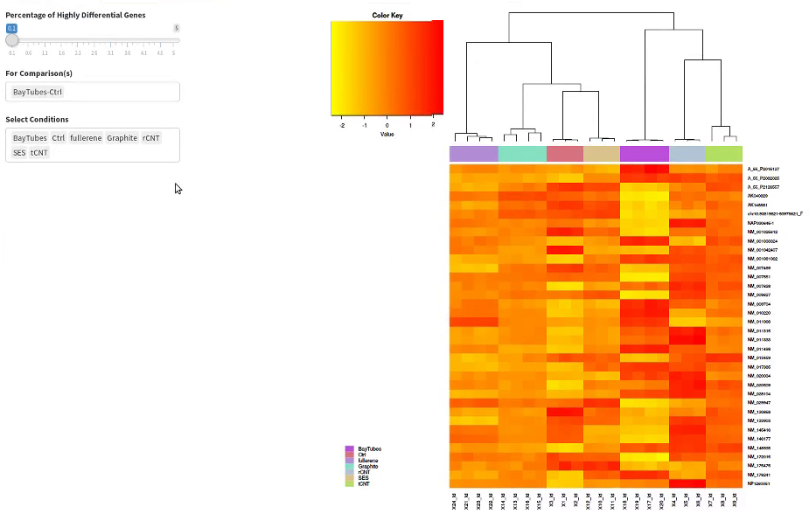

Heatmap (Two Comparisons)
Differential features from multiple comparisons can be displayed together in a single heatmap.
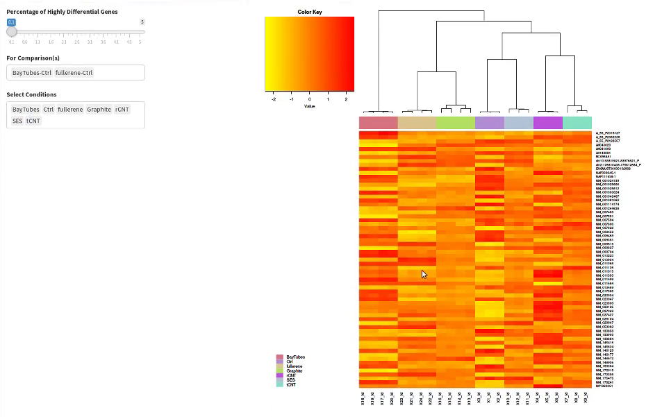

Heatmap (Specific Conditions)
Customizing the set of conditions to match the comparisons creates more readable plots. Samples on the x-axis correspond to the chosen conditions.
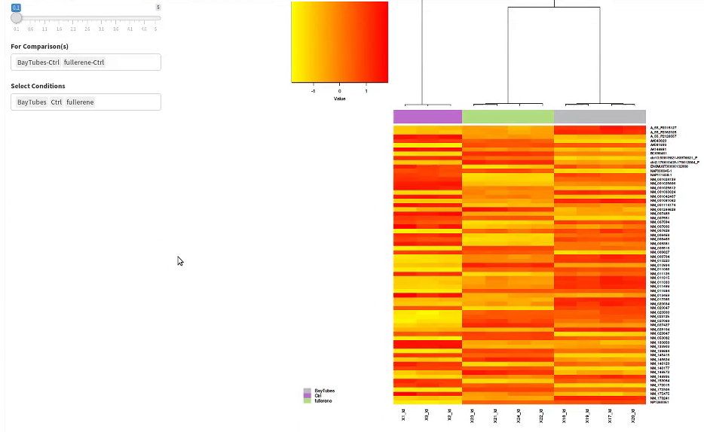

Heatmap (High Percentage)
Adjusting the percentage of differential features accordingly plots the features on the y-axis.
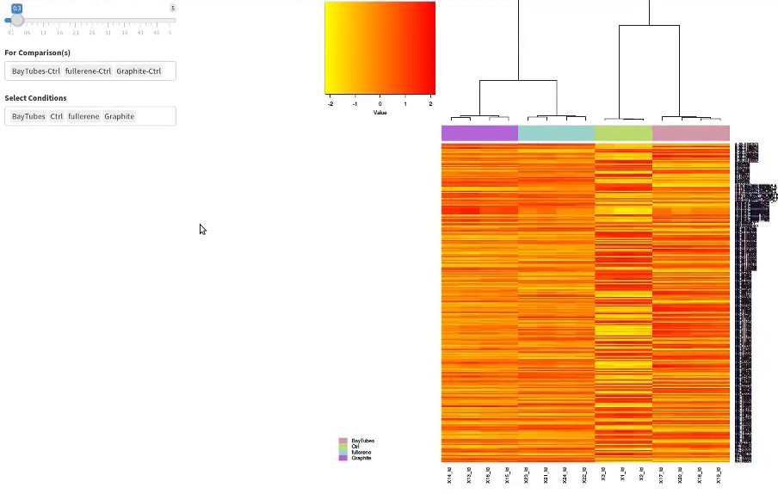

Reporting
REPORTING tab in the sidebar contains buttons to export expression matrices with different levels of processing and button to generate Analysis Report. Analysis report will contain plot representations as configured in the current analysis.
Available Options | Export Analysis Report
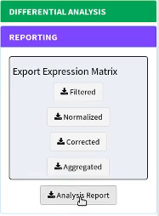 | 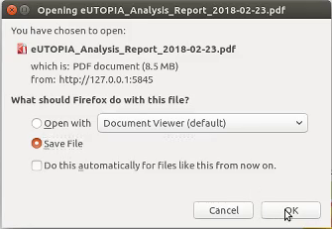

Exporting Analysis Report
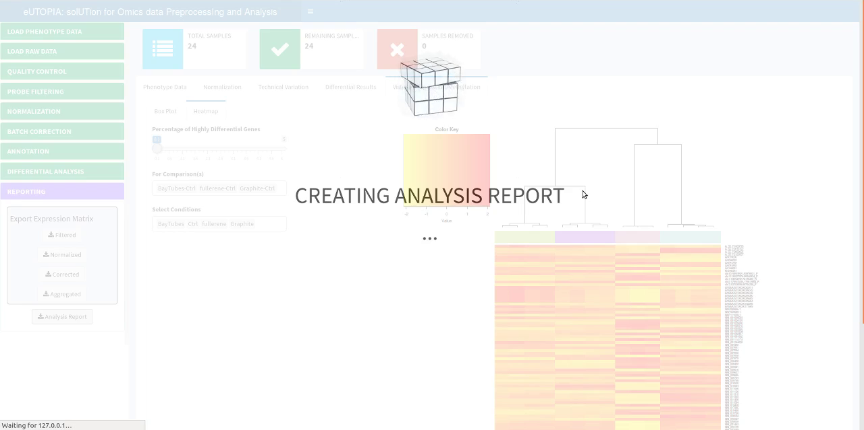

Analysis Report Index
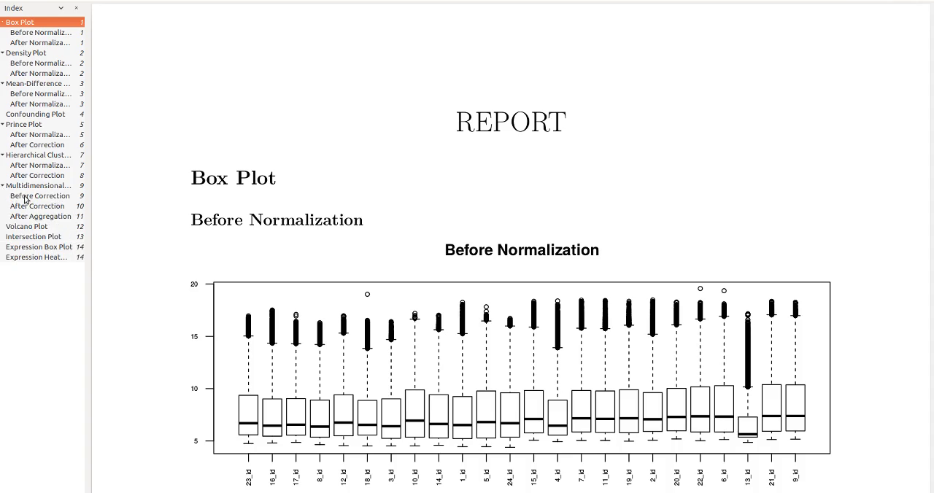

Analysis Report Content
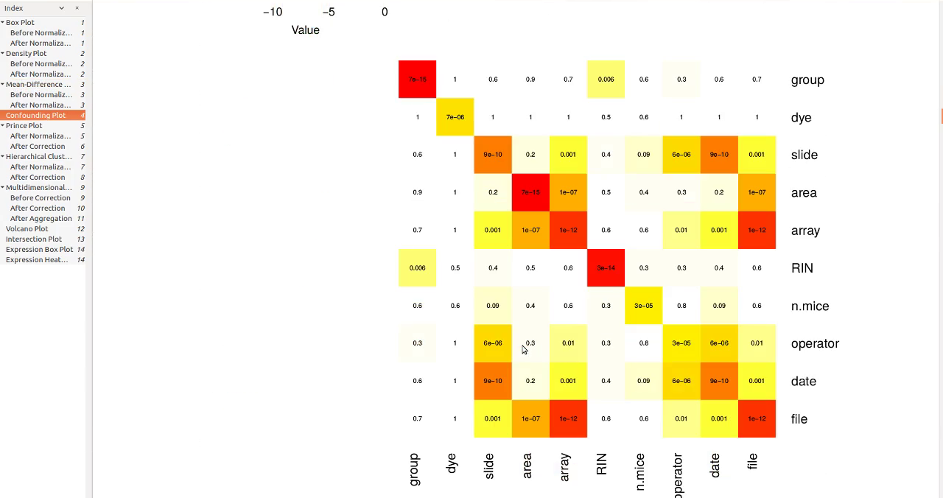

Terminate eUTOPIA Session
Finally stop the R session to close eUTOPIA instance.
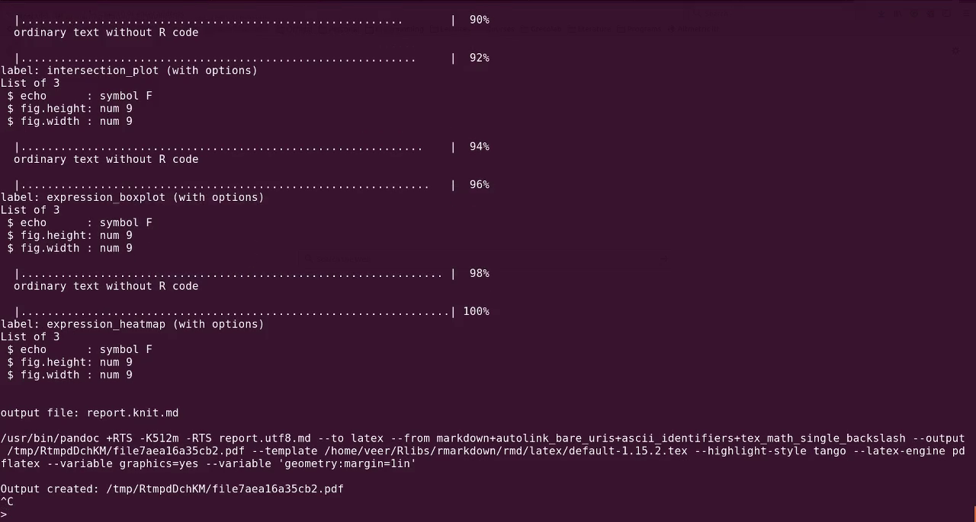

eUTOPIA dependencies
Name | Function | Citation
R Shiny | Graphical User Interface | (Chang et al., 2017)
shinyjs | Dynamic UI features | (Attali, 2018)
shinyBS | Dynamic UI features | (Bailey, 2015)
shinydashboard | Graphical User Interface | (Chang and Ribeiro, 2018)
shinyFiles | Directory Browser UI Component | (Pedersen, 2016)
shinycssloader | Plot loading graphics | (Sali, 2017)
DT | Tables UI component | (Xie, 2018)
rhandsontable | Interactive and formatted table UI component | (Owen, 2018)
ggplot2 | Volcano plot representation | (Wickham, 2009)
ggrepel | Volcano plot representation | (Slowikowski, 2017)
gplots | Heatmap representation | (Warnes et al., 2016)
VennDiagram | Venn representation | (Chen, 2018)
RColorBrewer | Color gradient | (Neuwirth, 2014)
randomcoloR | Distinct unique colors | (Ammar, 2017)
WriteXLS | Export of tabular data | (Schwartz et al., 2015)
rmarkdown | PDF report creation | (Allaire et al., 2018)
reshape2 | Tabular manipulation | (Wickham, 2007)
infotheo | Discretize data | (Meyer, 2014)
swamp | Adjustment and visualization of expression data | (Lauss, 2017)
UpSetR | Set intersection representation as UpSet plot | (Conway et al., 2017)
devtools | Installation of Affymetrix CDF annotation from source | (Wickham et al., 2018)
limma | Expression normalization, differential analysis, and visualization | (Ritchie et al., 2015)
sva | Surrogate variable identification and expression data correction | (Leek et al., 2012)
affy | Affymetrix raw data processing and normalization | (Gautier et al., 2004)
affyio | Information from Affymetrix CEL files | (Bolstad, 2017)
simpleaffy | CDF annotation compatibility with QC | (Miller, 2017)
affyQCReport | Quality control of Affymetrix raw data | (Parman et al., 2017)
arrayQualityMetrics | Quality control of Agilent raw data | (Kauffmann et al., 2009)
yaqcaffy | Quality Control of Affymetrix raw data | (Gatto, 2017)
made4 | Heatmap representation | (Culhane et al., 2005)
minfi | Illumina methylation raw data processing, normalization, filtering, and visualization | (Aryee et al., 2014)
IlluminaHumanMethylation450kmanifest | Manifest for Illumina 's 450k methylation arrays | (Hansen,K.D. and Aryee,M., 2012)
IlluminaHumanMethylation450kanno.ilmn12.hg19 | Annotation for Illumina's 450k methylation arrays | (Hansen, 2016a)
IlluminaHumanMethylationEPICmanifest | Manifest for Illumina's EPIC methylation arrays | (Hansen, 2016b)
IlluminaHumanMethylationEPICanno.ilm10b2.hg19 | Annotation for Illumina's EPIC methylation arrays | (Hansen, 2016c)
shinyMethyl | Illumina methylation array qc report | (Fortin et al., 2014)
GO.db | Gene Ontology annotation | (Carlson, 2017)
GOSemSim | Gene Ontology semantic similarity for summarization | (Yu et al., 2010)

References
Allaire,J.J. et al. (2018) rmarkdown: Dynamic Documents for R. R package version 1.9.
Ammar,R. (2017) randomcoloR: Generate Attractive Random Colors. R package version 1.1.0.
Aryee,M.J. et al. (2014) Minfi: a flexible and comprehensive Bioconductor package for the analysis of Infinium DNA methylation microarrays. Bioinformatics, 30, 1363–1369.
Attali,D. (2018) shinyjs: Easily Improve the User Experience of Your Shiny Apps in Seconds. R package version 1.0.
Bailey,E. (2015) shinyBS: Twitter Bootstrap Components for Shiny. R package version 0.61.
Barrett,T. et al. (2013) NCBI GEO: archive for functional genomics data sets—update. Nucleic Acids Res, 41, D991–D995.
Bolstad,B. (2017) affyio: Tools for parsing Affymetrix data files. R package version 1.48.0.
Carlson,M. (2017) GO.db: A set of annotation maps describing the entire Gene Ontology. R package version 3.5.0.
Chang,W. et al. (2017) shiny: Web Application Framework for R. R package version 1.0.5.
Chang,W. and Ribeiro,B.B. (2018) shinydashboard: Create Dashboards with 'Shiny'. R package version 0.7.0.
Chen,H. (2018) VennDiagram: Generate High-Resolution Venn and Euler Plots. R package version 1.6.20.
Conway,J.R. et al. (2017) UpSetR: an R package for the visualization of intersecting sets and their properties. Bioinformatics, 33, 2938–2940.
Culhane,A.C. et al. (2005) MADE4: an R package for multivariate analysis of gene expression data. Bioinformatics, 21, 2789–2790.
Fortin,J.-P. et al. (2014) shinyMethyl: interactive quality control of Illumina 450k DNA methylation arrays in R. F1000Res, 3.
Gatto,L. (2017) yaqcaffy: Affymetrix expression data quality control and reproducibility analysis. R package version 1.38.0.
Gautier,L. et al. (2004) affy—analysis of Affymetrix GeneChip data at the probe level. Bioinformatics, 20, 307–315.
Hansen,K.D. and Aryee,M. (2012) IlluminaHumanMethylation450kmanifest: Annotation for Illumina's 450k methylation arrays. R package version 0.4.0.
Hansen,K.D. (2016a) IlluminaHumanMethylation450kanno.ilmn12.hg19: Annotation for Illumina's 450k methylation arrays. R package version 0.6.0.
Hansen,K.D. (2016b). IlluminaHumanMethylationEPICmanifest: Manifest for Illumina's EPIC methylation arrays. R package version 0.3.0.
Hansen,K.D. (2016c) IlluminaHumanMethylationEPICanno.ilm10b2.hg19: Annotation for Illumina's EPIC methylation arrays. R package version 0.6.0.
Kauffmann,A. et al. (2009) arrayQualityMetrics—a bioconductor package for quality assessment of microarray data. Bioinformatics, 25, 415–416.
Kinaret,P. et al. (2017) Network Analysis Reveals Similar Transcriptomic Responses to Intrinsic Properties of Carbon Nanomaterials in Vitro and in Vivo. ACS Nano, 11, 3786–3796.

Lauss,M. (2017) swamp: Visualization, Analysis and Adjustment of High-Dimensional Data in Respect to Sample Annotations. R package version 1.3.1.
Leek,J.T. et al. (2012) The sva package for removing batch effects and other unwanted variation in high-throughput experiments. Bioinformatics, 28, 882–883.
Meyer,P.E. (2014) infotheo: Information-Theoretic Measures. R package version 1.2.0.
Miller,C.J. (2017) simpleaffy: Very simple high level analysis of Affymetrix data.
Neuwirth,E. (2014) RColorBrewer: ColorBrewer Palettes. R package version 1.1-2.
Owen,J. (2018). rhandsontable: Interface to the 'Handsontable.js' Library. R package version 0.3.6.
Parman,C. et al. (2017) affyQCReport: QC Report Generation for affyBatch objects. R package version 1.56.0.
Pedersen,T.L. (2016) shinyFiles: A Server-Side File System Viewer for Shiny. R package version 0.6.2.
Ritchie,M.E. et al. (2015) limma powers differential expression analyses for RNA-sequencing and microarray studies. Nucleic Acids Res, 43, e47.
Sali,A. (2017) shinycssloaders: Add CSS Loading Animations to 'shiny' Outputs. R package version 0.2.0.
Schwartz,M. et al. (2015) WriteXLS: Cross-Platform Perl Based R Function to Create Excel 2003 (XLS) and Excel 2007 (XLSX) Files. R package version 4.0.0.
Slowikowski,K. (2017) ggrepel: Repulsive Text and Label Geoms for 'ggplot2'. R package version 0.7.0.
Yu,G. et al. (2010) GOSemSim: an R package for measuring semantic similarity among GO terms and gene products. Bioinformatics, 26, 976–978.
Warnes,G.R. et al. (2016) gplots: Various R Programming Tools for Plotting Data. R package version 3.0.1.
Wickham,H. (2007) Reshaping Data with the reshape Package. Journal of Statistical Software, 21, 1-20.
Wickham,H. (2009) ggplot2: Elegant Graphics for Data Analysis. New York: Springer-Verlag.
Wickham,H. et al. (2018) devtools: Tools to Make Developing R Packages Easier. R package version 1.13.5.
Xie,Y. (2018) DT: A Wrapper of the JavaScript Library 'DataTables'. R package version 0.4.

