Additional File 2. Japanese version of the Figure Rating Scale
Participants were presented with the instruction: “Which figure do you think resembles yours? (CURRENT)” (Japanese: 「現在のあなたの容姿に似ていると思う図は何番ですか。」) [1,2]. Depending on their reported sex, participants were then shown either the female or male silhouette set and asked to select the number corresponding to the figure they felt most closely resembled their current body shape.
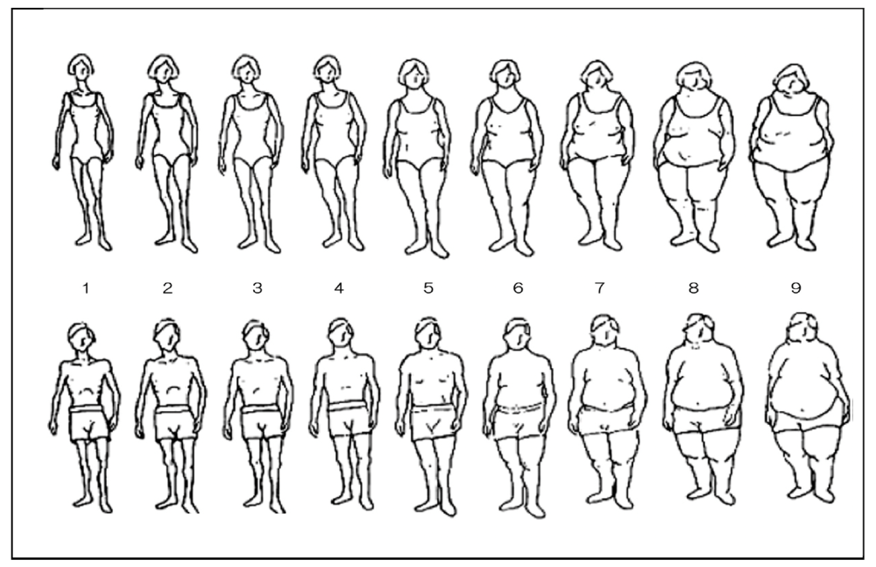
Reference
1. Sano A, Le D-SNT, Tran M-HT, Pham HTN, Kaneda M, Murai E, et al. Study on factors of body image in Japanese and Vietnamese adolescents. J Nutr Sci Vitaminol. 2008;54:169–75. Available from: http://dx.doi.org/10.3177/jnsv.54.169
2. Stunkard AJ, Sørensen T, Schulsinger F. Use of the Danish Adoption Register for the study of obesity and thinness. Res Publ Assoc Res Nerv Ment Dis. 1983;60:115–20. Available from: https://www.ncbi.nlm.nih.gov/pubmed/6823524

