Additional file 2: Model prediction figures for health rate variability (HRV) and self-reported autonomic nervous system (ANS) functioning outcomes
Notes. Figures 1 and 2: Data collected pre-1:1 Yoga Therapy (YT) session (Phase 0; weeks –6, –3, and 0a [immediately pre-1:1 YT] correspond to timepoints –3, –2, and –1 respectively). Data collected post 1:1 YT (Phase 1; before the first group session [week 1]) and after (weeks 7 and 12) the YT intervention correspond to timepoints 0, 1, and 2 respectively.

Figure 1. State ANS functioning (using the 14-item state version of the self-report autonomic regulation scale) | Figure 2. Trait ANS (using the 19-item trait version of the self-report autonomic regulation scale)
Notes. Figures 3 to 10: Data collected pre-1:1 Yoga Therapy (YT) session (Phase 0; weeks –6, –3, and 0a [immediately pre-1:1 YT] correspond to timepoints –3, –2, and –1 respectively). Data collected post 1:1 YT (Phase 1; immediately after the 1:1 YT session [week 0b], before the first group session [week 1]), and after (weeks 7 and 12) the YT intervention correspond to timepoints 0, 1, 2, and 3 respectively.

Figure 3. Mean heart rate (derived from Hexoskin Smart Shirt data)  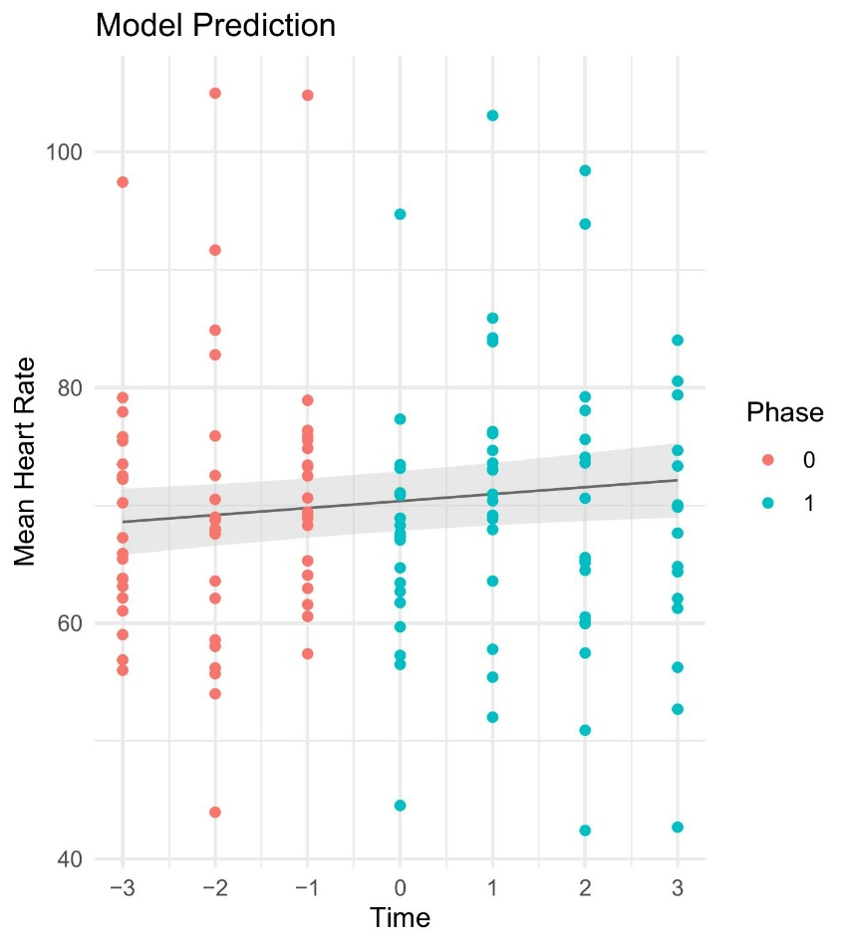 | Figure 4. Standard deviation of the normal-to-normal intervals (derived from Hexoskin Smart Shirt data)  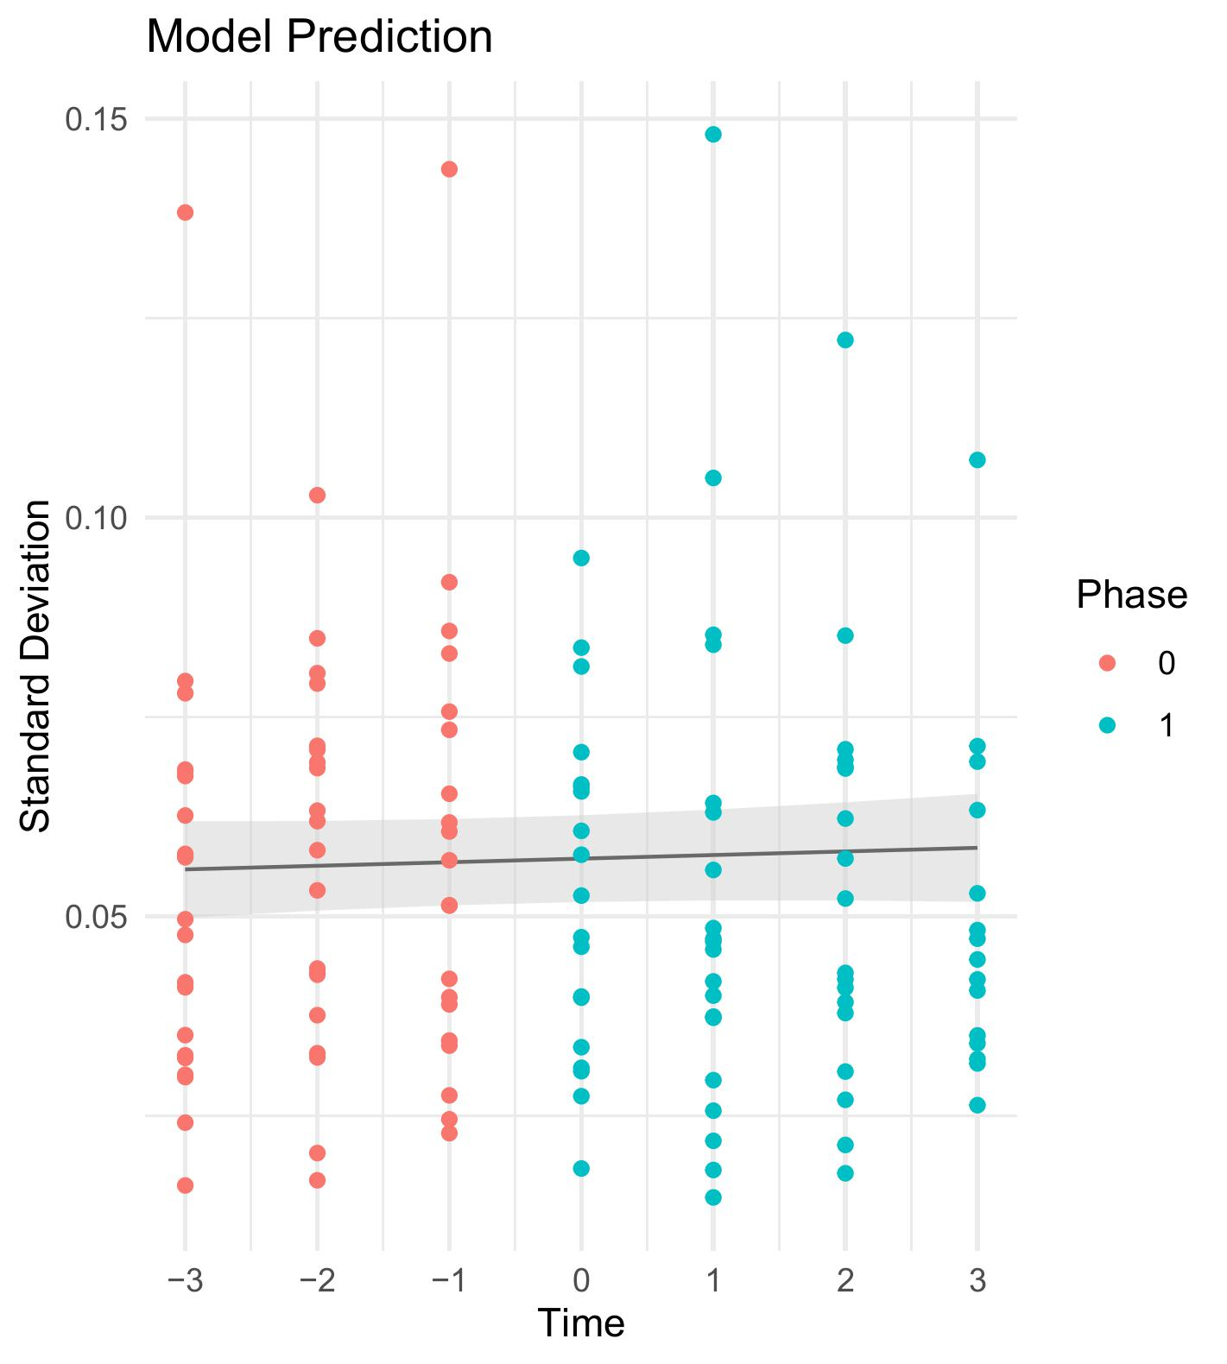
Figure 5. Coefficient of variation (derived from Hexoskin Smart Shirt data)  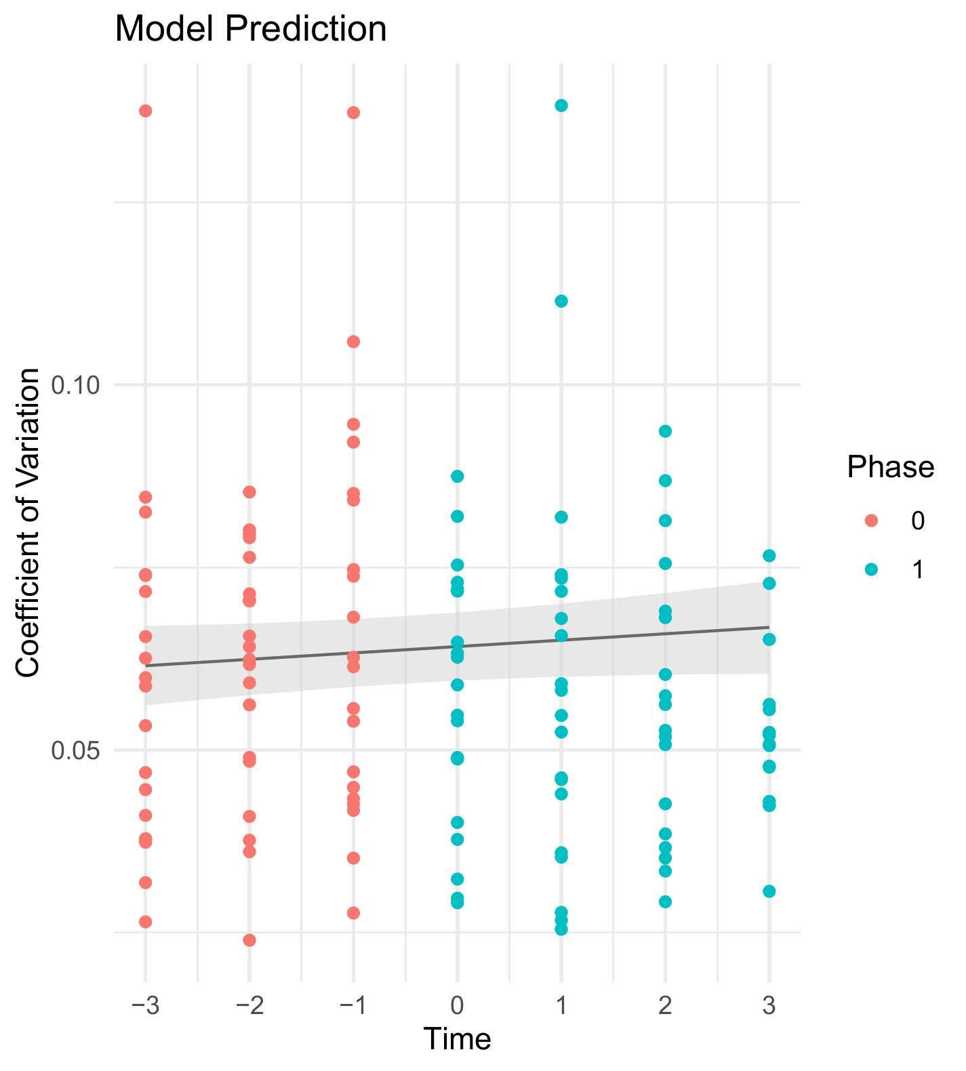 | Figure 6. Square root of the mean squared differences of successive normal-to-normal intervals (derived from Hexoskin Smart Shirt data)  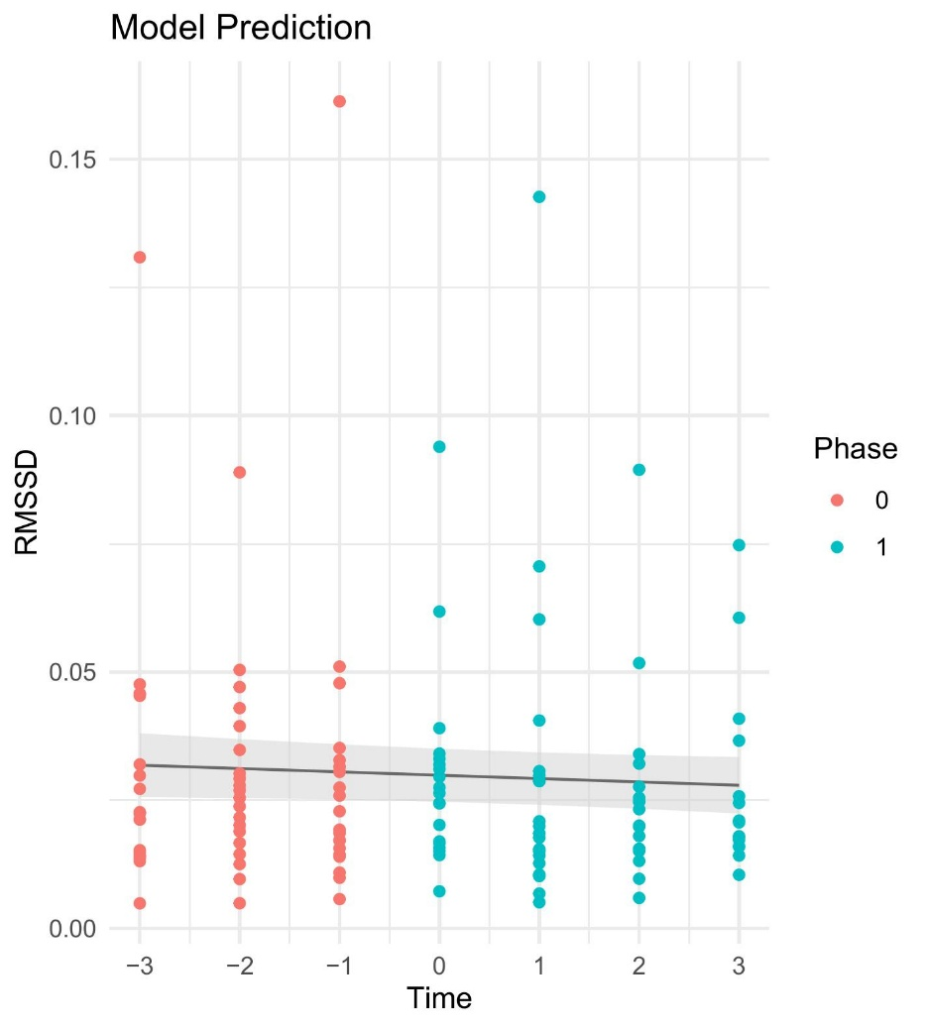
Figure 7. Sample entropy (derived from Hexoskin Smart Shirt data)  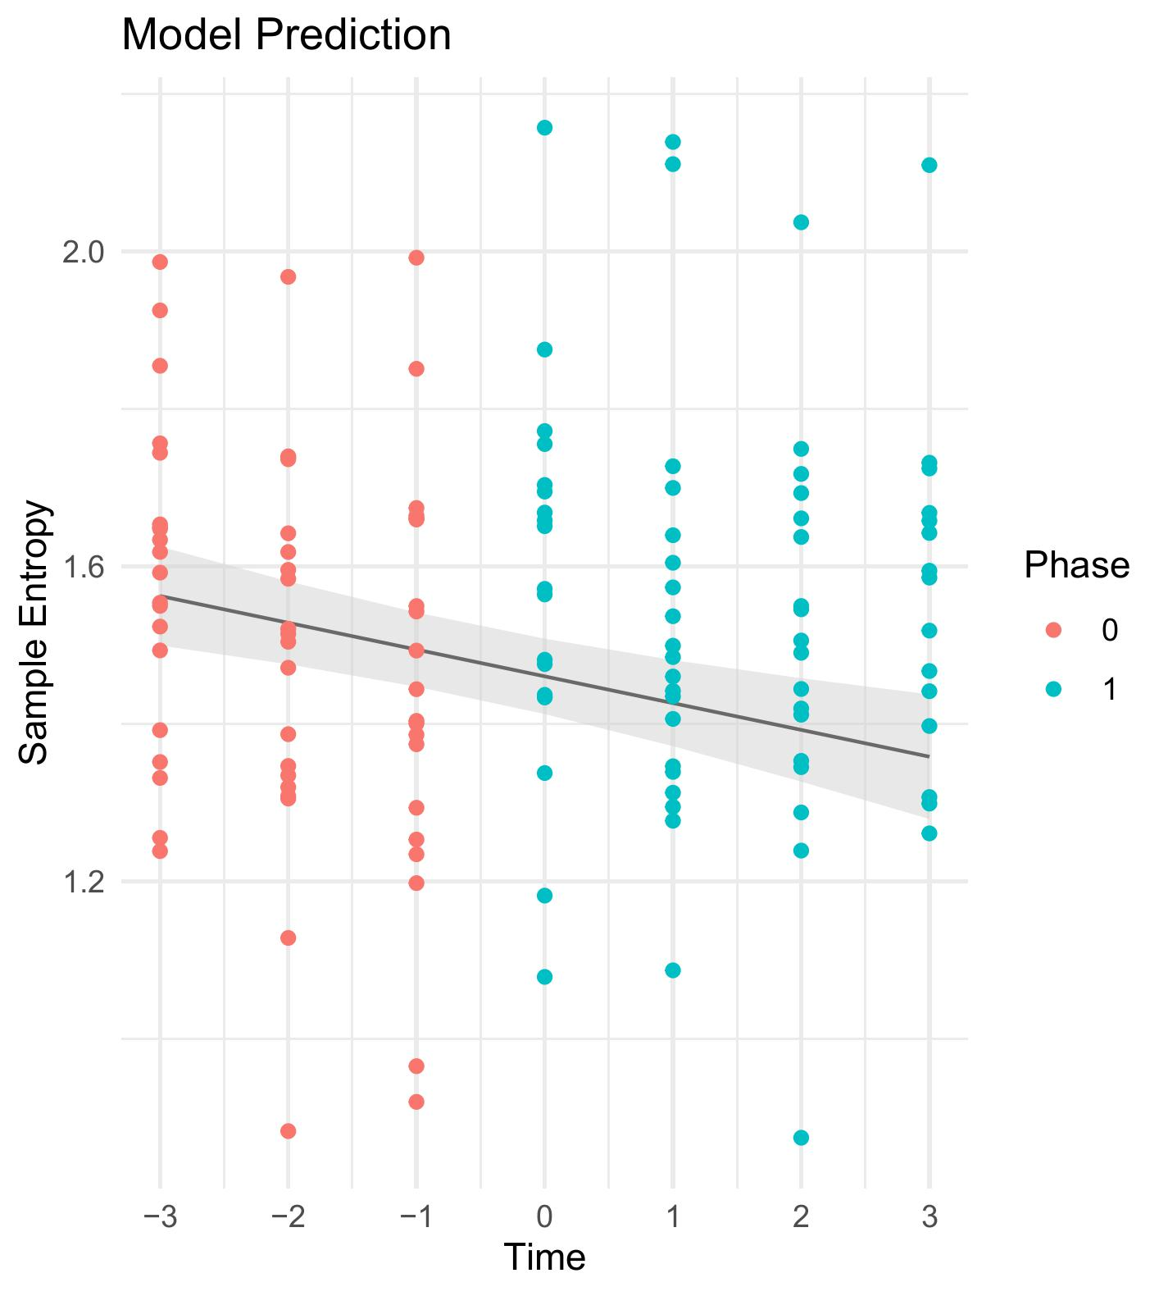 | Figure 8. Low-frequency/High-frequency ratio (derived from Hexoskin Smart Shirt data)  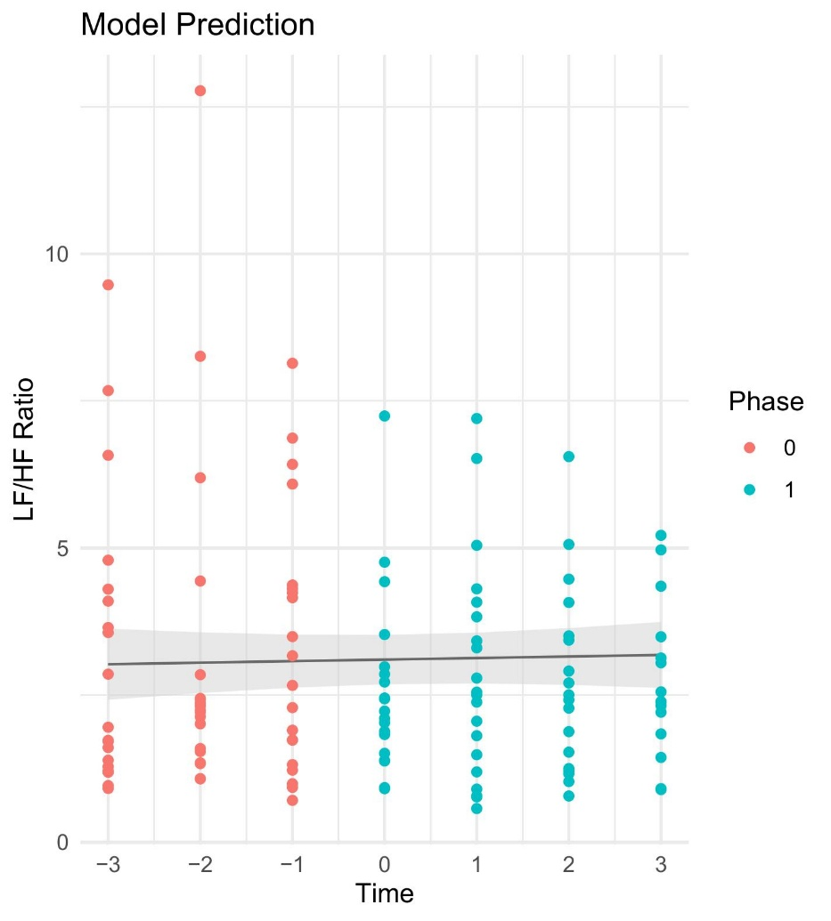
Figure 9. Low-frequency power (derived from Hexoskin Smart Shirt data)  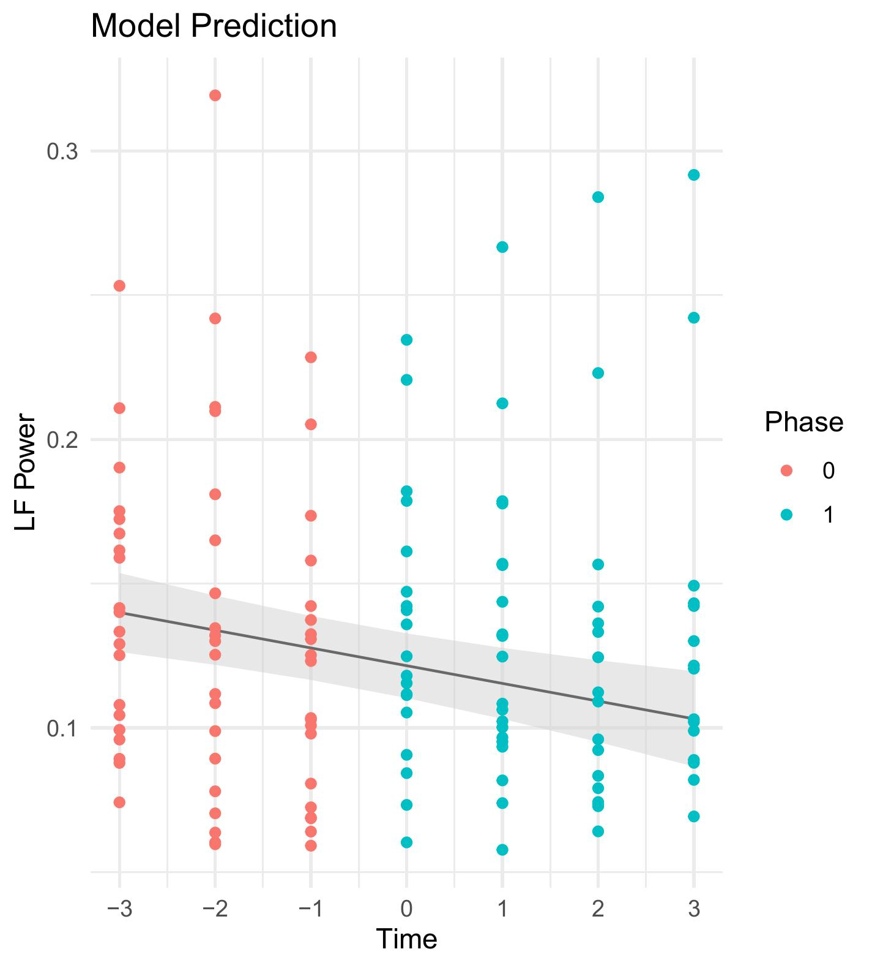 | Figure 10. High-frequency power (derived from Hexoskin Smart Shirt data)  