LICENSE TO PUBLISH / COPYRIGHT FORM
Manuscript Title: Physioyoga as a Structured Digital Detox Intervention: Sensorimotor Integration-Mediated Improvements in Insomnia and Perceived Stress Among Smartphone-Addicted Young Adults – A Pre-Post Feasibility Study.
Authors:
- SriNikhita.Nadimpalli.N.J
- Manikumar M (Corresponding Author)
- J. Mohanakrishnan
- Shanmugananth Elayaperumal
- Vadivelan Kanniappan
- V. Balchandar
- Selvam M
- Mohamed Shafiulla
Corresponding Author:
Dr. Manikumar M, MPT, PhD
Professor,
SRM College of Physiotherapy,
SRMIST, Kattankulathur,
Tamil Nadu, India – 603202
Email: manikumm@srmist.edu.in
1. Authorship and Originality
We, the undersigned authors, confirm that:
- The manuscript is original, has not been published elsewhere, and is not under consideration by another journal.
- All authors meet the criteria for authorship and have approved the final version of the manuscript.
- The manuscript complies with the journal’s ethical and scientific standards.
2. License Grant
Upon acceptance, the article will be published under the Creative Commons Attribution License (CC BY).
- Authors retain copyright.
- Authors grant Springer Nature the right to disseminate, archive, and index the work.
- The article may be freely shared, reused, and adapted, provided proper attribution is given.
3. Ethical Compliance
- Ethical approval was obtained from the Institutional Ethics Committee, SRM Medical College Hospital and Research Centre, SRMIST (Clearance No: 9130/IEC).
- Written informed consent was obtained from all participants.
4. Funding and Conflict of Interest
- Funding: SRM College of Physiotherapy supported article processing charges.
- Conflict of Interest: None declared.
5. Data Availability
Datasets are available from the corresponding author upon reasonable request.
Authors' Names (in sequence) ​​​​ Signature of Authors Date
​1. SRINIKHITA.NADIMPALLI. N. J | ​​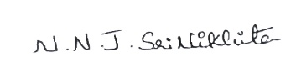 | 29.03.2026
2. MANIKUMAR.M | ​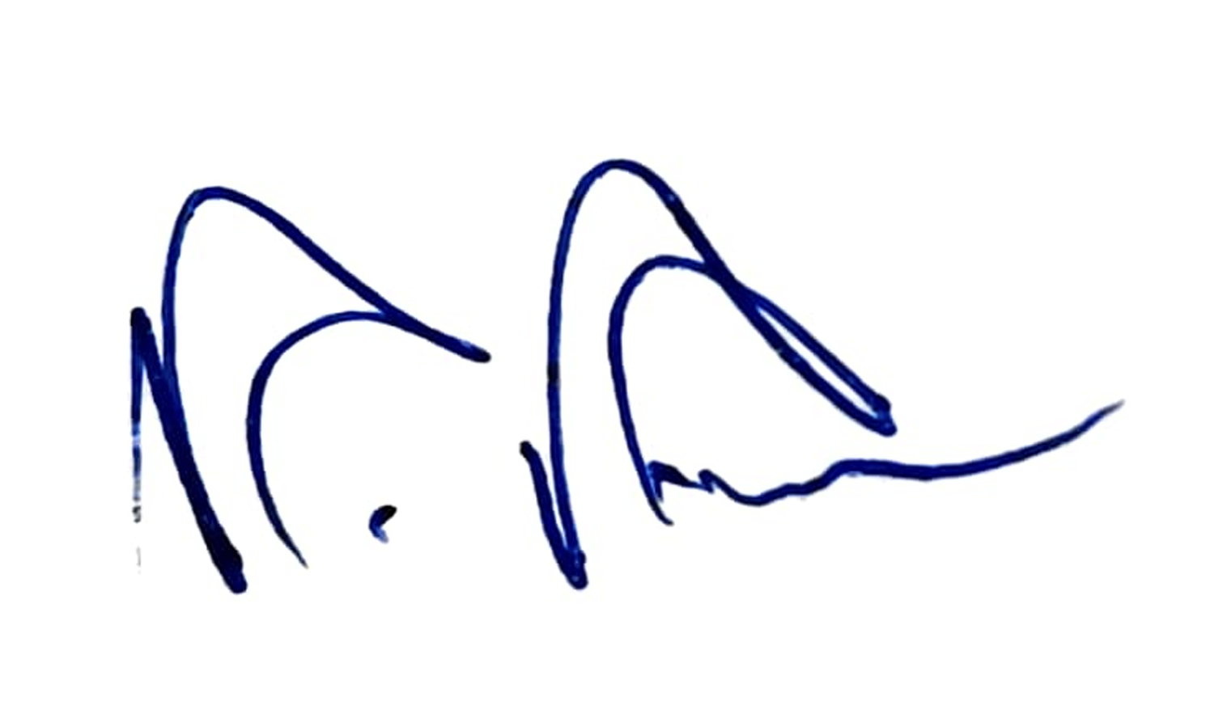 | 29.03.2026
3.J. MOHANAKRISHNAN |  | 29.03.2026
3.SHANMUGANANTH ELAYAPERUMAL | 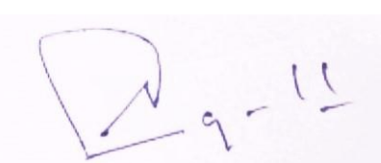 | 29.03.2026
3.VADIVELAN KANNIAPPAN | 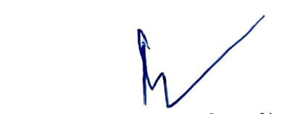 | 29.03.2026
​4. V.BALACHANDAR | ​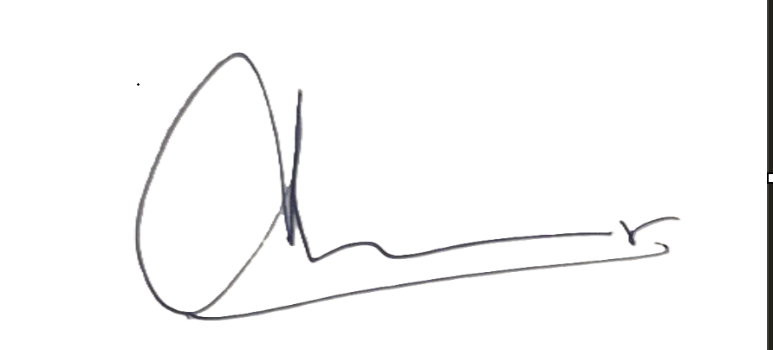 | 29.03.2026
​4. SELVAM M | ​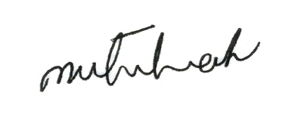 | 29.03.2026
​4. MOHAMED SHAFIULLA | ​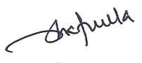 | 29.03.2026

