Map 1. Number of attacks on the medical mission by department
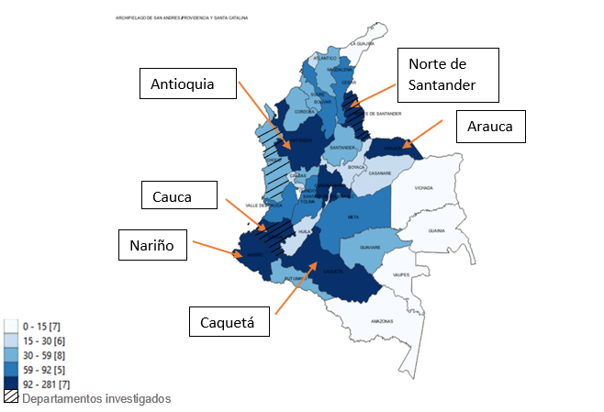
Source: University of Antioquia and Truth Commission. (2020) Database Violations of the Medical Mission. Consultation date August 18, 2022
Map 2. Proportion of attacks to the medical mission per population by department
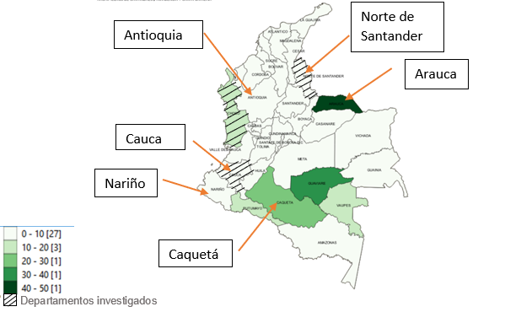
Source: University of Antioquia and Truth Commission. (2020) Database Violations of the Medical Mission. Consultation date August 18, 2022

