Suplemmentary Figure 1 : Flow Chart for Prospective Cohort Study among Children with complicated SAM Admitted to Therapeutic Feeding Centre, Sana’a City, Yemen
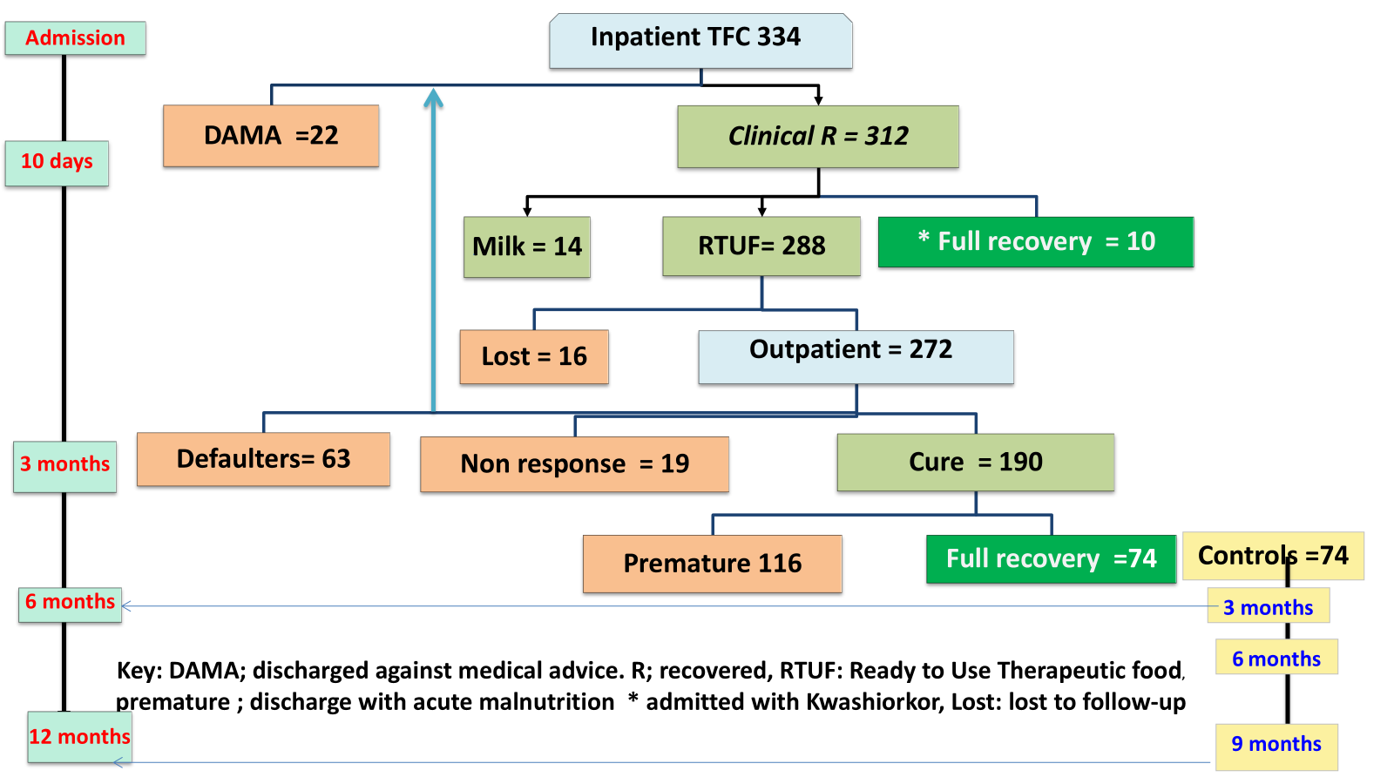
Supplementary Figure 1: The flowchart illustrates the journey of 334 children with complicated Severe Acute Malnutrition (SAM), followed prospectively from admission at Therapeutic Feeding Centers (TFCs) through their transition to Outpatient Therapeutic Programs (OTPs) and into a 12-month post-discharge period. Of 190 children completed treatments. Two cases were excluded due to implausible WHZ values (< -5 or > 5), resulting in a final analytic sample of 188 children included in the retrospective analysis.

Supplementary Table 1: Anthropometric Status and Admission Criteria of Children with Complicated SAM at Admission to Inpatient Therapeutic Care, Sana’a City, Yemen by Group
Study | Prospective study n=334 |  |  | Retrospective analysis n=188
Admission criteria WHO) | n(%) | Mean ±SD | Mean ±SD | n(%) | Mean ±SD | Mean ±SD
WHZ <-3 SD | 265(79%) | -4.15±0.8 | 10.7±1.1 | 154(82%) | -3.97±0.71 | 10.71±0.1.0
MUAC<11.5 cm | 54(16%) | -2.35±0.7 | 10.9±0.6 | 34(18%) | -2.50±0.48 | 11.05 ±0.34
Oedema* | 15(5%) | -1.24±1.0 | 12.9±1.1
 | Prospective study n=319 |  |  | Retrospective analysis n=188
Status at admission | n(%) | Mean ±SD | Mean ±SD | n(%) | Mean ±SD | Mean ±SD
WHZ & MUAC | 192(60%) | -4.15±0.9 | 10.2±0.9 | 111(59%) | -3.96 ±0.73 | 10.27±0.88
WHZ <-3 | 73(23%) | -3.94±0.7 | 11.9±0.4 | 43(23%) | -4.01 ±0.68 | 11.84±0.37
MUAC alone | 54(17%) | -2.35±0.7 | 10.9±0.6 | 34(18%) | -2.50±0.49 | 11.05 ±0.34
Total | 319(100%) | -3.80±1.0 | 10.7±1.0 | 188(100%) | -3.71±0.88 | 10.77±0.97
Mid-upper arm circumference, n.: Number, cm: centimeter, SD; standard deviation WHZ: weight for height z score,

Supplementary Table 2. Weight gain and length of stay by SAM status at admission to Therapeutic Feeding Centers, Sana’a City, Yemen
Status at Admission | All Admissions n (%) | Weight Gain at Discharge (kg), Mean (SD) | Length of Stay (Days), Mean (SD)
SAM Both (WHZ < -3 and MUAC < 11.5 cm) | 111 (59%) | 2.1 (0.9) | 77.7 (27.3)
SAM WHZ only | 43 (23%) | 2.0 (0.7) | 74.0 (28.6)
SAM MUAC only | 34 (18%) | 1.4 (0.9) | 64.6 (23.4)
P Value |  | 0.006 | 0.048
*p-values calculated using ANOVA test for comparisons of normally data across diagnostic categories

