Appendix/Supplementary Material

Table S1: Internal Consistency Measures
Measure | Cronbach's alpha | Guttman's lambda-6 | Any negative correlations?
Meaning | 0.87 | 0.94 | Yes
Engagement | 0.60 | 0.62 | No
Pos. Emotions | 0.84 | 0.87 | No
Accomplishments - Overall | 0.79 | 0.81 | No
Accomplishment – AS | 0.62 | 0.64 | No
Accomplishment - ESS | 0.79 | 0.80 | No
Hope | 0.79 | 0.87 | No
Autonomy | 0.63 | 0.80 | Yes
Relationships | 0.85 | 0.90 | No
Wellbeing - Overall | 0.91 | 0.94 | No
Wellbeing - WHO | 0.83 | 0.84 | No
Wellbeing – Financial | 0.92 | 0.92 | No
Wellbeing - SVS | 0.80 | 0.80 | No
Wellbeing - Arizona IOS | 0.78 | 0.64 | No
Adaptive Coping | 0.79 | 0.86 | No
Maladaptive Coping | 0.63 | 0.73 | No
Stress | 0.83 | 0.86 | No
Discrimination | 0.89 | 0.92 | No
Table S1: Internal Consistency Measures. Scales used are referenced here and described in detail in section 2.4.1. Meaning: Antonovsky’s Sense of Coherence; Engagement: The Engagement Scale; Pos. Emotions: The Positive and Negative Affect Schedule (PANAS); Accomplishments: Composite measure including The Accomplishment Scale (AS) and the European Social Survey (ESS); Hope: Snyder’s Hope Scale (SHS); Autonomy: The Index of Autonomous Functioning (IAF); Relationships: The Multidimensional Scale of Perceived Social Support (MSPSS); Wellbeing: Composite measure including the WHO-MH5, the InCharge Financial Distress/Financial Well-Being Scale, the Subjective Vitality Scale (SVS), and the Arizona Integrative Outcomes Scale (IOS); Adaptive Coping: Brief-COPE scale, broken into adaptive and maladaptive subscales; Stress: Perceived Stress Scale (PSS); Discrimination: Brief PEDQ-CV
(IOS)

Table S2: Pairwise Mechanism Interaction Terms Summary
Outcome | Mechanisms | Meaning  Est (p-val) | Engagement  Est (p-val) | Pos. Emot.  Est (p-val) | Acc.  Est (p-val) | Hope  Est (p-val) | Autonomy  Est (p-val)
Wellbeing | Engagement | 0.63 (0.59)
Wellbeing | Pos. Emot. | -1.18 (0.13) | 1.47 (0.23)
Wellbeing | Acc. | -1.98 (0.02) | -0.14 (0.91) | -0.77 (0.39)
Wellbeing | Hope | -1.5 (0.2) | 0.01 (0.99) | 0.27 (0.77) | -0.02 (0.98)
Wellbeing | Autonomy | -0.94 (0.32) | 1.41 (0.21) | -1.05 (0.27) | -0.79 (0.47) | -0.99 (0.4)
Wellbeing | Relationships | -0.6 (0.49) | -1.98 (0.11) | -0.38 (0.67) | -0.24 (0.79) | 0.31 (0.78) | -0.75 (0.49)
Adapt Coping | Engagement | 0.22 (0.76)
Adapt Coping | Pos. Emot. | -1.03 (0.04) | -0.45 (0.51)
Adapt Coping | Acc. | -1.71 (0) | -0.82 (0.27) | -1.13 (0.03)
Adapt Coping | Hope | -1.85 (0.01) | -0.67 (0.27) | -0.57 (0.28) | -1 (0.09)
Adapt Coping | Autonomy | -0.76 (0.22) | -0.09 (0.88) | -0.49 (0.37) | -1.04 (0.13) | -0.11 (0.87)
Adapt Coping | Relationships | -0.93 (0.09) | 0.47 (0.45) | -0.05 (0.93) | -0.15 (0.8) | 0.18 (0.76) | 0.23 (0.71)
Maladapt Coping | Engagement | -0.12 (0.79)
Maladapt Coping | Pos. Emot. | -0.5 (0.14) | -0.32 (0.52)
Maladapt Coping | Acc. | -0.99 (0) | -0.72 (0.12) | -0.81 (0.02)
Maladapt Coping | Hope | -0.68 (0.13) | -0.05 (0.9) | -0.47 (0.21) | -0.66 (0.07)
Maladapt Coping | Autonomy | -0.8 (0.04) | -0.6 (0.13) | -0.45 (0.25) | -1.16 (0.01) | 0.03 (0.94)
Maladapt Coping | Relationships | -0.55 (0.09) | 0.57 (0.15) | -0.47 (0.18) | -0.77 (0.03) | -0.06 (0.89) | -0.24 (0.55)
Stress | Engagement | -0.41 (0.39)
Stress | Pos. Emot. | 0.34 (0.34) | -0.15 (0.8)
Stress | Acc. | 0.31 (0.41) | -0.08 (0.89) | 0.51 (0.26)
Stress | Hope | -0.1 (0.83) | 0 (1) | -0.22 (0.64) | -0.36 (0.45)
Stress | Autonomy | -0.21 (0.62) | -0.91 (0.08) | 0.35 (0.46) | -0.24 (0.66) | -0.06 (0.92)
Stress | Relationships | 0.34 (0.34) | 0.91 (0.1) | 0.16 (0.72) | -0.06 (0.89) | 0.05 (0.92) | 0.29 (0.56)

Table S3: Main Effects Mechanism Model Results
 | Wellbeing  Est (SE) | Adaptive Coping  Est (SE) | Maladaptive Coping  Est (SE) | Stress  Est (SE)
(Intercept) | 60.44 (0.86)* | 48.05 (0.57)* | 19.27 (0.37)* | 14.3 (0.39)*
Meaning | 4.56 (1.35)* | 0.89 (0.88) | -1.62 (0.59)* | -3.58 (0.62)*
Engagement | -1.07 (0.92) | 0.4 (0.6) | 0.2 (0.4) | 0.47 (0.42)
Pos. Emotions | 4.08 (1.2)* | 2.78 (0.79)* | 0.32 (0.52) | -1.39 (0.55)*
Accomplishments | 1.53 (1.48) | -1.16 (0.97) | -0.8 (0.64) | 0.52 (0.68)
Hope | -1.29 (1.44) | 0.48 (0.94) | 0.95 (0.62) | 0.84 (0.66)
Autonomy | 2.13 (1.19) | 0.51 (0.78) | -0.36 (0.52) | -0.81 (0.54)
Relationships | 0.48 (0.91) | 0.48 (0.6) | 0.43 (0.4) | -0.15 (0.42)
Overall F p-value | <0.001 | <0.001 | 0.013 | 0.011
Main-effects models for wellbeing, adaptive coping, maladaptive coping, and stress with seven (standardized) mechanisms as predictors. *denotes p-value < 0.05. All variance inflation factors < 2.9.

Table S4: Discrimination Interaction Effects for Single Mechanism Models
 | Wellbeing |  | Adaptive Coping |  |  | Maladaptive Coping |  |  | Stress
 | Estimate | p-val | Estimate | p-val | Estimate |  | p-val | Estimate |  | p-val
Meaning | 2.10 | 0.02 | 1.47 | 0.01 | 0.71 |  | 0.04 | -0.78 |  | 0.03
Engagement | 1.44 | 0.30 | -0.14 | 0.85 | -0.56 |  | 0.22 | -0.13 |  | 0.83
Pos. Emotions | 2.05 | 0.02 | 0.70 | 0.18 | 0.28 |  | 0.46 | -0.39 |  | 0.39
Accomplishments | 2.17 | 0.02 | 0.97 | 0.11 | 0.58 |  | 0.12 | -0.66 |  | 0.17
Hope | 0.62 | 0.56 | 1.22 | 0.05 | 0.68 |  | 0.10 | -0.28 |  | 0.58
Autonomy | 1.55 | 0.11 | 0.76 | 0.19 | 0.45 |  | 0.23 | -0.61 |  | 0.19
Relationships | 0.86 | 0.47 | 0.19 | 0.77 | 0.68 |  | 0.09 | 0.31 |  | 0.56
Max F p-val | 0.002 |  | 0.396 |  | 0.463 |  |  | 0.012
Summary of interaction terms for models based on each standardized mechanism/outcome with discrimination. In general, little evidence for interactions with discrimination was found.

Table S5: Demographic breakdown of primary outcomes. Overall F-tests produced p-values > 0.05 for all variables for all outcomes. Cells are presented as: Mean (SD). Small cells (n=1) are suppressed.
Table S5: Demographics and Outcomes - Marginal Comparisons
Variable | Level | N | Wellbeing | Adaptive Coping | Maladaptive Coping | Stress
Gender | F | 52 | 61.93 (12.65) | 48.42 (5.72) | 19.13 (3.7) | 14.13 (5.61)
Gender | M | 34 | 58.17 (10.64) | 47.47 (6.57) | 19.47 (3.8) | 14.56 (4.88)
Age Group | 18-21 | 45 | 61.16 (13.02) | 48.04 (6.89) | 18.64 (3.34) | 13.73 (5.76)
Age Group | 22-24 | 41 | 59.66 (10.82) | 48.05 (5.07) | 19.95 (4.04) | 14.93 (4.75)
Marital Status | Married | 7 | 57.68 (16.82) | 49 (5.66) | 20 (5.83) | 14.71 (8.16)
Marital Status | Single | 79 | 60.69 (11.57) | 47.96 (6.12) | 19.2 (3.53) | 14.27 (5.06)
Education | High school | 24 | 60.28 (9.12) | 49.04 (6.15) | 19.58 (4.51) | 13.79 (3.93)
Education | Some college | 41 | 61.71 (10.44) | 48.63 (5.58) | 19.17 (3.07) | 14 (4.85)
Education | Technical school | 12 | 62.47 (18.72) | 45.5 (7.78) | 17.75 (4.14) | 13.5 (8.32)
Education | Completed college | 7 | 50.11 (14.12) | 45.86 (4.71) | 21.29 (3.55) | 19.14 (5.08)
Education | Other | 1 | - | - | - | -
Education | Prefer not to answer | 1 | - | - | - | -
Household Size | 1 | 3 | 56.83 (1.15) | 42.33 (2.31) | 20 (3.61) | 17.33 (2.08)
Household Size | 2 to 3 | 6 | 61.77 (4.54) | 48.83 (7.41) | 18.5 (2.95) | 13 (3.03)
Household Size | 4 to 5 | 26 | 62.01 (11.48) | 48.62 (4.33) | 19.77 (4.22) | 13.54 (5.09)
Household Size | 6 to 8 | 43 | 59.76 (11.21) | 48.81 (5.86) | 19.47 (3.54) | 14.98 (4.68)
Household Size | 9+ | 8 | 59.36 (21.95) | 43.62 (9.49) | 16.88 (3.36) | 13 (9.9)
Homeowner | Owned | 1 | - | - | - | -
Homeowner | Rented | 84 | 60.37 (12.11) | 47.92 (6.04) | 19.21 (3.75) | 14.26 (5.33)
Homeowner | Prefer not to answer | 1 | - | - | - | -
Access to Healthcare | Yes | 50 | 62.58 (10.12) | 49.04 (5.47) | 18.88 (3.03) | 13.56 (4.55)
Access to Healthcare | No | 24 | 59.24 (15.59) | 46.25 (6.82) | 19.12 (4.52) | 15.42 (7)
Access to Healthcare | Don’t know | 12 | 53.96 (8.64) | 47.5 (6.42) | 21.17 (4.32) | 15.17 (4.13)
Enough Money? | Yes | 11 | 55.86 (9.63) | 46.27 (5.48) | 20.45 (3.53) | 15.82 (3.28)
Enough Money? | No | 41 | 59.55 (13.25) | 48.39 (6.7) | 19.39 (4.23) | 14.78 (5.88)
Enough Money? | Does not apply | 28 | 63.26 (11.29) | 48.57 (5.44) | 19.11 (3.14) | 13 (5.25)
Enough Money? | Prefer not to answer | 6 | 61.81 (7.87) | 46.5 (5.61) | 17 (2.19) | 14.33 (3.98)

Table S6: associations between demographic variables and seven mechanisms. Presented as Mean (SD). Small counts (n=1) suppressed. Omnibus p-values < 0.05 are denoted with an *.

Table S6: Demographic Associations with Mechanisms
Variable | Level | N | Meaning | Engag. | Pos. Emot | Accomp. | Hope | Auton. | Relat.
Gender | F | 52 | 145.48 (20.57) | 2.85 (0.42) | 37 (5.87) | 3.72 (0.43) | 55.9 (5.17) | 53.5 (6.44) | 29.46 (5.12)
Gender | M | 34 | 138.88 (21) | 2.83 (0.36) | 35.79 (5.4) | 3.59 (0.46) | 53.82 (7.45) | 51.35 (5.27) | 29.82 (4.2)
AgeGrp | 18-21 | 45 | 143.09 (21.48) | 2.88 (0.43) | 36.89 (6.33) | 3.65 (0.47) | 54.29 (6.74) | 52 (5.96) | 29.4 (4.56)
AgeGrp | 22-24 | 41 | 142.63 (20.44) | 2.8 (0.36) | 36.12 (4.94) | 3.68 (0.42) | 55.95 (5.53) | 53.37 (6.18) | 29.83 (5)
MaritalStatus | Married | 7 | 152 (26.33) | 2.86 (0.48) | 33 (4) | 3.73 (0.47) | 57.57 (4.93) | 51.71 (7.16) | 30.86 (1.86)
MaritalStatus | Single | 79 | 142.06 (20.33) | 2.84 (0.39) | 36.84 (5.73) | 3.66 (0.45) | 54.86 (6.29) | 52.73 (6.01) | 29.49 (4.92)
Education | High school | 24 | 146.46 (18.34) | 2.99 (0.39) | 37.38 (4.18) | 3.69 (0.43) | 54.58 (6.36) | 52.21 (4.97) | 29.71 (4.06)
Education | Some college | 41 | 144.02 (20.16) | 2.84 (0.4) | 37.02 (6.41) | 3.67 (0.45) | 55.51 (6.93) | 53.12 (6.58) | 29.78 (4.95)
Education | Technical school | 12 | 143.33 (26.39) | 2.72 (0.36) | 35.58 (5.99) | 3.75 (0.5) | 55.92 (5.05) | 53.5 (6.56) | 29.67 (5.05)
Education | Completed college | 7 | 126 (21.16) | 2.67 (0.25) | 32.14 (4.49) | 3.4 (0.43) | 52.57 (3.64) | 48 (3.65) | 27.57 (6.08)
Education | Other | 1 | - | - | - | - | - | - | -
Education | Prefer not to answer | 1 | - | - | - | - | - | - | -
Household Size | 1 | 3 | 115.67 (10.26) | 2.67 (0.17) | 30.67 (1.53) | 3.33 (0.51) | 46.67 (4.16) | 51 (5) | 25.33 (10.5)
Household Size | 2 to 3 | 6 | 158 (17.18) | 2.61 (0.63) | 35.5 (4.32) | 3.81 (0.3) | 57.33 (2.5) | 56 (6.13) | 31 (2.76)
Household Size | 4 to 5 | 26 | 140.42 (14.11) | 2.96 (0.33) | 37.69 (5.68) | 3.67 (0.38) | 56.77 (4.3) | 53.81 (5.59) | 28.58 (5.17)
Household Size | 6 to 8 | 43 | 144.21 (20.95) | 2.86 (0.4) | 36.53 (5.6) | 3.67 (0.47) | 54.37 (6.93) | 51.95 (6.48) | 30.44 (3.84)
Household Size | 9+ | 8 | 142.5 (33.99) | 2.65 (0.36) | 35.62 (7.35) | 3.62 (0.6) | 54.88 (7.55) | 50.75 (5.09) | 29 (5.98)
Homeowner | Owned | 1 | - | - | - | - | - | - | -
Homeowner | Rented | 84 | 143.02 (21.06) | 2.85 (0.4) | 36.42 (5.68) | 3.66 (0.45) | 54.93 (6.2) | 52.67 (6.13) | 29.65 (4.79)
Homeowner | Prefer not to answer | 1 | - | - | - | - | - | - | -
Access Healthcare | Yes | 50 | 147.58 (18.96)* | 2.84 (0.4) | 37 (5.45) | 3.73 (0.41)* | 56.52 (5.21)* | 53.52 (6.52) | 29.46 (4.98)
Access Healthcare | No | 24 | 139.62 (24.06) | 2.88 (0.39) | 36.38 (6.65) | 3.69 (0.51) | 53.83 (7.69) | 51.38 (5.44) | 30 (4.57)
Access Healthcare | Don’t know | 12 | 129.75 (15.55) | 2.79 (0.43) | 34.83 (4.61) | 3.36 (0.35) | 51.58 (5.26) | 51.58 (5) | 29.42 (4.48)
Enough Money? | Yes | 11 | 133.91 (18.95) | 2.82 (0.44) | 34.27 (5.71) | 3.54 (0.51) | 55.27 (6.54) | 52.55 (5.63) | 28.64 (6.77)
Enough Money? | No | 41 | 145.41 (22.85) | 2.88 (0.41) | 37 (5.29) | 3.73 (0.43) | 55.41 (6.12) | 52.34 (5.99) | 30.07 (4.05)
Enough Money? | Does not apply | 28 | 144.07 (19.94) | 2.83 (0.4) | 36.71 (6.35) | 3.63 (0.46) | 55.11 (6.71) | 53.25 (6.35) | 29.07 (5.01)
Enough Money? | Prefer not to answer | 6 | 136.33 (8.5) | 2.67 (0.15) | 36.5 (5.5) | 3.59 (0.35) | 52.33 (4.27) | 52.17 (7.36) | 30.67 (4.41)

Figure S1 – Conceptual framework linking core mechanisms* to outcomes, moderated by perceived discrimination
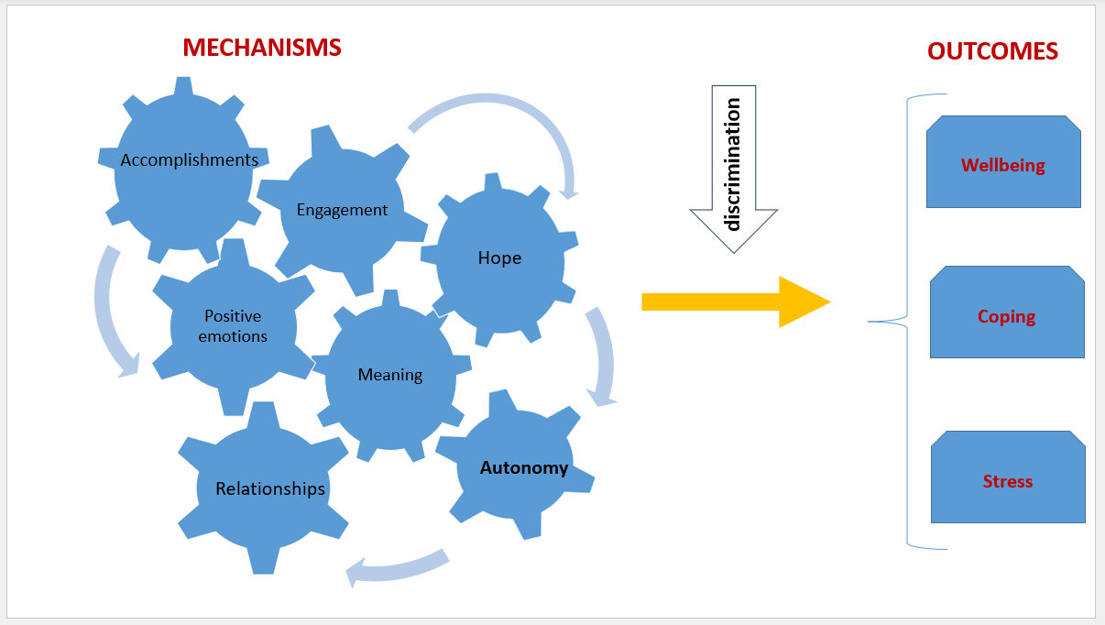
*although our RCT hypothesizes that the protective factors are mechanisms in the pathway between intervention and outcomes, here we are analyzing only pre-assessment data, prior to intervention implementation, and thus these mechanisms are independent protective factors.

Figure S2: Total mechanism scores are strongly linearly associated with the outcome measures, with positive associations for wellbeing and adaptive coping, and negative associations for maladaptive coping and stress.
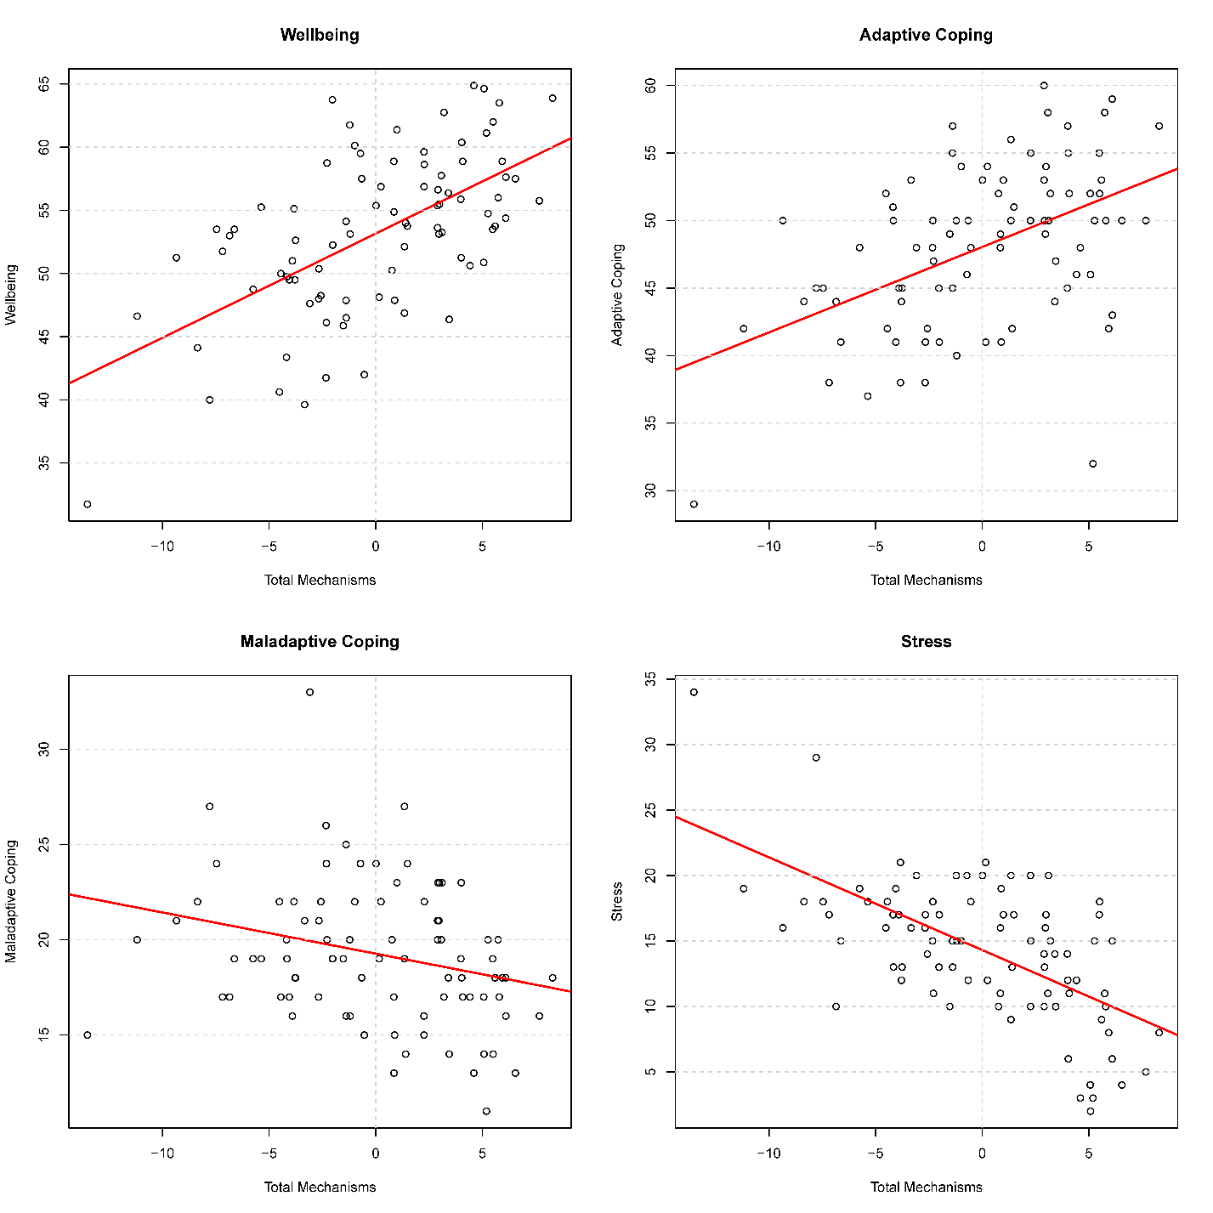
Figure S2 Total Mechanism Scores by Outcomes

Figure S3: Residuals by fitted values for selected regression models from Table 2. In general, the values are highly linear, with minor indications of heteroskedasticity. As described, non-linearity is in the opposite direction to that expected.
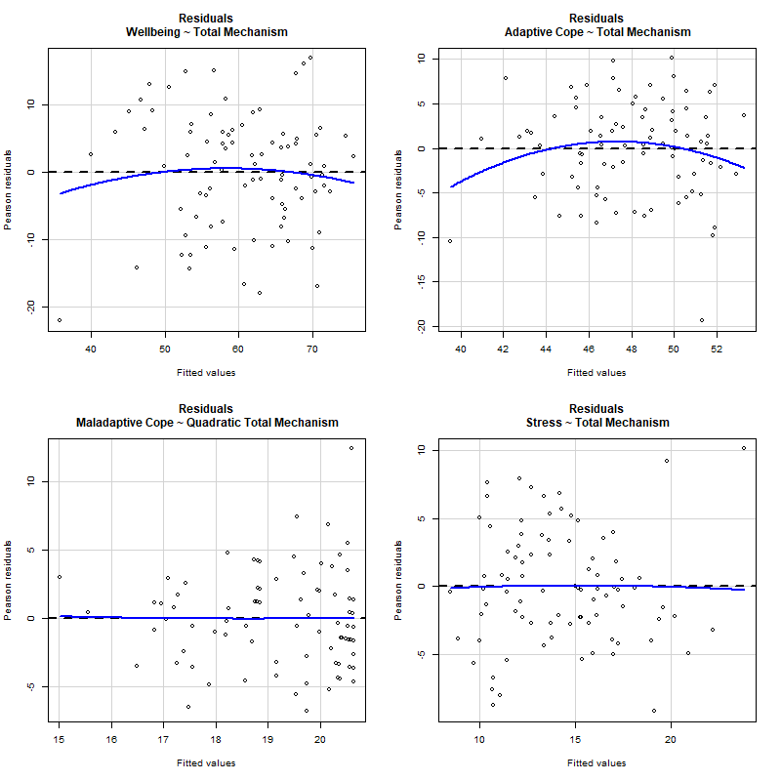

Figure S4: Residual QQ plots for regressions selected from Table 2.
