Supplementary Material 3: Reported food categories among children aged 6-11 months by their mother.
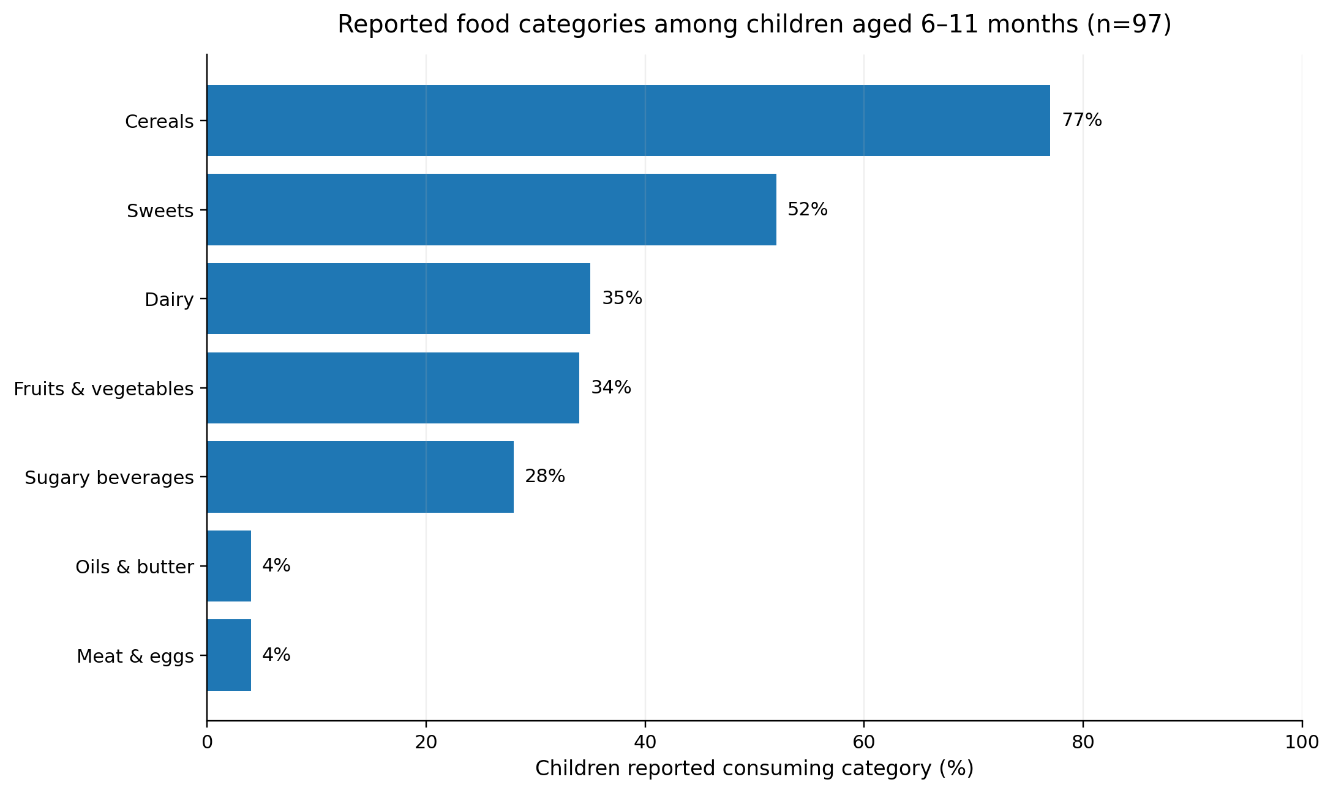
Supplementary Material 3. Caregiver-reported consumption of programme-defined food categories among children aged 6–11 months attending MSF-supported facilities in Herat, August–September 2022 (n=97). The dietary recall period was within the last 7 days before the interview took place. Food categories were defined as follows: cereals (bread, porridge and rice); sweets (cakes and biscuits); dairy (dairy products); fruits and vegetables (any fruit or vegetable); sugary beverages (sweetened drinks); oils and butter (added oils or butter); and meat and eggs (meat or eggs).

