Supplementary Information: Additional file 3
Title: Predictors of time until return to work and duration of sickness absence in sick-listed precarious workers with common mental disorders: a secondary data-analysis of two trials and one cohort study.
Authors: Yvonne Suijkerbuijk, Frederieke Schaafsma, Lyanne Jansen, Selwin Audhoe, Lieke Lammers, Johannes Anema, Karen Nieuwenhuijsen
Corresponding author: Yvonne Suijkerbuijk, Amsterdam UMC, location University of Amsterdam, Department of Public and Occupational Health, Meibergdreef 9, 1105 AZ Amsterdam, The Netherlands. E: y.b.suijkerbuijk@amsterdamumc.nl

Supplementary Figures 8-13: Univariable, unadjusted survival curves illustrating time until end of sick leave (=duration of sickness absence) stratified by baseline age, gender, employment status, psychological symptoms, return to work (RTW) self-efficacy, study and study allocation.

Figure 8. Unadjusted survival curve illustrating time until end of sick leave stratified by age
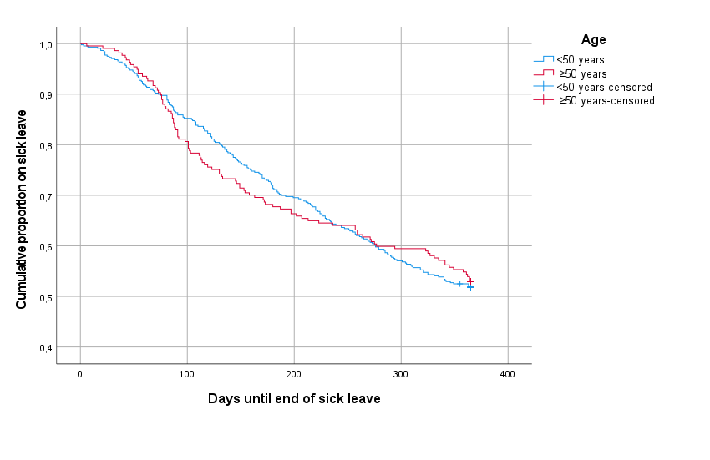

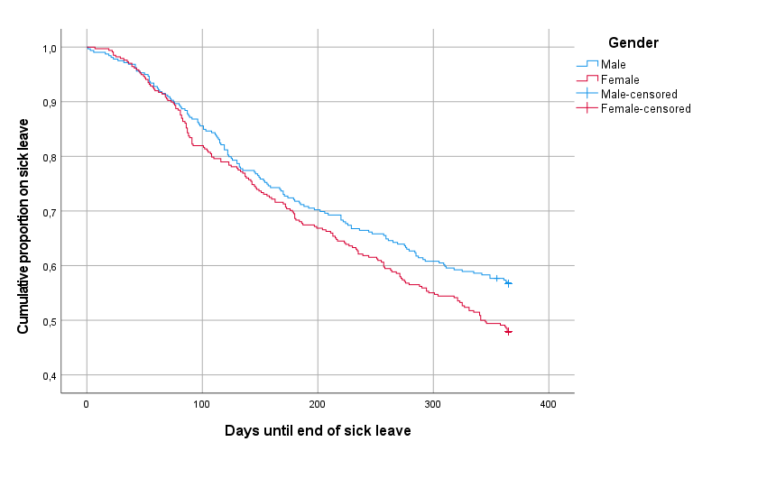
Figure 9. Unadjusted survival curve illustrating time until end of sick leave stratified by gender

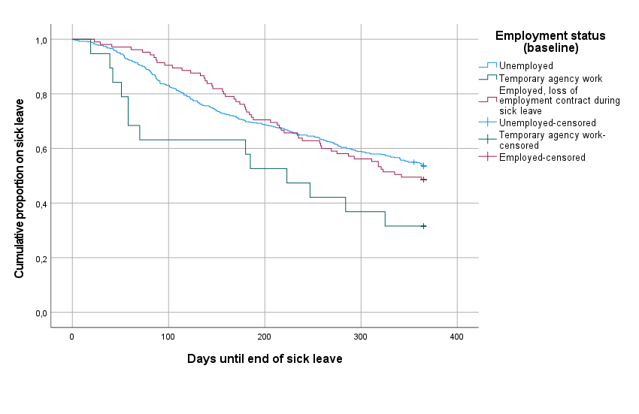
Figure 10. Unadjusted survival curve illustrating time until end of sick leave stratified by employment status

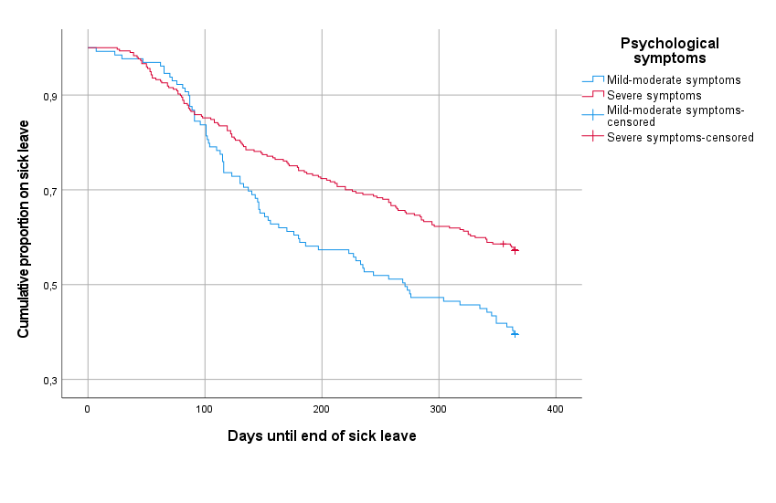
Figure 11. Unadjusted survival curve illustrating time until end of sick leave stratified by psychological symptoms

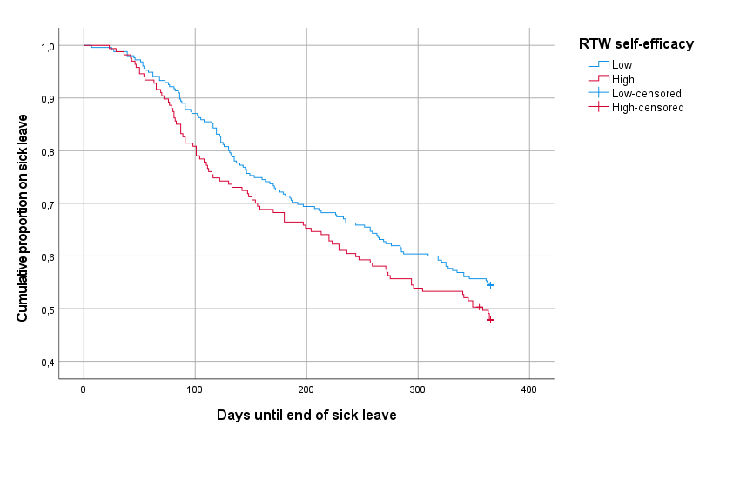
Figure 12. Unadjusted survival curve illustrating time until end of sick leave stratified by RTW self-efficacy

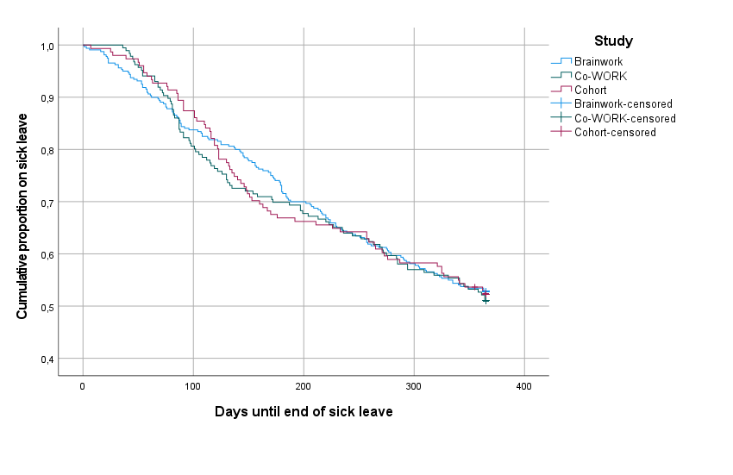
Figure 13. Unadjusted survival curve illustrating time until end of sick leave stratified by study

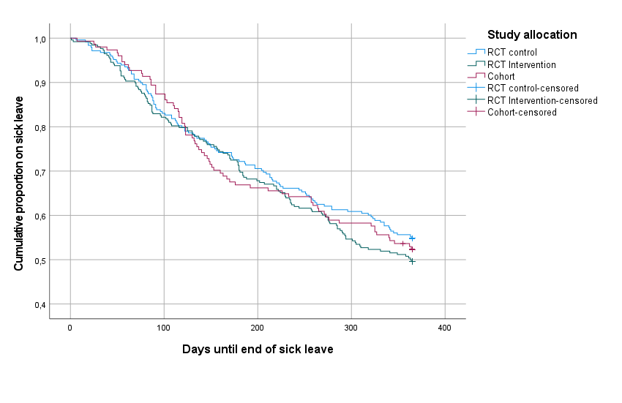
Figure 14. Unadjusted survival curve illustrating time until end of sick leave stratified by study allocation

