Additional File 7
Figure S1: Regressing the NHSTT Supply Measure on the Adjusted Model Covariates
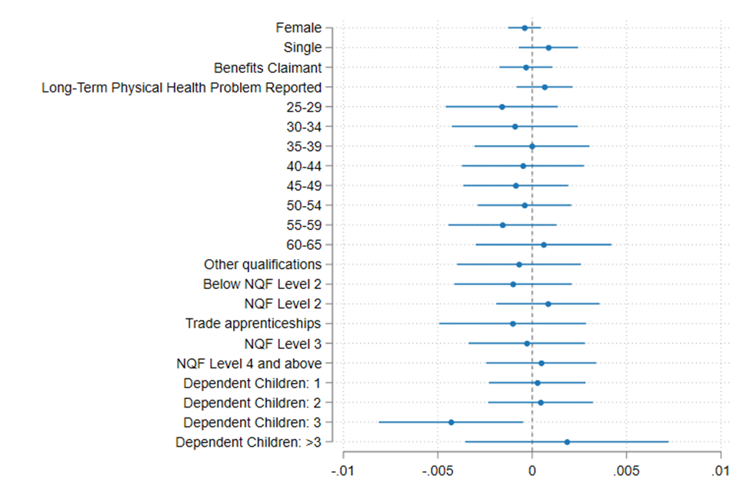Notes: The regression was estimated on the full analysis sample (N=535068). The coefficient plot includes the following categorical variables: age bands, highest attained level of qualification, and number of dependent children in the household. For age bands, 25-29 through to 60-65 are compared against the base category of 18-24. For qualification level, other qualifications, Below NQF level 2, NQF level 2, trade apprenticeships, NQF level 3, and NQF level 4 and above are compared against the base category of no qualifications. For number of dependent children in the household, 1, 2, 3, and more than 3 are compared against the base level of none.

