Additional file 5
Item functioning of the seven subgroups on the factor Antisocial behavior
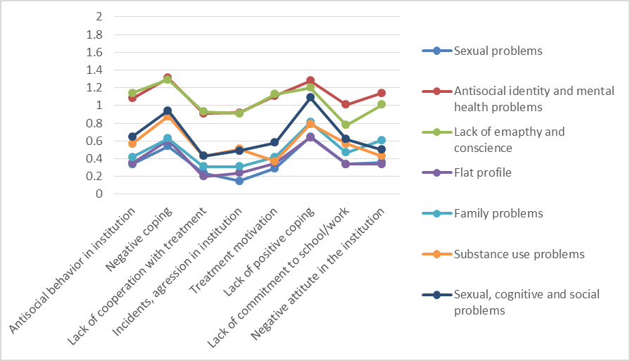

Item functioning of the seven subgroups on the factor Sexual problems
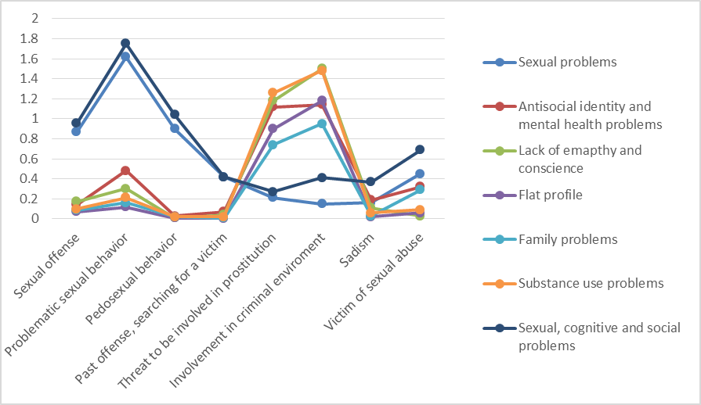

Item functioning of the seven subgroups on the factor Family background
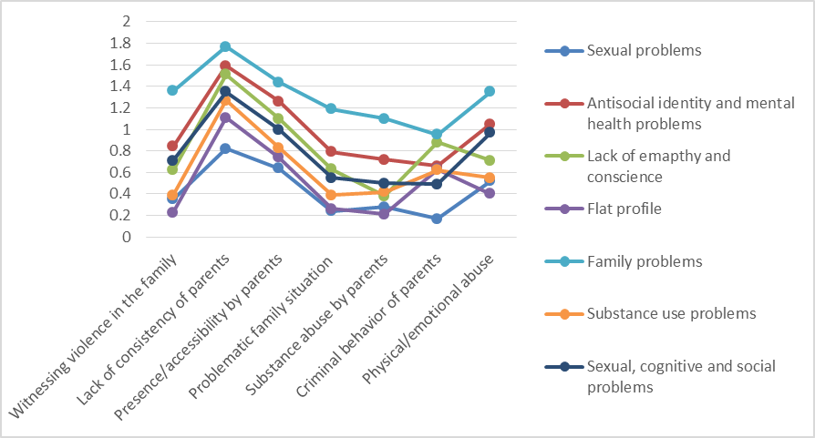

Item functioning of the seven subgroups on the factor Mental health problems
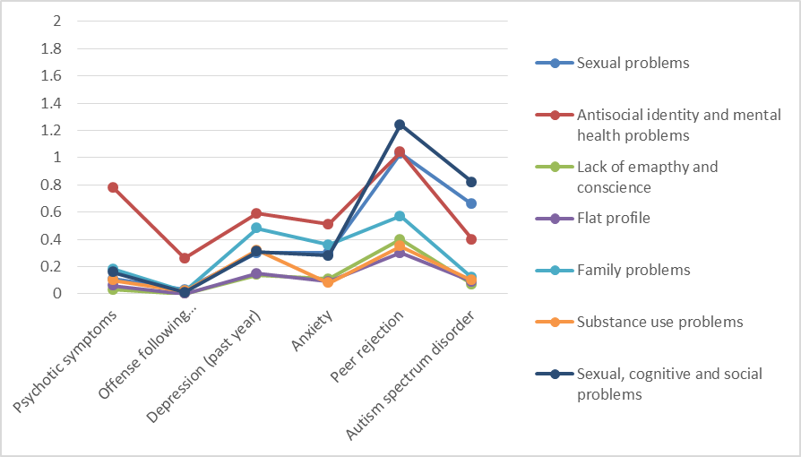
Item functioning of the seven subgroups on the factor Substance use
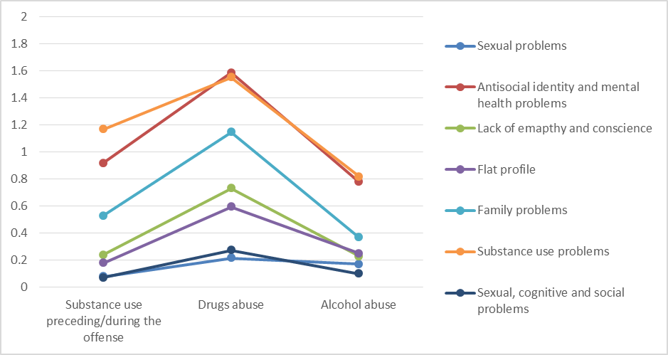

Figure 7: Item functioning of the seven subgroups on the factor Conscience and empathy
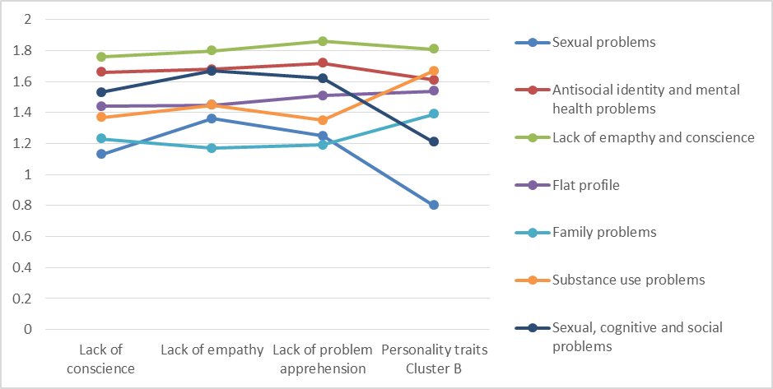
Item functioning of the seven subgroups on the factor Cognitive and social skills
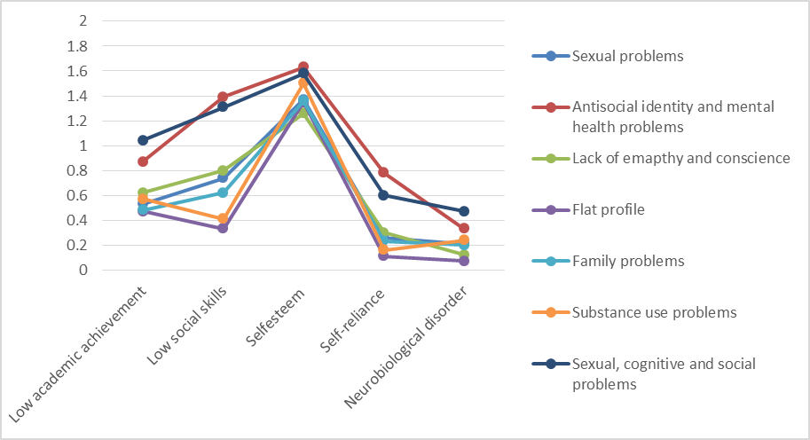

Item functioning of the seven subgroups on the factor Social network
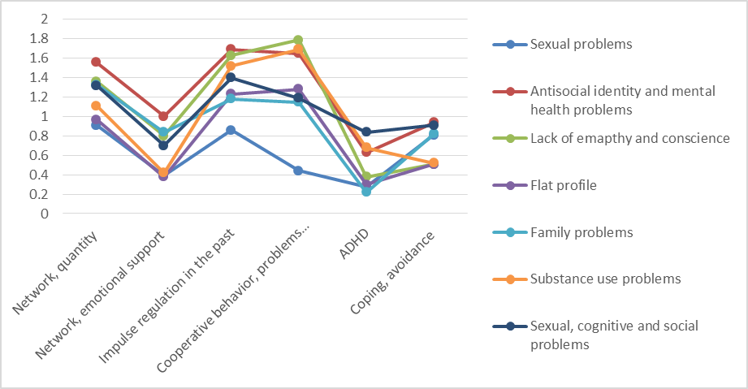
Item functioning of the seven subgroups on the factor Offenses
