Supplement 2 Effect of intervention on outcomes
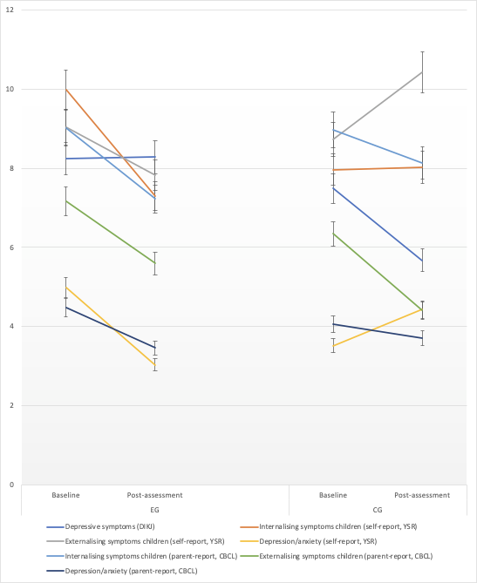
Note. All values are raw values. anx./depr. = anxiety/depressive symptoms; CBCL = Child Behaviour Checklist; DIKJ = Depressions-Inventar für Kinder und Jugendliche; ext. = externalising symptoms, int. = internalising symptoms, YSR = Youth Self-Report, error indicators are 5% CI.

