Supplement 4 Acceptance ratings Families’ratings of intervention (individual sessions)

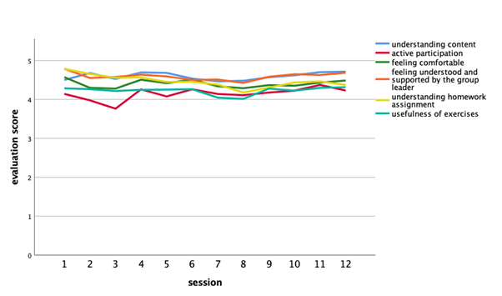
Note. N=135 children of n=100 families, signif. codes: 0 ‘***’ 0.001 ‘**’ 0.01 ‘*’ 0.05 ‘.’ 0.1 ‘ ’

