Additional file
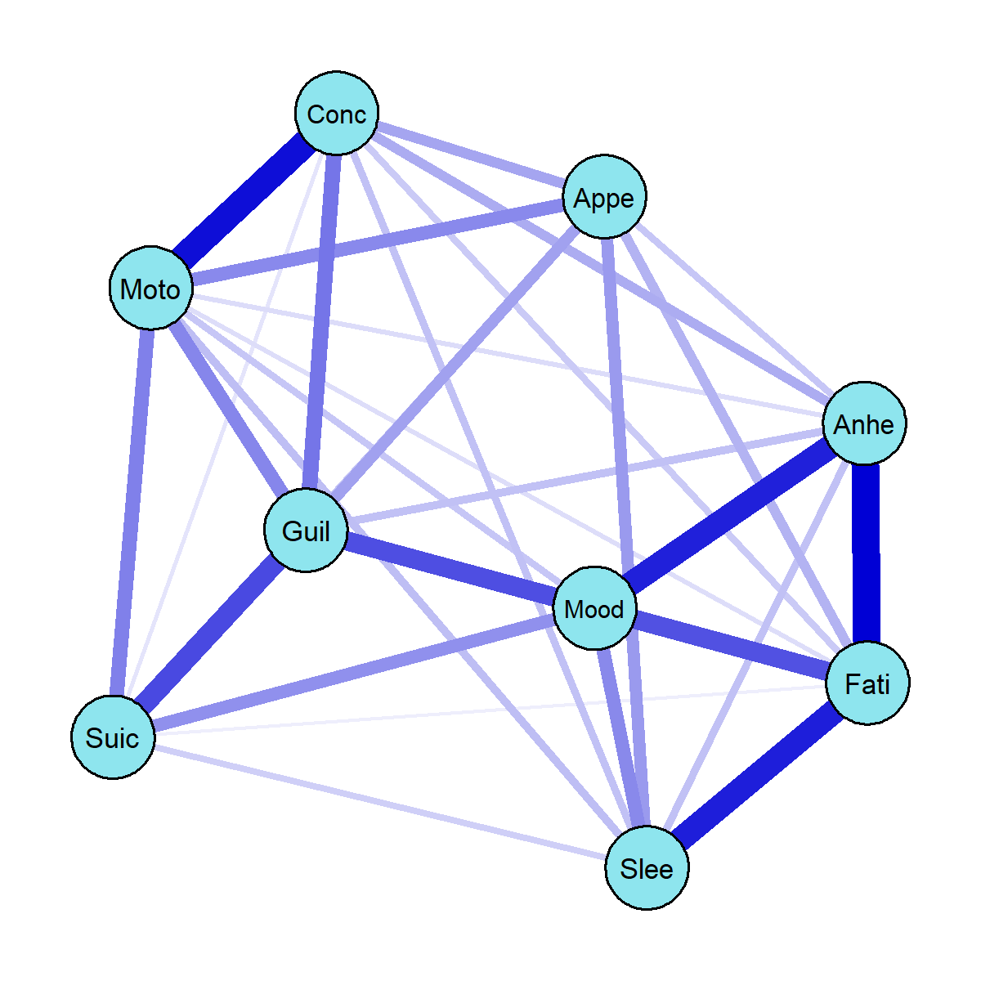  (a) Sample 1-males | 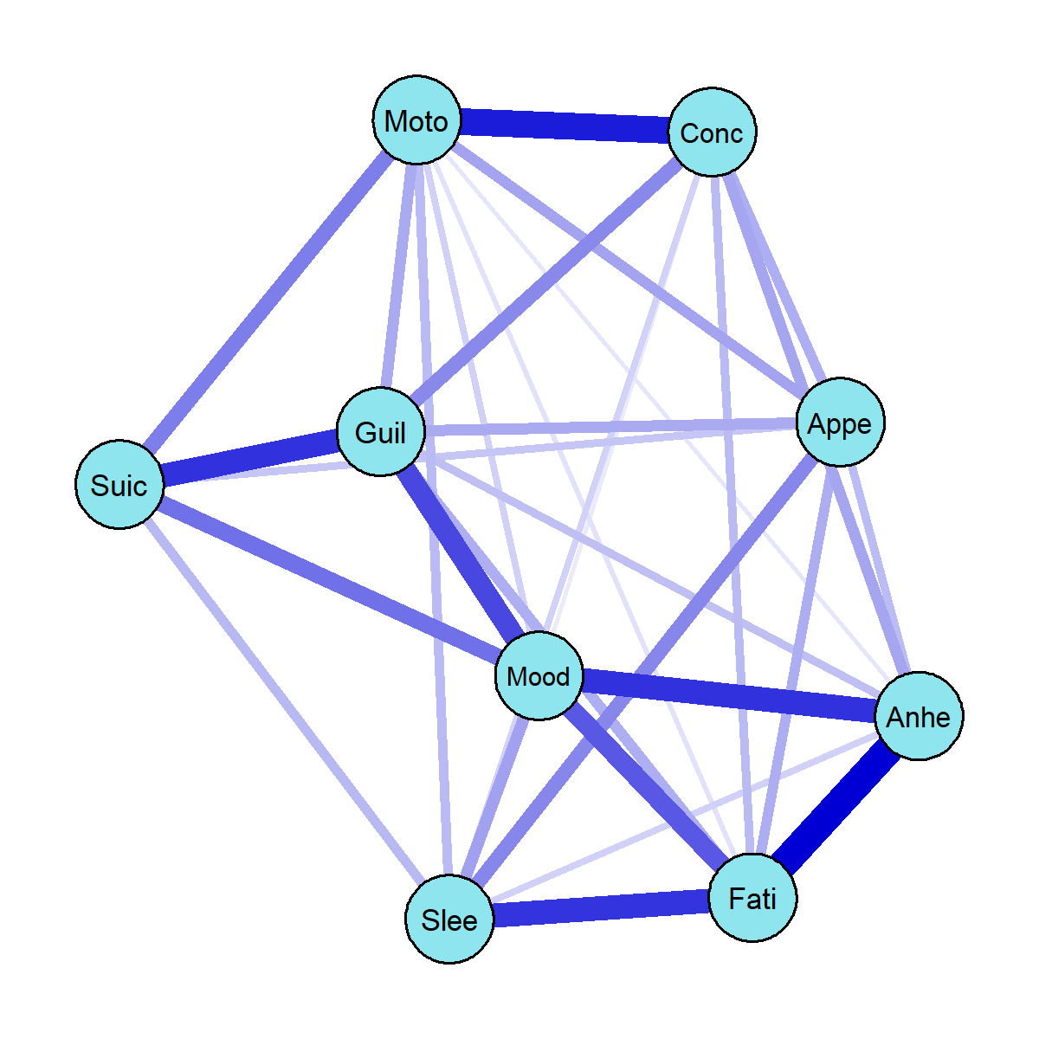  (b) Sample 1-females
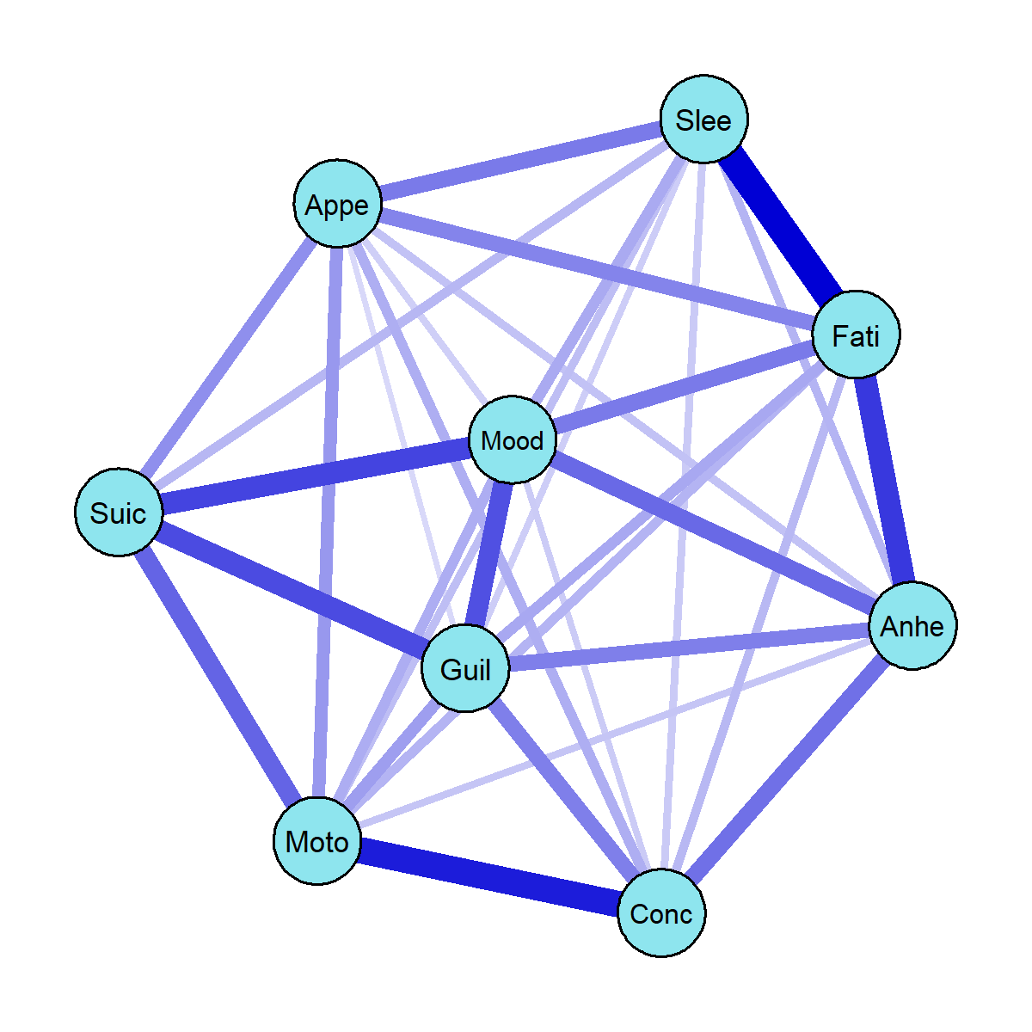  (c) Sample 2-males | 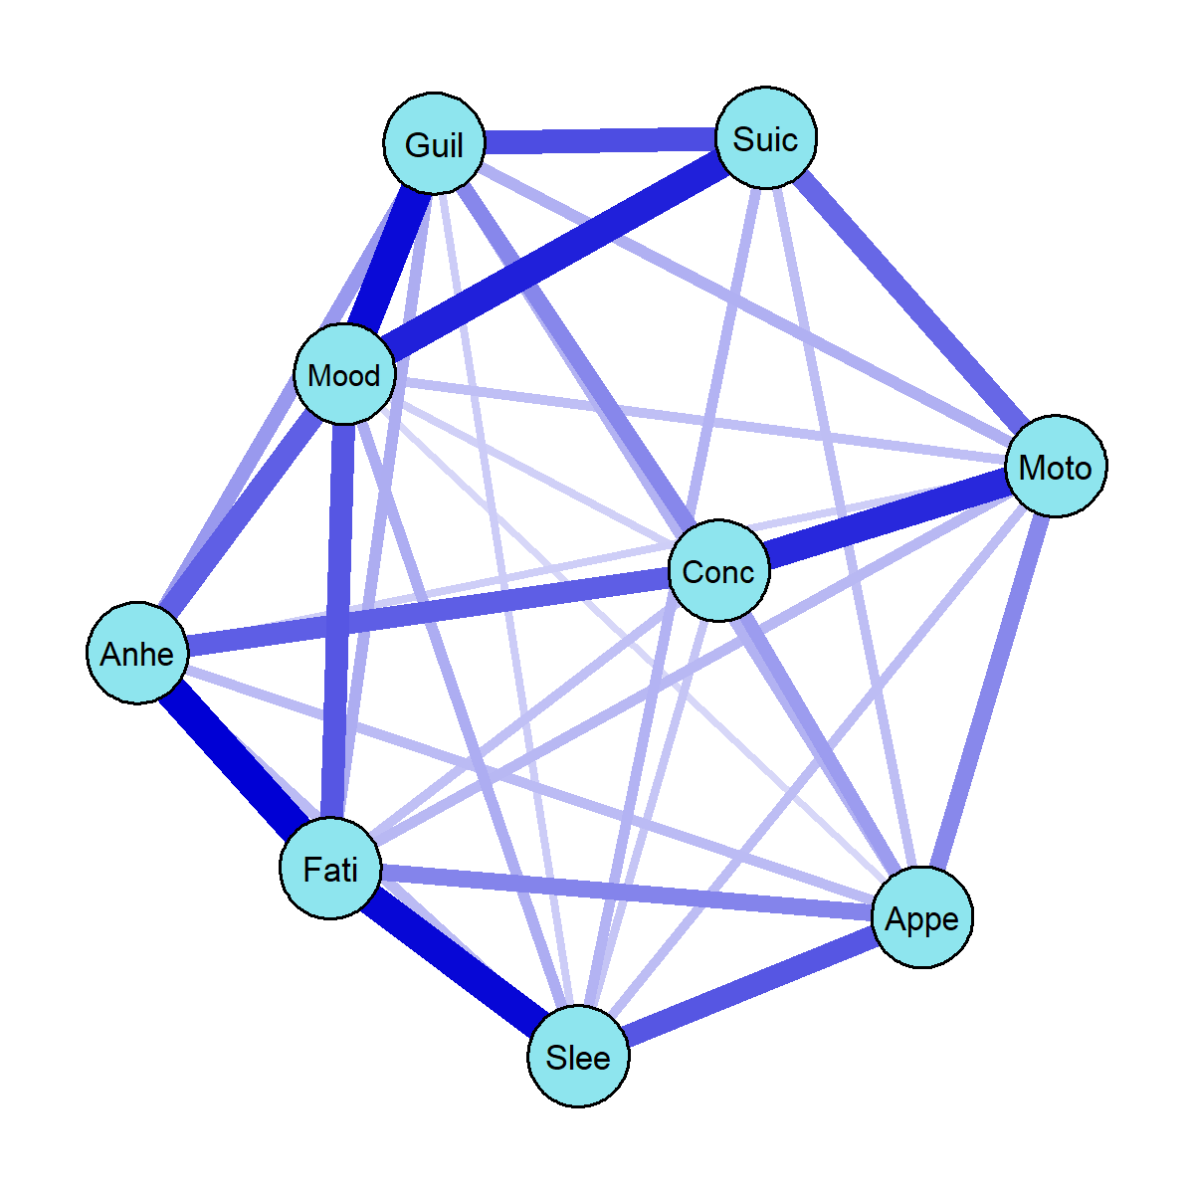  (d) Females 2-females
Figure S1. Network structure of PHQ-9 items
Note. The stronger the association between nodes, the thicker and more saturated the edge is represented in the network. Blue edges represent positive associations.

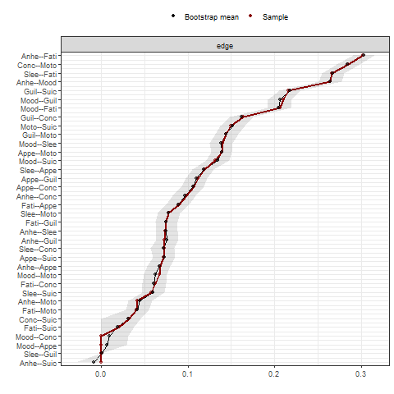  (a) Sample 1-males | 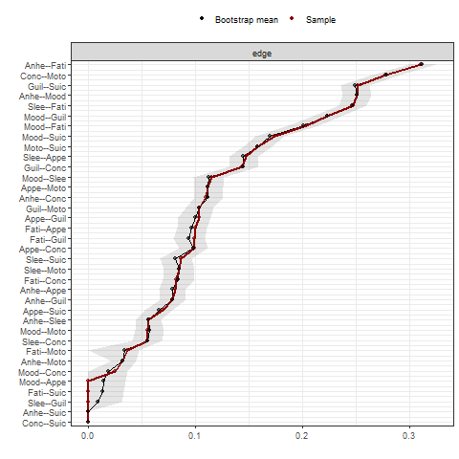(b) Sample 1-females
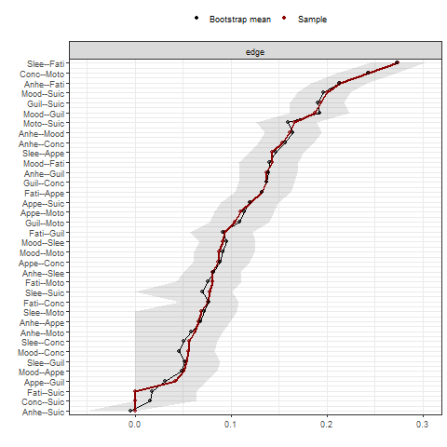  (c) Sample 2-males | 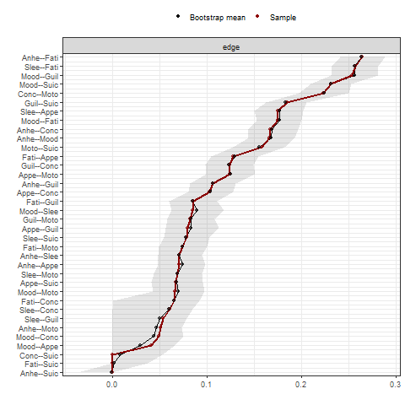(d) Females 2-females
Figure S2. Accuracy of edge weights
Note. The gray area shows the bootstrapped confidence intervals of the estimated edge weights for the estimated network. The red values (connected by the red line) indicate the sample mean values for the bootstrapped edge weights. The black values indicate the estimated edge weights.

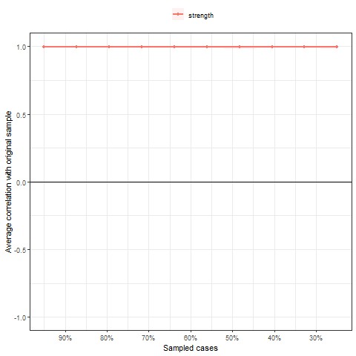  (a) Sample 1-males | 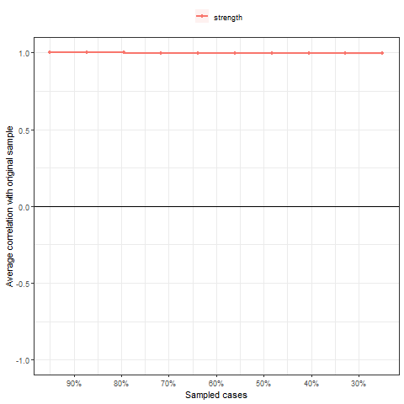(b) Sample 1-females
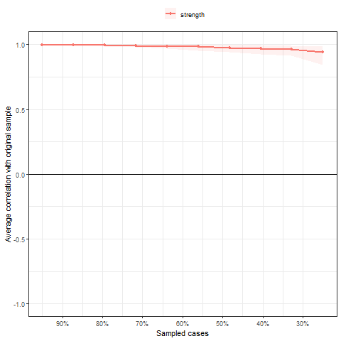  (c) Sample 2-males | 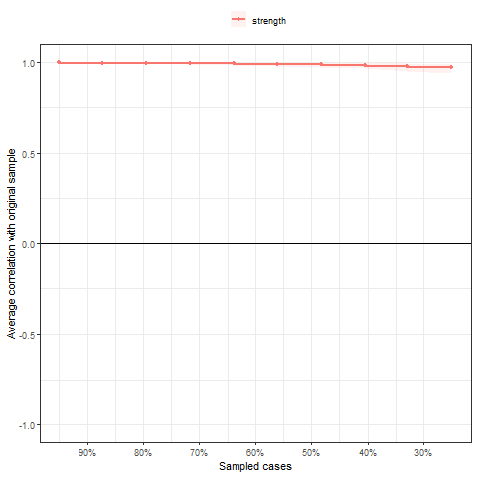(d) Females 2-females
Figure S3. Stability of nose strength centrality
Note. The plot shows the average correlation between the strength for the estimated network and the bootstrapped network. The lines indicates the mean correlation between centrality measures and the area around the indicates the 2.5th till the 97.5th quartile.

Table S1. Normative data of the PHQ-9
Total score | Male |  | Female
Total score | Percentage | Cumulative percentage | Percentage | Cumulative percentage
0 | 30.4 | 30.4 | 21.4 | 21.4
1 | 9.6 | 40.0 | 8.5 | 29.9
2 | 7.9 | 48.0 | 7.6 | 37.5
3 | 7.1 | 55.1 | 7.3 | 44.7
4 | 6.8 | 61.9 | 7.4 | 52.1
5 | 5.8 | 67.7 | 6.4 | 58.5
6 | 4.9 | 72.5 | 6.0 | 64.5
7 | 4.4 | 76.9 | 5.7 | 70.1
8 | 4.8 | 81.7 | 5.4 | 75.5
9 | 5.6 | 87.2 | 5.3 | 80.8
10 | 2.2 | 89.4 | 3.0 | 83.8
11 | 1.7 | 91.2 | 2.6 | 86.4
12 | 1.5 | 92.7 | 2.0 | 88.4
13 | 1.2 | 93.9 | 1.9 | 90.3
14 | 1.0 | 94.9 | 1.5 | 91.9
15 | 0.8 | 95.7 | 1.4 | 93.2
16 | 0.7 | 96.4 | 1.0 | 94.3
17 | 0.5 | 97.0 | 1.0 | 95.3
18 | 1.0 | 97.9 | 1.1 | 96.3
19 | 0.3 | 98.3 | 0.6 | 97.0
20 | 0.2 | 98.5 | 0.5 | 97.5
21 | 0.2 | 98.7 | 0.5 | 98.0
22 | 0.2 | 98.9 | 0.4 | 98.4
23 | 0.2 | 99.1 | 0.3 | 98.7
24 | 0.2 | 99.3 | 0.3 | 99.0
25 | 0.2 | 99.4 | 0.3 | 99.3
26 | 0.1 | 99.5 | 0.2 | 99.5
27 | 0.5 | 100.0 | 0.5 | 100.0

