Additional file 1
Table S1
Multicollinearity statistics for the regression model with PSS as dependent variable.
Variable | Variance Inflation Factor (VIF)
Femal gender | 1.07
Employment | 1.11
Income under poverty level | 1.15
Living in relationship with father/mother of youngest child | 1.10
Age of first child | 1.02
Pre-existing somatic disorder | 1.11
Pre-existing psychiatric disorder | 1.21
Depressive symptoms | 1.76
Anxiety symptoms | 1.87
Use of physical violence against children | 1.04
Parental experience of child maltreatment | 1.15
Variance Inflation factors above 10 represent strong evidence for multicollinearity. Durbin Watson statistic=1.66(values below 0.7 and above 2.3 indicate autocorrelation of residuals).

Figure S1
Distribution of residuals from the regression model with PSS as dependent variable (M=0, SD=1, N=415)
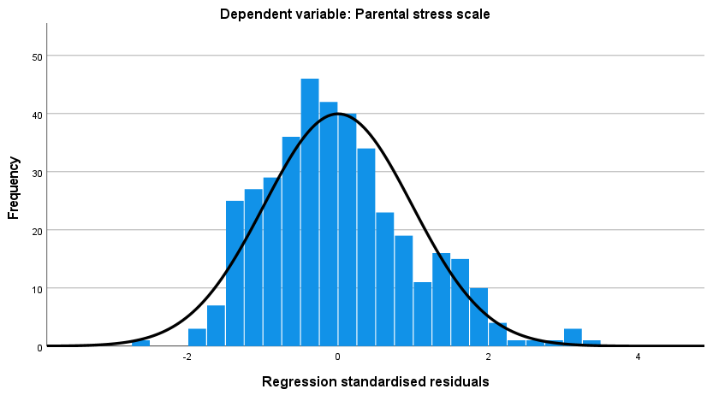

Figure S2
Scatterplot of residuals for the regression model with PSS as dependent variable
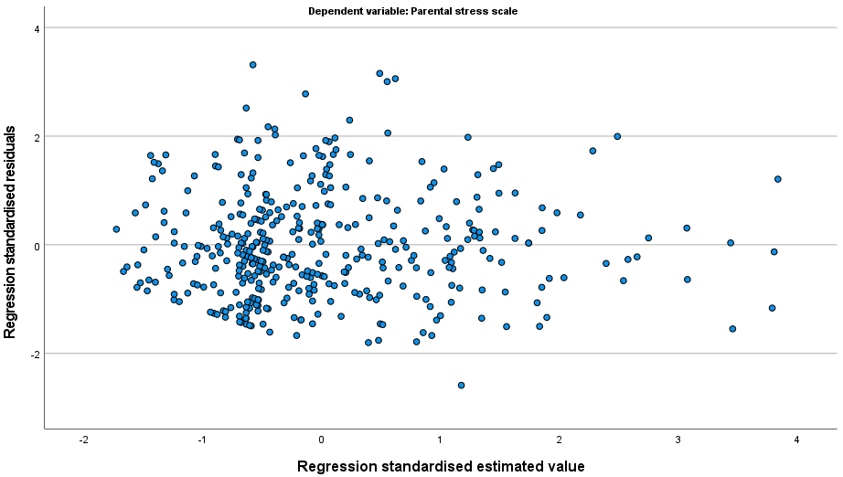

Table S2
Multicollinearity statistics for the regression model with change in parental stress as dependent variable.
Variable | Variance Inflation Factor (VIF)
Femal gender | 1.15
Employment | 1.10
Income under poverty level | 1.09
Living in relationship with father/mother of youngest child | 1.11
Age of first child | 1.05
Pre-existing somatic disorder | 1.07
Pre-existing psychiatric disorder | 1.27
Depressive symptoms | 1.72
Anxiety symptoms | 1.81
Use of physical violence against children | 1.05
Parental experience of child maltreatment | 1.27
„System-relevant“ job | 1.31
Working from home | 1.27
„System-relevant“ job partner | 1.20
Working from home | 1.20
Variance Inflation factors above 10 represent strong evidence for multicollinearity. Durbin Watson statistic=1.53(values below 0.7 and above 2.3 indicate autocorrelation of residuals).

Figure S3
Distribution of residuals from the regression model with change in PSS as dependent variable (M=0, SD=1, N=293)
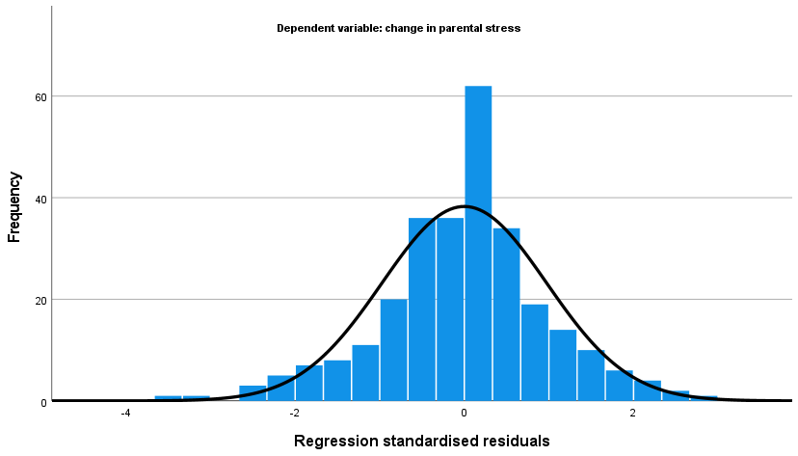

Figure S4
Scatterplot of residuals for the regression model with change in parental stress as dependent variable
