Maternal pre-pandemic mental health
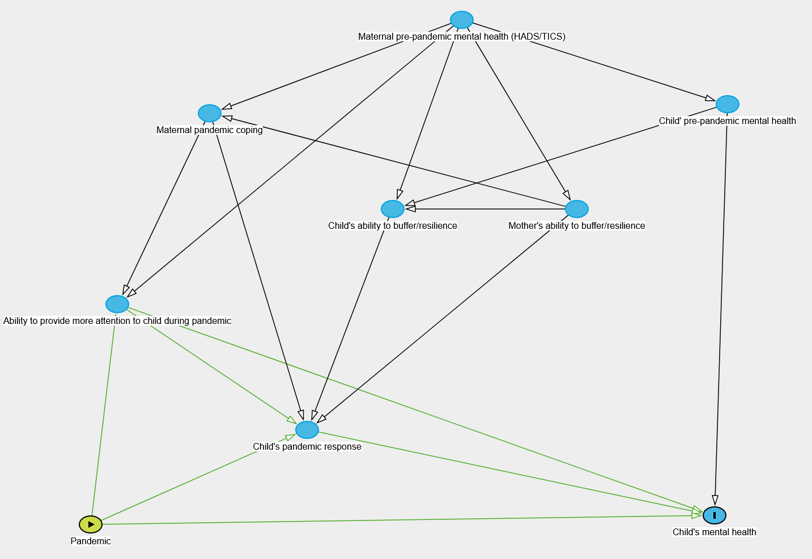Additional file 2: Figure S1. Directed Acyclic Graph depicting how maternal pre-pandemic mental health is possibly associated with child’s mental health during a pandemic.

Housing density as a social determinant of health
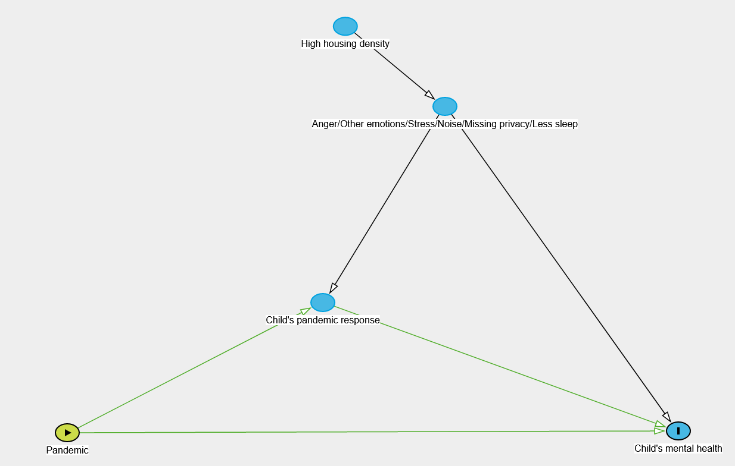
Additional file 2: Figure S2. Directed Acyclic Graph depicting how pre-pandemic high housing density (as a social determinant of health) is possibly associated with child’s mental health during a pandemic.

Maternal working days 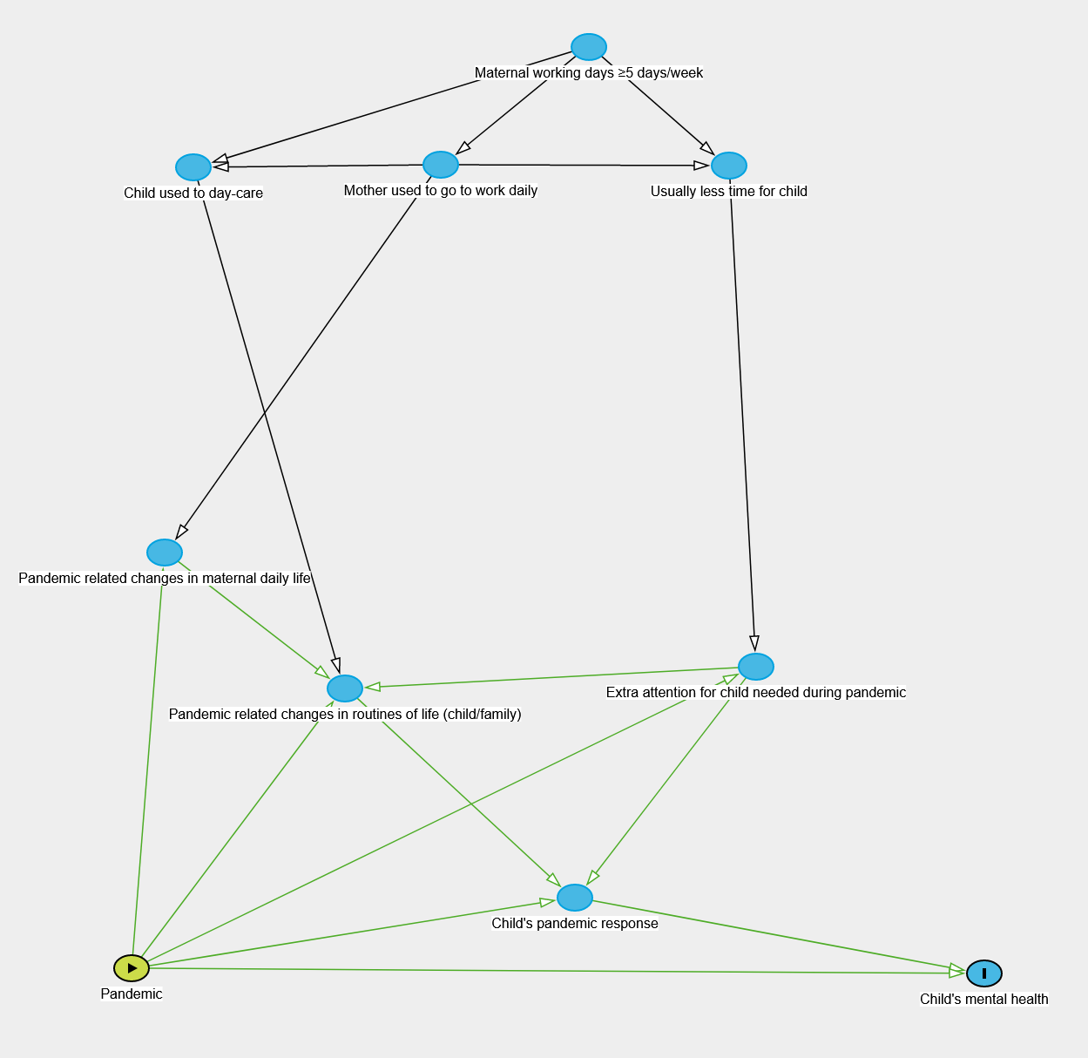
Additional file 2: Figure S3. Directed Acyclic Graph (DAG) depicting how maternal pre-pandemic working habits are possibly associated with child’s mental health during a pandemic. This DAG is explorative, as we assumed that the pandemic related restrictions/changes might cause a bigger change in daily routines of those mothers who were used to go to work on a daily basis (every day).

