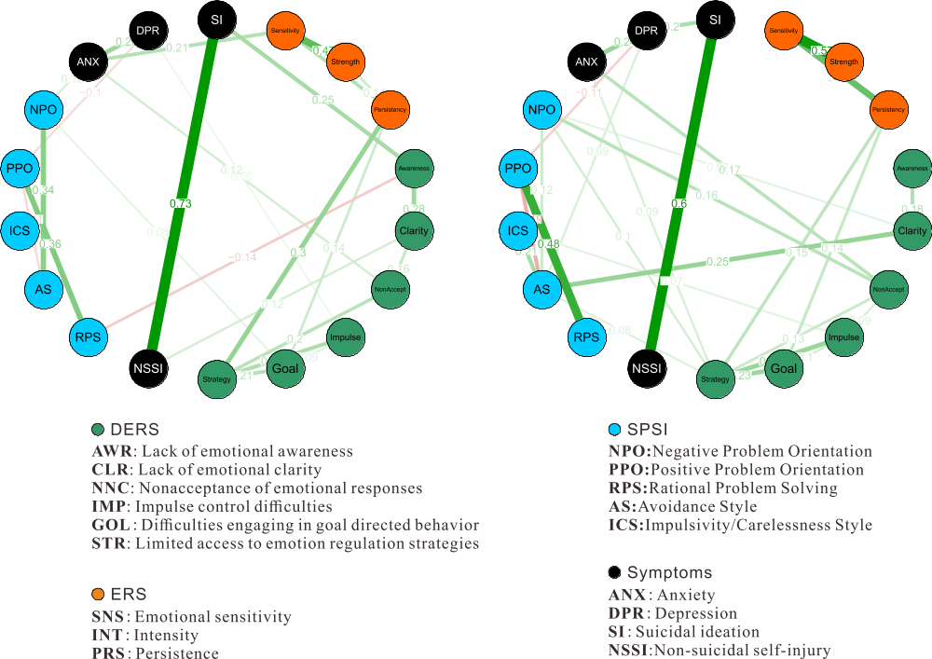

Additional file 1: Fig. S1 Two estimated network structures based on nonclinical (left) and clinical (right) samples. The networks show the relationships among variables, including symptoms (SI, NSSI, depression, and anxiety) and psychological characteristics (ERS, SPSI, and DERS). The edge weights are the regression coefficients with regularization. Blue edges represent positive relationships and red edges indicate negative relationships. The thickness of the edge reflects the magnitude of the relationship.

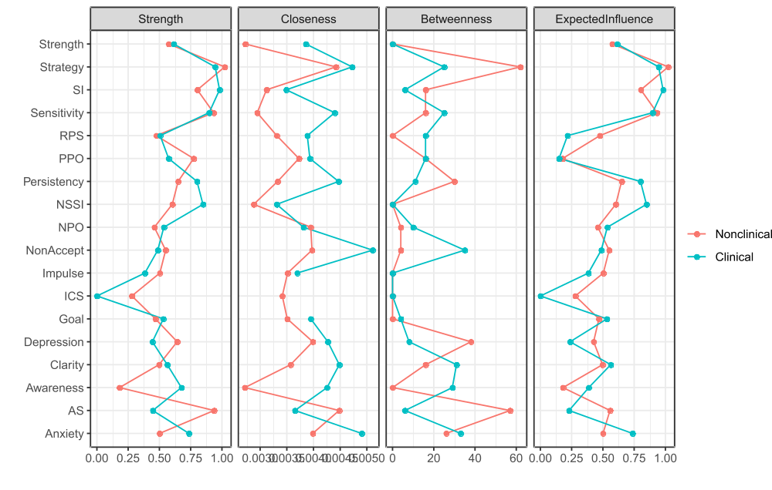
Additional file 1: Fig. S2. Centrality indices for the nodes in the nonclinical and clinical networks, including those for strength, betweenness, closeness, and expected influence. Red and blue represent female and male networks, respectively.

Additional file 1: Table S1 Logistic Regression Performed to Ascertain the Effects of Various Factors on the Likelihood of SI
 | Nonclinical |  |  |  | Clinical
 | B | SE | p | OR | B | SE | p | OR
Sensitivity | .088 | .059 | .135 | 1.092 | -.122 | .060 | .042 | .885
Intensity | -.115 | .078 | .140 | .891 | .093 | .075 | .215 | 1.097
Persistency | .308 | .122 | .012 | 1.360 | .006 | .110 | .959 | 1.006
Lack of Awareness | -.049 | .063 | .440 | .952 | .199 | .063 | .002 | 1.220
Clarity | .084 | .091 | .357 | 1.088 | -.113 | .084 | .179 | .894
Nonacceptance | -.090 | .062 | .146 | .914 | .000 | .062 | .994 | 1.000
Impulses | -.007 | .056 | .898 | .993 | .010 | .055 | .849 | 1.010
Goals | -.038 | .065 | .557 | .963 | .014 | .075 | .849 | 1.014
Strategies | -.053 | .056 | .342 | .948 | .106 | .060 | .078 | 1.112
NSSI | 1.586 | .460 | .001 | 4.884 | 1.838 | .506 | .000 | 6.284
RPS | -.054 | .037 | .141 | .947 | .021 | .033 | .516 | 1.022
AS | -.047 | .053 | .379 | .954 | .098 | .059 | .098 | 1.104
ICS | .034 | .079 | .670 | 1.034 | -.002 | .089 | .978 | .998
PPO | .015 | .095 | .878 | 1.015 | -.021 | .114 | .853 | .979
NPO | -.006 | .073 | .934 | .994 | -.016 | .077 | .836 | .984
Anxiety | .070 | .084 | .410 | 1.072 | .262 | .109 | .017 | 1.300
Depression | .178 | .078 | .022 | 1.195 | -.007 | .080 | .930 | .993

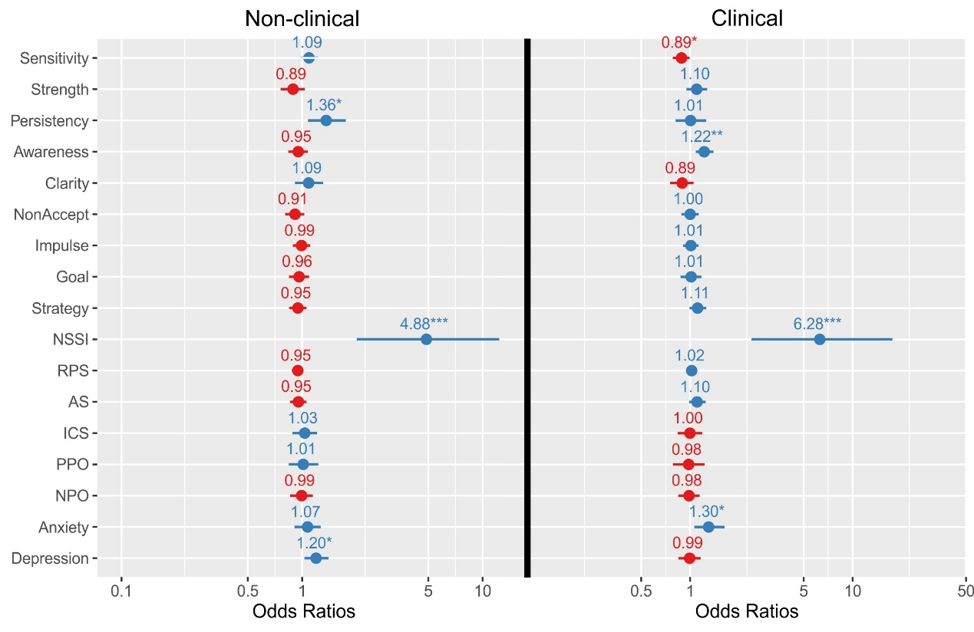
Additional file 1: Fig. S3 Forest plot of the odds ratios in the logistic regression. The red numbers indicate ORs less than 1 and the blue numbers indicate ORs equal to or greater than 1. Note that the OR value is large for NSSI because it’s a categorical variable.

