SUPPLEMENTARY MATERIALS

Supplementary Figure S1. Sample selection flowchart
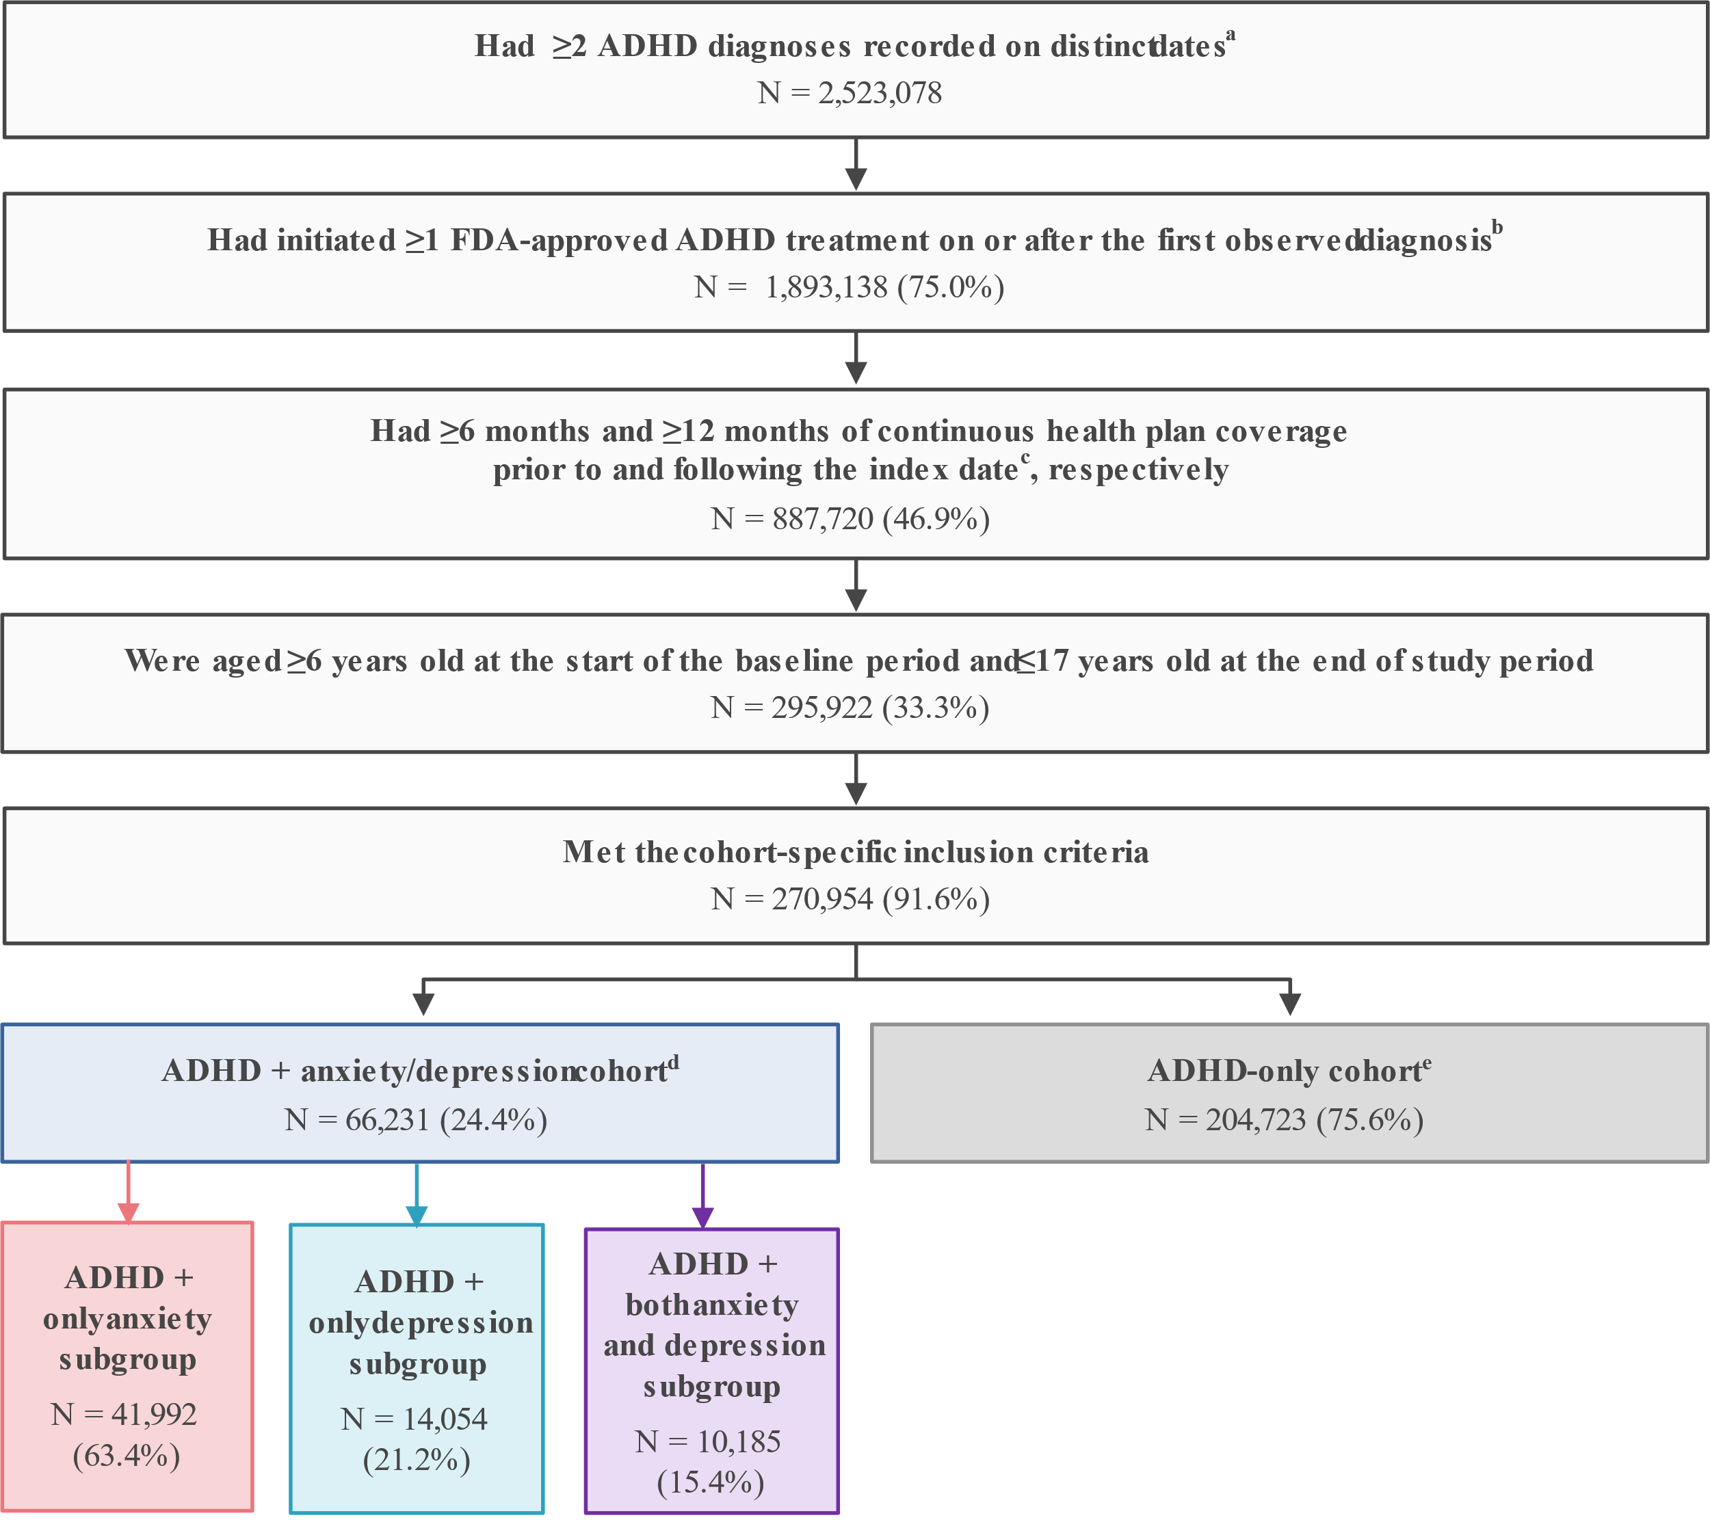

ADHD, attention-deficit/hyperactivity disorder; DSM-5, Diagnostic and Statistical Manual of Mental Disorders, Fifth Edition; FDA, Food and Drug Administration; ICD-10-CM, International Classification of Diseases, Tenth Revision, Clinical Modification.

Notes:
ª ADHD was defined as ICD-10-CM codes: F90.x.
^{b} Patients could have initiated more than one treatment (i.e., multiple candidate index dates).
^{c} The index date was defined as a randomly selected date on which an FDA-approved agent for the treatment of ADHD was newly initiated.
^{d} Patients had ≥1 diagnosis for anxiety, depression, or both, as defined by the DSM-5 recorded on a medical claim during the baseline period and ≥1 during the study period.
^{e} Patients had no diagnoses for anxiety nor depression recorded on a medical claim at any time during the baseline or study period.

