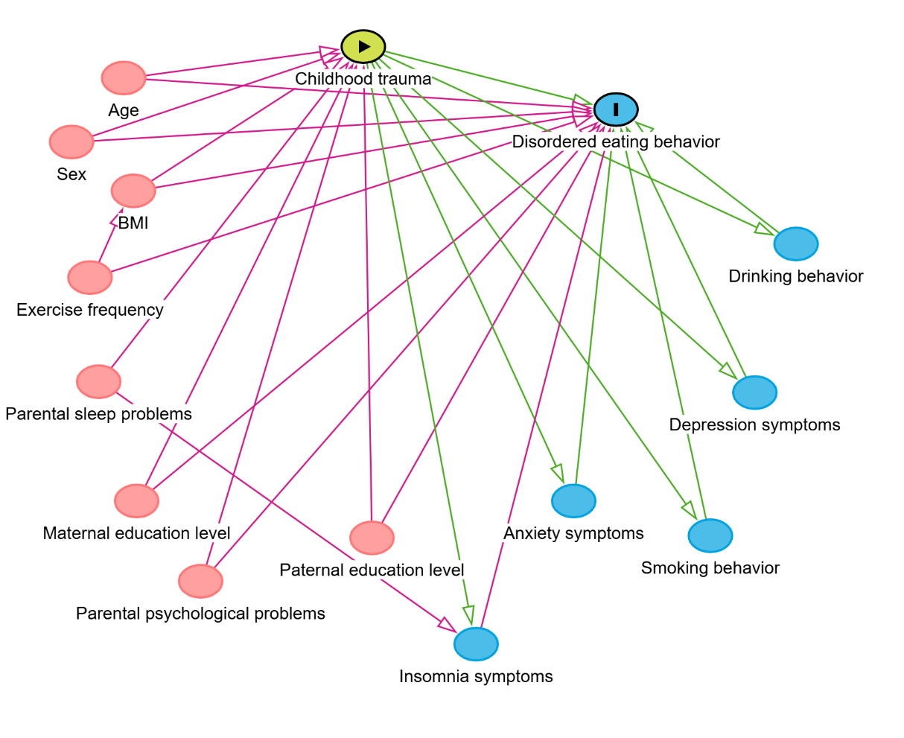
Figure S1. Directed Acyclic Graph illustrating hypothesized relationships among childhood trauma, disordered eating behaviors, and covariates.

Table S1 Model fit indices derived from latent class analysis on models with 1-5 classes

Model | Loglikelihood | AIC | BIC | SSABIC | Entropy | LMR(p) | BLRT(p) | Class counts and proportions
1 | -6662.605 | 13335.210 | 13365.903 | 13350.016 | - | - | -
2 | -6042.925 | 12107.850 | 12175.375 | 12140.423 | 0.713 | <0.0001 | <0.0001 | 969/2455 (0.28/0.72)
3 | -5893.708 | 11821.417 | 11925.773 | 11871.756 | 0.858 | <0.0001 | <0.0001 | 149/2179/1096(0.04/0.64/0.32)
4 | -5883.673 | 11813.345 | 11954.532 | 11881.450 | 0.785 | 0.1280 | <0.0001 | 1448/181/88/1707 (0.42/0.05/0.03/0.50)
5 | -5881.358 | 11820.716 | 11998.734 | 11906.588 | 0.728 | 0.1974 | 0.6667 | 125/56/1070/2092/81(0.04/0.02/0.31/0.61/0.02)
Note: AIC=Akaike Information Criterion; BIC=Bayesian Information Criterion; SSABIC=Sample Size Adjusted Bayesian Information Criterion; LMR=Vuong-Lo-Mendell-Rubin likelihood ratio test; BLRT=bootstrapped likelihood ratio test.

Table S2 Predicted probabilities of childhood trauma types by class membership
 | Low trauma | High neglect | High trauma
1. Emotional abuse | 0.012 | 0.055 | 0.777
2. Physical abuse | 0.012 | 0.013 | 0.608
3. Sexual abuse | 0.024 | 0.031 | 0.334
4. Emotional neglect | 0.000 | 0.916 | 0.862
5. Physical neglect | 0.183 | 0.695 | 0.762

Table S3 Differences in covariates and childhood trauma among LCA-identified childhood trauma types
Variables | Low trauma  (C1) | High neglect (C2) | High trauma (C3) | F/H/χ² | Post hoc tests | p
Covariates
Age, M (SD) | 18.15 (2.25) | 18.02 (2.27) | 18.19 (2.44) | 1.317 | C3≈C1≈C2 | 0.269
Sex, n (%) |  |  |  | 9.492 |  | 0.009
Male | 873 (40.1) | 496 (45.3) | 55 (36.9) |  | C1≈C3<C2
Female | 1306 (59.9) | 600 (54.7) | 94 (63.1) |  | C1≈C3>C2
BMI |  |  |  | 34.961 |  | <0.001
Under weight | 572 (26.3) | 261 (23.8) | 36 (24.2) |  | C1<C2≈C3
Normal weight | 1228 (56.4) | 658 (60.0) | 82 (55.0) |  | C1>C2≈C3
Over weight | 379 (17.4) | 177 (16.1) | 31 (20.8) |  | C1≈C2≈C3
Exercise frequency, n (%) |  |  |  | 27.752 |  | <0.001
No | 845 (38.8) | 498 (45.4) | 80 (53.7) |  | C1<C2≈C3
1-3 days/week | 906 (41.6) | 381 (34.8) | 40 (26.8) |  | C1>C2≈C3
>3 days/week | 428 (19.6) | 217 (19.8) | 29 (19.5) |  | C1≈C2≈C3
Smoking behavior |  |  |  | 130.697 |  | <0.001
No | 2068 (95.3) | 1011 (93.1) | 106 (71.6) |  | C1>C2>C3
Yes | 101 (4.7) | 75 (6.9) | 42 (28.4) |  | C1<C2<C3
Drinking behavior |  |  |  | 79.572 |  | <0.001
No | 1791 (82.3) | 883 (80.6) | 78 (52.3) |  | C1≈C2>C3
Yes | 385 (17.7) | 213 (19.4) | 71 (47.7) |  | C1≈C2<C3
Paternal education level, n (%) |  |  |  | 20.951 |  | <0.001
Middle school and below | 995 (45.7) | 570 (52.0) | 78 (52.3) |  | C1<C2≈C3
Senior high school | 588 (27.0) | 281 (25.6) | 25 (16.8) |  | C1≈C2>C3
College degree and above | 596 (27.4) | 245 (22.4) | 46 (30.9) |  | C1≈C3>C2
Maternal education level, n (%) |  |  |  | 10.579 |  | 0.032
Middle school and below | 1193 (54.7) | 656 (59.9) | 84 (56.4) |  | C1≈C3, C1<C2, C2≈C3
Senior high school | 539 (24.7) | 255 (23.3) | 31 (20.8) |  | C1≈C2≈C3
College degree and above | 447 (20.5) | 185 (16.9) | 34 (22.8) |  | C1>C2, C1≈C3, C2≈C3
Parental psychological problems, n (%) |  |  |  | 107.411 |  | <0.001
No | 2020 (92.7) | 956 (87.2) | 101 (67.8) |  | C1>C2>C3
Yes | 159 (7.3) | 140 (12.8) | 48 (32.2) |  | C1<C2<C3
Parental sleep problems, n (%) |  |  |  | 17.339 |  | <0.001
No | 1600 (73.46) | 798 (72.8) | 86 (57.7) |  | C1≈C2>C3
Yes | 579 (26.6) | 298 (27.2) | 63 (42.3) |  | C1≈C2<C3
Depression symptoms, Median (IQR) | 5.00 (7.00) | 7.00 (10.00) | 14.00 (10.00) | 198.902 | C1<C2<C3 | <0.001
Anxiety symptoms, Median (IQR) | 4.00 (7.00) | 5.00 (8.00) | 11.00 (9.00) | 153.703 | C1<C2<C3 | <0.001
Insomnia symptoms, Median (IQR) | 5.00 (7.00) | 7.00 (9.00) | 10.00 (9.00) | 116.273 | C1<C2<C3 | <0.001
Childhood trauma
Childhood trauma total score, M (SD) | 33.94 (5.69) | 48.87 (5.95) | 67.24 (12.87) | 2725.333 | C1<C2<C3 | <0.001
Emotional abuse, n (%) |  |  |  | 1300.043 |  | <0.001
No | 2145 (98.4) | 1006 (91.8) | 30 (20.1) |  | C1>C2>C3
Yes | 34 (1.6) | 90 (8.2) | 119 (79.9) |  | C1<C2<C3
Physical abuse, n (%) |  |  |  | 2209.796 |  | <0.001
No | 2153 (98.8) | 1088 (99.3) | 24 (16.1) |  | C1≈C2>C3
Yes | 26 (1.2) | 8 (0.7) | 125 (83.9) |  | C1≈C2<C3
Sexual abuse, n (%) |  |  |  | 545.688 |  | <0.001
No | 2126 (97.6) | 1061 (96.8) | 85 (57.0) |  | C1≈C2>C3
Yes | 53 (2.4) | 35 (3.2) | 64 (43.0) |  | C1≈C2<C3
Emotional neglect, n (%) |  |  |  | 3348.640 |  | <0.001
No | 2179 (100.0) | 0 (0.0) | 20 (13.4) |  | C1>C3>C2
Yes | 0 (0.0) | 1096 (100.0) | 129 (86.6) |  | C1<C3<C2
Physical neglect, n (%) |  |  |  | 824.528 |  | <0.001
No | 1725 (79.2) | 339 (30.9) | 30 (20.1) |  | C1>C2>C3
Yes | 454 (20.8) | 757 (69.1) | 119 (79.9) |  | C1<C2<C3
Cumulative childhood trauma, n (%) |  |  |  | 4209.117 |  | <0.001
0 | 1644 (75.4) | 0 (0.0) | 0 (0.0) |  | C1>C2≈C3
1 | 503 (23.1) | 289 (26.4) | 0 (0.0) |  | C1≈C2>C3
2 | 32 (1.5) | 724 (66.1) | 11 (7.4) |  | C1<C3<C2
≥3 | 0 (0.0) | 83 (7.6) | 138 (92.6) |  | C1<C2<C3
Note. M=Mean; SD=Standard deviation; n=Frequencies; %= Percentages; IQR=Interquartile range; BMI=Body mass index.

Table S4 Association of childhood trauma with disordered dieting behaviors: using ‘neither behavior’ as the reference category
Variables | Risky restrictive eating only |  |  | Binge/purging only |  |  | Both behaviors
Variables | OR (95%CI) | p |  | OR (95%CI) | p |  | OR (95%CI) | p
Individual childhood trauma types
Emotional abuse
No | Reference
Yes | 1.86 (1.02, 2.39) | 0.044 |  | 1.98 (1.08, 3.64) | 0.028 |  | 3.69 (1.71, 7.98) | 0.001
Physical abuse
No | Reference
Yes | 0.80 (0.36, 1.77) | 0.576 |  | 1.62 (0.80, 3.28) | 0.184 |  | 2.77 (1.24, 6.20) | 0.013
Sexual abuse
No | Reference
Yes | 1.51 (0.73, 3.12) | 0.263 |  | 0.89 (0.38, 2.10) | 0.791 |  | 1.40 (0.59, 3.30) | 0.447
Emotional neglect
No | Reference
Yes | 1.07 (0.64, 1.79) | 0.789 |  | 1.26 (0.76, 2.07) | 0.373 |  | 1.41 (0.65, 3.06) | 0.385
Physical neglect
No | Reference
Yes | 1.32 (0.80, 2.17) | 0.283 |  | 0.99 (0.60, 1.62) | 0.957 |  | 0.88 (0.41, 1.87) | 0.741
Cumulative childhood trauma types
0 | Reference
1 | 1.47 (0.79, 2.73) | 0.221 |  | 0.87 (0.46, 1.65) | 0.661 |  | 0.79 (0.25, 2.54) | 0.696
2 | 1.80 (0.97, 3.31) | 0.062 |  | 1.86 (1.08, 3.23) | 0.026 |  | 2.25 (0.88, 5.76) | 0.091
≥3 | 2.15 (1.07, 4.33) | 0.032 |  | 2.21 (1.11, 4.38) | 0.024 |  | 5.24 (2.07, 13.25) | <0.001
LCA-identified childhood trauma types
Low trauma | Reference
High neglect | 1.38 (0.85, 2.24) | 0.198 |  | 1.47 (0.92, 2.35) | 0.108 |  | 1.89 (0.88, 4.09) | 0.104
High trauma | 2.10 (1.04, 4.24) | 0.038 |  | 2.39 (1.18, 4.85) | 0.016 |  | 6.79 (2.95, 15.62) | <0.001
Note. LCA=latent class analysis; Reference=1; CI=confidence interval; The results of multinomial logistic regressions adjusted for age, sex, BMI, exercise frequency, smoking behavior, drinking behavior, paternal and maternal education level, parental psychological and sleep problems, depression symptoms, anxiety symptoms, and insomnia symptoms.

Table S5 Association of childhood trauma with disordered dieting behaviors: using ‘both behaviors’ as the reference category
Variables | Neither behavior |  |  | Risky restrictive eating only |  |  | Binge/purging only
Variables | OR (95%CI) | p |  | OR (95%CI) | p |  | OR (95%CI) | p
Individual childhood trauma types
Emotional abuse
No | Reference
Yes | 0.27 (0.13, 0.59) | 0.001 |  | 0.50 (0.21, 1.23) | 0.131 |  | 0.54 (0.22, 1.33) | 0.178
Physical abuse
No | Reference
Yes | 0.36 (0.16, 0.81) | 0.013 |  | 0.29 (0.10, 2.93) | 0.016 |  | 0.58 (0.22, 1.53) | 0.273
Sexual abuse
No | Reference
Yes | 0.72 (0.30, 1.69) | 0.447 |  | 1.08 (0.40, 2.93) | 0.874 |  | 0.64 (0.22, 1.89) | 0.416
Emotional neglect
No | Reference
Yes | 0.71 (0.33, 1.54) | 0.385 |  | 0.76 (0.32, 1.83) | 0.541 |  | 0.89 (0.37, 2.14) | 0.796
Physical neglect
No | Reference
Yes | 1.14 (0.53, 2.42) | 0.741 |  | 1.49 (0.63, 3.54) | 0.361 |  | 1.12 (0.47, 2.65) | 0.796
Cumulative childhood trauma types
0 | Reference
1 | 1.25 (0.39, 4.04) | 0.696 |  | 1.86 (0.51, 6.70) | 0.346 |  | 1.09 (0.30, 4.02) | 0.894
2 | 0.44 (0.17, 1.14) | 0.091 |  | 0.80 (0.27, 2.35) | 0.682 |  | 0.83 (0.29, 2.38) | 0.726
≥3 | 0.19 (0.08, 0.48) | <0.001 |  | 0.41 (0.14, 1.22) | 0.108 |  | 0.42 (0.14, 1.25) | 0.119
LCA-identified childhood trauma types
Low trauma | Reference
High neglect | 0.53 (0.25, 1.14) | 0.104 |  | 0.73 (0.30, 1.74) | 0.472 |  | 0.78 (0.33, 1.85) | 0.567
High trauma | 0.15 (0.06, 0.34) | <0.001 |  | 0.31 (0.12, 0.83) | 0.020 |  | 0.35 (0.13, 0.96) | 0.041
Note. LCA=latent class analysis; Reference=1; CI=confidence interval; The results of multinomial logistic regressions adjusted for age, sex, BMI, exercise frequency, smoking behavior, drinking behavior, paternal and maternal education level, parental psychological and sleep problems, depression symptoms, anxiety symptoms, and insomnia symptoms.

