Supplementary Materials
  - Sample recruitment
During the school year 2022/23, 15 secondary second degree schools of Palermo and Catania were selected on the basis of their Principals’ availability. The total population of the schools was 3,150 students: 69 classes for a total of 1,740 students (55.2% of total involved school population) were randomly selected for the study to estimate the prevalence of EDs and some of their related risk factors. Inclusion criteria for study participation were: age comprised between 14 and 16 years old; attending the first, second or third class.
1.2. Gender specific regression models
Generalized linear regression analysis splitting the data sample by gender were conducted. Three different models were generated using EDE-Q score as outcome and BMI, BAS, presence of physical exercise, alcohol consumption, smoking habits, self-harm episodes, body comparison throughout social media, presence of victimization and bullyism, impact of COVID and presence of EDs in family as continuous predictors. The results are shown in the Table S1.
Table S1. Generalized linear models results splitting by gender using EDE-Q as dependent variable.
GENDER | MODEL | UnStd. Coefficients |  | Std. Coefficients | t | pvalue
GENDER | MODEL | T | Std. Error | Beta | t | pvalue
Non binary | (Constant) | -2.857 | 4.453 |  | -,642 | ,587
Non binary | BMI | ,138 | ,165 | ,484 | ,837 | ,491
Non binary | BAS | -1.106 | ,570 | -,894 | -1.942 | ,192
Non binary | Sport | 5.168 | 1.851 | 1.793 | 2.792 | ,108
Non binary | Acohol consumption | -,643 | 1.340 | -,226 | -,480 | ,679
Non binary | Smoking | -1.621 | 1.617 | -,562 | -1.002 | ,422
Non binary | Self-Harm | ,263 | 2.175 | ,091 | ,121 | ,915
Non binary | Social comparison | -,205 | 1.021 | -,072 | -,201 | ,860
Non binary | Victimization | 4.230 | 1.789 | 1.421 | 2.364 | ,142
Non binary | Bullying | ,561 | 1.343 | ,161 | ,418 | ,717
Non binary | COVID-19 impact | 1.291 | 2.253 | ,453 | ,573 | ,624
Non binary | Familiar EDs | -1.076 | ,950 | -,377 | -1.132 | ,375
Females | (Constant) | 1.139 | ,238 |  | 4.780 | ,000
Females | BMI | ,061 | ,009 | ,166 | 6.640 | ,000
Females | BAS | -,646 | ,036 | -,505 | -17.752 | ,000
Females | Sport | ,139 | ,064 | ,051 | 2.183 | ,029
Females | Acohol consumption | ,257 | ,072 | ,094 | 3.583 | ,000
Females | Smoking | -,020 | ,075 | -,007 | -,273 | ,785
Females | Self-Harm | ,297 | ,083 | ,088 | 3.558 | ,000
Females | Social comparison | ,333 | ,071 | ,122 | 4.719 | ,000
Females | Victimization | ,068 | ,084 | ,020 | ,808 | ,419
Females | Bullying | -,077 | ,101 | -,018 | -,759 | ,448
Females | COVID-19 impact | ,510 | ,070 | ,187 | 7.334 | ,000
Females | Familiar EDs | ,133 | ,076 | ,043 | 1.761 | ,079
Males | (Constant) | ,066 | ,182 |  | ,362 | ,717
Males | BMI | ,068 | ,007 | ,270 | 10.059 | ,000
Males | BAS | -,407 | ,027 | -,411 | -15.066 | ,000
Males | Sport | ,167 | ,053 | ,078 | 3.168 | ,002
Males | Acohol consumption | -,016 | ,049 | -,008 | -,322 | ,747
Males | Smoking | ,160 | ,061 | ,069 | 2.629 | ,009
Males | Self-Harm | ,293 | ,089 | ,083 | 3.298 | ,001
Males | Social comparison | ,173 | ,056 | ,076 | 3.073 | ,002
Males | Victimization | ,277 | ,078 | ,091 | 3.557 | ,000
Males | Bullying | ,132 | ,060 | ,056 | 2.208 | ,028
Males | COVID-19 impact | ,327 | ,052 | ,167 | 6.293 | ,000
Males | Familiar EDs | ,194 | ,054 | ,089 | 3.559 | ,000
BMI: Body Mass Index (Kg/cm²); BAS: Body Appreciation Scale; EDs: Eating Disorders; Std: standardized; UnStd: UnStandardized.
1.3. Sensitivity analysis bullism/victimism
Generalized linear regression analyses were conducted, stratifying individuals based on their involvment in bullying either as pepetrators or as victims. The global EDE-Q score was used as the outcome variable. Predictor variables included BMI, BAS score, engagement in physical excersise, alcohol consumption, smoking habits, episodes of self-harm, body comparison throughout social media, impact of COVID-19 and presence of EDs in family. The results are presented in the Figure S1.
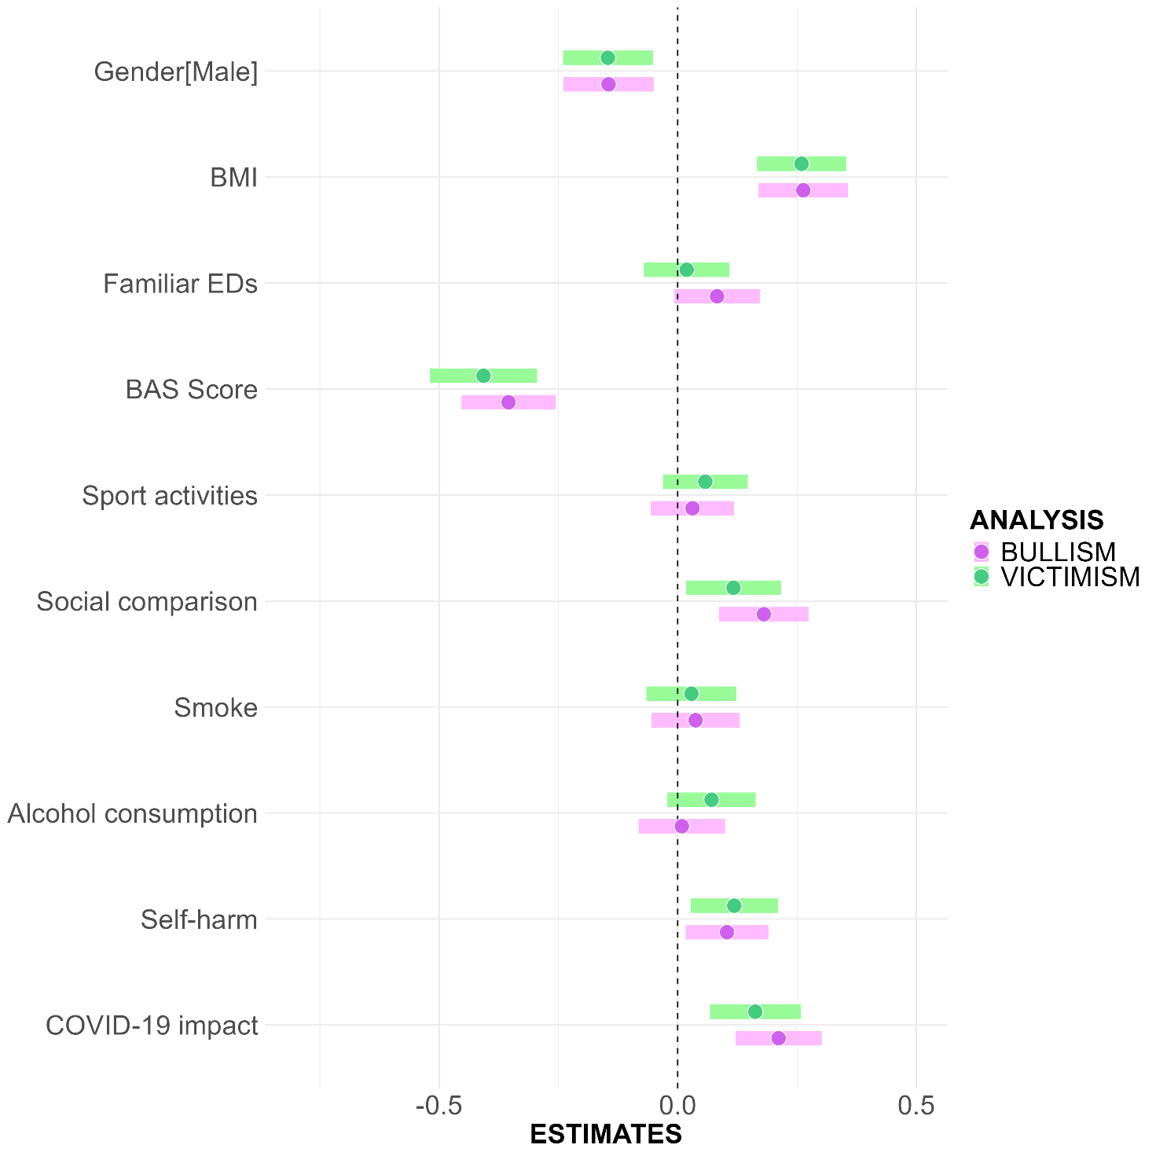
Figure S1. Standardized beta coefficients (with 95% confidence intervals) from generalized linear regression models assessing the association between individual and psychosocial factors and EDE-Q global score, stratified by involvement in bullying. Green bars represent individuals who reported being victims of bullying, and pink bars represent those who reported being perpetrators.

