Figure S1. Nonparametric bootstrapped difference tests
A: 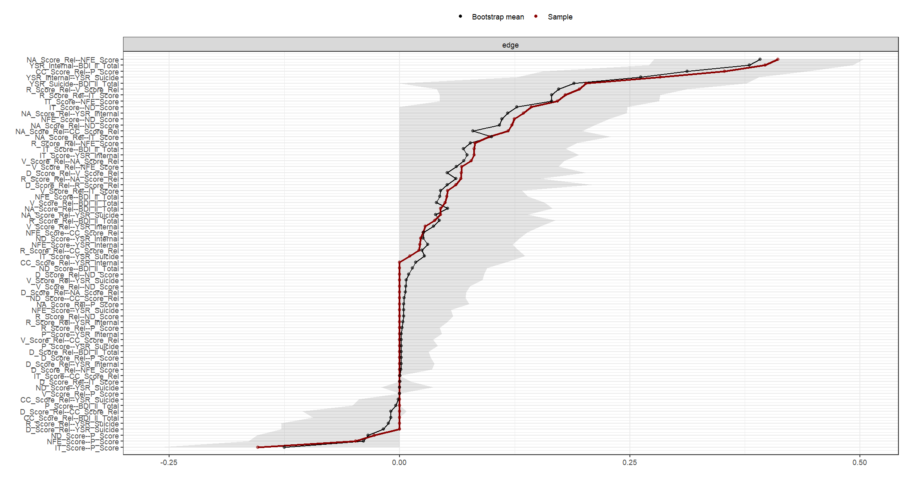

B:
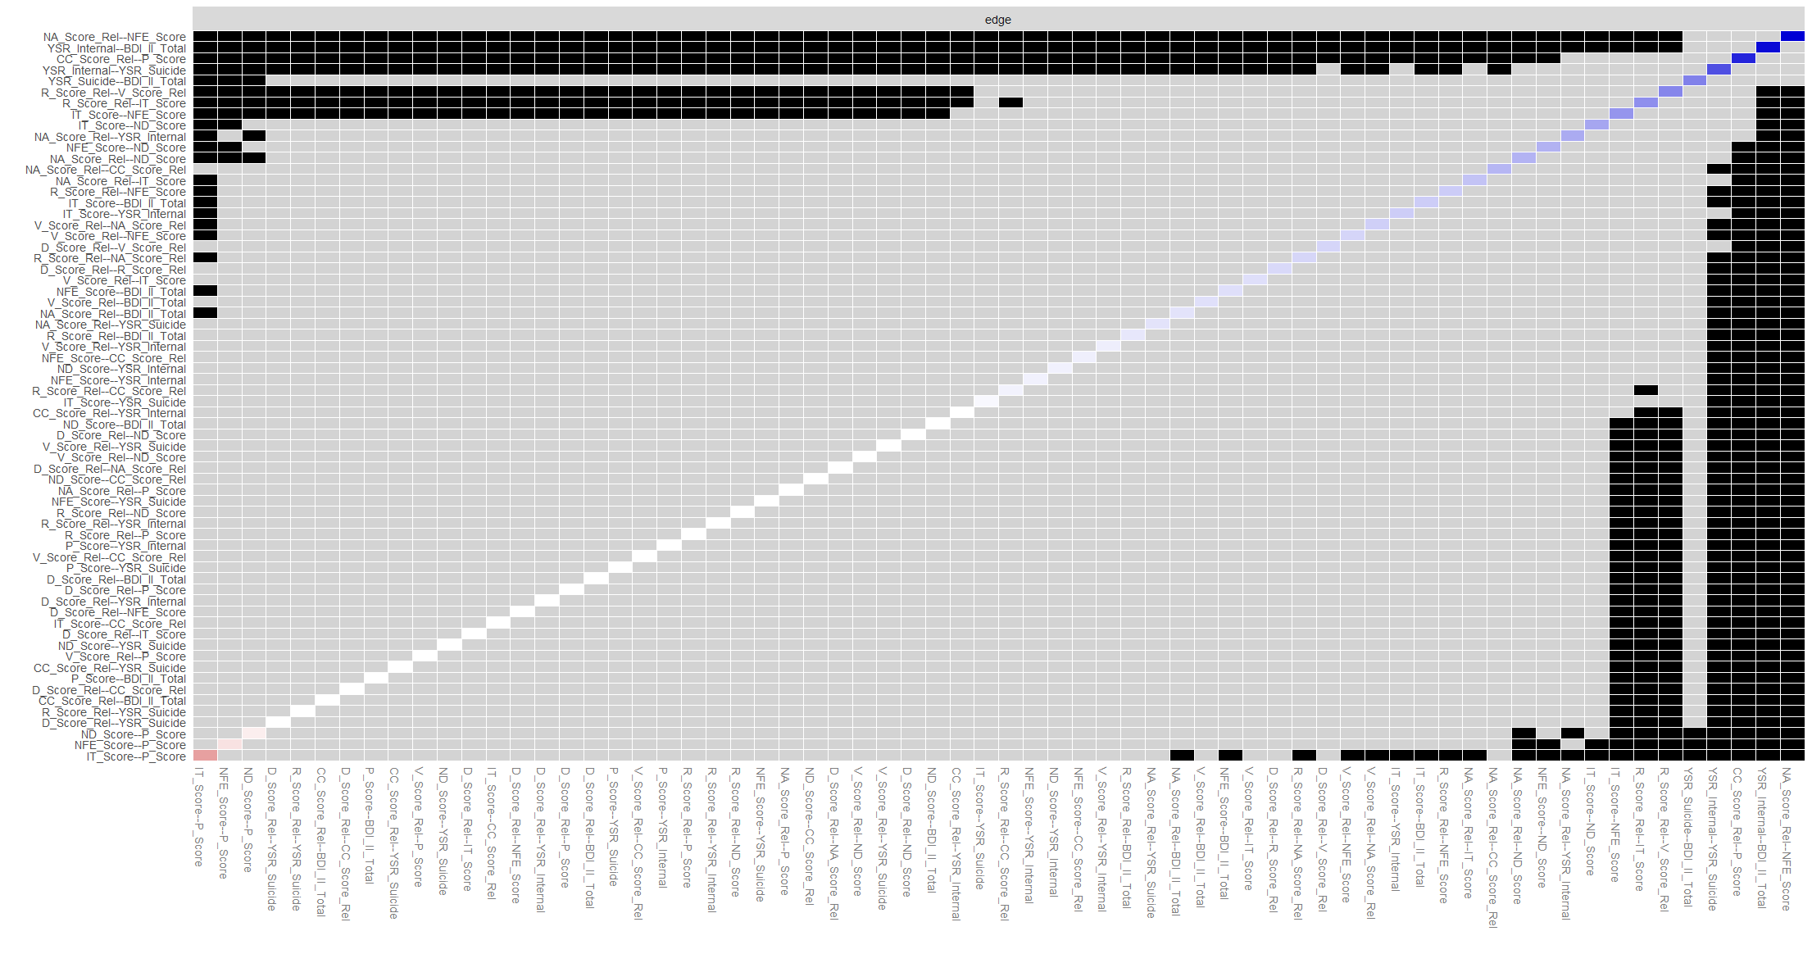
Figure S1. Panel A and Panel B: Nonparametric bootstrapped difference tests for the edges. For this, 95% bootstrapped confidence intervals (CIs) for edge-weights are constructed based on the normal variance in the bootstrapped sample. A wide interval represents low stability, and narrow intervals represent high stability.

